Social Media Plan

Social media platforms are great for gaining attention, reaching out and engaging with our audiences. Think about how you can promote to your audience in the days and weeks leading up to the day and on the day itself.

The official social media username for the TD Summer Reading Club is @TDSRC_CLETD and the official hashtag is #TDSRC. Please be sure to include this in your social media posts so we can track and share your posts on Get Your Summer Read On Day. And don’t forget to include it in all your social media throughout the summer!

If you are including program participants in your photos, please let them know that their image could be shared on the TD SRC’s social media platforms and get their approval before sharing their image with us.

General Tips

- Early in the morning or after kids’ bedtime is the best time to reach parents on Facebook and Twitter.

- Visual content gets better results than text-based posts on social media. In addition to text, post illustrations, photos and videos of your programming and special events to help liven up your posts.

- Good quality photos help increase the engagement rate (this includes likes, shares, and comments). Avoid posting blurry images and make sure to have good lighting when taking your photos.

- Think branding—whenever possible, try to incorporate the TD SRC logo by holding a notebook, wearing a T-shirt, or taking a picture near a poster.

- Always include the hashtag #TDSRC in your posts.

- Use @mention or tag prominent figures in the community who can help share your post and widen its reach.

- Utilize the live tweet and streaming features when possible.

- Tag other libraries so you can share and promote each another’s activities.
Sample Social Media Messages

Twitter
- Only 9/8/7 more days until we kick off the TD Summer Reading Club on [insert date]! #TDSRC @TDSRC_CLETD
- Hey kids! Get Your Summer Read On with the TD Summer Reading Club! Details on our website tdsummerreadingclub.ca #TDSRC @TDSRC_CLETD
- Visit your library on [insert date] to register for the TD Summer Reading Club and you could WIN prizes! #TDSRC @TDSRC_CLETD
- Keep kids reading! Register your child for the TD Summer Reading Club #TDSRC @TDSRC_CLETD
- Get Your Summer Read On! [insert date] at your library. Register for the TD Summer Club Reading Club. tdsummerreadingclub.ca #TDSRC @TDSRC_CLETD
- Parents! Keep kids reading all summer. Visit your library on [insert date] & register for the TD Summer Reading Club. tdsummerreadingclub.ca #TDSRC @TDSRC_CLETD
- This year's TD Summer Reading Club is back and better than ever! Sign up for fun games, challenges and great books all in accessible formats. tdsummerreadingclub.ca #TDSRC @TDSRC_CLETD
- We're excited for this year's #TDSRC that celebrates reading, fun and kids of all abilities! Sign up and join in the fun! tdsummerreadingclub.ca @TDSRC_CLETD

Facebook
- Only 9/8/7 more days until we kick off the TD Summer Reading Club on [insert date]! #TDSRC @TDSRC_CLETD
- Hey kids! Get Your Summer Read On with the TD Summer Reading Club! Details on our website tdsummerreadingclub.ca #TDSRC @TDSRC_CLETD
- Visit your library on [insert date] to register for the TD Summer Reading Club and you could WIN prizes! #TDSRC @TDSRC_CLETD
- Keep kids reading! Register your child for the TD Summer Reading Club on [insert date]. #TDSRC @TDSRC_CLETD
- Share what you're reading as part of the TD SRC this summer! Post with the hashtag #TDSRC @TDSRC_CLETD
- Share your fun and accessible activities inspired by this year's #TDSRC theme “Feed your passions.” We'd love to see what you are doing! @TDSRC_CLETD
- Find books that will feed your passions at our accessible TD Summer Reading Club! Join our launch party on [insert date]. All kinds of fun for all kinds of kids! #TDSRC @TDSRC_CLETD
- This year's TD Summer Reading Club is back and better than ever! Sign up for fun games, challenges and great books all in accessible formats. #TDSRC @TDSRC_CLETD
- We're excited for this year's #TDSRC that celebrates reading, fun and kids of all abilities! Sign up with us and join in the fun! @TDSRC_CLETD

Pinterest / Instagram

Post pictures of your TD Summer Reading Club’s fun activities. Make sure to tag them #TDSRC
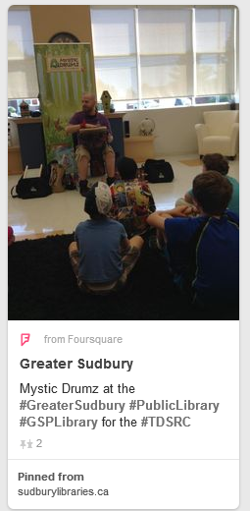
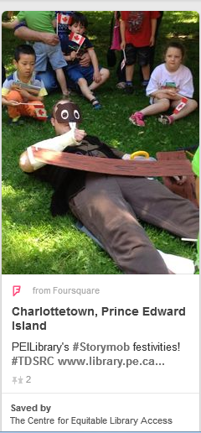

Sample Social Media Images:

Here are some sample images that would work well on social media. Use your own images in your social media posts to liven them up! We’ll be happy to share your posts on our national social media for the Club.

