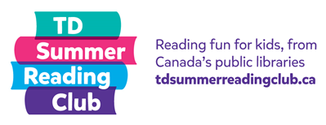

**Draw a picture about what you read!**

**Name: Age:**