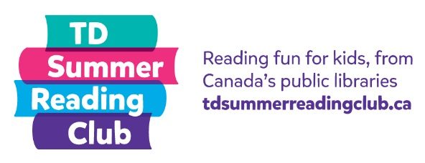
Book Reporting

Research shows that children who engage in conversations with adults have better language and cognitive skills. Consider book reporting as a fun way to start a conversation with kids about what they’ve read. It’s a great opportunity to get to know kids in your library and learn about their reading interests.

There are a variety of ways to determine which question to start with when a child comes to report on something they’ve read. Consider using one of the following popular methods:

Dice: Use a pair of dice and ask the question that corresponds to the total roll (number the questions 2 to 12, since 2 is the lowest roll with a pair of dice and 12 is the maximum). If desired, you can remove six of the questions and have them roll only one dice (number the questions 1 to 6).

Picking numbers: Make a special box or decorate a container. Add the questions or numbers that correspond to one of the questions and have the kids draw from the container.

Plastic eggs: Fill a basket with plastic eggs. Fill each egg with a different question or a number that corresponds to one of the questions. Have the kids select an egg.

Using a wheel: Create a wheel with corresponding numbers, which kids spin to determine their question. If you have access to a 3D printer, we’ve created a spinner and arrow you can download, print, and then put together to create a wheel. Alternatively, use an online wheel that kids can spin:

Online wheel

Modify the suggested questions and question numbers as desired.

Book Report Questions for Fiction

- What was the best part of the book?

- Who was the main character? Did you like them? Why?

- Imagine you could take a character from the book to any place. Where would you go? What would you do together?

- What happened at the beginning of the story?

- FREE STICKER—no questions asked!

- If you could be someone in the story, who would you be and why?

- What was the most interesting part of the story?

- How did the story end?

- Can you think of anything that would make the story even better?

- Why did you choose this book?

- Where did this story take place? Is it a place you would like to visit?

Book Report Questions for Non-fiction

- Describe one thing that you didn’t know until you read this book.

- What was the funniest, weirdest, or most interesting fact you read in this book?

- Out of a possible 5 stars, how many stars would you give this book? Why?

- FREE STICKER—no questions asked!

- Why did you choose this book?

- If you could ask the author one question, what would you ask?

