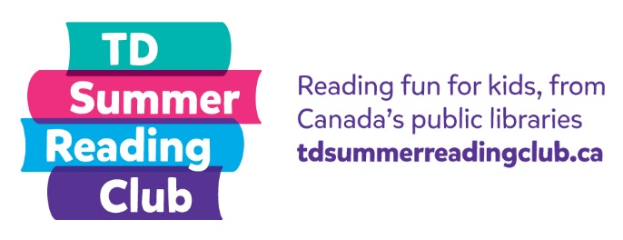

Kids Survey
Welcome to the Club survey. Let's begin!
- How old are you?
- 0-5 years
- 6-8 years
- 9-12 years
- 13+ years

- What town/city do you live in? _______________________________________

- Which province/territory do you live in?

- Alberta
- British Columbia
- Manitoba
- New Brunswick
- Newfoundland and Labrador
- Northwest Territories
- Nova Scotia
- Nunavut
- Ontario
- Prince Edward Island
- Quebec
- Saskatchewan
- Yukon

- Please circle the answer that best completes these sentences:

- Since joining the Club, I have been reading (by myself or with others)…

Less often The same amount More often

- Since joining the Club, I enjoy reading…

Less The same amount More

- Being a part of the Club allowed me to connect and share with other kids…

Less often The same amount More often

- Will you take part in the Club again?

- Yes
- No
- Not sure

5.b. If you answered no or not sure, why not?

- Is there anything else you’d like to tell us about the Club?

Thank you!

