April 30, 2018

POR 022-16

Call-Up No. **5Z011-180111/001/CY**

Contract Award Date: 25 August 2017

Ce rapport est aussi disponible en français

LAC TD Summer rEADING CLUB 2017

(Final Report of Program Statistics)

prepared for: Library and Archives Canada

prepared BY: Nielsen consumer insights

Proprietary Warning

Any material or information provided by Library and Archives Canada and all data collected by Nielsen will be treated as confidential by Nielsen and will be stored securely while on Nielsen's premise (adhering to industry standards and applicable laws).

TABLE OF CONTENTS

**Political Neutrality** 1

**Acknowledgements** 2

**Executive Summary / Key Findings** 3

Objectives and Methodology 3

Research Results 4

**Résumé et faits saillants** 8

Background and Objectives 14

Methodology 15

Quantitative Phase 15

Qualitative Phase 17

National Program Statistics 18

Response Rate 18

Statistics on Registration 19

Number of Children 19

Qualitative Insights About the Registration Process 25

Previous Participation 26

Statistics on Attendance 29

Programs and Activities Organized Around the Club Theme 29

Promotion of Program 32

School and Daycare Visits by Library Staff 32

Satisfaction and Suggestions 36

Qualitative Insights About the Program Overall 39

Qualitative Insights About the Website 44

Qualitative Insights About the Resources 54

Qualitative Insights About the Program Evaluation 60

Appendix 1 - Evaluation Forms 61

Appendix 2 – Ontario 85

Appendix 3 – Quebec 100

Appendix 4 – Manitoba 119

Appendix 5 – Saskatchewan 133

Appendix 6 – Alberta 149

Appendix 7 – Prince Edward Island 165

Appendix 8 – Nova Scotia 181

Appendix 9 – Newfoundland & Labrador 196

Appendix 10 – Territories 211

# **Political Neutrality**

I hereby certify as Senior Officer of Nielsen that the deliverables fully comply with the Government of Canada political neutrality requirements outlined in the Procedures for Planning and Contracting Public Opinion Research.  Specifically, the deliverables do not include information on electoral voting intentions, political party preferences, standings with the electorate or ratings of the performance of a political party or its leaders.



Mario Caceres

January 23, 2018

# **Acknowledgements**

Nielsen would like to extend its thanks to the many people who assisted with the TD Summer Reading Club (TDSRC) Statistics and Evaluation project. In particular, we would like to thank Lianne Fortin, Program Manager at Library and Archives Canada, for her guidance and commentary throughout the project, this year and in past years. We would also like to extend our thanks to Ashley-Ann Brooks, Project Assistant for the TD Summer Reading Club, who took the lead in contacting libraries and helping to collect information which was vital to the data collection and analysis.

We would also like to thank all of the provincial and regional library coordinators for their assistance in communicating with their library systems, as well as the library systems that took the time to compile the statistics from their branches and affiliates. Finally, we cannot overlook the contribution of the individual libraries that devoted their time to providing their program statistics and the employees and volunteers who collected all of the data that made this report possible.

The TDSRC is made possible thanks to the joint initiative between TD Bank Group (TDBG), Library and Archives Canada (LAC) and the Toronto Public Library (TPL).

# **Executive Summary / Key Findings**

### Objectives and Methodology

Library and Archives Canada’s (LAC) interest in conducting this study is to provide LAC and TD Bank Group with accurate information about the success of the TD Summer Reading Club (TDSRC). The TDSRC focuses on young Canadians, promoting the fun of reading with the goal of encouraging them to visit their local library over the summer months. The program gives children a structured reading environment and rewards personal achievements. In 2017, the TD Summer Reading Club (TDSRC) was offered in twelve provinces and territories across the country through the support of TD Bank Group.

As libraries are organized differently in each province and territory, a common denominator to respond to the evaluation was identified. A library system refers to either the main branch of a library with many library branches, an individual library, or a regional library system with many affiliated libraries. An example of the latter is the Toronto Public Library, whose system includes roughly 100 library branches. Each branch within the Toronto Public Library was sent a link to complete their own evaluation survey.

In some regions, the individual library branches were asked to provide the necessary information regarding the program to their library system using the Statistics and Evaluation Form found on the Reading Club website. The library systems then compiled the data and filled out a unique online Statistics and Evaluation Form on the TD Summer Reading Club, using Nielsen’s online evaluation tool.

Individual libraries and library systems were invited to complete their evaluation online via an email invitation with a unique link imbedded in the email text. This unique link pre-identified each library and library system. The link brought the libraries directly to the survey where they entered their data. In order to accommodate the reporting for both individual libraries and multiple libraries in a system, two separate survey instruments were programmed. Individual libraries were sent a link to the individual library study, enabling them to enter data for their library only, whereas those pre-identified to be reporting for multiple libraries (library coordinators) were sent a link that led them to the library systems study, enabling them to enter data for multiple libraries. If they provided answers which actually categorized them as the other type, they were shifted over, automatically, to the correct version.

In response to requests from libraries in 2012, the online form was opened in August for the past four years, much earlier than in the years before 2013. In 2017, the opening of the form was delayed slightly, but was available to libraries on August 30th. It also included a function that allowed for automatic generation of an electronic version of their results.

In 2017, Nielsen sent out 796 email invitations in both official languages to public libraries or systems within the twelve participating provinces and territories, explaining the process of evaluating the program. In total, 733 evaluations were collected between August 30th and October 13th, 2017. The completed evaluations contained data for 1,844 of the 2,009 total service points that participated in the TDSRC in 2017, resulting in a response rate of 92%, two points higher than 2016.

Wherever appropriate throughout the report, the results from the 2017 TDSRC program are compared to data obtained annually, beginning in 2005.

### Research Results

This section details the highlights of the research results.

**Statistics on Registration and Participation**

Within the twelve participating provinces and territories, 796 library systems participated in the TDSRC program during the summer of 2017. Within these 796 systems, a total of 2,009 branches (localities) participated in the program.

An estimated 329,934 children registered for the TDSRC 2017 program, increasing slightly (+2,770 children) compared to 2016 (327,164 children). The age distribution among participating children was similar to previous years. The table below shows the age distribution of the children who registered for this year’s program.

|  |  |
| --- | --- |
| **Age** | **2017 Registered Children** |
| **(N=329,934)** |
| Between 0 and 5 years old | 29% |
| Between 6 and 8 years old | 39% |
| Between 9 and 12 years old | 29% |
| 13 years old or more | 3% |

There has been a general trend of increased registration since the program evaluation and statistics have been collected, beginning with an estimated total of 216,312 in 2005. Although the trend slowed down in 2017, registrations for this year are the highest ever recorded. The 2017 registration numbers mean that roughly 5.6% of all Canadian children were registered in this year’s TD Summer Reading Club.

A total of 37,138 programs and activities were organized in 2017. Total attendance at these programs and activities amounted to 679,595 children, which translates to an approximate average of 18 children per activity.

**Promotion of the Program and Awareness**

The majority of all libraries/systems indicated that their library staff made at least one visit to promote the program to children in their community. More than two thirds (68%) visited schools, 31% visited child care centres and 20% made visits to day camps.

In total, 13,772 visits were made to schools, day camps, child care centres and other locations. Approximately 646,773 children were reached by these visits – roughly 52 children per visit.

|  |  |  |  |  |
| --- | --- | --- | --- | --- |
|  | **Visits Made To:** | | | |
|  | **Schools** | **Day Camps** | **Child Care Centres** | **Other** |
| % That Made Visits | 68% | 20% | 31% | 21% |
| # Of Visits Made | 9,443 | 1,449 | 1,521 | 1,359 |
| Number of Children Reached | 549,304 | 31,233 | 29,433 | 36,803 |

Consistent with the previous year, in 2017, when children registered, librarians recorded whether they had participated in the Summer Reading Program last year (or a previous year) or if this was their first time in the program. Although this split varied from region to region, slightly less than half of all children reported being new to the program.

|  |  |
| --- | --- |
| **Joined in Previous Years?** | |
| **Participated in a previous year** | **New to the program** |
| 56%  (183,752 children) | 44%  (146,182 children) |

**Satisfaction & Suggestions**

The satisfaction section focuses on the overall satisfaction with the program, web resources available to librarians and the program evaluation process itself. ***Wherever possible, the satisfaction scores for each question is compared to results from 2013 onward and use scales from 0 to 10.***

Overall satisfaction with the program was again high, 76%, which was one point higher than 2016 (75%). Likewise, ease of navigating to web resources was well received with 74% providing a positive rating. Satisfaction with the website and web content for the library staff was higher in 2017, with almost three-quarters giving a score out of ten of eight or higher (compared to roughly two thirds in 2016). Satisfaction with the program evaluation process was also high, with 72% rating their satisfaction in the top three. However, less than half were satisfied with how the program evaluation asks about relevant concerns.

| **T3 Box Summary (8,9,10 on 10-point scale)** | |
| --- | --- |
| Overall Satisfaction with the program | 76% |
| Satisfaction with the website and web content for library staff | 73% |
| Ease of navigating to web resources | 74% |
| Satisfaction with program evaluation process | 72% |
| Ease of using the program evaluation system | 63% |
| The program evaluation asks about relevant concerns | 42% |

Librarians were asked for suggestions on ways that the web resources available to librarians could be improved. Among those who provided a response, four in ten (44%) said that they were satisfied or had nothing to suggest. Those who did provide a suggestion were most likely to suggest providing a simpler and more user friendly navigation (11%) or suggested using ‘better’ of a more recent booklist (9%).

When asked how the program evaluation and statistical collection process could be improved, librarians suggested that the questions and forms should be available sooner or they should be told what they should track during the program (18%) and suggested that information requested be better defined and clearer (6%).

**Statistical Overview**

The following table summarize some of the key statistics collected in 2017.

|  |  |
| --- | --- |
| **Measure** | **Total** |
| Children who registered for TDSRC | 329,934 |
| Programs or activities organized around club theme | 37,138 |
| Attendance at programs and activities | 679,595 |
| Visits made to schools | 9,443 |
| Visits made to day camps | 1,449 |
| Visits made to child care centres | 1,521 |
| Other visits made | 1,359 |
| Children reached by all visits | 646,773 |
| % who attended in previous years | 56% |

**Qualitative Research**

The 2017 wave of research also included a qualitative component in the form of an online focus group with librarians and system administers across the country and requests for open-ended written feedback asking libraries to elaborate more on the satisfaction ratings provided. Overall, 24 libraries (12 in English and 12 in French) provided their qualitative feedback.

Satisfaction is high, when asked about words to describe, all provide positive perceptions and understand the positive impact the program has on children and their family.

For most, TDSRC provides the library with a platform for encouraging summer reading. The program provides great structure for the libraries to build on, especially from a programming perspective.

Librarians overwhelmingly suggested that the TD Summer reading materials are working well. Specifically, they like the log books, note books, the fortune teller craft sheets, stickers and the fact that the program is bilingual. Most librarians suggested that having prizes and stickers are important for engaging the children.

Moving beyond the resources, librarians appreciated that the program promotes Canadian authors and illustrators.

Regardless of the overall positive attitude towards the program, libraries offered constructive feedback that could be helpful in improving the impact and outcome of the program.

There were mixed opinions about the theme of the TD Summer Reading Program, some librarians liked that the theme is broad so they can customize the program, while others like having a more specific theme to help guide the program.

In Quebec, participants tended to be less inspired by the theme and would like to see better defined themes. In the French online discussion, participants, suggested attaching a cause to the theme, for example the environment and commented on how the theme should be better developed in the content.

Participants in the English focus groups expressed interest in having the school boards involved in the program and working with the local school districts to promote the TD Summer Reading Program in schools.

Many suggested that they would like to see an online space where libraries could exchange ideas and collect ideas on how to run the program and design activities. Some suggested using social media or social media style as a staff resource. For example a Facebook or Pinterest style group where libraries could share ideas with other libraries/librarians.

In the French online discussions and written feedback, librarians suggested that there needs to be more motivation and incentive for children to complete the program. In order to increase encourage participation they hold multiple activities to engage children, but without their own programming efforts there is not a lot of motivation. Both participants suggested using prizes based on the number of pages read, that would be something that could make a difference.

Additionally, a few commented on the need for more age appropriate content, and felt that materials were more geared towards young age groups, but there needs to be more of an effort to attract older participants (those aged 10 to 12 years old).

# **Résumé et faits saillants**

### Objectifs et méthodologie

L’objectif de l’étude menée par Bibliothèque et Archives Canada (BAC) est d’évaluer le succès du Club de lecture d’été de la Banque TD (CLÉ TD) pour en informer Bibliothèque et Archives Canada et le Groupe Banque TD. Le CLÉ TD cible les jeunes Canadiens et Canadiennes et cherche à promouvoir le plaisir de la lecture afin de les inciter à visiter leur bibliothèque locale au cours de l’été. Le programme permet de créer un environnement de lecture structuré pour les jeunes et encourage les réalisations personnelles. L’édition 2017 du Club de lecture d’été de la Banque TD (CLÉ TD) a été offerte dans douze provinces et territoires du Canada grâce au soutien du Groupe Banque TD.

Puisque les bibliothèques fonctionnent différemment selon la province et le territoire, un dénominateur commun a été défini de façon à ce qu’elles puissent toutes répondre à l’évaluation. Un réseau de bibliothèques désigne la succursale principale d’une bibliothèque possédant des succursales, une bibliothèque autonome ou un réseau régional de bibliothèques ayant des bibliothèques affiliées. À titre d’exemple, la Bibliothèque publique de Toronto, qui compte une centaine de succursales, constitue un réseau régional. Un lien a été envoyé à toutes les succursales de la Bibliothèque publique de Toronto afin qu’elles remplissent leur propre formulaire d’évaluation.

Dans certaines régions, chacune des succursales des bibliothèques devait fournir les informations nécessaires à propos du programme au réseau dont elle fait partie en remplissant le Formulaire d’évaluation et de statistiques qui se trouvait sur le site Web du Club de lecture. Les réseaux de bibliothèques ont ensuite compilé ces données et soumis un seul Formulaire de statistiques et d’évaluation du Club de lecture d’été de la Banque TD au moyen de l’outil d’évaluation en ligne de Nielsen.

Les bibliothèques autonomes et les bibliothèques de réseau étaient invitées à remplir une évaluation en ligne en suivant un lien inclus dans le message d’invitation. Ce lien unique permettait d’identifier chaque bibliothèque autonome et bibliothèque de réseau. Ce lien amenait directement les bibliothèques au sondage où elles entraient leurs données. Afin de permettre aux bibliothèques autonomes et aux bibliothèques de réseaux de saisir leurs données, deux sondages différents ont été programmés. Ainsi, les bibliothèques autonomes étaient dirigées vers un sondage leur permettant d’entrer les renseignements pour leur bibliothèque uniquement, alors que les coordonnateurs qui répondaient pour de multiples bibliothèques ont reçu un lien qui les amenait à un sondage où les données de multiples bibliothèques pouvaient être consignées. Si une bibliothèque fournissait des réponses qui la classaient effectivement dans l’autre type de bibliothèque, elle était redirigée vers la version appropriée du sondage.

Pour donner suite aux demandes formulées par les bibliothèques en 2012, le formulaire est mis en ligne au mois d’août depuis quatre ans, soit beaucoup plus tôt que lors des années antérieures à 2013. En 2017, l’accès au formulaire a été légèrement retardé, mais il a été mis à la disposition des bibliothèques le 30 août. Le formulaire comporte également une fonction permettant aux bibliothèques de générer automatiquement un document électronique incluant leurs résultats.

En 2017, Nielsen a envoyé des invitations à 796 bibliothèques publiques (réseaux) dans les douze provinces et territoires participants. Le courriel d’invitation, rédigé en français et en anglais, expliquait le processus d’évaluation du programme. En tout, 733 évaluations ont été recueillies pendant la période du 30 août au 13 octobre 2017. Les évaluations complétées contiennent les données de 1 844 des 2 009 points de service qui ont participé au CLÉ TD en 2017, ce qui donne un taux de réponse global de 92 %, soit deux points de plus qu’en 2016.

Partout où il est possible de le faire dans le rapport, les résultats du programme CLÉ TD 2017 sont comparés aux données obtenues chaque année depuis 2005.

### Résultats de la recherche

La présente section fournit un compte-rendu détaillé des points saillants de la recherche.

**Statistiques relatives à l’inscription et à la participation**

Dans les douze provinces et territoires participants, 796 réseaux de bibliothèques ont participé au Club de lecture d’été TD (CLÉ TD) pendant l’été 2017. Parmi ces 796 réseaux, 2 009 succursales (localités) ont participé au programme.

Environ 329 934 enfants se sont inscrits au programme CLÉ TD 2017, soit une légère hausse (+ 2 770 enfants) par rapport à 2016 (327 164 enfants). La distribution par groupe d’âge des participants est semblable aux années antérieures. Le tableau ci-dessous démontre la distribution par groupe d’âge des enfants qui se sont inscrits au programme cette année.

|  |  |
| --- | --- |
| **Âge** | **Enfants inscrits en 2017** |
| **(N = 329 934)** |
| 0 à 5 ans | 29 % |
| 6 à 8 ans | 39 % |
| 9 à 12 ans | 29 % |
| 13 ans ou plus | 3 % |

Depuis qu’il y a évaluation du programme et collecte de statistiques, les inscriptions suivent une tendance générale à la hausse. Lors de la première étude, en 2005, les inscriptions totales ont été estimées à 216 312. Malgré un ralentissement de la tendance en 2017, les inscriptions totales ont atteint un sommet historique cette année. Les données sur l’inscription de 2017 révèlent qu’environ 5,6 % de tous les enfants canadiens se sont inscrits au Club de lecture d’été TD cette année.

Un total de 37 138 programmes et activités ont été organisés en 2017. En tout, 679 595 enfants ont participé à ces activités et programmes, soit une moyenne de 18 enfants par activité.

**Promotion du programme et notoriété**

La majorité de l’ensemble des bibliothèques et des réseaux ont indiqué que leurs employés avaient fait au moins une visite dans leur collectivité pour faire la promotion du programme auprès des enfants de leur collectivité. Plus des deux tiers (68 %) d’entre eux ont effectué des visites dans des écoles, alors que 31 % ont effectué des visites dans des garderies et 20 %, dans des camps de jour.

En tout, les employés des bibliothèques ont effectué 13 772 visites dans des écoles, des camps de jour, des garderies et ailleurs. Environ 646 773 enfants ont été joints de cette façon, soit approximativement 52 enfants par visite.

|  |  |  |  |  |
| --- | --- | --- | --- | --- |
|  | **Visites effectuées dans des...** | | | |
|  | **Écoles** | **Camps  de jour** | **Garderies** | **Autre** |
| % des bibliothèques dont les employés ont effectué des visites | 68 % | 20 % | 31 % | 21 % |
| Nombre de visites effectuées | 9 443 | 1 449 | 1 521 | 1 359 |
| Nombre d’enfants joints | 549 304 | 31 233 | 29 433 | 36 803 |

De même que l’année précédente, en 2017, lorsque les enfants s’inscrivaient, les bibliothécaires notaient s’ils avaient participé au programme de lecture d’été l’année précédente (ou lors d’un été antérieur) ou si c’était leur première participation. Bien que la répartition varie d’une région à l’autre, globalement, un peu moins de la moitié des enfants ont dit qu’ils participaient au programme pour la première fois.

|  |  |
| --- | --- |
| **Participation lors d’années antérieures?** | |
| **Ont participé lors d’années antérieures** | **Nouveaux participants au programme** |
| 56 %  (183 752 enfants) | 44 %  (146 182 enfants) |

**Satisfaction et suggestions**

La section consacrée à la satisfaction porte surtout sur la satisfaction globale à l’égard du programme, sur les ressources Web mises à la disposition des bibliothécaires et sur le processus d’évaluation du programme en tant que tel. ***Lorsque c’est possible, les notes de satisfaction de chaque question sont comparées aux résultats obtenus depuis 2013. Les échelles vont de 0 à 10.***

La satisfaction globale à l’égard du programme était encore élevée, à 76 %, soit un point de plus qu’en 2016 (75 %). De même, la facilité de navigation dans les ressources Web a été bien reçue, avec une note positive de 74 %. La satisfaction à l’égard à l’égard du site Web et du contenu Web destinés au personnel des bibliothèques était plus élevée en 2017 : près des trois quarts des répondants accordent ici une note d’au moins huit sur dix (comparativement à près des deux tiers en 2016). La satisfaction à l’égard du système d’évaluation du programme était élevée également, puisque 72 % du personnel a accordé une note dans les trois cotes supérieures sur ce point. Toutefois, moins de la moitié du personnel était satisfaite de la pertinence des éléments examinés dans le cadre de l’évaluation du programme.

|  |  |
| --- | --- |
| **3 cotes supérieures (8, 9 et 10 sur une échelle de 10 points) – résumé** | |
| Satisfaction globale à l’égard du programme | 76 % |
| Satisfaction globale à l’égard du site Web et du contenu Web pour les bibliothécaires | 73 % |
| Facilité de la navigation dans les ressources Web | 74 % |
| Satisfaction à l’égard du processus d’évaluation du programme | 72 % |
| Facilité d’utilisation du système d’évaluation du programme | 63 % |
| Pertinence des éléments examinés dans le processus d’évaluation | 42 % |

Les bibliothécaires étaient invités à formuler des suggestions pour améliorer les ressources Web mises à leur disposition. Parmi ceux qui ont répondu à cette question, quatre bibliothécaires sur dix (44 %) se disent satisfaits et n’ont rien à suggérer. Ceux qui émettent une suggestion demandent généralement de rendre la navigation plus simple et plus conviviale (11 %) ou suggèrent d’utiliser une liste de livres « meilleure » ou plus récente (9 %).

Lorsque les bibliothécaires doivent indiquer comment améliorer l’évaluation du programme et le processus de collecte de statistiques, ils suggèrent de leur donner accès aux questions et aux formulaires d’évaluation plus tôt ou de leur dire ce qu’il faut suivre pendant le programme (18 %) et de mieux définir ou de clarifier les renseignements demandés (6 %).

**Aperçu statistique**

Le tableau qui suit résume les principales statistiques recueillies en 2017.

|  |  |
| --- | --- |
| **Facteurs évalués** | **Total** |
| Enfants inscrits au CLÉ TD | 329 934 |
| Programmes ou activités organisés autour du thème du club | 37 138 |
| Participation aux programmes et aux activités | 679 595 |
| Visites faites dans les écoles | 9 443 |
| Visites faites dans les camps de jour | 1 449 |
| Visites faites dans les garderies | 1 521 |
| Visites faites ailleurs | 1 359 |
| Enfants rejoints par toutes les visites | 646 773 |
| % qui y ont participé lors des années antérieures | 56 % |

**Recherche qualitative**

La vague de recherche de 2017 comprenait également une composante qualitative sous la forme d’un groupe de discussion en ligne auprès de bibliothécaires et d’administrateurs de systèmes des quatre coins du pays ainsi que des questions ouvertes dans lesquelles les bibliothèques étaient invitées à formuler par écrit des commentaires et à donner davantage d’explications sur les cotes attribuées. Au total, 24 bibliothèques (12 anglophones et 12 francophones) ont fourni des commentaires qualitatifs.

La satisfaction est élevée. Quand on demande aux participants de nommer des mots pour décrire le programme, tous formulent des perceptions positives et comprennent ses répercussions positives sur les enfants et leurs familles.

Pour la plupart, le programme CLÉ TD offre à la bibliothèque une plateforme pour promouvoir la lecture pendant l’été. Le programme offre une structure formidable sur laquelle peuvent s’appuyer les bibliothèques, en particulier sur le plan de la programmation.

La grande majorité des bibliothécaires ont laissé entendre que le matériel du Club de lecture d’été de la Banque TD fonctionne bien. Ils aiment tout particulièrement les carnets de lecture, les carnets de notes, les feuilles de bricolage de coin-coin, les autocollants et le fait que le programme est bilingue. La plupart des bibliothécaires ont indiqué qu’il est important de proposer des prix et des autocollants pour susciter l’intérêt des enfants.

Au-delà des ressources, les bibliothécaires ont aimé le fait que le programme met de l’avant les auteurs et les illustrateurs canadiens.

Si l’attitude à l’égard du programme est généralement positive, les bibliothécaires ont émis des commentaires constructifs qui pourraient s’avérer utiles pour améliorer les répercussions et les résultats du programme.

Les opinions sur le thème du Club de lecture d’été de TD étaient partagées. Certains bibliothécaires ont affirmé préférer un thème général qui leur permet de personnaliser le programme, tandis que d’autres préfèrent un thème plus précis pour en faciliter l’orientation.

Au Québec, les participants ont tendance à se sentir moins inspirés par le thème et aimeraient voir des thèmes mieux définis. Lors de la discussion en ligne en français, les participants ont émis la suggestion d’associer le thème à une cause, par exemple l’environnement, et ont formulé des commentaires sur les possibilités d’amélioration du thème sur le plan du contenu.

Les participants des groupes de discussion en anglais ont exprimé leur intérêt à l’idée de faire participer les commissions scolaires au programme et de collaborer avec les arrondissements scolaires à l’échelle locale pour promouvoir le Club de lecture d’été de TD dans les écoles.

Un grand nombre de participants aimeraient qu’il existe un espace en ligne où les bibliothécaires pourraient échanger et recueillir des idées sur la façon d’administrer le programme et de concevoir des activités. Certains ont suggéré d’utiliser les médias sociaux ou une plateforme semblable en guise de ressource pour le personnel. Par exemple, il pourrait s’agir d’un groupe comme on en trouve sur Facebook ou Pinterest où les bibliothèques pourraient échanger des idées avec d’autres bibliothèques.

Lors des groupes de discussion en ligne et dans les commentaires écrits en français, les bibliothécaires ont indiqué que les enfants ont besoin de davantage de motivation et d’incitatifs pour terminer le programme. Si les bibliothécaires ne déploient pas personnellement des efforts pour rehausser la programmation et offrir de multiples activités pour susciter l’intérêt des enfants et promouvoir la participation, la motivation est faible. Les participants des groupes anglophones et francophones ont émis la suggestion d’offrir des prix en fonction du nombre de pages lues en affirmant que cette mesure pourrait faire la différence.

Par ailleurs, quelques participants ont évoqué la nécessité d’adapter davantage le contenu en fonction de l’âge. À leur avis, le matériel s’adresse davantage à de jeunes enfants et des efforts supplémentaires devraient être déployés pour attirer les lecteurs plus âgés (enfants de 10 à 12 ans).

# Background and Objectives

The TD Summer Reading Club (TDSRC) focuses on young Canadians, promoting the fun of reading and encouraging them to visit their local library over the summer months. The program gives children a structured reading environment and rewards personal achievements. The 2016 TDSRC was offered in twelve provinces and territories across the country through the support of TD Bank Group[1] in addition to a series of independent libraries and systems. Beginning in Toronto in 1994, the program expanded across Ontario in 2001 and has been widely available across Canada under the auspices of Library and Archives Canada as of summer 2004.

In collaboration with the Toronto Public Library and Library and Archives Canada, teams of librarians from Toronto, Ottawa, Montreal and Quebec City created the bilingual material for this program. Public libraries were encouraged to contact local schools in May to drop off fortune teller invitations and request that they be distributed with the children’s report cards.

A ‘school age or pre-school notebook’ was again provided to every child who registered for the TD Summer Reading Club in 2016. The notebooks allowed children to keep track of the books that they had read throughout the summer. Sticker sheets were also distributed to participating children by libraries over the course of the summer.

# Methodology

### Quantitative Phase

Previous waves of this research were conducted by *Harris/Decima*, but *Harris/Decima* recently joined the Nielsen family of companies. Although the name of the company has changed the key project team members have remained intact to ensure continuity of the institutional knowledge gained from conducting this research project for most of the years over the last decade.

The 2017 wave of research also included a qualitative component in the form of an online focus group with librarians and system administers across the country and requests for open-ended written feedback asking libraries to elaborate more on the satisfaction ratings provided.

According to the data collected and the information provided by the provincial library services and associations coordinating the program regionally, 1,844 public library localities supplied their statistics from the 2017 TD Summer Reading Club program[2]. As a provision for receiving the free program materials, each library was asked to collect and evaluate statistical information related to the program. So that libraries would know what information to collect over the summer, a version of the evaluation form was included on the Reading Club website.

As in previous years, Library and Archives Canada assumed responsibility for analyzing these statistics, and teamed with Nielsen to collect the requisite information and perform the analysis. Since libraries are organized differently in each province and territory, LAC had to identify a common denominator to respond to the evaluation. The library systems were identified as the online evaluation respondents.

The program evaluation began in 2005, but Nielsen (at that time, *Harris/Decima*) developed a new online evaluation form in 2013 using the form from previous years as a starting point. This form was further refined in 2014 to streamline the data reporting process for libraries and systems so that fewer individual statistics would need to be gathered. The online form was made available in August, several weeks earlier than it was in the years before 2013. The 2017 version of the form has maintained the approach begun in 2013 that moved from an ‘electronic form’ approach to an ‘online library file’ format that which allowing librarians to complete the evaluation in sections, add notes and re-access their form as many times as needed over the reporting period.

LAC provided Nielsen with a database containing the most recent contact information available for all participating systems. This database was compiled based on the most recent contact information provided to LAC by each provincial/territorial coordinator.

Once all of the individual files were set up, each contact in the database was sent an email invitation by Nielsen (on behalf of LAC) that contained the unique password-encrypted hyperlink to their online evaluation file. A unique URL was generated for each library/system to ensure that only one file existed per library/system (i.e. no duplicate entries would be possible) and as a means of tracking which libraries/systems had submitted results. The systems compiled the data from their library branches and subsequently entered their totals into the online file created for their system.

During the data collection period, Nielsen provided LAC with updates on which systems had not yet accessed their online file. LAC relayed this information to provincial/territorial coordinators, who then followed up with these systems to encourage participation.

This year, a total of 1,844 of the 2,009 participating libraries reported data, translating to a 92% response rate. Evaluations were collected between August 30th and October 13th, 2017.

The numbers presented in this report are based on a weighting system that represents the estimated 2,009 participating branches and not just the 1,844 that provided statistics for their respective systems. The weighting scheme takes into account all of the individual libraries within a given province or territory and weighting the available data to represent the missing libraries.

In each province, a total of individual participating libraries was compared to the total number of those who reported their statistics to Nielsen. For each province or territory, a weight was calculated and applied to the whole territory so that the libraries which have participated, but did not report their statistics, are included in the totals. For example, in Alberta, a total of 291 libraries participated in the Summer Reading Club in 2017, but statistics were available for only 240 of them (82%). This means that the responses from those 240 libraries are multiplied by 1.21 in order to represent the 51 missing libraries.

The final weights used in each region are presented in the table below:

**Figure 1. Overall Response Rate & Weighting Scheme Used**

| **Regions** | **# of Libraries Reporting** | **# of Libraries Participating** | **% of Libraries Reporting** | **Weight Used** |
| --- | --- | --- | --- | --- |
| Alberta | 240 | 291 | 82% | 1.21 |
| ABPQ | 169 | 175 | 97% | 1.04 |
| British Columbia | 1 | 1 | 100% | 1.00 |
| Manitoba | 79 | 80 | 99% | 1.01 |
| Newfoundland & Labrador | 68 | 77 | 88% | 1.13 |
| OLS-North | 73 | 84 | 87% | 1.15 |
| Northwest Territories | 2 | 2 | 100% | 1.00 |
| Nova Scotia | 63 | 64 | 98% | 1.02 |
| PEI | 23 | 23 | 100% | 1.00 |
| Réseau BIBLIO | 188 | 222 | 85% | 1.18 |
| Saskatchewan | 265 | 308 | 86% | 1.16 |
| SOLS | 564 | 569 | 99% | 1.01 |
| Toronto | 103 | 105 | 98% | 1.02 |
| Yukon | 1 | 1 | 100% | 1.00 |
| Independent LAC | 5 | 7 | 71% | 1.40 |
| **Total** | 1,844 | 2,009 | 92% | 1.09 |

To help the reader reference the appropriate question in the questionnaire, the question number(s) and wording have been added at the bottom of each graph throughout the report.

### Qualitative Phase

The 2017 research included a qualitative element in order to gather deeper and richer understanding of the *why* behind the numbers, aiming to obtain insights on how to further improve the satisfaction with the program and its outcomes.

The qualitative phase consisted on two methods: 1) two online focus groups, one in English and one in French; and 2) submission of an open ended questionnaire that contained follow up probing for the satisfaction ratings provided throughout the quantitative phase.

A total of 24 libraries participated in the qualitative phase. The online focus groups were joined by seven libraries conducting the program in English and two libraries conducting the program in French. In addition to this, four libraries conducting the program in English submitted their qualitative feedback by completing the open ended questionnaire, while 10 libraries conducting the program in French completed the questionnaire as well.

Although the participation in the online focus groups was not as high as expected, especially among Francophone libraries, the conversations were rich and provided context to the numbers. This context has been added after each of the relevant sections throughout this report.

# National Program Statistics

### Response Rate

Participating libraries or systems were asked to tally the results from their own library as well as any subsidiary branches (if they were a system). Of the 797 participating libraries/systems for which an online file was created, 733 submitted their results. The response rate refers to the total number of libraries whose data are represented in the responses received. When calculating the overall response rate, the unit of measure under consideration is ‘libraries’ (including individual service points within larger systems). Systems were recorded by including the number of participating and reporting service points within each system in the total. The result is a more accurate overall picture of how many of the libraries that participated in the TD Summer Reading Club are actually represented in the data.

The figure below depicts the response rate by region. With 1,844 of the total 2,009 libraries being represented, the overall response rate was 92%.

Figure 2. Response Rate by Region

|  |  |  |  |
| --- | --- | --- | --- |
|  | **(A)** | **(B)** | **(C)** |
| **Regions** | **Total Service Points Responded** | **Total Service Points Participated** | **Evaluation Response Rate** |
| **Atlantic** | **154** | **164** | **94%** |
| Newfoundland & Labrador | 68 | 77 | 88% |
| Nova Scotia | 63 | 64 | 98% |
| PEI | 23 | 23 | 100% |
| **Québec** | **357** | **397** | **90%** |
| ABPQ | 169 | 175 | 97% |
| Réseau BIBLIO | 188 | 222 | 85% |
| **Ontario** | **740** | **758** | **98%** |
| SOLS | 564 | 569 | 99% |
| OLS-North | 73 | 84 | 87% |
| Toronto | 103 | 105 | 98% |
| **West** | **585** | **680** | **86%** |
| Manitoba | 79 | 80 | 99% |
| Saskatchewan | 265 | 308 | 86% |
| Alberta | 240 | 291 | 82% |
| British Columbia | 1 | 1 | 100% |
| **Territories** | **3** | **3** | **100%** |
| Yukon | 1 | 1 | 100% |
| Northwest Territories | 2 | 2 | 100% |
| Nunavut | - | - | - |
| **Independent LAC** | **5** | **7** | **71%** |
| **Totals** | **1,844** | **2,009** | **92%** |

## Statistics on Registration

### Number of Children

The first section of the Statistics and Evaluation Form asked librarians to indicate the total number of children registered for the TDSRC 2017 program. This reflects the total number of children who were registered with a library and were given program materials.

Across Canada, an estimated 329,934 children registered for the TDSRC 2017 program[3]. This represents the highest total yet recorded for the TD Summer Reading Club in one year and is a slight increase over the 2016 wave. Last year saw a large increase in registration (increasing from 308,686 in 2015 to 327,164 in 2016) while registration had been fairly steady for the four years prior to that (from 2011 to 2014). Although overall registration increased in 2017 most regions, there was a decrease in Quebec (of around 7,800) especially among ABPQ libraries (with a decrease of around 6,800). There was an increase amongst Atlantic Canada (around 3,000 more than in 2016) and Alberta (around 8,000 more). Despite the decrease since 2015, registration in Quebec in 2017 was higher than it has been from 2005 to 2014. The registration figures going back to 2005 are given below for comparison purposes.

Beginning in 2016, gender is no longer gathered and recorded by librarians and administrators. As a result, all comparisons to previous years will consider only the age grouping of registered children.

Figure 3. Registration Totals by Region (Tracking)

|  |  |  |  |  |  |  |  |  |  |  |  |  |  |
| --- | --- | --- | --- | --- | --- | --- | --- | --- | --- | --- | --- | --- | --- |
|  | **2017** | **2016** | **2015** | **2014** | **2013** | **2012** | **2011** | **2010** | **2009** | **2008** | **2007** | **2006** | **2005** |
| **Region** | **Totals** | **Totals** | **Totals** | **Totals** | **Totals** | **Totals** | **Totals** | **Totals** | **Totals** | **Totals** | **Totals** | **Totals** | **Totals** |
| **Atlantic** | **16,636** | **13,664** | **16,979** | **13,395** | **17,847** | **20,365** | **17,909** | **16,762** | **17,369** | **12,375** | **14,632** | **13,700** | **14,941** |
| Nfld. & Lab. | 2,093 | 2,591 | 2,453 | 2,497 | 2,608 | 3,788 | 3,148 | 3,388 | 2,912 | 2,840 | 1,691 | 2,905 | 2,090 |
| Nova Scotia | 12,739 | 9,357 | 12,739 | 9,518 | 13,848 | 15,131 | 13,348 | 12,003 | 13,197 | 8,380 | 11,927 | 9,639 | 11,719 |
| PEI | 1,804 | 1,716 | 1,787 | 1,380 | 1,391 | 1,447 | 1,413 | 1,371 | 1,260 | 1,156 | 1,014 | 1,156 | 1,132 |
| **Quebec** | **42,989** | **50,814** | **47,229** | **38,570** | **28,517** | **32,808** | **27,391** | **27,068** | **29,813** | **24,276** | **23,321** | **22,193** | **18,339** |
| ABPQ | 34,266 | 41,141 | 36,344 | 28,151 | 23,023 | 22,491 | 18,681 | 16,507 | 22,483 | 17,388 | 16,614 | 18,277 | 12,968 |
| Reseau Biblio | 8,723 | 9,673 | 10,885 | 10,418 | 5,494 | 10,317 | 8,710 | 10,561 | 7,330 | 6,888 | 6,707 | 3,916 | 5,371 |
| **Ontario** | **165,209** | **165,695** | **159,437** | **153,232** | **154,153** | **143,213** | **153,779** | **153,003** | **161,275** | **161,057** | **149,827** | **145,619** | **132,530** |
| SOLS | 124,038 | 123,587 | 116,924 | 113,634 | 119,687 | 107,589 | 113,490 | 114,861 | 125,244 | 120,991 | 111,232 | 110,811 | 98,476 |
| OLS-North | 3,982 | 5,358 | 4,411 | 4,841 | 4,025 | 4,365 | 5,078 | 5,377 | 6,590 | 5,693 | 6,892 | 3,858 | 3,404 |
| Toronto | 37,189 | 36,750 | 38,102 | 34,758 | 30,442 | 31,259 | 35,211 | 32,765 | 29,441 | 34,373 | 31,703 | 30,949 | 30,650 |
| **West** | **104,173** | **95,481** | **84,746** | **83,517** | **86,198** | **92,101** | **81,207** | **61,285** | **64,062** | **70,847** | **60,109** | **55,814** | **49,883** |
| Manitoba | 15,449 | 17,677 | 13,985 | 11,954 | 10,881 | 10,798 | 10,997 | 9,550 | 9,722 | 7,900 | 7,640 | 7,686 | 6,421 |
| Saskatchewan | 24,744 | 21,943 | 21,968 | 20,424 | 21,460 | 26,434 | 20,527 | 15,098 | 17,547 | 16,476 | 17,677 | 17,605 | 16,047 |
| Alberta | 63,814 | 55,717 | 48,661 | 51,138 | 53,857 | 54,869 | 49,683 | 36,637 | 36,793 | 46,471 | 34,792 | 30,523 | 27,415 |
| British Columbia | 166 | 145 | 132 | - | - | - | - | - | - | - | - | - | - |
| **Territories** | **428** | **430** | **296** | **829** | **1,412** | **609** | **1,300** | **761** | **744** | **556** | **127** | **764** | **619** |
| Yukon | 280 | 166 | 78 | 594 | 486 | 316 | 224 | 371 | 617 | 370 | - | 243 | 307 |
| NWT | 148 | 264 | 218 | 235 | 312 | 293 | 155 | 108 | 85 | 96 | 100 | 70 | 44 |
| Nunavut | 0 | - | - | - | 614 | - | 921 | 282 | 42 | 90 | 27 | 451 | 268 |
| **Independent LAC** | **499** | **1,080** | **-** | **-** | **1,385** | **-** | **-** | **-** | **-** | **-** | **-** |  |  |
| **Registration Totals:** | **329,934** | **327,164** | **308,686** | **289,542** | **289,512** | **289,097** | **281,586** | **258,878** | **273,263** | **269,112** | **248,016** | **238,090** | **216,312** |

**Source:** *Q1 Total number of children who registered for the TDSRC 2017.*

The table below summarizes the number of children who participated in the 2017 program by province, and by network for Quebec and Ontario. The table features detailed totals by age for each province.

|  |  |  |  |  |  |
| --- | --- | --- | --- | --- | --- |
|  | **Total Registration** | | | | **Province** |
| **Region** | **0-5** | **6-8** | **9-12** | **13+** | **Totals** |
| **Atlantic** | **4,286** | **6,377** | **5,120** | **853** | **16,636** |
| Nfld. & Lab. | 767 | 807 | 490 | 29 | 2,093 |
| Nova Scotia | 2,982 | 4,778 | 4,282 | 697 | 12,739 |
| PEI | 537 | 792 | 348 | 127 | 1,804 |
| **Quebec** | **10,210** | **16,477** | **14,785** | **1,517** | **42,989** |
| ABPQ | 7,912 | 12,973 | 12,172 | 1,209 | 34,266 |
| Reseau Biblio | 2,298 | 3,504 | 2,613 | 308 | 8,723 |
| **Ontario** | **51,864** | **65,417** | **44,223** | **3,705** | **165,209** |
| SOLS | 36,882 | 49,460 | 34,471 | 3,225 | 124,038 |
| OLS-North | 1,373 | 1,635 | 866 | 108 | 3,982 |
| Toronto | 13,609 | 14,322 | 8,886 | 372 | 37,189 |
| **West** | **28,503** | **40,486** | **31,970** | **3,214** | **104,173** |
| Manitoba | 5,013 | 5,961 | 4,129 | 346 | 15,449 |
| Saskatchewan | 7,063 | 9,904 | 7,206 | 571 | 24,744 |
| Alberta | 16,370 | 24,576 | 20,580 | 2,288 | 63,814 |
| British Columbia | 57 | 45 | 55 | 9 | 166 |
| **Territories** | **118** | **124** | **115** | **71** | **428** |
| Yukon | 70 | 70 | 70 | 70 | 280 |
| NWT | 48 | 54 | 45 | 1 | 148 |
| Nunavut | 0 | 0 | 0 | 0 | 0 |
| **Independent LAC** | **56** | **286** | **153** | **4** | **499** |
| **Age Totals:** | **95,037** | **129,167** | **96,366** | **9,364** | **329,934** |
| **Percentage By Age:** | **29%** | **39%** | **29%** | **3%** | **100%** |

Figure 4. Number of Registered Children by Age & Region

**Source:** *Q1 Total number of children who registered for the TDSRC 2017.*

The distribution of registered children by age group remains consistent from year to year. In 2017, 29% of children fell in the 0-5 age group, 39% were aged 6-8, 28% were aged 9-12, and 3% were 13 years or older. There is a small general trend toward registered children getting younger over time. The figure below shows results by age group from 2006 onward.

**Figure 5. Percentage of Participating Children by Age**

|  |  |  |  |  |  |  |  |  |  |  |  |  |
| --- | --- | --- | --- | --- | --- | --- | --- | --- | --- | --- | --- | --- |
| **Children** | **2017** | **2016** | **2015** | **2014** | **2013** | **2012** | **2011** | **2010** | **2009** | **2008** | **2007** | **2006** |
| **0-5** | 29% | 31% | 30% | 30% | 30% | 29% | 28% | 28% | 26% | 26% | 24% | 24% |
| **6-8** | 39% | 39% | 38% | 39% | 39% | 39% | 39% | 39% | 38% | 39% | 38% | 39% |
| **9-12** | 29% | 28% | 29% | 29% | 28% | 29% | 30% | 30% | 32% | 32% | 34% | 33% |
| **13+** | 3% | 2% | 3% | 2% | 2% | 3% | 3% | 3% | 3% | 3% | 4% | 4% |

**Source:** *Q1. Total number of children who registered for the TDSRC 2017 program.*

Comparing the demographic breakdown by region, there are no major age differences across the country. Regarding age, there is some variation, but the same general trends emerge. Children 6-8 years old make up the largest group in most regions.

**Figure 6. Percentage of Registered Children by Age**

|  |  |  |  |  |
| --- | --- | --- | --- | --- |
|  | **Total Registration** | | | |
| **Region** | **0-5** | **6-8** | **9-12** | **13+** |
| **Atlantic** | **26%** | **38%** | **31%** | **5%** |
| Nfld. & Lab. | 37% | 39% | 23% | 1% |
| Nova Scotia | 23% | 38% | 34% | 5% |
| PEI | 30% | 44% | 19% | 7% |
| **Quebec** | **24%** | **38%** | **34%** | **4%** |
| ABPQ | 23% | 38% | 36% | 4% |
| Reseau Biblio | 26% | 40% | 30% | 4% |
| **Ontario** | **31%** | **40%** | **27%** | **2%** |
| SOLS | 30% | 40% | 28% | 3% |
| OLS-North | 34% | 41% | 22% | 3% |
| Toronto | 37% | 39% | 24% | 1% |
| **West** | **27%** | **39%** | **31%** | **3%** |
| Manitoba | 32% | 39% | 27% | 2% |
| Saskatchewan | 29% | 40% | 29% | 2% |
| Alberta | 26% | 39% | 32% | 4% |
| British Columbia | 34% | 27% | 33% | 5% |
| **Territories** | **28%** | **29%** | **27%** | **17%** |
| Yukon | 25% | 25% | 25% | 25% |
| NWT | 32% | 36% | 30% | 1% |
| Nunavut | -- | -- | -- | -- |
| **Independent LAC** | **11%** | **57%** | **31%** | **1%** |
| **Age Totals:** | **29%** | **39%** | **29%** | **3%** |

**Source:** *Q1. Total number of children who registered for the TDSRC 2017 program.*

The table on the following page summarizes the registration rate by age and region compared to the 2011 census data. Similar to previous years, program reach in 2017 was highest among 6 to 8 year old children in almost every province and territory, but particularly in Saskatchewan (26.1%), Alberta (18.7%), Nova Scotia (18.1%) and Prince Edward Island (17.5%). Ontario (15.3%) and Manitoba (13.4%) were also very high. Conversely, reach continues to be lowest for teenagers between 13 and 17 years old with a national average reach of 0.5%.

Saskatchewan (10.2%), Alberta (7.7%) and Nova Scotia (7.4%) had the greatest proportion of children register overall for the Summer Reading Club in the country. Although traditionally, Quebec usually had the lowest registration for any province, beginning in 2015 a greater percentage of children registered for the program (2.8%) than did in Newfoundland and Labrador (2.2%) or the Territories (1.4%). The national average saw a very small increase from 5.5% in 2016 to 5.6% in 2017.

|  |  |  |  |  |  |  |
| --- | --- | --- | --- | --- | --- | --- |
|  | **2011 CENSUS** | **2017 TD SRC REGISTRANTS** | **% PARTICIP. CHILDREN** | **% PARTICIP. CHILDREN** | **% PARTICIP. CHILDREN** | **% PARTICIP. CHILDREN** |
|  | **(A)** | **(B)** | **2017** | **2016** | **2015** | **2014** |
| **Province / Territory** | **Total Children** | **Total Children** | **Total Children** | **Total Children** | **Total Children** | **Total Children** |
| **Newfoundland** | **94,150** | **2,093** | **2.22%** | **2.75%** | **2.61%** | **2.65%** |
| 0-5 | 29,415 | 767 | 2.61% | 3.17% | 3.32% | 3.22% |
| 6-8 | 15,085 | 807 | 5.35% | 6.58% | 5.88% | 6.20% |
| 9-12 | 21,030 | 490 | 2.33% | 3.02% | 2.62% | 2.78% |
| 13+ | 19,170 | 29 | 0.15% | 0.17% | 0.21% | 0.16% |
| **Nova Scotia** | **171,790** | **12,739** | **7.42%** | **5.45%** | **7.42%** | **5.54%** |
| 0-5 | 52,725 | 2,982 | 5.66% | 3.96% | 5.83% | 4.12% |
| 6-8 | 26,460 | 4,778 | 18.06% | 14.96% | 18.17% | 14.51% |
| 9-12 | 38,310 | 4,282 | 11.18% | 8.16% | 10.63% | 8.43% |
| 13+ | 54,295 | 697 | 1.28% | 0.34% | 1.44% | 0.50% |
| **PEI** | **28,795** | **1,804** | **6.26%** | **5.96%** | **6.21%** | **4.79%** |
| 0-5 | 8,665 | 537 | 6.20% | 6.54% | 6.49% | 5.12% |
| 6-8 | 4,525 | 792 | 17.50% | 14.50% | 14.41% | 12.55% |
| 9-12 | 6,380 | 348 | 5.45% | 6.57% | 7.24% | 4.73% |
| 13+ | 9,225 | 127 | 1.38% | 0.80% | 1.20% | 0.72% |
| **Québec** | **1,546,480** | **42,989** | **2.78%** | **3.29%** | **3.05%** | **2.49%** |
| 0-5 | 523,395 | 10,210 | 1.95% | 2.29% | 2.13% | 1.75% |
| 6-8 | 237,390 | 16,477 | 6.94% | 8.57% | 7.92% | 6.54% |
| 9-12 | 322,760 | 14,785 | 4.58% | 5.30% | 4.94% | 3.89% |
| 13+ | 462,935 | 1,517 | 0.33% | 0.30% | 0.29% | 0.29% |
| **Ontario** | **2,693,835** | **165,209** | **6.13%** | **6.15%** | **5.92%** | **5.69%** |
| 0-5 | 846,055 | 51,864 | 6.13% | 6.70% | 6.17% | 5.93% |
| 6-8 | 427,470 | 65,417 | 15.30% | 14.66% | 14.19% | 14.05% |
| 9-12 | 590,615 | 44,223 | 7.49% | 7.25% | 7.38% | 6.76% |
| 13+ | 829,695 | 3,705 | 0.45% | 0.42% | 0.36% | 0.37% |
| **Manitoba** | **283,235** | **15,449** | **5.45%** | **6.24%** | **4.94%** | **4.22%** |
| 0-5 | 92,185 | 5,013 | 5.44% | 5.37% | 4.33% | 3.80% |
| 6-8 | 44,480 | 5,961 | 13.40% | 16.76% | 12.08% | 10.58% |
| 9-12 | 62,225 | 4,129 | 6.64% | 7.90% | 6.91% | 5.58% |
| 13+ | 84,345 | 346 | 0.41% | 0.42% | 0.38% | 0.33% |
| **Saskatchewan** | **240,645** | **24,744** | **10.28%** | **9.12%** | **9.13%** | **8.49%** |
| 0-5 | 81,605 | 7,063 | 8.66% | 7.95% | 8.43% | 7.56% |
| 6-8 | 37,925 | 9,904 | 26.11% | 23.79% | 22.61% | 20.32% |
| 9-12 | 51,470 | 7,206 | 14.00% | 11.75% | 11.86% | 12.03% |
| 13+ | 69,645 | 571 | 0.82% | 0.55% | 0.58% | 0.51% |
| **Alberta** | **826,285** | **63,814** | **7.72%** | **6.74%** | **5.89%** | **6.19%** |
| 0-5 | 290,125 | 16,370 | 5.64% | 5.66% | 4.45% | 4.81% |
| 6-8 | 131,415 | 24,576 | 18.70% | 16.53% | 14.31% | 14.96% |
| 9-12 | 173,625 | 20,580 | 11.85% | 9.39% | 8.62% | 9.46% |
| 13+ | 231,120 | 2,288 | 0.99% | 0.56% | 0.86% | 0.48% |
| **Territories** | **30,490** | **428** | **1.40%** | **1.41%** | **0.97%** | **2.72%** |
| 0-5 | 10,845 | 118 | 1.09% | 1.70% | 1.19% | 2.04% |
| 6-8 | 4,930 | 124 | 2.52% | 2.74% | 1.66% | 6.13% |
| 9-12 | 6,310 | 115 | 1.82% | 1.58% | 1.35% | 3.57% |
| 13+ | 8,405 | 71 | 0.84% | 0.13% | 0.00% | 0.96% |
| **Canada (Participating  regions excl. BC + Independents)** | **5,915,705** | **329,269** | **5.6%** | **5.5%** | **5.2%** | **4.9%** |
| 0-5 | 1,935,015 | 94,924 | 4.91% | 5.18% | 4.75% | 4.48% |
| 6-8 | 929,680 | 128,836 | 13.86% | 13.65% | 12.76% | 12.19% |
| 9-12 | 1,272,725 | 96,158 | 7.56% | 7.19% | 7.08% | 6.52% |
| 13+ | 1,768,835 | 9,351 | 0.53% | 0.41% | 0.45% | 0.37% |

Figure 7. Number of Registered Children

***Note****: BC is not included in the National totals here because only one library in the province participated and including the entire population of BC would skew the overall participation percentage calculation.*

**Source:** *Q1 Total number of children who registered for the TDSRC 2017, 2016, 2015, 2014. Population statistics provided by Statistics Canada Census 2011. 2015 and 2014 columns present data that was collected by Nielsen (as Harris/Decima*)*.*

### Qualitative Insights About the Registration Process

Most librarians said that they use a paper method (either registration sheet provided by provided the TD Summer Reading Program or their own version) to track the registration. While this helps libraries record program statistics, many said it would be helpful to have an online registration form. However, others, have an online registration process already in place.

Some liked the idea of an app, to not only help keep track of registration – but to help keep kids engaged in the summer.

Information registered tends to be name, age, school, while some take phone number or emails to be able to update or contact families about the program.

Most agreed that they would like to see a registration page be made available through the website, on the staff section. One that could automatically tally program statistics at the end of the summer. One recommendation was to have an online form that collects the statistics needed by the TD Summer Reading Program, but does not collect personal information

Participants in the French discussion groups commented on how promotional efforts are going well to encourage registration. These libraries attend schools at the end of the year (May and June) to encourage participation and also do activities with families to generate interest. Both libraries mentioned they use prizes to encourage participation.

## Previous Participation

In order to streamline the process of entering the data for each library/system, the question that asked how each of their registrants heard about the program was changed so that it asked only whether or not each registrant had joined in a previous year. Prior the data which was gathered for this question was not provided for a large proportion of the libraries/systems that reported their data and extrapolations were always done in order to estimate what proportion of children who had found out about the program from each source. In 2014, the question of whether each child registering had participated in the past was changed to simply be a yes or no question during the registration process, and as a result, the numbers were available for virtually every library/system. While the results provided here are less detailed than in previous years, they are far more reliable.

Nationally, more than half of all registered children (56%) said that they had participated in previous years. Children in Quebec (61%) were the most likely to say they had participated in the past with children in the Territories being the least likely to have been repeat participants (26%).

**Figure 8. Previous Participation by Region**

**Figure 9. Previous Participation by Region**

|  |  |  |  |  |
| --- | --- | --- | --- | --- |
| **Region** | **Joined in previous years** | | **New Registrants** | |
| **Atlantic** | **9,383** | **56%** | **7,252** | **44%** |
| Nfld. & Lab. | 944 | 45% | 1,149 | 55% |
| Nova Scotia | 7,702 | 60% | 5,036 | 40% |
| PEI | 737 | 41% | 1067 | 59% |
| **Quebec** | **26,377** | **61%** | **16,613** | **39%** |
| ABPQ | 20,787 | 61% | 13,480 | 39% |
| Reseau Biblio | 5,590 | 64% | 3,133 | 36% |
| **Ontario** | **90,621** | **55%** | **74,386** | **45%** |
| SOLS | 73,136 | 59% | 50,902 | 41% |
| OLS-North | 2,167 | 54% | 1,816 | 46% |
| Toronto | 15,318 | 41% | 21,668 | 59% |
| **West** | **57,059** | **55%** | **47,112** | **45%** |
| Manitoba | 8,036 | 52% | 7,412 | 48% |
| Saskatchewan | 11,082 | 45% | 13,661 | 55% |
| Alberta | 37,836 | 59% | 25,978 | 41% |
| British Columbia | 105 | 63% | 61 | 37% |
| **Territories** | **110** | **26%** | **318** | **74%** |
| Yukon | 60 | 21% | 220 | 79% |
| NWT | 50 | 34% | 98 | 66% |
| Nunavut | -- | -- | -- | -- |
| **Independent LAC** | **87** | **17%** | **412** | **83%** |
| **Overall** | **183,637** | **56%** | **146,093** | **44%** |

***Source****: Q2. How many of the children registered in your library had participated in the TD Summer Reading Club in previous years and how many were new to the program?*

The table on the next page compares the responses received over the past three years. Given the change in how this question was asked in 2014, comparisons to years prior to 2014 are difficult therefore, only the four most recent waves are included. In these three years, the proportion of children who joined in previous years has been very stable overall with some regional changes over time. Children in most regions are now more likely to have joined in previous years than in the past, with the exception of the Territories, where only around one-quarter of children joined in previous years.

**Figure 10.** **Previous Participation by Region (Tracking)**

|  |  |  |  |  |
| --- | --- | --- | --- | --- |
| **% Joined in previous years** | | | | |
| **Region** | **2017** | **2016** | **2015** | **2014** |
| **Atlantic** | **56%** | **53%** | **54%** | **58%** |
| Nfld. & Lab. | 45% | 51% | 48% | 49% |
| Nova Scotia | 60% | 56% | 58% | 62% |
| PEI | 41% | 45% | 39% | 50% |
| **Quebec** | **61%** | **58%** | **48%** | **50%** |
| ABPQ | 61% | 57% | 47% | 52% |
| Reseau Biblio | 64% | 58% | 51% | 47% |
| **Ontario** | **55%** | **51%** | **51%** | **47%** |
| SOLS | 59% | 56% | 56% | 49% |
| OLS-North | 54% | 45% | 61% | 62% |
| Toronto | 41% | 38% | 37% | 40% |
| **West** | **55%** | **44%** | **48%** | **57%** |
| Manitoba | 52% | 37% | 45% | 48% |
| Saskatchewan | 45% | 34% | 34% | 50% |
| Alberta | 59% | 50% | 56% | 62% |
| British Columbia | 63% | 30% | 57% | - |
| **Territories** | **26%** | **36%** | **16%** | **39%** |
| Yukon | 21% | 7% | 2% | 40% |
| NWT | 34% | 54% | 21% | 38% |
| Nunavut | -- | - | - | - |
| **Overall** | **56%** | **50%** | **50%** | **51%** |

**Source:** *Q2. How many of the children registered in your library had participated in the TD Summer Reading Club in previous years and how many were new to the program?*

## Statistics on Attendance

### Programs and Activities Organized Around the Club Theme

To help gauge the success of the TDSRC, libraries were asked to indicate the total number of programs and activities organized around this year’s club theme as well as the total attendance of children at these activities (not including parents and care givers).

When reviewing these numbers, several points need to be kept in mind:

* Every child who registered for the reading club with the library is considered to have attended an activity;
* It is possible that a child did not register for the TDSRC, but attended one or more of the activities; and
* Attendance was calculated on a per activity basis. It is possible that a child attended more than one activity, and thus is represented more than once in total attendance.

A total of 37,138 organized programs and activities were scheduled in libraries across Canada in the summer of 2017, with an average of 18 children attending each activity.

Attendance decreased from in 2017 (by 38,804), a decrease of 5% compared to 2016. The number of activities also had a slight decrease of around 3% (or 1,188 less activities than in 2016). Despite this slight decrease the number of children each activity is very similar to that recorded in recent years. This number does vary from year to year, however, it could be influenced by factors such as the themes and activities available. The table below gives the average attendance per activity since data collection began.

**Figure 10a. Average Number of Children per Activity**

|  |  |  |  |  |  |  |  |  |  |
| --- | --- | --- | --- | --- | --- | --- | --- | --- | --- |
| **2017** | **2016** | **2015** | **2014** | **2013** | **2012** | **2011** | **2010** | **2009** | **2008** |
| 18.3 | 18.7 | 18.1 | 17.9 | 18.4 | 22.7 | 16.9 | 19.7 | 19 | 18.3 |

Figure 11 on the following page graphically displays the total attendance of programs and activities organized this year compared to the results obtained in previous years.

Figure 11. Organized Programs/Activities and Attendance

**Source:** *Q3. Total number of activities in your libraries and in your community. Attendance at activities in your libraries and in your community.*

Given that the average number of children attending each activity has remained roughly similar over the years, it appears that attendance is simply increasing in line with increased registration along with libraries running more activities each summer.

The table below summarizes the total number of theme-related programs and activities, along with the total theme-related activity attendance. The average attendance to each activity is also shown by province and region. As mentioned above, the average attendance at each activity has been stable over the last four despite the fact that both attendance and activities have decreased. Historically, average attendance was highest in 2012 (22.7) and lowest in 2011 (16.9).

Figure 12. Organized Programs and Activities and Attendance by Region

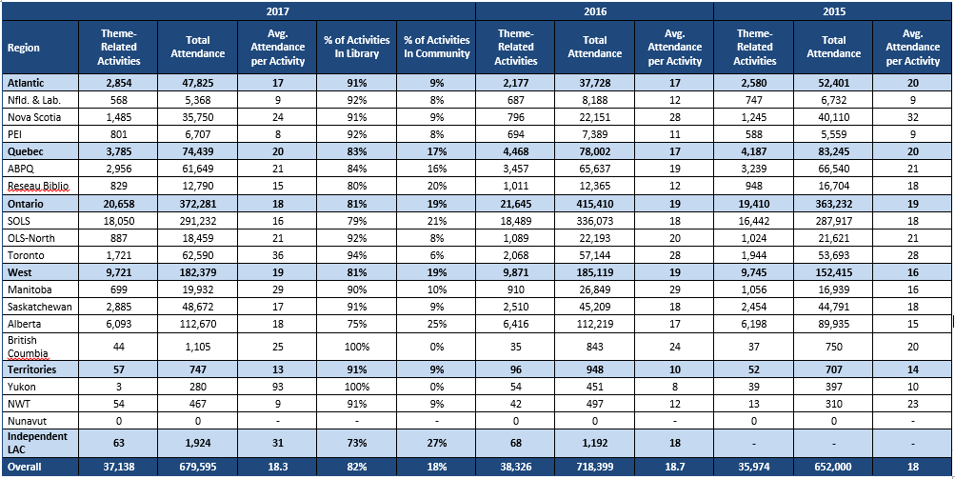

**Source:** *Q3. Total number of activities in your libraries and in your community. Attendance at activities in your libraries and in your community.*

## Promotion of Program

### School and Daycare Visits by Library Staff

Librarians were asked how they promoted the program, the number of visits made in their promotional efforts and how many children they reached as a result of these efforts.

Two thirds (68%) visited schools, one third (33%) visited child care centres and one fifth (20%) made visits to day camps and one fifth of all libraries (21%) made visits to other locations to promote their program.

Figure 13. School and Daycare Visits by Staff

**Source:** *Q4. Did any library staff promote the program at schools, day camps, child-care centres, or other locations (community/public housing projects/faith-based programs, etc.)? / How many of the libraries in your system made visits to promote the program at schools, day camps, child-care centres, or other locations (community/public housing projects/faith-based programs, etc.)?*

The proportion of libraries who indicated their staff had made visits to schools was high in almost every region of the country. In Nova Scotia, PEI, SOLS, Toronto, and Alberta more than 70% of libraries made visits to schools in their community. The rate was the lowest in Newfoundland, Saskatchewan, and the Reseau Biblio network in Quebec and in the Territories. Visits to child care centres were the second most common type of promotional visit made, and were most common in PEI and Toronto.

Figure 14. Promotional Visits by Staff by Region

|  |  |  |  |  |
| --- | --- | --- | --- | --- |
|  | **Made Visits (%)** | | | |
|  | **Schools** | **Child Care Centres** | **Day Camps** | **Other** |
| **Atlantic** | **62%** | **32%** | **21%** | **18%** |
| Nfld. & Lab. | 51% | 21% | 16% | 21% |
| Nova Scotia | 100% | 0% | 0% | 0% |
| PEI | 91% | 65% | 35% | 13% |
| **Quebec** | **62%** | **19%** | **27%** | **16%** |
| ABPQ | 65% | 18% | 26% | 17% |
| Reseau Biblio | 52% | 24% | 32% | 8% |
| **Ontario** | **78%** | **45%** | **22%** | **26%** |
| SOLS | 77% | 42% | 29% | 29% |
| OLS-North | 64% | 26% | 15% | 28% |
| Toronto | 84% | 55% | 20% | 22% |
| **West** | **66%** | **22%** | **9%** | **20%** |
| Manitoba | 67% | 28% | 11% | 33% |
| Saskatchewan | 58% | 25% | 7% | 20% |
| Alberta | 74% | 16% | 12% | 16% |
| British Columbia | 100% | 100% | 0% | 100% |
| **Territories** | **0%** | **0%** | **0%** | **0%** |
| Yukon | 0% | 0% | 0% | 0% |
| NWT | 0% | 0% | 0% | 0% |
| Nunavut | - | - | - | - |
| **Independent LAC** | **40%** | **20%** | **40%** | **40%** |
| **Overall** | **68%** | **31%** | **20%** | **21%** |

**Source:** *Q4. Did any library staff promote the program at schools, day camps, child-care centres, or other locations (community/public housing projects/faith-based programs, etc.)? / How many of the libraries in your system made visits to promote the program at schools, day camps, child-care centres, or other locations (community/public housing projects/faith-based programs, etc.)?*

This table summarizes the percentage of library systems whose staff made promotional visits in 2017 and also includes the total number of visits and the total children reached by those visits. More promotional visits were made to schools than to all other locations combined. They were also responsible for the vast majority of the children reached by promotional visits with an average of around 52 children reached per visit.

Figure 15. Promotional Visits by Staff by Location



**Source:** *Q4. Did any library staff promote the program at schools, day camps, child-care centres, or other locations (community/public housing projects/faith-based programs, etc.)? / How many of the libraries in your system made visits to promote the program at schools, day camps, child-care centres, or other locations (community/public housing projects/faith-based programs, etc.)?*

Before 2014, the specific number of individual libraries that made visits to schools, day camps and child care centres was never known precisely because systems were not asked what proportion of their libraries made visits, only whether any libraries in their system made promotional visits or not. That year the evaluation form included this information so more precise measurements were made for each type of visit. This method was carried forward in 2016 and 2017.

In 2017, more than two thirds of libraries across the country reported visiting a school (68%), which is higher than the proportion in 2016 (63%). The proportion of libraries that made promotional visits to child care centres increased to 31% in 2017 from 20% last year, while the proportion visiting day camps increased slightly to 20% compared to 16% in 2016.

Figure 16. Promotional Visits by Staff by Region (Tracking)



**Source:** *Q4. Did any library staff promote the program at schools, day camps, child-care centres, or other locations (community/public housing projects/faith-based programs, etc.)? / How many of the libraries in your system made visits to promote the program at schools, day camps, child-care centres, or other locations (community/public housing projects/faith-based programs, etc.)?*

## Satisfaction and Suggestions

In 2013 changes to the satisfaction and suggestion section were made in order to streamline the process and lower the burden on library staff who are required to keep track of and enter a number of metrics. These changes involved switching from a five-point scale to a ten-point scale in order to measure satisfaction with more precision. Using a five-point scale tended to give results with very little differentiation as the great majority of libraries responded to each question with either ‘very satisfied’ (5) or ‘satisfied’ (4) and a lot of more nuanced differences might have been missed. Due to the changes made in 2013, direct comparisons can only be made with research done since that year and only in some instances.

The 2016 Statistics and Evaluation Form was further streamlined in order to gather information from librarians about only the most important and actionable elements of the program.

The following section will provide satisfaction scores for every question asked by giving the proportion of libraries who responded with each score from 10 down to 6, along with those who gave a score of 0-5. The results for each question is directly compared to data from 2013 onward where possible. Libraries were also asked for suggestions and comments and their open-ended responses have been coded and are presented below as graphs.

Please note that libraries that did not provide information for any given question are not considered in the percentages reported here so that each graph will sum to 100%.

#### Overall Program Satisfaction

Overall, 76% of libraries were satisfied with the program itself, with a little over one quarter rating their satisfaction as ten out of ten. The Territories (the Yukon and the North West Territories) reported the highest level of satisfaction followed by Quebec. Atlantic Canada reported the lowest overall satisfaction with a top three score of 68%.

**Figure 17. Overall Program Satisfaction**

**Top 3 Box %**

**76%**

**75**

**Source:** *Q6. Overall, how satisfied were you with the TDSRC in 2017?*

**Figure 18. Overall Program Satisfaction by Region Top 3 Box Scores**

|  |  |
| --- | --- |
|  | **Overall Satisfaction With the Program** |
| **Region** | **2017** |
| *Top 3 Box* |
| **Atlantic** | **68%** |
| Nfld. & Lab. | 62% |
| Nova Scotia | 72% |
| PEI | 87% |
| **Quebec** | **78%** |
| ABPQ | 79% |
| Reseau Biblio | 76% |
| **Ontario** | **77%** |
| SOLS | 81% |
| OLS-North | 77% |
| Toronto | 71% |
| **West** | **74%** |
| Manitoba | 78% |
| Saskatchewan | 67% |
| Alberta | 79% |
| British Columbia | 100% |
| **Territories** | **100%** |
| Yukon | 100% |
| NWT | 100% |
| Nunavut | -- |
| **Independent LAC** | **80%** |
| **Total** | **75%** |

**Source:** *Q6. Overall, how satisfied were you with the TDSRC in 2017?*

### Qualitative Insights About the Program Overall

Participating libraries feel mostly positive about the program.

For most, TDSRC provides the library with a platform for encouraging summer reading. The program provides great structure for the libraries to build on, especially from a programming perspective.

Librarians overwhelmingly suggested that the TD Summer reading materials are working well. Specifically, they like the log books, note books, the fortune teller craft sheets, stickers and the fact that the program is bilingual. Most librarians suggested that having prizes and stickers are important for engaging the children.

Many libraries reported that they do “tweak” and customize the materials provided by the program. For example, some libraries reported using their own incentives for reading. Libraries like being able to change the program to suit their own needs.

For example, a few libraries mentioned that they have a “charm” incentive, where children bring in their log books and they get a bead to build a bracelet, or have a “General Store” approach where children are paid in “library bucks” and can redeem the points for small prizes.

Moving beyond the resources, librarians appreciated that the program promotes Canadian authors and illustrators.

*“The tradition and continuity of the program from year to year. It is a staple program in our library. Families come to know it will be offered regularly and it is a way to motivate & engage children in reading each summer.”*

Regardless of the overall positive attitude towards the program, libraries offered constructive feedback that could be helpful in improving the impact and outcome of the program.

There were mixed opinions about the theme of the TD Summer Reading Program, some librarians liked that the theme is broad so they can customize the program, while others like having a more specific theme to help guide the program.

In Quebec, participants tended to be less inspired by the theme and would like to see better defined themes. In the French online discussion, participants, suggested attaching a cause to the theme, for example the environment and commented on how the theme should be better developed in the content.

Participants in the English focus groups expressed interest in having the school boards involved in the program and working with the local school districts to promote the TD Summer Reading Program in schools.

Regarding the materials, some participant suggested that the log book is too small for younger readers. And other suggested the importance of having age appropriate content and making sure there are materials available for all age groups.

Many suggested that they would like to see an online space where libraries could exchange ideas and collect ideas on how to run the program and design activities. Some suggested using social media or social media style as a staff resource. For example a Facebook or Pinterest style group where libraries could share ideas with other libraries/librarians.

*“Perhaps a contest using a hashtag or something with social media and tagging your library could be created to win a prize.”*

In the French online discussions and written feedback, librarians suggested that there needs to be more motivation and incentive for children to complete the program. In order to increase encourage participation they hold multiple activities to engage children, but without their own programming efforts there is not a lot of motivation. Both participants suggested using prizes based on the number of pages read, that would be something that could make a difference. Additionally, a few commented on the need for more age appropriate content, and felt that materials were more geared towards young age groups, but there needs to be more of an effort to attract older participants (those aged 10 to 12 years old).

Overall Website Satisfaction

Libraries were asked to rate their level of satisfaction with the web content available to them on the librarians’ website. The level of satisfaction in 2017 is slightly higher compared to the previous three years, with a top three score of 72%. From 2014 to 2016 satisfaction with the web content was stable with roughly two thirds of libraries providing a top three score, however, there was a measurable shift from 2013 to 2014.

**Figure 19. Satisfaction with Website and Web Content for Librarians**

57%

**Top 3 Box %**

72%

65%

66%

65%

**Source:** *Q5.* *Website and Web Content for Librarians Satisfaction Questions.*

Satisfaction regarding the web content for librarians remains high in Quebec, which has traditionally been the most satisfied with web content since 2015. Overall, satisfaction with web content is quite strong across all regions, with the lowest top three score being 66% (for both Alberta and Saskatchewan). Specific details by province and region are provided in the table below.

Although the Yukon and North West Territories were the most satisfied with the content on the librarian’s website, with a top three score of 100% in 2017, results should be interpreted with caution given the small sample size in each territory.

**Figure 20. Satisfaction with Web Content for Librarians by Region Top 3 Box Scores**

|  |  |  |  |  |
| --- | --- | --- | --- | --- |
|  | **Overall Satisfaction With Librarian Website (Top 3 Box)** | | | |
| **Region** | **2017** | **2016** | **2015** | **Difference (2017 to 2016)** |
| *Top 3 Box* | *Top 3 Box* | *Top 3 Box* | *% Change* |
| **Atlantic** | **69%** | **48%** | **64%** | **21%** |
| Nfld. & Lab. | 68% | 61% | 61% | 7% |
| Nova Scotia | 67% | 16% | 61% | 51% |
| PEI | 78% | 56% | 76% | 22% |
| **Quebec** | **82%** | **78%** | **79%** | **4%** |
| ABPQ | 79% | 78% | 83% | 1% |
| Reseau Biblio | 85% | 78% | 76% | 7% |
| **Ontario** | **74%** | **62%** | **64%** | **12%** |
| SOLS | 73% | 58% | 65% | 15% |
| OLS-North | 83% | 73% | 67% | 10% |
| Toronto | 69% | 69% | 58% | 0% |
| **West** | **67%** | **64%** | **60%** | **3%** |
| Manitoba | 75% | 71% | 69% | 4% |
| Saskatchewan | 66% | 67% | 61% | -1% |
| Alberta | 66% | 58% | 57% | 8% |
| British Columbia | 0% | 100% | 100% | -100% |
| **Territories** | **100%** | **75%** | **62%** | **25%** |
| Yukon | 100% | 100% | 100% | 0% |
| NWT | 100% | 67% | 33% | 33% |
| Nunavut | - | - | - | - |
| **Independent LAC** | **-** | **100%** | **-** | **-** |
| **Total** | **73%** | **65%** | **66%** | **8%** |

**Source:** *Q5.* *Website and Web Content For Librarians Satisfaction Questions.*

Website Navigation

The only element of the web content for librarians which was measured was the ease of navigating the website. The level of satisfaction with the navigation of the website closely mirrored the overall satisfaction with the site itself. Almost one third (31%) gave the highest possible satisfaction score and two thirds (67%) gave a score of 8 or higher.

**Figure 21. Ease of Navigating the Website for Librarians**

**Top 3 Box %**

74%

65%

67%

67%

62%

**Source:** *Q5.* *Website and Web Content For Librarians Satisfaction Questions.*

### Qualitative Insights About the Website

Most agreed that the website is easy to navigate and that it has an “attractive and modern feel”.

Most find the staff section is user friendly and has useful content, for example, the activities, the artwork and illustrations, and program ideas.

The artwork tended to be widely used for branding on their own material. Many could not comment too much on the kids section, but said they liked that the site encouraged getting badges for reading.

In the written feedback a few participants said that they chose not to focus on promoting the website to children and families as it causes confusion and some stated that they are in rural areas where not all patrons have access to the internet. Also, a few reported that some parents do not want their children playing on the computer in the summer.

*“The staff website is great. Easy to navigate and I like the addition of the popup menus that you can easily exit out of without losing your page. However, I have had many parents complain to me about the child website in the past years saying it was too busy and very hard to navigate.”*

Much like the English participants, the French online discussion participants felt the content on the website was good and found the staff section useful, however, while most said they direct children to the website they are unsure if it gets used by children.

#### Librarian Web Resources

Beginning in 2015, librarians were asked about which librarian resources were used and how satisfied they were with each of the resources that they used. The questions were asked of those who ran their program in English and those who ran them in French. Although this split closely mirrors the split between Quebec and the rest of Canada, there were a handful of libraries outside of Quebec that ran their program in French and some within Quebec who ran their program in English. The section begins by discussing only those libraries that ran their program in English before examining those who ran it in French.

Librarians were asked specifically which of the resources that were available to them were actually used in running their TD Summer Reading Club in 2017. Among libraries that ran their program in English, the images were the most commonly utilized resource – by four in every five libraries. The recommended reads and the activities were both used by seven in ten libraries. More than half of all libraries used the promotional templates (64%), the programs (59%) the brand guidelines (56%) and the ‘How to Run a Successful Program’ section (53%). Around one third made use of the news feed offering.

**Figure 22. Usage of Librarian Web Resources (English)**

**Source:** *Q6.**Please identify which of the resources on the Librarians’ website you used and, for each resource that you did use, please give your level of satisfaction with it.*

There were no clear regional patterns with regard to librarian usage of English web resources. Although the actual rate of usage varies from region to region, there are few cases where a resource was used in one region more or less than others, with the exception of the Territories and English Quebec, which tended to have more extreme answers due to their small sample size. Generally speaking, libraries in Atlantic Canada were more likely to have used all of the resources than those in the West.

**Figure 23. Usage of Librarian Web Resources (English)**

|  |  |  |  |  |  |  |  |  |
| --- | --- | --- | --- | --- | --- | --- | --- | --- |
| **Region** | **Librarian Web Resource Usage (% Yes)** | | | | | | | |
| **Used The Recommended Reads** | **Used The Images** | **Used The Activities** | **Used The Programs** | **Used The Staff Newsfeed** | **Used The ‘How to run a successful program’ section** | **Used The Brand Guidelines** | **Used The Promotional Templates** |
| **% Yes** | **% Yes** | **% Yes** | **% Yes** | **% Yes** | **% Yes** | **% Yes** | **% Yes** |
| **Atlantic** | **82%** | **81%** | **88%** | **77%** | **49%** | **71%** | **60%** | **74%** |
| Nfld. & Lab. | 72% | 65% | 82% | 68% | 38% | 65% | 37% | 65% |
| Nova Scotia | 100% | 100% | 100% | 100% | 96% | 100% | 100% | 100% |
| PEI | 86% | 91% | 91% | 77% | 27% | 59% | 73% | 64% |
| **Quebec** | **75%** | **100%** | **75%** | **100%** | **25%** | **75%** | **100%** | **50%** |
| ABPQ *(n=4)* | 75% | 100% | 75% | 100% | 25% | 75% | 100% | 50% |
| **Ontario** | **75%** | **89%** | **75%** | **66%** | **37%** | **51%** | **65%** | **70%** |
| SOLS | 76% | 89% | 74% | 66% | 38% | 50% | 62% | 63% |
| OLS-North | 76% | 88% | 84% | 63% | 33% | 67% | 76% | 85% |
| Toronto | 70% | 88% | 76% | 68% | 30% | 44% | 68% | 91% |
| **West** | **64%** | **72%** | **61%** | **45%** | **27%** | **51%** | **44%** | **53%** |
| Manitoba | 61% | 84% | 65% | 53% | 27% | 52% | 26% | 51% |
| Saskatchewan | 62% | 61% | 60% | 47% | 40% | 52% | 42% | 49% |
| Alberta | 68% | 80% | 62% | 40% | 14% | 51% | 51% | 58% |
| British Columbia | 100% | 100% | 0% | 0% | 0% | 0% | 100% | 100% |
| **Territories** | **100%** | **100%** | **100%** | **67%** | **33%** | **100%** | **67%** | **100%** |
| Yukon | 100% | 100% | 100% | 100% | 0% | 100% | 0% | 100% |
| NWT | 100% | 100% | 100% | 50% | 50% | 100% | 100% | 100% |
| Nunavut | -- | -- | -- | -- | -- | -- | -- | -- |
| **Independent LAC** | **50%** | **50%** | **100%** | **100%** | **0%** | **100%** | **0%** | **50%** |
| **Overall** | **71%** | **81%** | **71%** | **59%** | **34%** | **53%** | **56%** | **64%** |

**Source:** *Q6.**Please identify which of the resources on the Librarians’ website you used and, for each resource that you did use, please give your level of satisfaction with it.*

Those who reported using the web resources were then asked to rate their satisfaction with those resources. Librarians reported being the most satisfied with the images (79%), the brand guidelines (77%) and the promotional templates (76%). Satisfaction was also quite high for the ‘How to run a successful program’ section (73%), while around two-thirds were satisfied with the programs, the activities and with the recommended reads.

**Figure 24. Satisfaction with the Librarian Web Resources (English)**

**(Ranked By Top Three Box Score)**

Top 3 Box %

77%

67%

68%

68%

69%

73%

76%

79%

**Source:** *Q6A.**Please identify which of the resources on the Librarians’ website you used and, for each resource that you did use, please give your level of satisfaction with it.*

Atlantic Canada tended to be slightly more satisfied compared to Ontario and the West for many of the program resources, however, generally there is no real difference in satisfaction region to region. Due to small sample sizes, the Territories and English Quebec tended to have more extreme responses compared to the other regions.

**Figure 25. Satisfaction with the Librarian Web Resources (English)**

|  |  |  |  |  |  |  |  |  |
| --- | --- | --- | --- | --- | --- | --- | --- | --- |
| **Region** | **Satisfaction With Web Content For Librarians (Top 3 Box)** | | | | | | | |
| **The Recommended Reads** | **The Images** | **The Activities** | **The Programs** | **The Newsfeed** | **The 'How to run a successful program' section** | **The Brand Guidelines** | **The Promotional Templates** |
| **Top 3 Box** | **Top 3 Box** | **Top 3 Box** | **Top 3 Box** | **Top 3 Box** | **Top 3 Box** | **Top 3 Box** | **Top 3 Box** |
| **Atlantic** | **69%** | **76%** | **75%** | **78%** | **74%** | **80%** | **77%** | **70%** |
| Nfld. & Lab. | 67% | 68% | 71% | 76% | 81% | 79% | 80% | 70% |
| Nova Scotia | 74% | 82% | 84% | 83% | 68% | 83% | 75% | 73% |
| PEI | 68% | 80% | 70% | 76% | 67% | 77% | 75% | 64% |
| **Quebec** | **100%** | **100%** | **67%** | **25%** | **0%** | **100%** | **100%** | **100%** |
| ABPQ *(n=4)* | 100% | 100% | 67% | 25% | 0% | 100% | 100% | 100% |
| **Ontario** | **66%** | **79%** | **64%** | **63%** | **68%** | **73%** | **79%** | **76%** |
| SOLS | 63% | 76% | 61% | 60% | 66% | 71% | 78% | 75% |
| OLS-North | 78% | 92% | 71% | 66% | 89% | 84% | 88% | 84% |
| Toronto | 69% | 81% | 68% | 71% | 65% | 68% | 71% | 76% |
| **West** | **67%** | **82%** | **69%** | **71%** | **68%** | **71%** | **74%** | **76%** |
| Manitoba | 56% | 87% | 66% | 72% | 46% | 73% | 89% | 68% |
| Saskatchewan | 78% | 78% | 72% | 72% | 73% | 71% | 69% | 78% |
| Alberta | 57% | 84% | 65% | 68% | 63% | 70% | 74% | 76% |
| British Columbia | 100% | 0% | -- | -- | -- | -- | 100% | 100% |
| **Territories** | **100%** | **67%** | **100%** | **100%** | **100%** | **100%** | **100%** | **100%** |
| Yukon | 100% | 0% | 100% | 100% | -- | 100% | -- | -- |
| NWT | 100% | 100% | 100% | 100% | 100% | 100% | 100% | 100% |
| Nunavut | -- | -- | -- | -- | -- | -- | -- | -- |
| **Independent LAC** | **100%** | **100%** | **100%** | **100%** | **--** | **100%** | **--** | **100%** |
| **Overall** | **67%** | **79%** | **68%** | **68%** | **69%** | **73%** | **77%** | **76%** |

**Source:** *Q6A.**Please identify which of the resources on the Librarians’ website you used and, for each resource that you did use, please give your level of satisfaction with it.*

The libraries that ran their program in French were also asked about the resources that were available to them that they actually made use of. Among these libraries, the *illustrations* were also the most commonly used resource (85%). The *titres recommandés* (73%), the *modèles et directives* (66%), and the *image de marque* (65%) were also commonly utilized by libraries. More than half of the libraries used the the *activités express* (56%) the *bricolages* (54%), and the *conseils pour la mise sur pied d’un club de lecture d’été réussi* (51%). The *nouvelles du club* (44%) and the *activités longues* (35%) were less popular with less than half of libraries making use of these resources.

**Figure 26. Usage of Librarian Web Resources (French)**

**Source:** *Q6FR.**Please identify which of the resources on the Librarians’ website you used and, for each resource that you did use, please give your level of satisfaction with it (French).*

The sample sizes among the regions outside Quebec were very small and it is difficult to draw conclusions about them based on such small sample sizes, but there are some notable differences between Reseau Biblio and ABPQ. ABPQ libraries tended to use each French web resource more than the Reseau Biblio libraries except for *the conseils pour la mise sur pied d’un club de lecture d’été réussi* (used by 58% of Reseau Biblio libraries and 44% ABPQ).

**Figure 27. Usage of Librarian Web Resources (French)**

|  |  |  |  |  |  |  |  |  |  |
| --- | --- | --- | --- | --- | --- | --- | --- | --- | --- |
| **Region** | **Librarian Web Resource Usage (French - % Yes)** | | | | | | | | |
| ***Titres recommandés*** | ***Illustrations*** | ***Activités Express*** | ***Activités longues*** | ***Bricolages*** | ***Nouvelles du Club*** | ***Consils pour la mise sur pied d’un club de lecture d’été réussi*** | ***Image de marque*** | ***Modèles et directives*** |
| **% Yes** | **% Yes** | **% Yes** | **% Yes** | **% Yes** | **% Yes** | **% Yes** | **% Yes** | **% Yes** |
| **Atlantic** | **100%** | **100%** | **0%** | **0%** | **100%** | **0%** | **100%** | **0%** | **100%** |
| PEI *(n=1)* | 100% | 100% | 0% | 0% | 100% | 0% | 100% | 0% | 100% |
| **Quebec** | **74%** | **86%** | **58%** | **36%** | **54%** | **45%** | **51%** | **66%** | **67%** |
| ABPQ | 79% | 92% | 65% | 44% | 60% | 55% | 44% | 75% | 68% |
| Reseau Biblio | 70% | 81% | 50% | 28% | 48% | 36% | 58% | 57% | 66% |
| **Ontario** | **50%** | **60%** | **40%** | **10%** | **60%** | **10%** | **40%** | **40%** | **40%** |
| SOLS *(n=4)* | 44% | 56% | 33% | 11% | 56% | 0% | 44% | 33% | 33% |
| OLS-North *(n=1)* | 100% | 100% | 100% | 0% | 100% | 100% | 0% | 100% | 100% |
| **West** | **0%** | **0%** | **0%** | **0%** | **0%** | **0%** | **0%** | **0%** | **0%** |
| Manitoba *(n=1)* | 0% | 0% | 0% | 0% | 0% | 0% | 0% | 0% | 0% |
| **Independent LAC *(n=3)*** | **67%** | **100%** | **33%** | **0%** | **0%** | **33%** | **100%** | **100%** | **100%** |
| **Overall** | **73%** | **85%** | **56%** | **35%** | **54%** | **44%** | **51%** | **65%** | **66%** |

**Source:** *Q6FR.**Please identify which of the resources on the Librarians’ website you used and, for each resource that you did use, please give your level of satisfaction with it (French).*

Those who reported using the web resources were then asked to rate their satisfaction with those resources. The scores for every resource were high when considering top three box scores which ranged from 86% for the *image de marque* to 68% for the *nouvelles du club.* Looking at the highest satisfaction score, provides a slightly different view where the *illustrations* received by far the highest scores (50% of all French libraries) and the *activités longues* scored the lowest, with a top score of 29%.

**Figure 28. Satisfaction With The Librarian Web Resources (French)**

**(Ranked By Top Three Box Score)**

Top 3 Box %

86%

80%

79%

68%

73%

79%

81%

77%

71%

**Source:** *Q6AFR.**Please identify which of the resources on the Librarians’ website you used and, for each resource that you did use, please give your level of satisfaction with it (French).*

In previous waves of research, measures of satisfaction with the various resources has been higher in Quebec than elsewhere in the country. Again the small number of libraries that used French resources outside Quebec make direct comparisons difficult, but the scores are higher across the board when compared to the scores for the English resources in the rest of the country. Generally speaking Reseau Biblio libraries were more satisfied with the resources than the ABPQ libraries were.

**Figure 29. Satisfaction with the Librarian Web Resources (French)**

|  |  |  |  |  |  |  |  |  |  |
| --- | --- | --- | --- | --- | --- | --- | --- | --- | --- |
| **Region** | **Satisfaction With Web Content For Librarians (French - Top 3 Box)** | | | | | | | | |
| ***Titres recommandés*** | ***Illustra-tions*** | ***Activités Express*** | ***Activités longues*** | ***Bricolages*** | ***Nouvelles du Club*** | ***Consils pour la mise sur pied d’un club de lecture d’été réussi*** | ***Image de marque*** | ***Modèles et directives*** |
|  |
| **Top 3 Box** | **Top 3 Box** | **Top 3 Box** | **Top 3 Box** | **Top 3 Box** | **Top 3 Box** | **Top 3 Box** | **Top 3 Box** | **Top 3 Box** |
| **Atlantic** | **0%** | **0%** | **--** | **--** | **0%** | **--** | **0%** | **--** | **0%** |
| PEI *(n=1)* | 0% | 0% | -- | -- | 0% | -- | 0% | -- | 0% |
| **Quebec** | **71%** | **82%** | **79%** | **79%** | **80%** | **68%** | **74%** | **87%** | **80%** |
| ABPQ | 61% | 78% | 72% | 69% | 75% | 61% | 60% | 90% | 77% |
| Reseau Biblio | 82% | 87% | 87% | 95% | 85% | 77% | 84% | 83% | 83% |
| **Ontario** | **42%** | **67%** | **28%** | **100%** | **51%** | **1** | **50%** | **28%** | **100%** |
| SOLS *(n=4)* | 25% | 60% | 0% | 100% | 40% | -- | 50% | 0% | 100% |
| OLS-North *(n=1)* | 100% | 100% | 100% | -- | 100% | 1 | -- | 100% | -- |
| **West** | **--** | **--** | **--** | **--** | **--** | **--** | **--** | **--** | **--** |
| Manitoba *(n=1)* | -- | -- | -- | -- | -- | -- | -- | -- | -- |
| **Independent LAC *(n=3)*** | **100%** | **100%** | **0%** | **--** | **--** | **100%** | **67%** | **67%** | **67%** |
| **Overall** | **71%** | **82%** | **77%** | **80%** | **78%** | **68%** | **73%** | **86%** | **79%** |

**Source:** *Q6AFR.**Please identify which of the resources on the Librarians’ website you used and, for each resource that you did use, please give your level of satisfaction with it (French).*

Librarians were asked for suggestions on how to improve the librarians’ website for future years. Four in ten (44%) of respondents said that they were satisfied or had nothing to suggest. Those who did provide a suggestion were most likely to mention simpler/better navigation and search/print functions (11%). Others requested Better/more recent/broader booklists (9%) and Age specific content/separate by age/school level (8%). Other suggestions include making material available sooner (7%) and more visually appealing clip art and a greater variety (7%).

|  |  |
| --- | --- |
| **Suggestions on how to improve any of the web resources for library staff?** | **2017** |
| *Satisfied/no suggestions* | *44%* |
| *Simpler/more user friendly/better navigation/search/print functions* | 11% |
| *Better/more recent/broader booklists* | *9%* |
| *Age specific content/separate by age/school level* | 8% |
| *Improve clip art/more visually appealing/more variety* | *7%* |
| *Make material available sooner* | 7% |
| *More suggestions/ideas for programs/activities* | *6%* |
| *Provide visual/photo/video guidance/instruction* | 3% |
| *Provide specific examples/outreach ideas/program suggestions* | *3%* |
| *Ability to share ideas/information between libraries/through social media/online forum* | 3% |
| *Provide more detailed/clearer information* | *3%* |
| *More cost-effective ideas/more consideration for libraries with smaller budgets* | 2% |
| *Program/activities were too geared toward larger libraries* | *2%* |
| *Lack of relevance/relation to theme/reading programs* | 2% |
| *Less restrictive/more flexible promotional templates/brand guidelines* | *2%* |
| *More promotion/awareness for website/website content* | 2% |
| *Other* | *18%* |

**Figure 30. Suggestions for Librarian Web Resources**

**Source:** *QD10.* *Do you have any suggestions on how to improve any of the web resources for library staff*

### Qualitative Insights About the Resources

**Recommended Reads**

In terms of content, librarians like the Recommended Reads section since it helps bring children back each week. The recommended reads brochure was popular and sent out to school aged children.

Most libraries reported that they buy all or some of the recommended reads, but do not always incorporate them into their programs, depending on if they fit the theme or not.

However, a few said that the Recommended Reads needs to have an indication that they are recommended, but each individual library may or may not have the titles listed. Some French libraries indicated that the recommended reads are not always easily accessible for the libraries.

*“It is tough for us small town libraries to have all the titles listed and because they show up on the children’s web page as a recommended read parents automatically feel that they should be available at our libraries.”*

The French online focus group participants tended to be less satisfied with the recommended reads section. Some commented on how the list of recommended reads is too short, especially amongst French book titles, and not relevant to all age groups. Two French participants suggested that they would like to see the program expanded beyond age 13 to include older readers.

**Images/Illustrations**

Participants like that the images are designed by Canadian illustrators. Many commented that they use the images for posters and promotional materials and use them on their websites and social media. Librarians in the English focus groups agreed that it would be helpful to have time images designed so that the children could colour them in. For example, so they can print colouring sheets for younger children to colour in.

**Activities**

Similar to the programs, librarians stated that they use the activities for ideas and tend to use them as a guide to suit their own library’s needs.

One participant suggested that it may be useful to group the activities section by age group, rather than in alphabetical order, to better plan programming.

**Programs**

Many say they do not use all of the program materials and are more likely to use the materials for inspiration and customize the materials to fit the needs of their community.

**Staff Newsfeed**

Most have not used the staff news feed, however, some find it important for key updates throughout the year for programming staff. Valuable to read for first-time planners or at the beginning of each year.

**“How to run a successful program’ section**

Many commented that the “How to run a successful program” section would be helpful for libraries or librarians that are just getting started with the program. One participant mentioned that it is important to consider the needs of each library and the region they are in as not all libraries are created equal.

*“Each library should understand what will and will not work, because something works in Toronto or Hamilton, does not mean it will work in small town Ontario. This should be left up to each library to decide how to run their own successful program, rather than give them an unachievable goal.”*

#### Satisfaction with the Program Evaluation

Finally, libraries were asked to rate their level of satisfaction with the program evaluation and statistics process. Overall, satisfaction was relatively high with seven in ten (72%) of respondents giving top three box satisfaction scores. One third of respondents (33%) gave the highest possible score. Only 14% of respondents gave a score which would indicate dissatisfaction with the process.

The top three box score in 2017 is an increase over the previous three years and a sizeable increase over 2013 (which was 55%). The continued streamlining of the form and the dropping of the requirement that gender among registering children be tracked are likely to have contributed to this increase.

Libraries tended to be more satisfied with the ‘ease of using the system’ (63% top three score) compared to ‘the evaluation asks about relevant concerns’ which has a top three score of 42%. Over one-third provided a score that would indicates that the evaluation does not ask about relevant concerns.

**Figure 31. Satisfaction with Program Evaluation and Statistics Process**

43%

Top 3 Box %

72%

61%

55%

62%

66%

63%

**Source:** *Q7.* *Program Evaluation and Statistics Process Questions.*

Ontario and Quebec libraries were the most satisfied with the program evaluation process, with three quarters reporting high satisfaction. While, Quebec libraries also reported high satisfaction with ease of using the evaluation systems (74%). Atlantic was the most likely to report that the program evaluation asks about relevant concerns (62%).

Libraries in the Yukon reported highest satisfaction with both the program evaluation process and the ease of using the evaluation system, with a top three score of 100% for each attribute, however given the small sample size caution should be used when interpreting this result.

Specific details by province and region are provided in the table below.

**Figure 32. Satisfaction with Program Evaluation and Statistics Process by Region**

**Top 3 Box Scores**

|  |  |  |  |
| --- | --- | --- | --- |
| **Region** | **Satisfaction With The Program Evaluation Process (Top 3 Box)** | | |
| **Satisfaction With Program Evaluation Process** | **Ease Of Using The Evaluation System** | **Asks About Relevant Concerns** |
| *Top 3 Box* | *Top 3 Box* | *Top 3 Box* |
| **Atlantic** | **67%** | **64%** | **62%** |
| Nfld. & Lab. | 67% | 74% | 67% |
| Nova Scotia | 50% | 16% | 59% |
| PEI | 70% | 83% | 65% |
| **Quebec** | **74%** | **74%** | **41%** |
| ABPQ | 71% | 75% | 46% |
| Reseau Biblio | 83% | 74% | 38% |
| **Ontario** | **75%** | **60%** | **40%** |
| SOLS | 73% | 53% | 33% |
| OLS-North | 87% | 75% | 67% |
| Toronto | 72% | 78% | 71% |
| **West** | **67%** | **61%** | **43%** |
| Manitoba | 70% | 38% | 58% |
| Saskatchewan | 63% | 65% | 38% |
| Alberta | 70% | 65% | 44% |
| British Columbia | 100% | 100% | 100% |
| **Territories** | **100%** | **100%** | **29%** |
| Yukon | 100% | 100% | 100% |
| NWT | -- | -- | 17% |
| Nunavut | -- | -- | -- |
| **Independent LAC** | **80%** | **80%** | **80%** |
| **Overall** | **71%** | **63%** | **42%** |

**Source:** *Q7.* *Program Evaluation and Statistics Process Questions.*

Librarians were asked for their suggestions on how the program evaluation and statistical collection process could be improved. The most popular single response, given by 46% of librarians, was that they had no suggestions to give. Among those who had something to suggest, the most common answer was make questions and forms available sooner or let libraries know what to track during the program (18%), other suggestions were to clarify or better define information being requested (6%).

*The table below details all of the responses given by at least 2% of respondents.*

**Figure 33. Suggestions for Improving the Program Evaluation and Statistics Process**

|  |  |
| --- | --- |
| **Suggestions on how to improve the statistical collection and program evaluation process?** | **2017** |
| *Satisfied/no suggestions* | *46%* |
| *Make questions/forms available sooner/let us know what to track* | 18% |
| *Clarify/better define information requested* | *6%* |
| *Include a comments section for each question to allow for explanation of data collected* | 4% |
| *Questions don't apply/we can't collect certain statistics* | *4%* |
| *Include stats on number of books read* | 2% |
| *Standardized forms/Excel format to accommodate formulas* | *2%* |
| *Date for Get your summer read on was too early/should be closer to school break* | 2% |
| *Fewer questions/reduce survey length* | *2%* |
| *Problems recording children who weren't officially registered* | 2% |
| *Other* | *25%* |

**Source:** *QD11. Do you have any suggestions for how to improve the statistical collection and program evaluation process?*

Finally, libraries were asked to indicate whether they had any indicators of children’s increased enjoyment of reading, reading successes or changes in attitudes toward reading. The most common response was that children were excited about the program and that it kept them reading over the summer (28% of libraries). Others heard that the challenges/incentives were a motivating factor for their children (17%) and many children said they enjoyed the program and that it motivated them to read more (16%). 13% of librarians reported that the program brings more children into the library and 10% indicated that there was a noticeable improvement in reading level.

*The table below details all of the responses given by at least 2% of respondents.*

**Figure 34. Testimonials Indicating an Increased Love of Reading**

|  |  |
| --- | --- |
| **Testimonials indicating increased love of reading?** | **2017** |
| *Makes them excited/keeps them reading over the summer* | *28%* |
| *Challenges/incentives were a motivating factor* | 17% |
| *Children enjoyed the program/enjoyed reading/were motivated to read more (unspecified)* | *16%* |
| *Children/parents enjoyed the activities/crafts/website* | 14% |
| *Brings more children to the library/they enjoy coming* | *13%* |
| *Noticeable improvement in reading level* | 10% |
| *Children checking out more books from library* | *8%* |
| *Children love adding stickers to their passports* | 7% |
| *Children enjoy coming back each year* | *6%* |
| *Children enjoyed this year's theme* | 6% |
| *Improved confidence/communication skills* | *6%* |
| *Children exceeding goals of club/reading extra* | 5% |
| *Children enjoyed story time/hearing stories recited* | *4%* |
| *Children exploring more/new genres/topics* | 4% |
| *Children more willing to read at home/share with family* | *4%* |
| *Increased interest/abilities in school* | 3% |
| *Children learned new words/information* | *2%* |
| *Higher program registration numbers* | 2% |
| *Children/parents wish program was longer/all year* | *2%* |
| *Other* | 23% |

**Source:** *QD12.* *Do you have any testimonials from parents, caregivers or teachers that may indicate an increased love of reading?*

### Qualitative Insights About the Program Evaluation

Most are satisfied with the evaluation process, although one common theme among many was that they would like to have the final evaluation and statistic requirements well before the program starts.

For many, the purpose of local evaluations is to track registration, measure outcomes, completion rates (number of hours spent reading) and satisfaction with the program. Some librarians suggested that an online form provided by TDRC would be helpful to measure the program locally.

Most online focus group participants said they use the half size paper evaluation sheets and look at the statistics the TD Summer Reading Program collects.

Many said they also run their own survey at the end of the summer with both staff and parents. The method of administering the survey was not always reported; some use survey monkey, or paper based survey. However, some reported that they only collect the stats needed by TD Summer Reading Program.

Most of the French participants suggested that they do not evaluate the program locally, a few use paper surveys, however, most only collect statistics needed by the TD Summer reading program.

# 

# Appendix 1 - Evaluation Forms

**TD Summer Reading Club** **STATISTICS AND EVALUATION FORM 2017**

**Library System Form**

## Introduction / Splash Screen

Thank you for participating in the 2017 TD Summer Reading Club. The form below contains the statistics and feedback that you will be asked to provide at the conclusion of your library system’s 2017 program.

Our interest in conducting this study is to provide information about the success of the program to the program's partners (Toronto Public Library, Library and Archives Canada and TD Bank Group), as well as to participating libraries. The feedback gathered will help us to continue to make improvements to the TD Summer Reading Club program.

The online file will be accessible between August 30th and September 30th and will allow you to enter the results for your library system. You will also be able to print your results and/or have an electronic version emailed to you for your records.

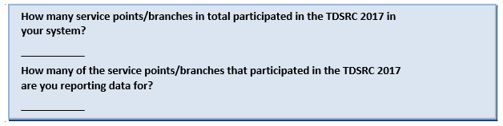

## Program Registration Module

**Q1 – REGISTRATION:** Please enter your totals for the number of children who registered to participate in the TDSRC 2017 at all of the libraries in your system. This refers to the total number of children who were registered with your library system and were given program materials. The counts can be transcribed from the appropriate category of your registration form(s). Registration is distinct from participation in activities – children must be registered to be counted here, not just participate in TDSRC activities *(see the ‘Program Participation Statistics and Materials Module’ for more information).*

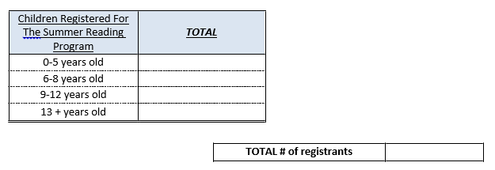

**[Exclusive Option]** No children registered for The Summer Reading Program **[Skip to Q4]**

**Q2 – AWARENESS METHODS**: How many of the children registered in your **library system** had participated in the TD Summer Reading Club in previous years and how many were new to the program? Please transcribe the totals from your registration form(s) below.

**Note**: Please ensure the total number of registrants (previous years + new to the program) is equal to the total number of registrants listed in Q1- Registration.

|  |  |
| --- | --- |
| **How many registrants joined the TDSRC last year (or in previous years)?** |  |
| **How many registrants are new to the TDSRC?** |  |

## 

## Program Participation Statistics & Materials Module

**Q3 - PARTICIPATION:** Participation refers to the total number of children who attended any or all of the programs* conducted at **ALL** of the **libraries in your system** – it is designed to measure the total reach of the TDSRC program. This number refers to the total attendance (**children only)** at activities/programs conducted by your library system for the Summer Reading Club - these children may or may not be registered for the TDSRC as described in the ‘Registration’ section. A child is counted as having participated if they took part in any number of activities/programs within the libraries or outside of them. **PLEASE NOTE**: this section is asking about ***program*** outreach (*i.e.* activities), NOT ***promotional*** outreach*.

*Include programming activities such as story time, author readings, arts and crafts, etc.

*Exclude promotional activities such as school visits, contests, newspaper articles, etc.

**Please enter the totals for all libraries in the system that you are reporting for:**

|  |  |
| --- | --- |
| Number of Club programs **in your libraries** |  |
| Number of Club programs **in your community** |  |
| = Total number of programs |  |

|  |  |
| --- | --- |
| Attendance at programs for **children in your libraries** |  |
| Attendance at programs for **children in your community** |  |
| = Total attendance by children at programs |  |

**Promotion of Program Module**

**Q4 - STAFF PROMOTION**: How many of **the libraries** in your system made visits to promote the program at schools, day camps, child-care centers, or other locations (community/public housing projects/faith-based programs, etc.)?

|  |  |  |  |  |
| --- | --- | --- | --- | --- |
|  | Schools | Day Camps | Child Care Centres | Other |
| **# of libraries in your system that made visits to:** |  |  |  |  |

**If any libraries made visits, fill in the total number of individual visits made in total and the total number of children in attendance at each type of visit**

|  |  |  |  |  |  |
| --- | --- | --- | --- | --- | --- |
|  | No | Yes |  | **(If Yes)** Number of individual visits | **(If Yes)** Estimated number of children in attendance |
| Schools |  |  |  |  |
| Day Camps |  |  |  |  |
| Child Care Centres |  |  |  |  |
| Other |  |  |  |  |

**[Include this as module title for part IV: “Part IV - Program Evaluation and Suggestions for Improvement]**

**Language of Program**

**Q5 -** In which language did you primarily conduct the TDSRC?

|  |  |
| --- | --- |
|  | Please check one |
| English |  |
| French |  |
| Bilingual |  |

## Q6 - Satisfaction With Program

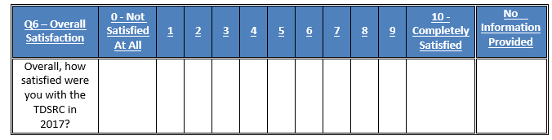

**Staff Website Evaluation and Suggestions for Improvement**

You are reporting data for multiple service points/branches. Please enter the number of libraries who gave each response on the 10-point scales below. If some service points did not supply information, enter that number under 'No Information Provided.' Each row should total the number of service points you are reporting data for.

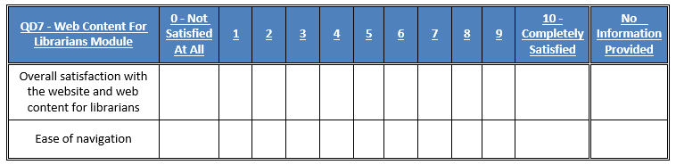

**Q8 – LIBRARY STAFF WEBSITE:** Please enter the **number of libraries** that used each resource below and the number that did not use the resource.

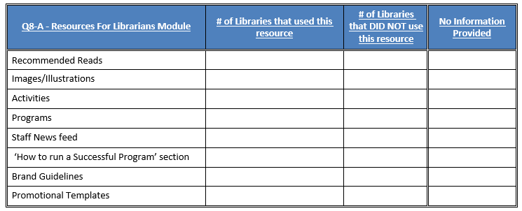

**QD8-B -** If any libraries in your system used the resources above, please enter the number of libraries who gave each satisfaction score for that resource on the 10-point scales below.

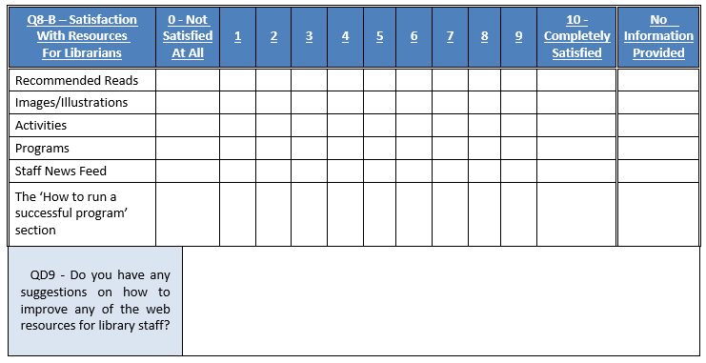

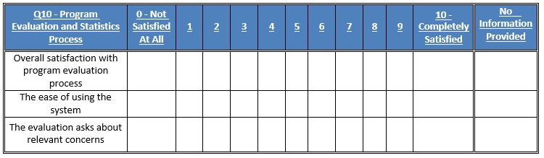

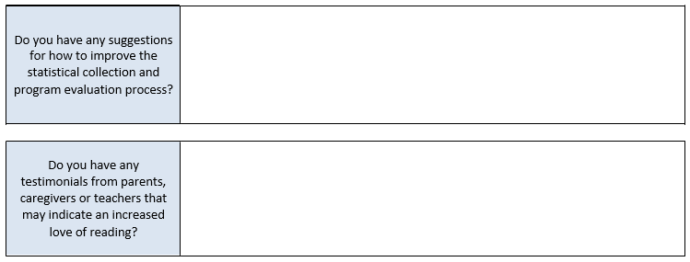

## Thank You for Your Participation!

**TD Summer Reading Club STATISTICS AND EVALUATION FORM 2017**

**Individual Library Form**

## Introduction / Splash Screen

Thank you for participating in the 2017 TD Summer Reading Club. The form below contains the statistics and feedback that you will be asked to provide at the conclusion of your library’s 2017 program.

Our interest in conducting this study is to provide information about the success of the program to the program's partners (Toronto Public Library, Library and Archives Canada and TD Bank Group), as well as to participating libraries. The feedback gathered will help us to continue to make improvements to the TD Summer Reading Club program.

The online file will be accessible between August 30th and September 30th and will allow you to enter the results for your library. You will also be able to print your results and/or have an electronic version emailed to you for your records.

## Program Registration Module

**Q1 – REGISTRATION:** Please enter your totals for the number of children who registered to participate in the TDSRC 2017. This refers to the total number of children who were registered with your library and were given program materials. The counts can be transcribed from the appropriate category of your registration form. Registration is distinct from participation in activities – children must be registered to be counted here, not just participate in TDSRC activities *(see the ‘Program Participation Statistics and Materials Module’ for more information).*

*(NOTE: Please note that we no longer require staff to record children’s gender at registration.)*



**[Exclusive Option]** No children registered for The Summer Reading Program **[Skip to Q4]**

**Q2 – AWARENESS METHODS**: How many of the children registered in your library had participated in the TD Summer Reading Club in previous years and how many were new to the program? Please transcribe the totals from your registration form below.

**Note**: Please ensure the total number of registrants (previous years + new to the program) is equal to the total number of registrants listed in Q1- Registration.



## Program Participation Statistics & Materials Module

**Q3 - PARTICIPATION:** Participation refers to the total number of children who attended any or all of the programs* conducted by your library – it is designed to measure the total reach of the TDSRC program. This number refers to the total attendance (**children only)** at activities/programs conducted by your library for the Summer Reading Club - these children may or may not be registered for the TDSRC as described in the ‘Registration’ section. A child is counted as having participated if they took part in any number of TDSRC programs within the library or outside of it. **PLEASE NOTE**: this section is asking about ***program*** outreach (*i.e.* activities), NOT ***promotional*** outreach*.

*Include programming activities such as story time, author readings, and arts and crafts.

*Exclude promotional activities such as school visits, contests, newspaper articles.

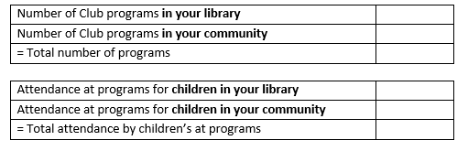

## Promotion of Program Module

**Q4 – STAFF PROMOTION:** Did any library staff promote the program at schools, day camps, child-care centres, or other locations (community/public housing projects/faith-based programs, etc.)? **If yes, please answer the follow-up question:**

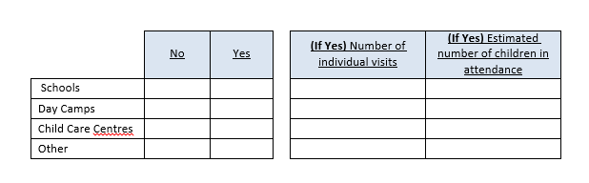

## [Include this as module title for part IV: “Part IV - Program Evaluation and Suggestions for Improvement]

## Language of Program

**Q5 -** In which language did you primarily conduct the TDSRC?

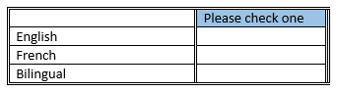

## Q6 - Satisfaction With Program

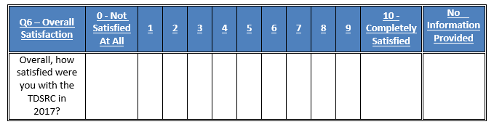

**Staff Website Evaluation and Suggestions for Improvement**

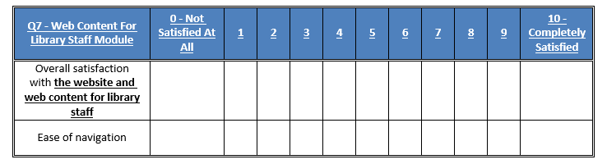

**Q8 – LIBRARY STAFF WEBSITE**: Please identify which of the resources on the library staff website you used and, for each resource that you did use, please give your level of satisfaction with it.

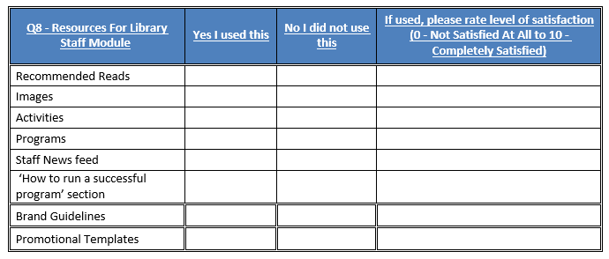

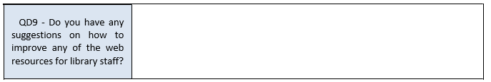

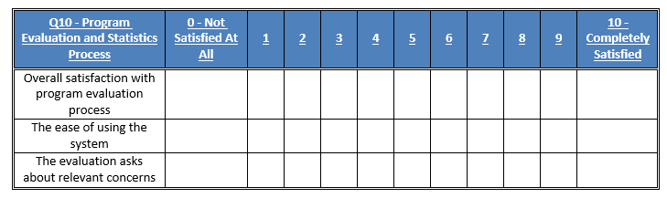

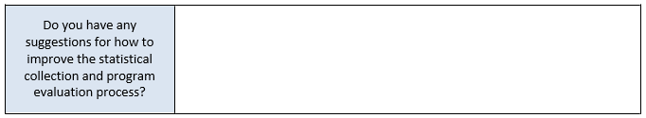



## Thank You for Your Participation!

**Club de lecture d’été TD**

**FORMULAIRE D’ÉVALUATION ET DE STATISTIQUES 2017**

**Formulaire pour les réseaux de bibliothèques**

## Introduction/Écran de démarrage

Merci de participer à l’édition 2017 du Club de lecture d’été TD. Le formulaire ci-dessous vous servira à inscrire les statistiques et les commentaires qui vous seront demandés à la fin du Club dans votre réseau de bibliothèques.

Nous menons cette étude parce que nous souhaitons fournir des renseignements sur le programme aux bibliothèques participantes ainsi qu’aux partenaires (la Bibliothèque publique de Toronto, Bibliothèque et Archives Canada et le Groupe Banque TD). Les commentaires recueillis nous aideront à améliorer le Club de lecture d’été TD.

Grâce à ce fichier en ligne, accessible en tout temps du 30 août au 30 septembre, vous pourrez enregistrer les statistiques relatives à votre réseau. Vous pourrez aussi imprimer vos résultats et en obtenir une version électronique par courriel pour vos dossiers.

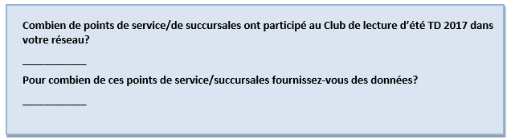

## Module sur l’inscription au programme

**Q1 – INSCRIPTION :** Veuillez indiquer le nombre total d’enfants qui se sont inscrits au Club de lecture d’été TD 2017 dans toutes les bibliothèques de votre réseau (c’est-à-dire le nombre total d’enfants qui se sont inscrits dans votre réseau de bibliothèques et à qui vous avez remis le matériel du Club). Ces données peuvent être compilées à partir de vos formulaires d’inscription. À noter que l’inscription diffère de la participation aux activités : pour être comptabilisés ici, les enfants doivent s’être inscrits au Club; la participation aux activités à elle seule ne suffit pas. (Veuillez vous reporter au Module sur les statistiques de participation aux activités et sur le matériel pour de plus amples renseignements.)

Veuillez noter qu’il n’est plus nécessaire d’inscrire le sexe des enfants lors de l’inscription.

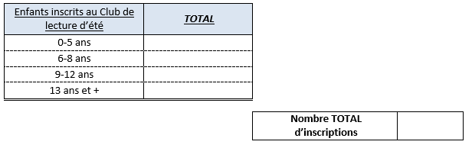

**[Option exclusive]** Aucune inscription au Club de lecture d’été **[Passer à la Q4]**

**Q2 – SENSIBILISATION :** Parmi les enfants inscrits au Club dans votre réseau de bibliothèques, combien y avaient déjà participé lors d’années antérieures, et combien y participaient pour la première fois? Ces données peuvent être compilées à partir de vos formulaires d’inscription; transcrivez les totaux ci-dessous.

Note : Veuillez vous assurer que le nombre total d’enfants inscrits (enfants des années antérieures + nouvelles inscriptions) est égal au nombre total d’enfants inscrits indiqué à la Q1 – Inscription.

#### 

## Module sur les statistiques de participation aux activités et sur le matériel

**Q3 – PARTICIPATION :** La participation fait référence au nombre total d’enfants qui ont pris part à une ou à plusieurs des activités* du Club organisées dans TOUTES les bibliothèques de votre réseau. (Nous cherchons à mesurer la portée globale du Club.) Veuillez inclure les activités de nature littéraire, culturelle ou éducative planifiées, offertes et animées par vos bibliothèques ‒ y compris sur le Web ‒ pour faire connaître ses services et ses collections, tant à l’intérieur qu’à l’extérieur de ses locaux.

Les données sur la participation font référence à la participation totale des enfants seulement aux activités du Club organisées par votre réseau de bibliothèques, que les enfants soient inscrits ou non au Club (voir la description fournie à la section « Inscription »). On considère qu’un enfant a participé s’il a pris part à une ou à plusieurs des activités, tant dans les bibliothèques que dans votre collectivité.

**À NOTER :** Cette section porte sur les enfants joints par les activités estivales du Club, ET NON PAS lors de la promotion du programme.

*Inclure les activités d’animation telles que les heures du conte, les rencontres avec les écrivains ainsi que les activités artistiques et le bricolage.

*Exclure les activités de promotion telles que les visites dans les écoles, les tirages et les articles dans les journaux.

**Veuillez entrer le total pour toutes les bibliothèques de votre réseau :**

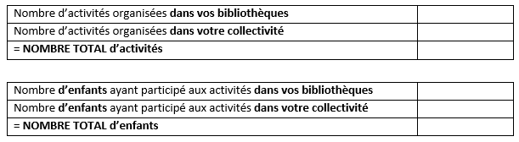

## Module Promotion du programme

**Q4 – PROMOTION PAR LE PERSONNEL :** Combien de bibliothèques de votre réseau ont fait des visites pour promouvoir le Club dans les écoles, les camps de jour, les garderies ou d’autres endroits (projets communautaires ou ensembles de logements publics, programmes confessionnels, etc.)?

|  |  |  |  |  |
| --- | --- | --- | --- | --- |
|  | Dans les écoles | Dans les camps de jour | Dans les garderies | Ailleurs |
| **Nombre de bibliothèques  qui ont fait des visites :** |  |  |  |  |

**Le cas échéant, veuillez indiquer le nombre total de visites effectuées, ainsi que le nombre total d’enfants présents pour chaque type de visite.**

|  |  |  |  |  |  |
| --- | --- | --- | --- | --- | --- |
|  | Non | Oui |  | **(Si oui)** Nombre de visites individuelles | **(Si oui)** Nombre d’enfants présents (une estimation suffit) |
| Écoles |  |  |  |  |  |
| Camps de jour |  |  |  |  |  |
| Garderies |  |  |  |  |  |
| Autres |  |  |  |  |  |

#### [Include this as module title for part IV: “Partie IV – Évaluation du Programme et suggestions d'améliorations]

## Langue du programme

**Q5 –** Dans quelle langue se sont principalement déroulées les activités du Club de lecture d’été TD?

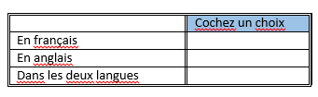

**Q6 -** Satisfaction à l’égard du programme

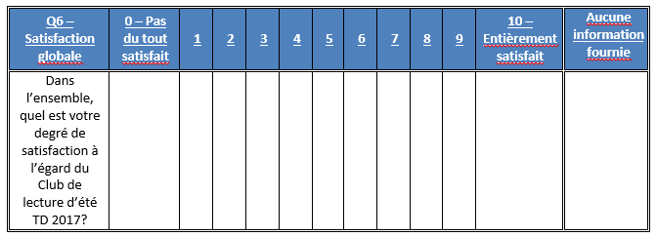

## Évaluation du programme par les bibliothécaires et suggestions d’améliorations

Vous fournissez des données pour plusieurs points de service ou succursales. Sur l’échelle de 0 à 10 ci-dessous, veuillez inscrire sous chaque échelon le nombre de bibliothèques qui ont accordé cette note au programme. Si certains points de service n’ont pas fourni d’information, veuillez les comptabiliser sous « Aucune information fournie ». Le total de chaque rangée doit être égal au nombre de points de service pour lesquels vous fournissez des données.

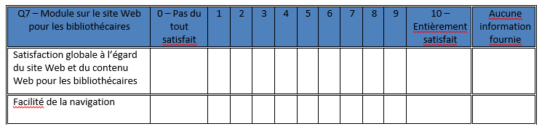

**Q8 – SITE WEB POUR LES BIBLIOTHÉCAIRES :** Veuillez inscrire le **nombre de bibliothèques** qui ont utilisé chacune des ressources ci-dessous et le nombre de bibliothèques qui ne l’ont pas fait.

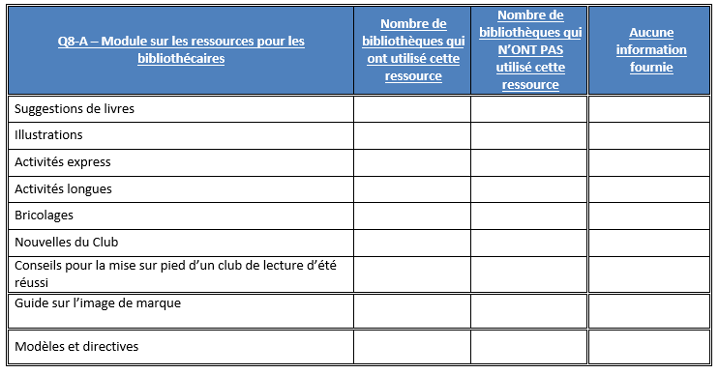

Si des bibliothèques de votre réseau ont utilisé ces ressources, veuillez l’indiquer ci-dessous, en mentionnant combien de bibliothèques ont attribué quelle note à chacune.

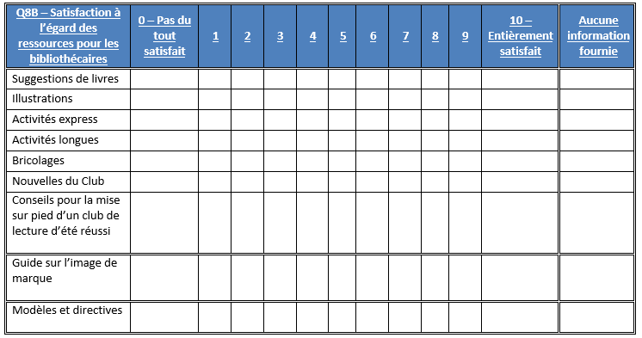

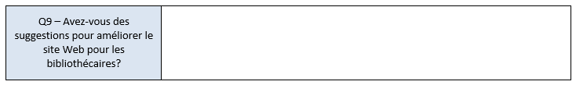

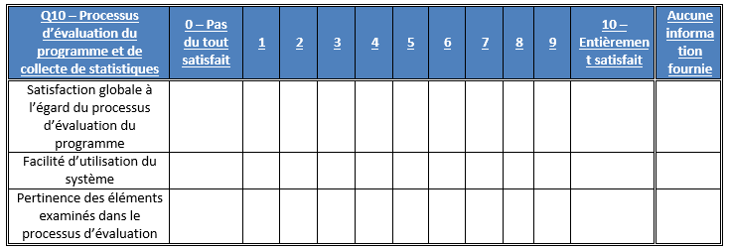

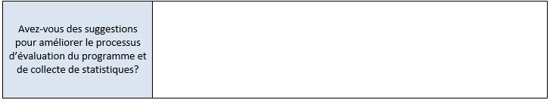

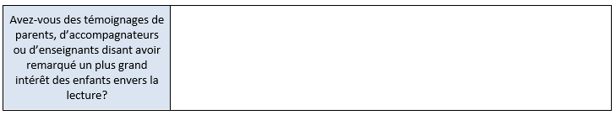

**Merci de votre participation!**

**Club de lecture d’été TD**

**FORMULAIRE D’ÉVALUATION ET DE STATISTIQUES 2017**

**Formulaire pour les bibliothèques autonomes**

## Introduction/Écran de démarrage

Merci de participer à l’édition 2017 du Club de lecture d’été TD. Le formulaire ci-dessous vous servira à inscrire les statistiques et les commentaires qui vous seront demandés à la fin du Club dans votre bibliothèque.

Nous menons cette étude parce que nous souhaitons fournir des renseignements sur le programme aux bibliothèques participantes ainsi qu’aux partenaires (la Bibliothèque publique de Toronto, Bibliothèque et Archives Canada et le Groupe Banque TD). Les commentaires recueillis nous aideront à améliorer le Club de lecture d’été TD.

Grâce à ce fichier en ligne, accessible en tout temps du 30 août au 30 septembre, vous pourrez enregistrer les statistiques relatives à votre bibliothèque. Vous pourrez aussi imprimer vos résultats et en obtenir une version électronique par courriel pour vos dossiers.

## Module sur l’inscription au programme

**Q1 – INSCRIPTION :** Veuillez indiquer le nombre total d’enfants qui se sont inscrits au Club de lecture d’été TD 2017 dans votre bibliothèque (c’est-à-dire le nombre total d’enfants qui se sont inscrits dans votre bibliothèque et à qui vous avez remis le matériel du Club). Ces données peuvent être compilées à partir de vos formulaires d’inscription. À noter que l’inscription diffère de la participation aux activités : pour être comptabilisés ici, les enfants doivent s’être inscrits au Club; la participation aux activités à elle seule ne suffit pas. (Veuillez vous reporter au Module sur les statistiques de participation aux activités et sur le matériel pour de plus amples renseignements.)

Veuillez noter qu’il n’est plus nécessaire d’inscrire le sexe des enfants lors de l’inscription.

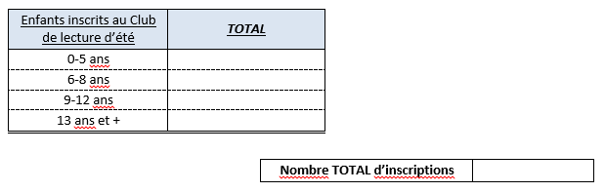

**Q2 –SENSIBILISATION :** Parmi les enfants inscrits au Club dans votre bibliothèque, combien y avaient participé lors d’années antérieures, et combien y participaient pour la première fois? Ces données peuvent être compilées à partir de vos formulaires d’inscription; transcrivez les totaux ci-dessous.

**Note :** Veuillez vous assurer que le nombre total d’inscrits (enfants des années antérieures + nouvelles inscriptions) est égal au nombre total d’enfants inscrits indiqué à la Q1 – Inscription.

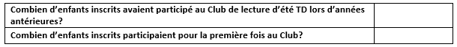

## Module sur les statistiques de participation aux activités et sur le matériel

**Q3 – PARTICIPATION :** La participation fait référence au nombre total d’enfants qui ont pris part à une ou à plusieurs des activités* du Club organisées par votre bibliothèque. (Nous cherchons à mesurer la portée globale du Club.) Veuillez inclure les activités de nature littéraire, culturelle ou éducative planifiées, offertes et animées par votre bibliothèque ‒ y compris sur le Web ‒ pour faire connaître ses services et ses collections, tant à l’intérieur qu’à l’extérieur de ses locaux.

Les données sur la participation nous permettent de mesurer la portée globale du programme. Elles font référence à la participation totale des enfants seulement aux activités du Club organisées par votre bibliothèque, que les enfants soient inscrits ou non au Club (voir la description fournie à la section « Inscription »). On considère qu’un enfant a participé s’il a pris part à une ou à plusieurs des activités, tant à la bibliothèque que dans votre collectivité.

**À NOTER :** Cette section porte sur les enfants joints par ***les activités estivales du Club***, ET NON PAS lors de la promotion du programme.  
  
*Inclure les activités d’animation telles que les heures du conte, les rencontres avec les écrivains ainsi que les activités artistiques et le bricolage.

*Exclure les activités de promotion telles que les visites dans les écoles, les tirages et les articles dans les journaux.

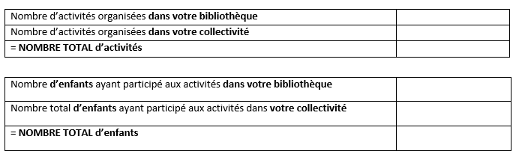

## Module sur Promotion du programme

**Q4 – PROMOTION PAR LE PERSONNEL :** Le personnel de la bibliothèque a-t-il fait la promotion du Club dans les écoles, les camps de jour, les garderies ou d’autres endroits (projets communautaires ou ensembles de logements publics, programmes confessionnels, etc.)? **Si oui, veuillez fournir les précisions suivantes :**

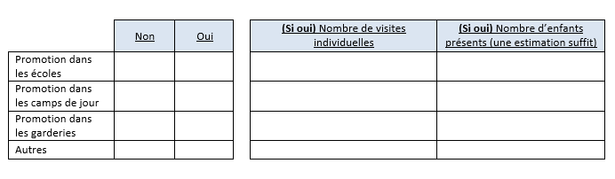

#### [Include this as module title for part IV: “Partie IV – Évaluation du Programme et suggestions d'améliorations]

## Langue du programme

**Q5 –** Dans quelle langue se sont principalement déroulées les activités du Club de lecture d’été TD?

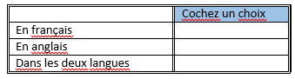

#### Q6 – Satisfaction à l’égard du programme

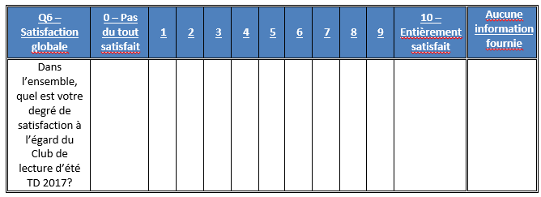

## Évaluation du programme par le personnel et suggestions d’améliorations

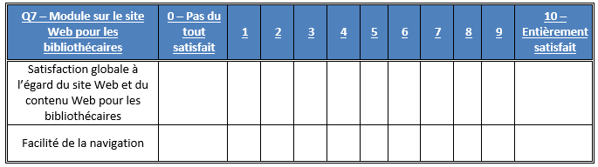

**Q8 – SITE WEB POUR LES BIBLIOTHÉCAIRES :** Parmi les ressources énumérées ci-dessous, veuillez indiquer lesquelles vous avez utilisées, et pour chacune, précisez votre niveau de satisfaction.

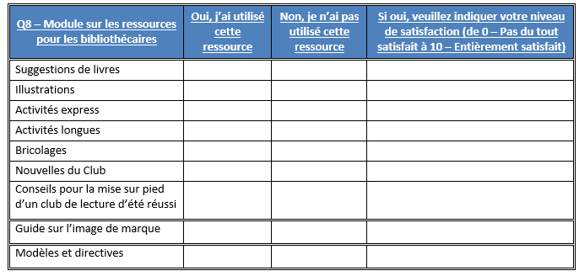

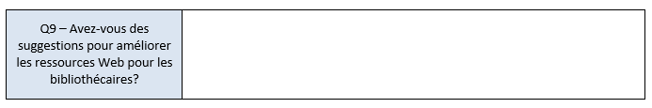

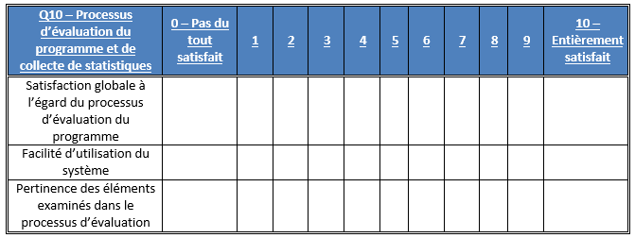



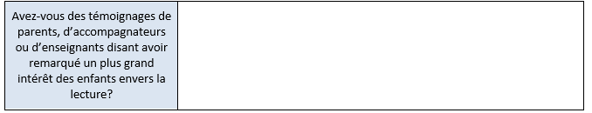

**Merci de votre participation!**

# Appendix 2 – Ontario

(SOLS, NOLS, AND TORONTO)

**ONTARIO PROGRAM STATISTICS**

**RESPONSE RATE**

The participating libraries in Ontario were asked to tally the results of participants in the summer reading club for all of their subsidiary branches. Within all systems, 740 of the 758 participating individual libraries submitted their results, representing an overall response rate of 98%.

Figure 1. Response Rate

|  |  |  |  |  |
| --- | --- | --- | --- | --- |
|  | **Ontario** | **TPL** | **SOLS** | **OLS-N** |
| **(A) Total Participating Libraries** | 758 | 105 | 569 | 84 |
| **(B) Total Responded to Survey** | 740 | 103 | 564 | 73 |
| **(C) Survey Response Rate** | **98%** | **98%** | **99%** | **87%** |

**Source:** Row (A) provided by Library and Archives Canada. Rows (B) and (C)represent data collected by Nielsen.

## Statistics on Registration & Attendance

### TD Summer Reading Program Registration

The first section of the Statistics and Evaluation Form asked librarians to indicate the total number of children registered for the TDSRC 2017. This reflects the number of children who registered on the sign-up sheet, with the intent to read books as part of the TD Summer Reading Club.

In Ontario, an estimated 165,209 children registered for the TDSRC 2017 program, which is slightly below 2016. Registrations increased in SOLS and Toronto, but declined in Northern Ontario.

Figure 2. Total Registration 2009 – 2017

|  |  |  |  |  |  |  |  |  |  |
| --- | --- | --- | --- | --- | --- | --- | --- | --- | --- |
|  | **Total Registration** | | | | | | | | |
| **Region** | **2017** | **2016** | **2015** | **2014** | **2013** | **2012** | **2011** | **2010** | **2009** |
| **Ontario** | **165,209** | **165,695** | **159,437** | **153,232** | **154,153** | **143,213** | **153,779** | **153,003** | **161,275** |
| SOLS | 124,038 | 123,587 | 116,924 | 113,634 | 119,687 | 107,589 | 113,490 | 114,861 | 125,244 |
| OLS-North | 3,982 | 5,358 | 4,411 | 4,841 | 4,025 | 4,365 | 5,078 | 5,377 | 6,590 |
| Toronto | 37,189 | 36,750 | 38,102 | 34,758 | 30,442 | 31,259 | 35,211 | 32,765 | 29,441 |

**Source:** *Q1 Total number of children who registered for the TDSRC 2016.*

The figure below shows the age breakdown of registered children. For the summer 2017, 31% of the registered children were in the 0-5 age group, 40% were 6-8, 27% were 9-12, and 2% were 13 years or older.

**Figure 3. Percentage of Registered Children by Age 2009 – 2017**

|  |  |  |  |  |  |  |  |  |  |
| --- | --- | --- | --- | --- | --- | --- | --- | --- | --- |
| **Ontario** | **2017** | **2016** | **2015** | **2014** | **2013** | **2012** | **2011** | **2010** | **2009** |
| **0-5** | 31% | 34% | 33% | 33% | 32% | 32% | 30% | 30% | 28% |
| **6-8** | 40% | 38% | 38% | 39% | 40% | 39% | 39% | 39% | 38% |
| **9-12** | 27% | 26% | 27% | 26% | 26% | 27% | 28% | 28% | 30% |
| **13+** | 2% | 2% | 2% | 2% | 2% | 2% | 2% | 2% | 3% |

**Source:** *Q1 Total number of children who registered for the TDSRC 2016.*

Figure 4 below summarizes the participation rate for Ontario by age based on 2011 census data. The proportion of all children who were registered in 2017 was slightly lower than 2016, but higher than 2015. The age group with the highest proportion of the total population taking part in the 2017 TD Summer Reading Club was 6-8 year olds, with more than 15% of children in this age group taking part in the program.

Figure 4. Number of Registered Children

|  |  |  |  |  |  |
| --- | --- | --- | --- | --- | --- |
|  | **2011 CENSUS** | **2017 TD SRC  REGISTRANTS** | **% PARTICIP.  CHILDREN** | **% PARTICIP.  CHILDREN** | **% PARTICIP.  CHILDREN** |
| **(A)** | **(B)** | **2017** | **2016** | **2015** |
| **Province / Territory** | **Total Children** | **Total Children** | **Total Children** | **Total Children** | **Total Children** |
| **Ontario** | **2,693,835** | **165,209** | **6.13%** | **6.15%** | **5.92%** |
| 0-5 | 846,055 | 51,864 | 6.13% | 6.70% | 6.17% |
| 6-8 | 427,470 | 65,417 | 15.30% | 14.66% | 14.19% |
| 9-12 | 590,615 | 44,223 | 7.49% | 7.25% | 7.38% |
| 13+ | 829,695 | 3,705 | 0.45% | 0.42% | 0.36% |

**Source:** *Q1 Total number of children who registered for the TDSRC 2016, 2015, 2014. Column (A) provided by Statistics Canada Census 2011. Column (B)*

### TD Summer Reading Program Attendance & Activities

To help gauge the success of the TDSRC, libraries were asked to indicate the total number of programs and activities organized around this year’s club theme as well as the total attendance of children at these activities (not including parents or care givers).

When reviewing these numbers, several points need to be kept in mind:

* Every child who registered for the reading club with the library is considered to have attended an activity;
* It is possible that a child did not register for the TDSRC, but attended one or more of the activities; and
* Attendance was calculated on a per activity basis. It is possible that a child attended more than one activity, and thus is represented more than once in total attendance.

A total of 372,281 children attended the 20,658 theme-related activities which were organized in libraries across Ontario over the summer months of 2017. Within Ontario, SOLS organized the large majority of the activities and as a result, the majority of children who attended did so at SOLS libraries. Overall, an average of 18 children attended each activity in 2017, with the average attendance per activity in Toronto being the highest of any of the regions. Provincially, 81% of all activities were conducted inside libraries.

Figure 5. Total Activities and Attendance

|  |  |  |  |  |  |
| --- | --- | --- | --- | --- | --- |
|  | **Activity Attendance** | | | | |
| **Region** | **Theme-Related Activities** | **Total Attendance** | **Avg. Attendance per Activity** | **% of Activities In Library** | **% of Activities In Community** |
| **Ontario** | **20,658** | **372,281** | **18** | **81%** | **19%** |
| SOLS | 18,050 | 291,232 | 16 | 79% | 21% |
| OLS-North | 887 | 18,459 | 21 | 92% | 8% |
| Toronto | 1,721 | 65,590 | 36 | 94% | 6% |

**Source:** *Q2. Total number of activities in your libraries and in your community. Attendance at activities in your libraries and in your community.*

Both the number of activities and total attendance at those activities in Ontario decreased in 2017, when compared to 2016.

Figure 6. Activities and Attendance 2015 – 2017

|  |  |  |  |  |  |  |
| --- | --- | --- | --- | --- | --- | --- |
|  | **2017** | | **2016** | | **2015** | |
| **Region** | **Theme-Related Activities** | **Total Attendance** | **Theme-Related Activities** | **Total Attendance** | **Theme-Related Activities** | **Total Attendance** |
| **Ontario** | **20,658** | **372,281** | **21,645** | **415,410** | **19,410** | **363,232** |
| SOLS | 18,050 | 291,232 | 18,489 | 336,073 | 16,442 | 287,917 |
| OLS-North | 887 | 18,459 | 1,089 | 22,193 | 1,024 | 21,621 |
| Toronto | 1,721 | 65,590 | 2,068 | 57,144 | 1,944 | 53,693 |

**Source:** *Q2. How many of the children registered in your library had participated in the TD Summer Reading Club in previous years and how many were new to the program?*

## 

## Promotion of Program

Librarians were asked to indicate if anyone from their library branch made any visits to the local schools, child care centres, day camps, or to any other locations in order to promote the program.

In Ontario, 78% of libraries indicated that their library staff made promotional visits to schools, while 45% visited child care centres, 22% visited day camps, and 26% made other promotional visits. A total of 7,088 promotional visits were made, reaching a total of 341,522 children.

**Figure 7. Total Number of Visits and Children Reached by Segment**

|  |  |  |  |  |  |  |
| --- | --- | --- | --- | --- | --- | --- |
|  | **Made Visits 2017 (%)** | | | | | |
|  | **Schools** | | | **Day Camps** | | |
|  | **School Visits (% Yes)** | **Total Visits** | **Children Attended** | **Day Camp Visits (%)** | **Total Visits** | **Children Attended** |
| Ontario | 78% | 4,652 | 282,486 | 22% | 847 | 16,254 |
|  | **Child Care Centres** | | | **Other Locations** | | |
|  | **Child care Visits (%)** | **Total Visits** | **Children Attended** | **Other Visits (%)** | **Total Visits** | **Children Attended** |
| Ontario | 45% | 1,002 | 19,591 | 26% | 587 | 23,221 |

**Source:** *Q3. Total number of activities in your libraries and in your community. Attendance at activities in your libraries and in your community.*

### Previous Participation

In Ontario, more than half of all registered children (55%) said that they had participated in previous years. This number was highest in Southern Ontario (59%) and lowest in Toronto (41%). The proportion of children who reported having participated in a previous year was higher compared to the previous two years.

Figure 8. Previous Participation

|  |  |  |  |  |
| --- | --- | --- | --- | --- |
| **Region** | **Joined in previous years** | | **New Registrants** | |
| **Ontario** | **90,621** | **55%** | **74,386** | **45%** |
| SOLS | 73,136 | 59% | 50,902 | 41% |
| OLS-North | 2,167 | 54% | 1,816 | 46% |
| Toronto | 15,318 | 41% | 21,668 | 59% |

|  |  |  |  |
| --- | --- | --- | --- |
| **% Joined in Previous Years** | | | |
| **Region** | **2017** | **2016** | **2015** |
| **Ontario** | **55%** | **51%** | **51%** |
| SOLS | 59% | 56% | 56% |
| OLS-North | 54% | 45% | 61% |
| Toronto | 41% | 38% | 37% |

**Source:** *Q4. How many of the children registered in your library had participated in the TD Summer Reading Club in previous years and how many were new to the program?*

## Satisfaction & Suggestions

The following section will provide satisfaction scores for every question asked by giving the proportion of libraries who responded with each score from 10 down to 6, along with those who gave a score of 0-5. The overall satisfaction question for each section is reported first and directly compared to previous waves of data (wherever applicable). It is followed by the individual element scores, ranked by the proportion giving a score of 10 (unless otherwise noted). Libraries were also asked for their suggestions and comments in each section.

Please note that libraries that did not provide information for any given question are not considered in the percentages reported here so that each graph will sum to 100%. In some cases, the sum of percentages reported may not add exactly to 100% due to rounding.

#### Overall Satisfaction with the Program

This question was added in 2017 to be able to obtain a measurement of the satisfaction with the program as a whole. Overall satisfaction with the program in Ontario is 77%. Satisfaction is highest in Southern Ontario (81%) and lowest in Toronto (71%).

#### **Figure 9. Overall Satisfaction with the Program**

|  |  |
| --- | --- |
| **Region** | **Overall Satisfaction**  **with the Program (Top 3 Box)** |
| **2017** |
| **Ontario** | **77%** |
| SOLS | 81% |
| OLS-North | 77% |
| Toronto | 71% |

**Source:** *Q6.* *Overall satisfaction with the program.*

#### Overall Web Content Satisfaction

Libraries were asked to rate their level of satisfaction with the web content available to them on the librarians’ website. The levels of satisfaction in 2017 are high, increasing more than 10 points when compared to last year. Satisfaction increase is driven by SOLS and Northern Ontario. Toronto’s satisfaction with the web content is consistent with last year.

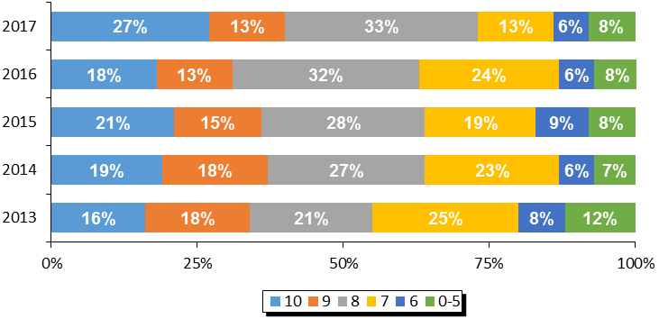**Figure 10. Satisfaction with Website and Web Content for Librarians**

|  |  |  |  |  |
| --- | --- | --- | --- | --- |
| **Region** | **Overall Satisfaction With Librarians' Website (Top 3 Box)** | | | |
| **2017** | **2016** | **2015** | **2014** |
| **Ontario** | **73%** | **62%** | **64%** | **64%** |
| SOLS | 72% | 58% | 65% | 63% |
| OLS-North | 83% | 73% | 67% | 76% |
| Toronto | 70% | 69% | 58% | 58% |

**Source:** *QD9.* *Website and Web Content For Librarians Satisfaction Questions.*

#### Website Navigation

The only element of the web content for librarians which was measured was the ease of navigating the website. The level of satisfaction with the navigation of the website also experienced a double-digit increase compared to 2016. Again, satisfaction increased mostly among SOLS and OLS-North libraries.

**Figure 11. Ease of Navigating the Website for Librarians**

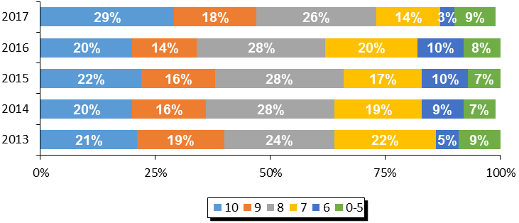

|  |  |  |  |  |
| --- | --- | --- | --- | --- |
| **Region** | **Ease of Navigation (Top 3 Box)** | | | |
| **2017** | **2016** | **2015** | **2014** |
| **Ontario** | **73%** | **62%** | **66%** | **65%** |
| SOLS | 74% | 58% | 67% | 63% |
| OLS-North | 83% | 74% | 73% | 80% |
| Toronto | 68% | 65% | 56% | 60% |

**Source:** *QD9.* *Website and Web Content For Librarians Satisfaction Questions.*

#### Librarian Web Resources

Librarians were asked specifically which of the resources that were available to them were actually used in running their TD Summer Reading Club in 2017. Usage of the resources was varied and ranged from the images (89% of Ontario libraries) and the recommended reads (75%) to the newsfeed which was used by only 37% of libraries.

**Figure 12. Usage of Librarian Web Resources**

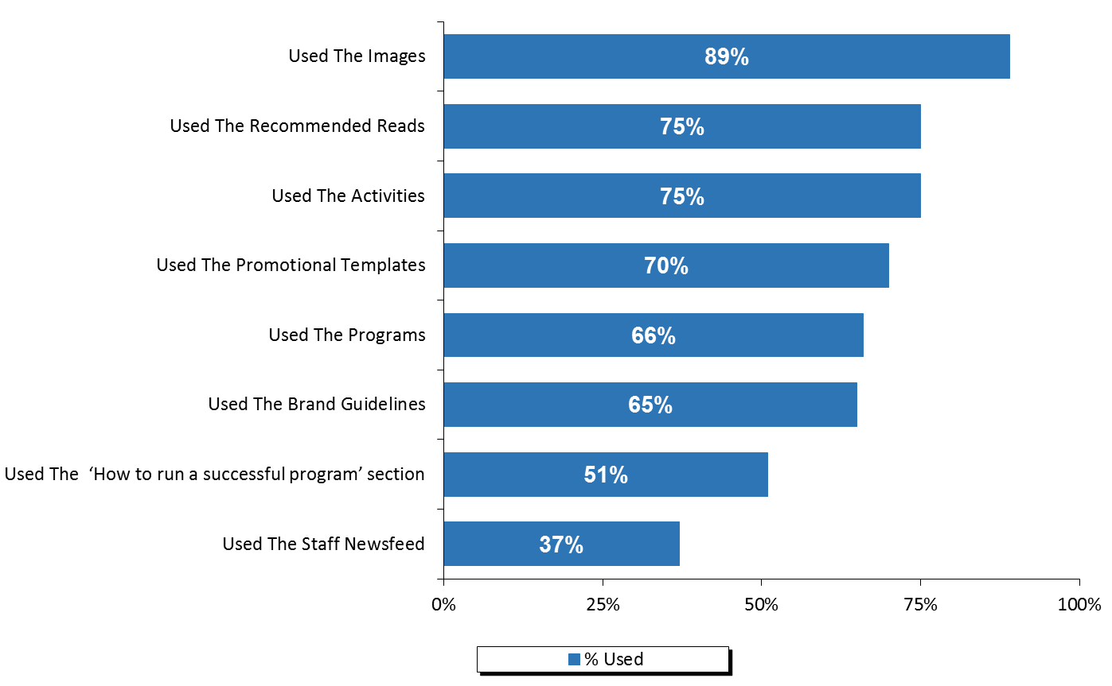

**Source:** *Q6.**Please identify which of the resources on the Librarians’ website you used and, for each resource that you did use, please give your level of satisfaction with it.*

Those who reported using the web resources were then asked to rate their satisfaction with those resources. Although satisfaction was high for the librarian resources in general, it was highest for the images (79% top three box), the brand guidelines (78%), and promotional templates (76%).

Figure 13. Satisfaction with the Librarian Web Resources

Top 3 Box %

79%

78%

76%

73%

68%

65%

64%

62%

**(Ranked By Top Three Box Score)**

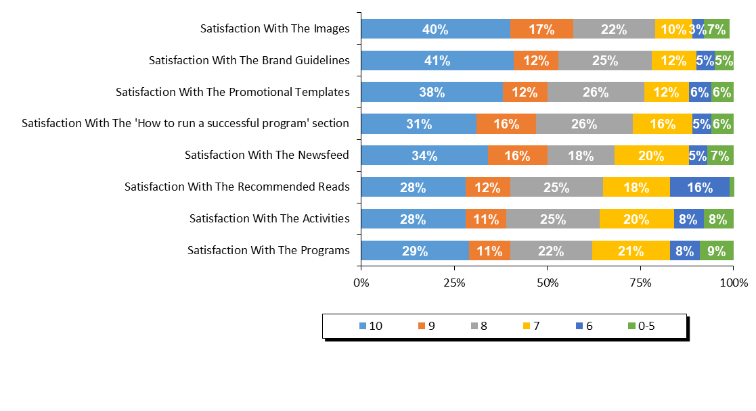

**Source:** *Q15.**Please identify which of the resources on the Librarians’ website you used and, for each resource that you did use, please give your level of satisfaction with it.*

Librarians were asked for suggestions on how to improve the librarians’ website for future years. Just over a third of respondents said that they were satisfied or had nothing to suggest. Those who did provide a suggestion were most likely to mention more recent/broader booklists (11%), improvement in the clip art (9%), and simpler/better navigation and search/print functions (8%).

**Figure 14. Suggestions for Librarian Web Resources**

|  |  |
| --- | --- |
| **Suggestions on how to improve any of the web resources for library staff?** | **2017** |
| *Satisfied/no suggestions* | *35%* |
| Better/more recent/broader booklists | 11% |
| Improve clip art/more visually appealing/more variety | 9% |
| Simpler/more user friendly/better navigation/search/print functions | 8% |
| Provide visual/photo/video guidance/instruction | 7% |
| More suggestions/ideas for programs/activities | 7% |
| Provide specific examples/outreach ideas/program suggestions | 7% |
| Age specific content/separate by age/school level | 6% |
| Make material available sooner | 6% |
| Ability to share ideas/information between libraries/through social media/online forum | 5% |
| More cost-effective ideas/more consideration for libraries with smaller budgets | 5% |
| Program/activities were too geared toward larger libraries | 5% |
| Provide more detailed/clearer information | 3% |
| Better craft ideas | 2% |
| Lack of relevance/relation to theme/reading programs | 2% |
| More promotion/awareness for website/website content | 2% |
| Provide regular updates/newsletters/ability to subscribe to mailing list | 2% |
| Information/activities available in English and French | 1% |
| More printable activities | 1% |
| Provide promotional material in a common format/unable to use them in the format provided | 1% |
| Printable certificate/participation award | 1% |
| Other | 25% |

**Source:** *QD10.* *Do you have any suggestions on how to improve any of the web resources for library staff?*

#### Satisfaction With The Program Evaluation

Finally, libraries were asked to rate their level of satisfaction with the program evaluation and statistics process for 2017. Satisfaction peaked in 2017 at 75%, with more than a third rating it a ten, the highest possible score.

Among the elements of the program evaluation process, the score for ‘ease of using the system’ was relatively high at 60%, while the score for ‘the evaluation asks about relevant concerns’ was low at 39%.

**Figure 15. Satisfaction with Program Evaluation and Statistics Process**

Top 3 Box %

75%

73%

57%

61%

60%

39%



**Source:** *Q17.* *Program Evaluation and Statistics Process Questions.*

Librarians were asked for their suggestions on how the program evaluation and statistical collection process could be improved. The most common single response was that respondents were satisfied or had no suggestions to offer (34%). The most common suggestions were related to making the questions/forms available sooner and letting them know what to track (12%).

**Figure 16. Suggestions for Improving the Program Evaluation and Statistics Process**

|  |  |
| --- | --- |
| **Suggestions on how to improve the statistical collection and program evaluation process?** | **2017** |
| *Satisfied/no suggestions* | *34%* |
| Make questions/forms available sooner/let us know what to track | 12% |
| Clarify/better define information requested | 5% |
| Include a comments section for each question to allow for explanation of data collected | 4% |
| Include stats on number of books read | 4% |
| Questions don't apply/we can't collect certain statistics | 3% |
| Make survey available online | 2% |
| Problems recording children who weren't officially registered | 2% |
| Standardized forms/Excel format to accommodate formulas | 2% |
| Survey should ask feedback on promotional/program material | 2% |
| Survey should ask feedback on themes/future themes | 2% |
| Date for Get your summer read on was too early/should be closer to school break | 1% |
| Fewer questions/reduce survey length | 1% |
| Improve navigation of online survey | 1% |
| Offer a printable version | 1% |
| Other | 33% |

**Source:** *QD12. Do you have any suggestions for how to improve the statistical collection and program evaluation process?*

Finally, libraries were asked to indicate whether they had any indicators of children’s increased enjoyment of reading, reading successes or changes in attitudes toward reading. The most common response was that the program makes the kids excited and keeps them reading over the summer (29%). Other popular testimonials were related to the challenges/incentives being a motivating factor (19%), and that children enjoyed the program and were motivated to read more (16%).

**Figure 17. Testimonials Indicating an Increased Love of Reading**

|  |  |
| --- | --- |
| **Testimonials indicating increased love of reading?** | **2017** |
| Makes them excited/keeps them reading over the summer | 29% |
| Challenges/incentives were a motivating factor | 19% |
| Children enjoyed the program/enjoyed reading/were motivated to read more (unspecified) | 16% |
| Brings more children to the library/they enjoy coming | 13% |
| Children love adding stickers to their passports | 12% |
| Children/parents enjoyed the activities/crafts/website | 10% |
| Noticeable improvement in reading level | 10% |
| Children exceeding goals of club/reading extra | 9% |
| Improved confidence/communication skills | 8% |
| Children checking out more books from library | 7% |
| Children enjoyed this year's theme | 7% |
| Children enjoy coming back each year | 5% |
| Children more willing to read at home/share with family | 5% |
| Children exploring more/new genres/topics | 3% |
| Children learned new words/information | 3% |
| Children/parents wish program was longer/all year | 3% |
| Children enjoyed story time/hearing stories recited | 2% |
| Increased interest/abilities in school | 2% |
| Higher program registration numbers | 1% |
| Other | 23% |

**Source:** *QD13.* *Do you have any testimonials from parents, caregivers or teachers that may indicate an increased love of reading?*

# 

# Appendix 3 – Quebec

**QUEBEC PROGRAM STATISTICS**

### Response Rate

The participating libraries in Quebec were asked to tally the results of participants in the summer reading club for all of their subsidiary branches. Within all systems, 357 of the 397 participating individual libraries submitted their results, representing an overall response rate of 90%.

Figure 1. Response Rate

|  |  |  |  |
| --- | --- | --- | --- |
|  | **Quebec** | **ABPQ** | **RBQ** |
| **(A) Total Participating Libraries** | 397 | 175 | 222 |
| **(B) Total Responded to Survey** | 357 | 169 | 188 |
| **(C) Survey Response Rate** | **90%** | **97%** | **85%** |

**Source:** Row (A) provided by Library and Archives Canada. Rows (B) and (C)represent data collected by Nielsen.

## Statistics on Registration & Attendance

### TD Summer Reading Program Registration

The first section of the Statistics and Evaluation Form asked librarians to indicate the total number of children registered for the TDSRC 2017. This reflects the number of children who registered on the sign-up sheet, with the intent to read books as part of the TD Summer Reading Club.

In Quebec, an estimated 42,989 children registered for the TDSRC 2017 program, which is a notable decrease compared to the past two years. The decrease happened in both ABPQ and RBQ libraries.

Figure 2. Total Registration 2009 – 2017

|  |  |  |  |  |  |  |  |  |  |
| --- | --- | --- | --- | --- | --- | --- | --- | --- | --- |
|  | **Total Registration** | | | | | | | | |
| **Region** | **2017** | **2016** | **2015** | **2014** | **2013** | **2012** | **2011** | **2010** | **2009** |
| Quebec | **42,989** | **50,814** | **47,229** | **38,570** | **28,517** | **32,808** | **27,391** | **27,068** | **29,813** |
| ABPQ | 34,266 | 41,141 | 36,344 | 28,151 | 23,023 | 22,491 | 18,681 | 16,507 | 22,483 |
| RBQ | 8,723 | 9,673 | 10,885 | 10,418 | 5,494 | 10,317 | 8,710 | 10,561 | 7,330 |

**Source:** *Q1 Total number of children who registered for the TDSRC 2017.*

The figure below shows the age breakdown of registered children. For the summer 2017, 24% of the registered children were in the 0-5 age group, 38% were 6-8, 34% were 9-12, and 4% were 13 years or older. Although the age make-up of registered children is very consistent with the past years.

**Figure 3. Percentage of Registered Children by Age 2009 – 2017**

|  |  |  |  |  |  |  |  |  |  |
| --- | --- | --- | --- | --- | --- | --- | --- | --- | --- |
| **Quebec** | **2017** | **2016** | **2015** | **2014** | **2013** | **2012** | **2011** | **2010** | **2009** |
| **0-5** | 24% | 24% | 24% | 24% | 23% | 22% | 19% | 20% | 17% |
| **6-8** | 38% | 40% | 40% | 40% | 40% | 38% | 39% | 38% | 39% |
| **9-12** | 34% | 34% | 34% | 33% | 36% | 35% | 39% | 37% | 40% |
| **13+** | 4% | 3% | 3% | 3% | 2% | 5% | 4% | 5% | 3% |

**Source:** *Q1 Total number of children who registered for the TDSRC 2017.*

Figure 5 below summarizes the participation rate for Quebec by age based on 2011 census data. The proportion of all children who were registered in 2017 was lower than the previous two years, decreasing from 3.29% to 2.78%. The age group with the highest proportion of the total population taking part in the TD Summer Reading Club was 6-8 year olds, with almost 7% of children in this age group taking part in the program.

Figure 4. Number of Registered Children

|  |  |  |  |  |  |
| --- | --- | --- | --- | --- | --- |
|  | **2011 CENSUS** | **2017 TD SRC  REGISTRANTS** | **% PARTICIP.  CHILDREN** | **% PARTICIP.  CHILDREN** | **% PARTICIP.  CHILDREN** |
|  | **(A)** | **(B)** | **2017** | **2016** | **2015** |
| **Province / Territory** | **Total Children** | **Total Children** | **Total Children** | **Total Children** | **Total Children** |
| **Quebec** | **1,546,480** | **42,989** | **2.78%** | **3.29%** | **3.05%** |
| 0-5 | 523,395 | 10,210 | 1.95% | 2.29% | 2.13% |
| 6-8 | 237,390 | 16,477 | 6.94% | 8.57% | 7.92% |
| 9-12 | 322,760 | 14,785 | 4.58% | 5.30% | 4.94% |
| 13+ | 462,935 | 1,517 | 0.33% | 0.30% | 0.29% |

**Source:** *Q1 Total number of children who registered for the TDSRC 2017, 2016, 2015. Column (A) provided by Statistics Canada Census 2011. Column (B)*

### TD Summer Reading Program Attendance & Activities

To help gauge the success of the TDSRC, libraries were asked to indicate the total number of programs and activities organized around this year’s club theme as well as the total attendance of children at these activities (not including parents or care givers).

When reviewing these numbers, several points need to be kept in mind:

* Every child who registered for the reading club with the library is considered to have attended an activity;
* It is possible that a child did not register for the TDSRC, but attended one or more of the activities; and
* Attendance was calculated on a per activity basis. It is possible that a child attended more than one activity, and thus is represented more than once in total attendance.

A total of 74,439 children attended the 3,785 theme-related activities which were organized in libraries across Quebec over the summer months of 2017. Within Quebec, ABPQ organized the majority of the activities and as a result, the majority of children who attended did so at ABPQ libraries. Overall, an average of 20 children attended each activity in 2017, with the average attendance per activity in ABPQ (21) being considerably higher than in Reseau Biblio (15). Provincially, 83% of all activities were conducted inside libraries.

Figure 5. Total Activities and Attendance

|  |  |  |  |  |  |
| --- | --- | --- | --- | --- | --- |
|  | **Activity Attendance** | | | | |
| **Region** | **Theme-Related Activities** | **Total Attendance** | **Avg. Attendance per Activity** | **% of Activities In Library** | **% of Activities In Community** |
| **Quebec** | **3,785** | **74,439** | **20** | **83%** | **17%** |
| ABPQ | 2,956 | 61,649 | 21 | 84% | 16% |
| RBQ | 829 | 12,790 | 15 | 80% | 20% |

**Source:** *Q2. Total number of activities in your libraries and in your community. Attendance at activities in your libraries and in your community.*

The number of activities run by Quebec libraries its lower than 2016 and 2015, resulting also in a lower attendance. This pattern was true in both ABPQ and RBQ.

Figure 6. Activities and Attendance 2015 – 2017

|  |  |  |  |  |  |  |
| --- | --- | --- | --- | --- | --- | --- |
|  | **2017** | | **2016** | | **2015** | |
| **Region** | **Theme-Related Activities** | **Total Attendance** | **Theme-Related Activities** | **Total Attendance** | **Theme-Related Activities** | **Total Attendance** |
| **Quebec** | **3,785** | **74,439** | **4,468** | **78,002** | **4,187** | **83,245** |
| ABPQ | 2,956 | 61,649 | 3,457 | 65,637 | 3,239 | 65,540 |
| RBQ | 829 | 12,790 | 1,011 | 12,365 | 948 | 16,704 |

**Source:** *Q2. How many of the children registered in your library had participated in the TD Summer Reading Club in previous years and how many were new to the program?*

## Promotion of Program

Librarians were asked to indicate if anyone from their library branch made any visits to the local schools, child care centres, day camps, or to any other locations in order to promote the program.

In Quebec, 62% of libraries indicated that their library staff made promotional visits to schools, while 19% visited child care centres, 27% visited day camps, and 16% made other promotional visits. A total of 2,514 visits were made, reaching a total of 100,244 children (the vast majority of them at schools).

**Figure 7. Total Number of Visits and Children Reached by Segment**

|  |  |  |  |  |  |  |
| --- | --- | --- | --- | --- | --- | --- |
|  | **Made Visits 2017 (%)** | | | | | |
|  | **Schools** | | | **Day Camps** | | |
|  | **School Visits (% Yes)** | **Total Visits** | **Children Attended** | **Day Camp Visits (%)** | **Total Visits** | **Children Attended** |
| Quebec | 62% | 1,718 | 81,847 | 27% | 433 | 10,122 |
|  | **Child Care Centres** | | | **Other Locations** | | |
|  | **Childcare Visits (%)** | **Total Visits** | **Children Attended** | **Other Visits (%)** | **Total Visits** | **Children Attended** |
| Quebec | 19% | 124 | 3,978 | 16% | 239 | 4,297 |

**Source:** *Q3. Total number of activities in your libraries and in your community. Attendance at activities in your libraries and in your community.*

### Previous Participation

In Quebec, the majority of all registered children (61%) said that they had participated in previous years. This number was slightly higher in Reseau Biblio (64%) than in ABPQ (61%) but this proportion increased in both systems over 2016.

Figure 8. Previous Participation

|  |  |  |  |  |
| --- | --- | --- | --- | --- |
| **Region** | **Joined in previous years** | | **New Registrants** | |
| **Quebec** | **26,377** | **61%** | **16,613** | **39%** |
| ABPQ | 20,787 | 61% | 13,480 | 39% |
| RBQ | 5,590 | 64% | 3,133 | 36% |

|  |  |  |  |
| --- | --- | --- | --- |
| **% Joined in Previous Years** | | | |
| **Region** | **2017** | **2016** | **2015** |
| **Quebec** | **61%** | **58%** | **48%** |
| ABPQ | 61% | 57% | 47% |
| RBQ | 64% | 58% | 51% |

**Source:** *Q4. How many of the children registered in your library had participated in the TD Summer Reading Club in previous years and how many were new to the program?*

## Satisfaction & Suggestions

The following section will provide satisfaction scores for every question asked by giving the proportion of libraries who responded with each score from 10 down to 6, along with those who gave a score of 0-5. The overall satisfaction question for each section is reported first and directly compared to previous waves of data (wherever applicable). It is followed by the individual element scores, ranked by the proportion giving a score of 10 (unless otherwise noted). Libraries were also asked for their suggestions and comments in each section.

Please note that libraries that did not provide information for any given question are not considered in the percentages reported here so that each graph will sum to 100%. In some cases, the sum of percentages reported may not add exactly to 100% due to rounding.

#### Overall Satisfaction with the Program

This question was added in 2017 to be able to obtain a measurement of the satisfaction with the program as a whole. Top 3 box overall satisfaction with the program in Quebec is 78%, with 24% of libraries rating it a perfect 10.

#### **Figure 9. Overall Satisfaction with the Program**

Top 3 Box %

78%

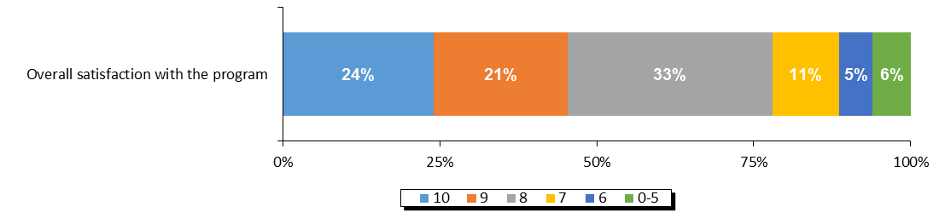

**Source:** *Overall satisfaction with the program.*

#### Overall Web Content Satisfaction

Libraries were asked to rate their level of satisfaction with the web content available to them on the librarians’ website. Taking into account the top three box, the levels of satisfaction with the web content in 2017 are at their highest point in at least five years. Nonetheless, the proportion of libraries rating their satisfaction as 10 out of 10 decreased slightly to 33%. Satisfaction is higher among RBQ libraries than ABPQ libraries.

**Figure 10. Satisfaction with Website and Web Content for Librarians**

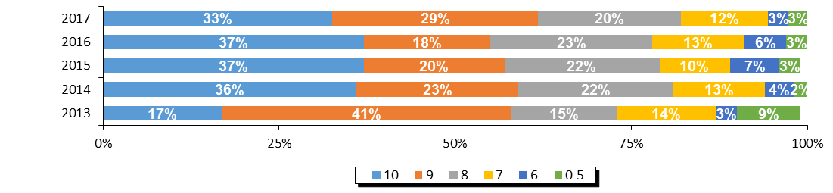

|  |  |  |  |  |  |
| --- | --- | --- | --- | --- | --- |
| **Region** | **Overall Satisfaction With Librarians' Website (Top 3 Box)** | | | | |
| **2017** | **2016** | **2015** | **2014** | **2013** |
| **Quebec** | **82%** | **78%** | **79%** | **81%** | **73%** |
| ABPQ | 80% | 78% | 83% | 78% | 62% |
| RBQ | 85% | 78% | 76% | 84% | 81% |

**Source:** *QD9.* *Website and Web Content For Librarians Satisfaction Questions.*

#### Website Navigation

The only element of the web content for librarians which was measured was the ease of navigating the website. The top three box level of satisfaction with the navigation of the website remained at the same level as in 2016 (79%). Satisfaction was higher among RBQ libraries (82%) than ABPQ libraries (76%). Top box score (10 out of 10) ratings are at a four year low.

**Figure 11. Ease of Navigating the Website for Librarians**

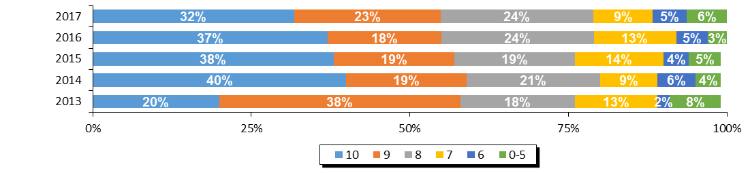

|  |  |  |  |  |  |
| --- | --- | --- | --- | --- | --- |
| **Region** | **Ease of Navigation (Top 3 Box)** | | | | |
| **2017** | **2016** | **2015** | **2014** | **2013** |
| **Quebec** | **79%** | **79%** | **76%** | **80%** | **76%** |
| ABPQ | 76% | 80% | 80% | 79% | 69% |
| RBQ | 82% | 77% | 72% | 82% | 81% |

**Source:** *QD9.* *Website and Web Content For Librarians Satisfaction Questions.*

#### Librarian Web Resources

The vast majority of libraries in Quebec ran their programs in French and the questions on the next two pages refer only to the French language versions of these materials.

Libraries were asked which of the resources that were available to them did they actually make use of. The *illustrations* were the most commonly used resource (86%), followed by the *titres recommandés* (74%), the *modèles et directives* (68%), and the *image de marque* (66%).

**Figure 12. Usage of Librarian Web Resources (French)**

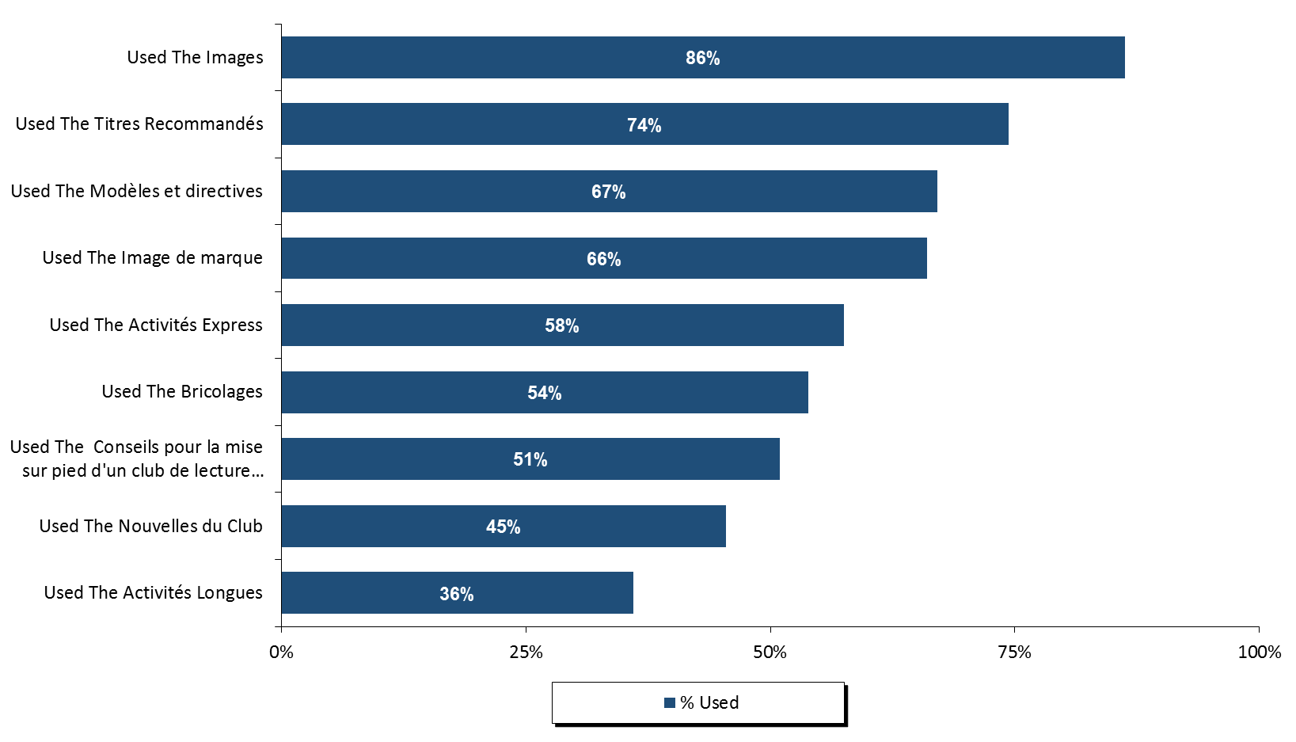

Those who reported using the web resources were then asked to rate their satisfaction with those resources. The scores for every resource were high when considering top three box scores only – they ranged from the *image de marque* to 67% for the *nouvelles du club*. Looking at the highest satisfaction score provides a slightly different view where the *illustrations* received the highest scores (49% of all French libraries).

**Figure 13. Satisfaction with the Librarian Web Resources (French)**

**(Ranked By Top Three Box Score)**

Top 3 Box %

87%

82%

79%

79%

79%

79%

73%

70%

67%

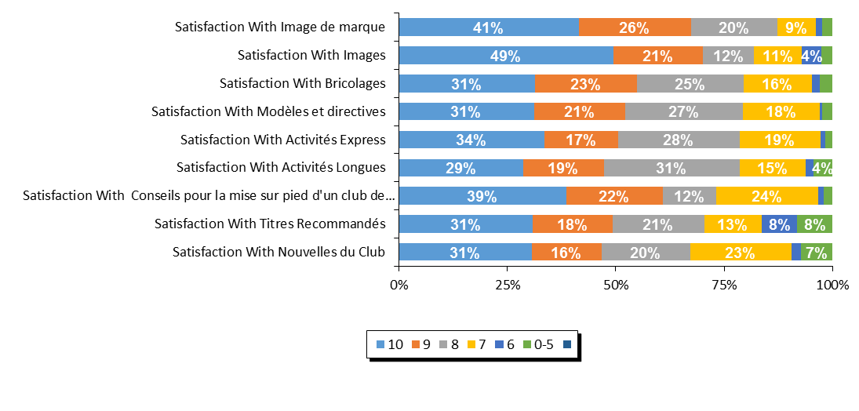

There were 4 libraries/systems in Quebec that ran their program as an English language program and reported statistics. These librarians were asked specifically about the English language resources.

All libraries reported using the images, the programs, and brand guidelines. The staff newsfeed was only used by one library.

**Figure 14. Usage of Librarian Web Resources (English)**

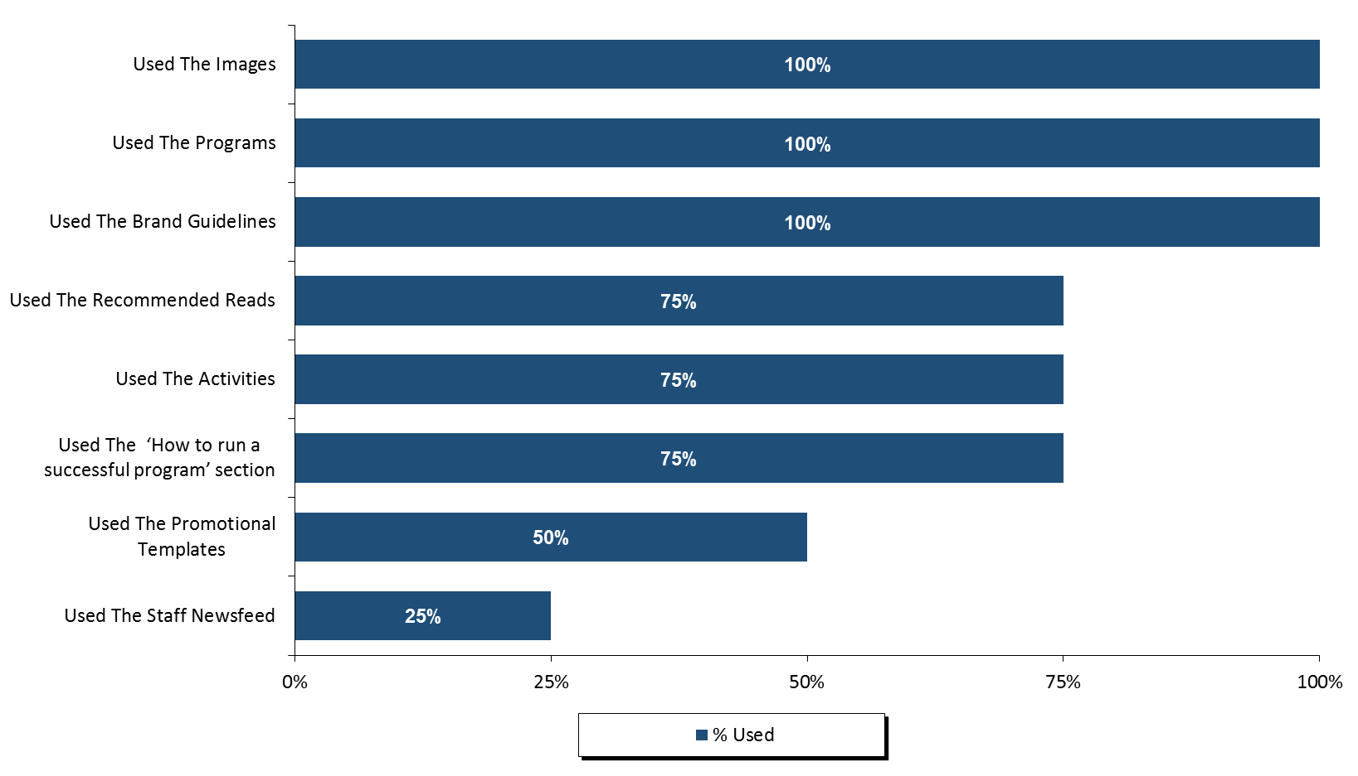

**Source:** *Q6.**Please identify which of the resources on the Librarians’ website you used and, for each resource that you did use, please give your level of satisfaction with it.*

Those who reported using the web resources were then asked to rate their satisfaction with those resources. Given the low number of libraries reporting, satisfaction ratings were varied. The three resources with highest satisfaction levels were the brand guidelines, the images, and the ‘how to run a successful program’ section.

**Figure 15. Satisfaction with the Librarian Web Resources**

**(Ranked By Top Three Box Score)**

Top 3 Box %

100%

100%

100%

100%

100%

67%

25%

0%

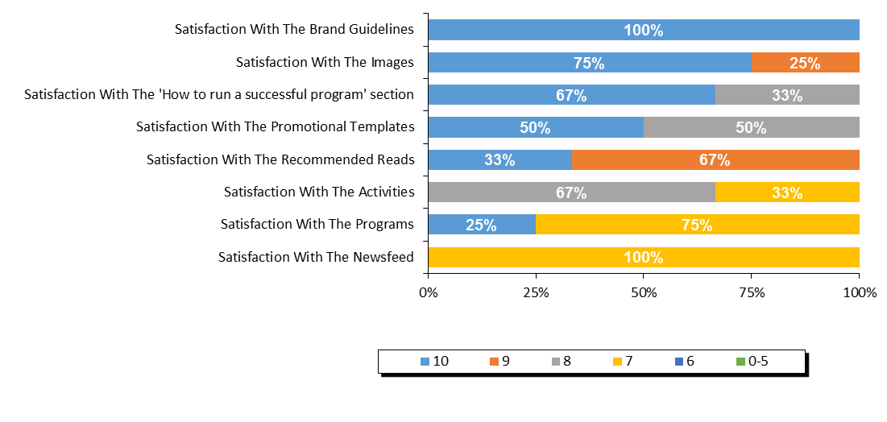

**Source:** *Q15.**Please identify which of the resources on the Librarians’ website you used and, for each resource that you did use, please give your level of satisfaction with it.*

Librarians were asked for suggestions on how to improve the librarians’ website for future years. Almost half of respondents said that they were satisfied or had nothing to suggest (46%). Those who did provide a suggestion were most likely to mention simpler/better navigation and search/print functions (17%) or to request that the materials be made available sooner (11%).

**Figure 16. Suggestions for Librarian Web Resources**

|  |  |
| --- | --- |
| **Suggestions on how to improve any of the web resources for library staff?** | **2017** |
| Satisfied/no suggestions | 46% |
| Simpler/more user friendly/better navigation/search/print functions | 17% |
| Make material available sooner | 11% |
| Age specific content/separate by age/school level | 9% |
| Better/more recent/broader booklists | 7% |
| Ability to share ideas/information between libraries/through social media/online forum | 4% |
| Information/activities available in English and French | 4% |
| More suggestions/ideas for programs/activities | 4% |
| Improve clip art/more visually appealing/more variety | 2% |
| Less restrictive/more flexible promotional templates/brand guidelines | 2% |
| Problems related to browser compatibility | 2% |
| Website did not scale properly to our screens | 2% |
| Other | 15% |

**Source:** *QD10.* *Do you have any suggestions on how to improve any of the web resources for library staff?*

#### Satisfaction with the Program Evaluation

Finally, libraries were asked to rate their level of satisfaction with the program evaluation and statistics process for 2017. When looking at the top three box scores, satisfaction inched up 2 points from 72% the past two years to 74% in 2017. However, there was a notable decrease in libraries rating their satisfaction with the program evaluation as a 10 out of 10 when compared to the previous year (29% in 2017 compared to 40% in 2016).

Among the elements of the program evaluation process, the score for ‘ease of using the system’ was higher than ‘the evaluation asks about relevant concerns.’

**Figure 17. Satisfaction with Program Evaluation and Statistics Process**

**Top 3 Box %**

**74%**

**72%**

**72%**

**75%**

**75%**

**40%**

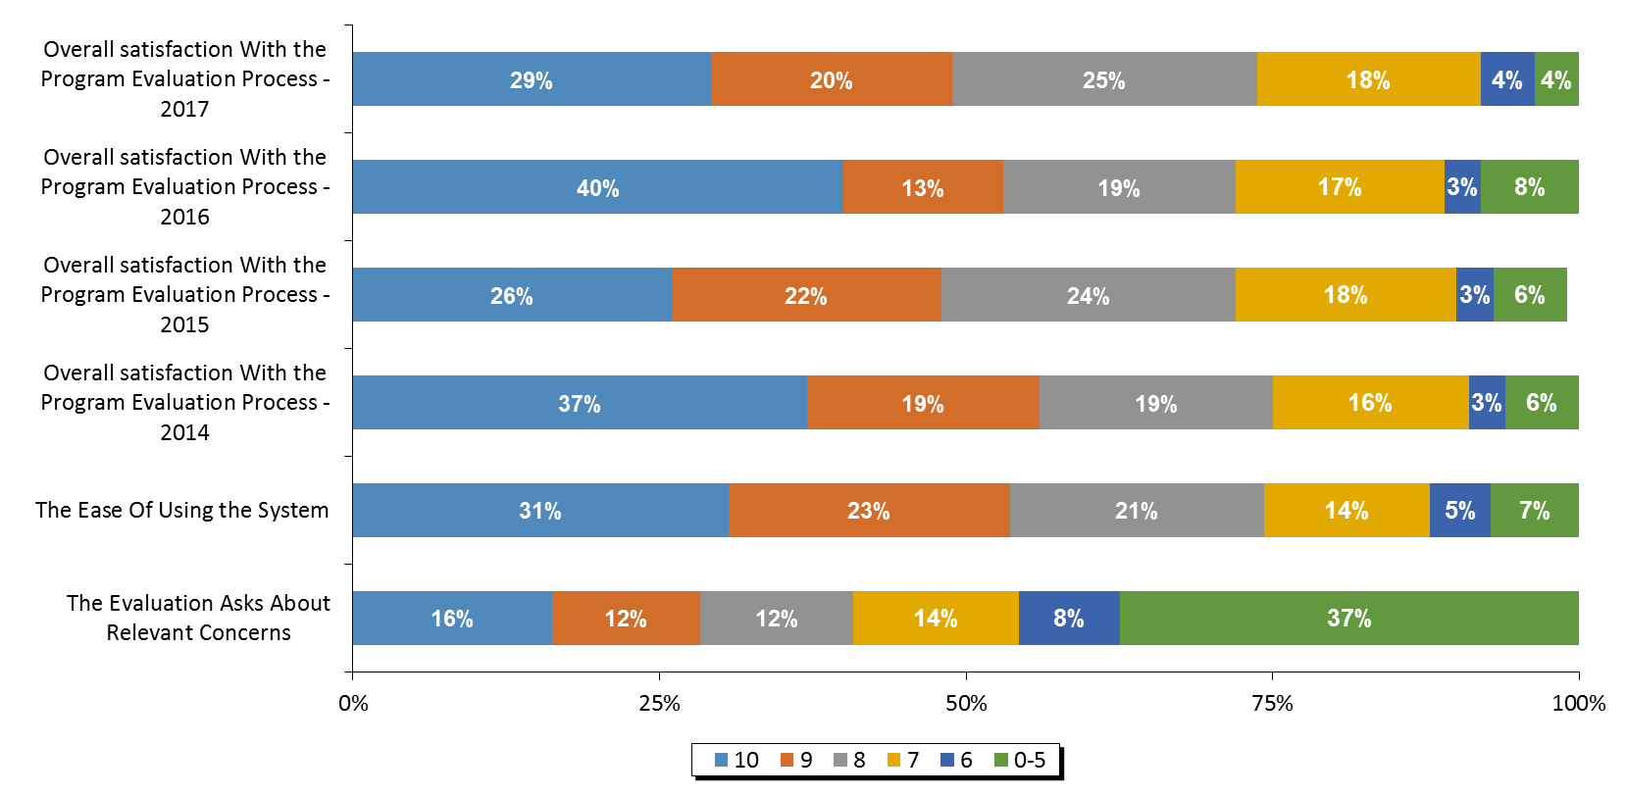

**Source:** *Q17.* *Program Evaluation and Statistics Process Questions.*

Librarians were asked for their suggestions on how the program evaluation and statistical collection process could be improved. The most common single response was that respondents were satisfied or had no suggestions to offer (53%). The most common theme of suggestions were related to making the questions/forms available sooner (19%).

**Figure 18. Suggestions for Improving the Program Evaluation and Statistics Process**

|  |  |
| --- | --- |
| **Suggestions on how to improve the statistical collection and program evaluation process?** | **2017** |
| Satisfied/no suggestions | 53% |
| Make questions/forms available sooner/let us know what to track | 19% |
| Standardized forms/Excel format to accommodate formulas | 6% |
| Include a comments section for each question to allow for explanation of data collected | 4% |
| Questions don't apply/we can't collect certain statistics | 4% |
| Clarify/better define information requested | 2% |
| Fewer questions/reduce survey length | 2% |
| Problems recording children who weren't officially registered | 2% |
| Other | 11% |

**Source:** *QD12. Do you have any suggestions for how to improve the statistical collection and program evaluation process?*

Finally, libraries were asked to indicate whether they had any indicators of children’s increased enjoyment of reading, reading successes or changes in attitudes toward reading. The most common response was that the program makes kids excited and keeps them reading over the summer (36%). Other popular responses were that children and parents enjoyed the activities and program overall.

**Figure 19. Testimonials Indicating an Increased Love of Reading**

|  |  |
| --- | --- |
| **Testimonials indicating increased love of reading?** | **2017** |
| Makes them excited/keeps them reading over the summer | 36% |
| Children/parents enjoyed the activities/crafts/website | 19% |
| Children enjoyed the program/enjoyed reading/were motivated to read more (unspecified) | 13% |
| Challenges/incentives were a motivating factor | 11% |
| Noticeable improvement in reading level | 11% |
| Brings more children to the library/they enjoy coming | 9% |
| Children enjoyed this year's theme | 6% |
| Children enjoy coming back each year | 4% |
| Children enjoyed story time/hearing stories recited | 4% |
| Higher program registration numbers | 4% |
| Children checking out more books from library | 2% |
| Children exploring more/new genres/topics | 2% |
| Children more willing to read at home/share with family | 2% |
| Improved confidence/communication skills | 2% |
| Increased interest/abilities in school | 2% |
| Other | 13% |

**Source:** *QD13.* *Do you have any testimonials from parents, caregivers or teachers that may indicate an increased love of reading?*

# 

# Appendix 4 – Manitoba

**MANITOBA PROGRAM STATISTICS**

### Response Rate

The participating libraries in Manitoba were asked to tally the results of participants in the summer reading club for all of their subsidiary branches. Within Manitoba, 79 of the 80 participating individual libraries submitted their results, representing an overall response rate of 99%.

Figure 1. Response Rate

|  |  |
| --- | --- |
|  | **Manitoba** |
| **(A) Total Participating Libraries** | 80 |
| **(B) Total Responded to Survey** | 79 |
| **(C) Survey Response Rate** | 99% |

**Source:** Row (A) provided by Library and Archives Canada. Rows (B) and (C)represent data collected by Nielsen.

## Statistics on Registration & Attendance

### TD Summer Reading Program Registration

The first section of the Statistics and Evaluation Form asked librarians to indicate the total number of children registered for the TDSRC 2017. This reflects the number of children who registered on the sign-up sheet, with the intent to read books as part of the TD Summer Reading Club. In Manitoba, an estimated 15,449 children registered for the TDSRC 2017 program, which is a decrease from 2016, but still higher than all the years before.

Figure 2. Total Registration 2009 – 2017

|  |  |  |  |  |  |  |  |  |  |
| --- | --- | --- | --- | --- | --- | --- | --- | --- | --- |
|  | **Total Registration** | | | | | | | | |
| **Region** | **2017** | **2016** | **2015** | **2014** | **2013** | **2012** | **2011** | **2010** | **2009** |
| Manitoba | 15,449 | 17,677 | 13,985 | 11,954 | 10,881 | 10,798 | 10,997 | 9,550 | 9,722 |

**Source:** *Q1 Total number of children who registered for the TDSRC 2017.*

The figure below shows the age breakdown of registered children. In 2017 the gender of registering children was not recorded. For the summer 2017, 32% of the registered children were in the 0-5 age group, 39% were 6-8, 27% were 9-12, and 2% were 13 years or older. The age make-up of registered children is largely similar from year to year and there is no discernable trend over time in terms of the age of children registered for the program.

**Figure 3. Percentage of Registered Children by Age 2009 – 2017**

|  |  |  |  |  |  |  |  |  |  |
| --- | --- | --- | --- | --- | --- | --- | --- | --- | --- |
| **Manitoba** | **2017** | **2016** | **2015** | **2014** | **2013** | **2012** | **2011** | **2010** | **2009** |
| **0-5** | 32% | 28% | 29% | 29% | 29% | 30% | 29% | 28% | 27% |
| **6-8** | 39% | 42% | 38% | 39% | 40% | 41% | 40% | 39% | 38% |
| **9-12** | 27% | 28% | 31% | 29% | 29% | 27% | 29% | 30% | 31% |
| **13+** | 2% | 2% | 2% | 2% | 2% | 2% | 2% | 2% | 7% |

**Source:** *Q1 Total number of children who registered for the TDSRC 2017.*

Figure 4 below summarizes the participation rate for Manitoba by age based on 2011 census data. The proportion of all children who were registered in 2017 was lower than 2016, but higher than 2015. The age group with the highest proportion of the total population taking part in the TD Summer Reading Club was 6-8 year olds, with just over 13% of all of the children in the province in this age group taking part in the program.

Figure 4. Number of Registered Children

|  |  |  |  |  |  |
| --- | --- | --- | --- | --- | --- |
|  | **2011 CENSUS** | **2017 TD SRC  REGISTRANTS** | **% PARTICIP.  CHILDREN** | **% PARTICIP.  CHILDREN** | **% PARTICIP.  CHILDREN** |
|  | **(A)** | **(B)** | **2017** | **2016** | **2015** |
| **Province / Territory** | **Total Children** | **Total Children** | **Total Children** | **Total Children** | **Total Children** |
| **Manitoba** | **283,235** | **15,449** | **5.45%** | **6.24%** | **4.94%** |
| 0-5 | 92,185 | 5,013 | 5.44% | 5.37% | 4.33% |
| 6-8 | 44,480 | 5,961 | 13.40% | 16.76% | 12.08% |
| 9-12 | 62,225 | 4,129 | 6.64% | 7.90% | 6.91% |
| 13+ | 84,345 | 346 | 0.41% | 0.42% | 0.33% |

**Source:** *Q1 Total number of children who registered for the TDSRC 2017, 2016, 2015. Column (A) provided by Statistics Canada Census 2011. Column (B)*

### TD Summer Reading Program Attendance & Activities

To help gauge the success of the TDSRC, libraries were asked to indicate the total number of programs and activities organized around this year’s club theme as well as the total attendance of children at these activities (not including parents or care givers).

When reviewing these numbers, several points need to be kept in mind:

* Every child who registered for the reading club with the library is considered to have attended an activity;
* It is possible that a child did not register for the TDSRC, but attended one or more of the activities; and
* Attendance was calculated on a per activity basis. It is possible that a child attended more than one activity, and thus is represented more than once in total attendance.

A total of 19,932 children attended the 699 theme-related activities which were organized in libraries across Manitoba over the summer months of 2017. Overall, an average of 29 children attended each activity in 2017, and 90% of all activities were conducted in libraries.

Figure 5. Total Activities and Attendance

|  |  |  |  |  |  |
| --- | --- | --- | --- | --- | --- |
|  | **Activity Attendance** | | | | |
| **Region** | **Theme-Related Activities** | **Total Attendance** | **Avg. Attendance per Activity** | **% of Activities In Library** | **% of Activities In Community** |
| Manitoba | 699 | 19,932 | 29 | 90% | 10% |

**Source:** *Q2. Total number of activities in your libraries and in your community. Attendance at activities in your libraries and in your community.*

The number of activities run by Manitoba libraries have decreased year over year since 2015. Total attendance was notably lower than 2016, and slightly higher than 2015.

Figure 6. Activities and Attendance 2015 – 2017

|  |  |  |  |  |  |  |
| --- | --- | --- | --- | --- | --- | --- |
|  | **2017** | | **2016** | | **2015** | |
| **Region** | **Theme-Related Activities** | **Total Attendance** | **Theme-Related Activities** | **Total Attendance** | **Theme-Related Activities** | **Total Attendance** |
| Manitoba | 699 | 19,932 | 910 | 26,849 | 1,056 | 16,939 |

**Source:** *Q2. How many of the children registered in your library had participated in the TD Summer Reading Club in previous years and how many were new to the program?*

## Promotion of Program

Librarians were asked to indicate if anyone from their library branch made any visits to the local schools, child care centres, day camps, or to any other locations in order to promote the program.

In Manitoba, 67% of libraries indicated that their library staff made promotional visits to schools, while 28% visited child care centres, 11% visited day camps, and 33% made other promotional visits. A total of 507 visits were made, reaching a total of 41,116 children (the vast majority of them at schools).

**Figure 7. Total Number of Visits and Children Reached by Segment**

|  |  |  |  |  |  |  |
| --- | --- | --- | --- | --- | --- | --- |
|  | **Made Visits 2017 (%)** | | | | | |
|  | **Schools** | | | **Day Camps** | | |
|  | **School Visits (% Yes)** | **Total Visits** | **Children Attended** | **Day Camp Visits (%)** | **Total Visits** | **Children Attended** |
| Manitoba | 67% | 344 | 36,469 | 11% | 48 | 1,162 |
|  | **Child Care Centres** | | | **Other Locations** | | |
|  | **Childcare Visits (%)** | **Total Visits** | **Children Attended** | **Other Visits (%)** | **Total Visits** | **Children Attended** |
| Manitoba | 28% | 31 | 974 | 33% | 84 | 2,511 |

**Source:** *Q3. Total number of activities in your libraries and in your community. Attendance at activities in your libraries and in your community.*

### Previous Participation

In Manitoba, 52% of all registered children said that they had participated in previous years and 48% were new registrants in 2017. The proportion of children saying they participated in previous years was the highest since 2015.

Figure 8. Previous Participation

|  |  |  |  |  |
| --- | --- | --- | --- | --- |
| **Region** | **Joined in previous years** | | **New Registrants** | |
| Manitoba | 8,036 | 52% | 7,412 | 48% |

|  |  |  |  |
| --- | --- | --- | --- |
| **% Joined in Previous Years** | | | |
| **Region** | **2017** | **2016** | **2015** |
| Manitoba | 52% | 37% | 45% |

**Source:** *Q4. How many of the children registered in your library had participated in the TD Summer Reading Club in previous years and how many were new to the program?*

## Satisfaction & Suggestions

The following section will provide satisfaction scores for every question asked by giving the proportion of libraries who responded with each score from 10 down to 6, along with those who gave a score of 0-5. The overall satisfaction question for each section is reported first and directly compared to previous waves of data (wherever applicable). It is followed by the individual element scores, ranked by the proportion giving a score of 10 (unless otherwise noted). Libraries were also asked for their suggestions and comments in each section.

Please note that libraries that did not provide information for any given question are not considered in the percentages reported here so that each graph will sum to 100%. In some cases, the sum of percentages reported may not add exactly to 100% due to rounding.

#### Overall Satisfaction with the Program

This question was added in 2017 to be able to obtain a measurement of the satisfaction with the program as a whole. Top 3 box overall satisfaction with the program in Manitoba is 78%, with just over 40% of libraries rating it a perfect 10.

#### **Figure 9. Overall Satisfaction with the Program**

**Top 3 Box %**

**78%**

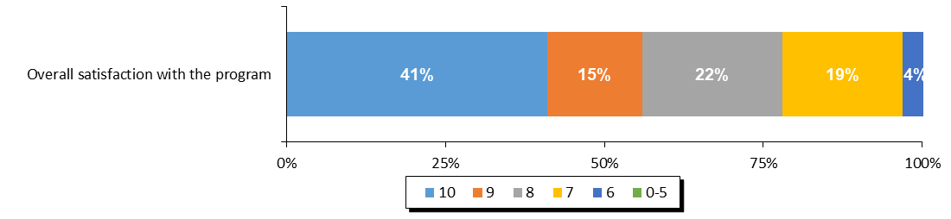

**Source:** *Overall satisfaction with the program.*

#### 

#### Overall Web Content Satisfaction

Libraries were asked to rate their level of satisfaction with the web content available to them on the librarians’ website. The levels of satisfaction in 2017 were the highest since 2013, with 75% rating their satisfaction as an 8 or higher, and almost 50% of libraries rating it 10 out of 10.

**Figure 10. Satisfaction with Website and Web Content for Librarians**

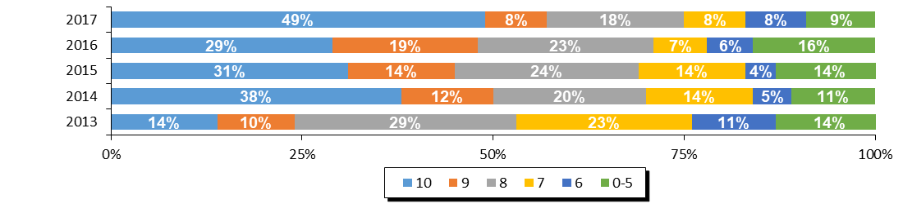

|  |  |  |  |  |  |
| --- | --- | --- | --- | --- | --- |
| **Region** | **Overall Satisfaction With Librarians' Website (Top 3 Box)** | | | | |
| **2017** | **2016** | **2015** | **2014** | **2013** |
| Manitoba | 75% | 71% | 69% | 70% | 53% |

**Source:** *Q5.* *Website and Web Content For Librarians Satisfaction Questions.*

#### Website Navigation

The only element of the web content for librarians which was measured was the ease of navigating the website. The level of satisfaction with the navigation of the website specifically was notably high compared to the previous two years, with a majority (58%) rating it a 10 out of 10.

**Figure 11. Ease of Navigating the Website for Librarians**

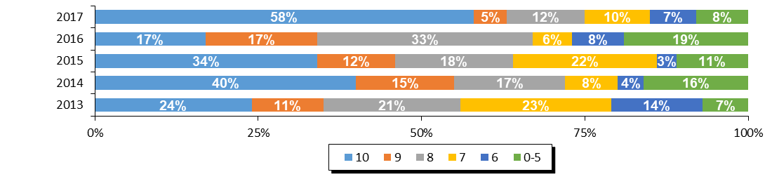

|  |  |  |  |  |  |
| --- | --- | --- | --- | --- | --- |
| **Region** | **Ease of Navigation (Top 3 Box)** | | | | |
| **2017** | **2016** | **2015** | **2014** | **2013** |
| Manitoba | 75% | 67% | 64% | 72% | 56% |

**Source:** *Q5.* *Website and Web Content For Librarians Satisfaction Questions.*

#### Librarian Web Resources

Librarians were asked specifically which of the resources that were available to them were actually used in running their TD Summer Reading Club in 2017. Usage of the resources was higher for the images, which were used by most (84%) of libraries, the activities (65%) and the recommended reads (61%). The staff newsfeed and the brand guidelines were the least used resources (27% and 26% respectively).

**Figure 12. Usage of Librarian Web Resources**

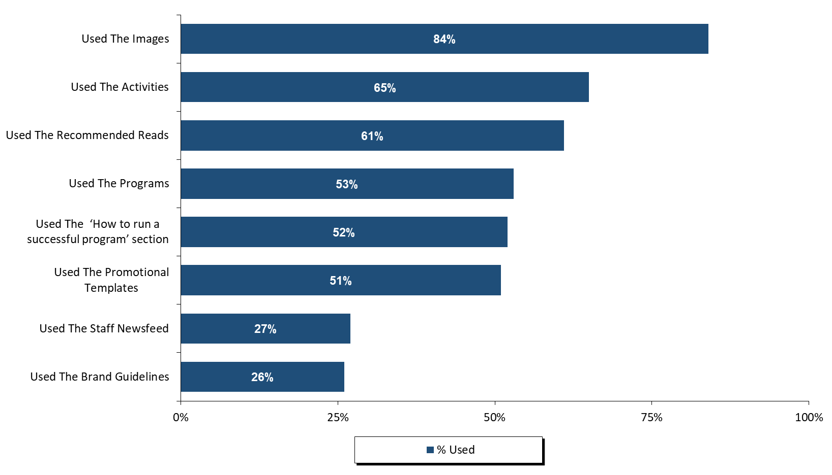

**Source:** *Q6.**Please identify which of the resources on the Librarians’ website you used and, for each resource that you did use, please give your level of satisfaction with it.*

Those who reported using the web resources were then asked to rate their satisfaction with those resources. The brand guidelines were the least used resource, but generated the highest satisfaction (88%) when considering ratings 8 or above. Satisfaction with the images was also very high (87%) with more than half rating their satisfaction a perfect 10.

**Figure 13. Satisfaction with the Librarian Web Resources**

**(Ranked By Top Three Box Score)**

**Top 3 Box %**

**88%**

**87%**

**74%**

**71%**

**68%**

**66%**

**56%**

**44%**

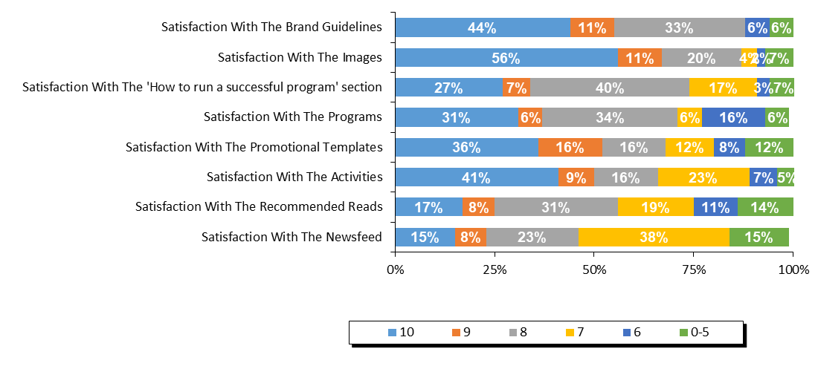

**Source:** *Q6A.**Please identify which of the resources on the Librarians’ website you used and, for each resource that you did use, please give your level of satisfaction with it.*

Librarians were asked for suggestions on how to improve the librarians’ website for future years. Among the few that offered suggestions, one-third included comments related to improving the clip art variety and look.

**Figure 14. Suggestions for Librarian Web Resources**

|  |  |
| --- | --- |
| **Suggestions on how to improve any of the web resources for library staff?** | **2017** |
| Satisfied/no suggestions | *33%* |
| Improve clip art/more visually appealing/more variety | 33% |
| Other | 33% |

**Source:** *QD10.* *Do you have any suggestions on how to improve any of the web resources for library staff?*

#### Satisfaction with the Program Evaluation

Finally, libraries were asked to rate their level of satisfaction with the program evaluation and statistics process for 2017. When looking at the top three box scores, satisfaction is fairly consistent with 2016 (70% vs. 73%).

Among the elements of the program evaluation process, the score for ‘ease of using the system’ was lower than ‘the evaluation asks about relevant concerns.’

**Figure 15. Satisfaction with Program Evaluation and Statistics Process**

**Top 3 Box %**

**70%**

**73%**

**55%**

**46%**

**38%**

**58%**

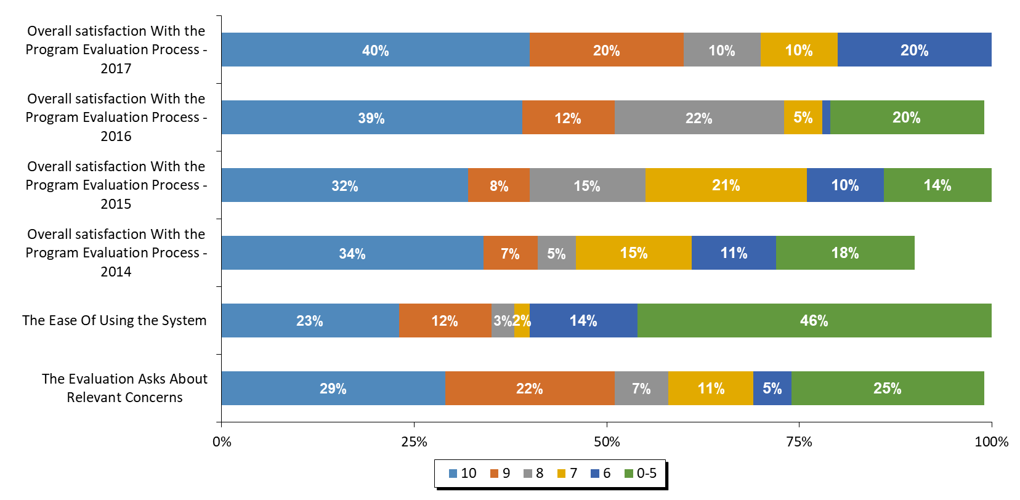

**Source:** *Q7.* *Program Evaluation and Statistics Process Questions.*

Librarians were asked for their suggestions on how the program evaluation and statistical collection process could be improved. A majority of respondents responded that they were satisfied or had no suggestions to offer (75%).

**Figure 16. Suggestions for Improving the Program Evaluation and Statistics Process**

|  |  |
| --- | --- |
| **Suggestions on how to improve the statistical collection and program evaluation process?** | **2017** |
| Satisfied/no suggestions | *75%* |
| Other | 25% |

**Source:** *QD11. Do you have any suggestions for how to improve the statistical collection and program evaluation process?*

Finally, libraries were asked to indicate whether they had any indicators of children’s increased enjoyment of reading, reading successes or changes in attitudes toward reading. The most common response was that the program brings more children to the library, that the challenges and incentives were a motivating factor, and that children enjoy coming back each year.

**Figure 17. Testimonials Indicating an Increased Love of Reading**

|  |  |
| --- | --- |
| **Testimonials indicating increased love of reading?** | **2017** |
| Brings more children to the library/they enjoy coming | 25% |
| Challenges/incentives were a motivating factor | 25% |
| Children enjoy coming back each year | 25% |
| Children enjoyed the program/enjoyed reading/were motivated to read more (unspecified) | 13% |
| Children more willing to read at home/share with family | 13% |
| Increased interest/abilities in school | 13% |
| Noticeable improvement in reading level | 13% |
| Children checking out more books from library | 13% |
| Other | 25% |

**Source:** *QD12. Do you have any testimonials from parents, caregivers or teachers that may indicate an increased love of reading?*

# 

# Appendix 5 – Saskatchewan

**SASKATCHEWAN PROGRAM STATISTICS**

### Response Rate

The participating libraries in Saskatchewan were asked to tally the results of participants in the summer reading club for all of their subsidiary branches. Within Saskatchewan, 265 of the 308 participating individual libraries submitted their results, representing an overall response rate of 86%.

Figure 1. Response Rate

|  |  |
| --- | --- |
|  | **Saskatchewan** |
| **(A) Total Participating Libraries** | 308 |
| **(B) Total Responded to Survey** | 265 |
| **(C) Survey Response Rate** | **86%** |

**Source:** Row (A) provided by Library and Archives Canada. Rows (B) and (C)represent data collected by Nielsen.

## Statistics on Registration & Attendance

### TD Summer Reading Program Registration

The first section of the Statistics and Evaluation Form asked librarians to indicate the total number of children registered for the TDSRC 2017. This reflects the number of children who registered on the sign-up sheet, with the intent to read books as part of the TD Summer Reading Club. In Saskatchewan, an estimated 24,744 children registered for the TDSRC 2017 program, which is an increase of almost 3,000 from 2016. Registration numbers are the highest since 2012.

Figure 2. Total Registration 2009 – 2017

|  |  |  |  |  |  |  |  |  |  |
| --- | --- | --- | --- | --- | --- | --- | --- | --- | --- |
|  | **Total Registration** | | | | | | | | |
| **Region** | **2017** | **2016** | **2015** | **2014** | **2013** | **2012** | **2011** | **2010** | **2009** |
| Saskatchewan | 24,744 | 21,943 | 21,968 | 20,424 | 21,460 | 26,434 | 20,527 | 15,098 | 17,547 |

**Source:** *Q1 Total number of children who registered for the TDSRC 2017.*

The figure below shows the age breakdown of registered children. For the summer 2017, 29% of the registered children were in the 0-5 age group, 40% were 6-8, 29% were 9-12, and 2% were 13 years or older. The age make-up of registered children is similar from year to year and there is no clear trend in Saskatchewan over time in terms of the age of children registered for the program.

**Figure 3. Percentage of Registered Children by Age 2009 – 2017**

|  |  |  |  |  |  |  |  |  |  |
| --- | --- | --- | --- | --- | --- | --- | --- | --- | --- |
| **Saskatchewan** | **2017** | **2016** | **2015** | **2014** | **2013** | **2012** | **2011** | **2010** | **2009** |
| **0-5** | 29% | 30% | 31% | 30% | 29% | 28% | 28% | 26% | 25% |
| **6-8** | 40% | 41% | 39% | 38% | 39% | 41% | 40% | 41% | 38% |
| **9-12** | 29% | 28% | 28% | 30% | 30% | 30% | 30% | 31% | 34% |
| **13+** | 2% | 2% | 2% | 2% | 3% | 1% | 2% | 2% | 3% |

**Source:** *Q1 Total number of children who registered for the TDSRC 2017.*

Figure 4 below summarizes the participation rate for Saskatchewan by age based on 2011 census data. The proportion of all children who were registered in 2017 was similar to previous years and moved where the age group with the highest proportion of the total population taking part in the TD Summer Reading Club was 6-8 year olds, with more than 26% of all of the children in the province in this age group taking part in the program.

Figure 4. Number of Registered Children

|  |  |  |  |  |  |
| --- | --- | --- | --- | --- | --- |
|  | **2011 CENSUS** | **2017 TD SRC  REGISTRANTS** | **% PARTICIP.  CHILDREN** | **% PARTICIP.  CHILDREN** | **% PARTICIP.  CHILDREN** |
|  | **(A)** | **(B)** | **2017** | **2016** | **2015** |
| **Province / Territory** | **Total Children** | **Total Children** | **Total Children** | **Total Children** | **Total Children** |
| **Saskatchewan** | **240,645** | **24,744** | **10.28%** | **9.12%** | **9.13%** |
| 0-5 | 81,605 | 7,063 | 8.66% | 7.95% | 8.43% |
| 6-8 | 37,925 | 9,904 | 26.11% | 23.79% | 22.61% |
| 9-12 | 51,470 | 7,206 | 14.00% | 11.75% | 11.86% |
| 13+ | 69,645 | 571 | 0.82% | 0.55% | 0.58% |

**Source:** *Q1 Total number of children who registered for the TDSRC 2017, 2016, 2015. Column (A) provided by Statistics Canada Census 2011. Column (B)*

### TD Summer Reading Program Attendance & Activities

To help gauge the success of the TDSRC, libraries were asked to indicate the total number of programs and activities organized around this year’s club theme as well as the total attendance of children at these activities (not including parents or care givers).

When reviewing these numbers, several points need to be kept in mind:

* Every child who registered for the reading club with the library is considered to have attended an activity;
* It is possible that a child did not register for the TDSRC, but attended one or more of the activities; and
* Attendance was calculated on a per activity basis. It is possible that a child attended more than one activity, and thus is represented more than once in total attendance.

A total of 48,672 children attended the 2,885 theme-related activities which were organized in libraries across Saskatchewan over the summer months of 2017. Overall, an average of 17 children attended each activity in 2017, and 91% of all activities were conducted in libraries.

Figure 5. Total Activities and Attendance

|  |  |  |  |  |  |
| --- | --- | --- | --- | --- | --- |
|  | **Activity Attendance** | | | | |
| **Region** | **Theme-Related Activities** | **Total Attendance** | **Avg. Attendance per Activity** | **% of Activities In Library** | **% of Activities In Community** |
| Saskatchewan | 2,885 | 48,672 | 17 | 91% | 9% |

**Source:** *Q2. Total number of activities in your libraries and in your community. Attendance at activities in your libraries and in your community.*

Both the number of activities run by Saskatchewan libraries as well as the attendance at the activities has increased over the past three years.

Figure 6. Activities and Attendance 2015 – 2017

|  |  |  |  |  |  |  |
| --- | --- | --- | --- | --- | --- | --- |
|  | **2017** | | **2016** | | **2015** | |
| **Region** | **Theme-Related Activities** | **Total Attendance** | **Theme-Related Activities** | **Total Attendance** | **Theme-Related Activities** | **Total Attendance** |
| Saskatchewan | 2,885 | 48,672 | 2,510 | 45,209 | 2,454 | 44,791 |

**Source:** *Q2. How many of the children registered in your library had participated in the TD Summer Reading Club in previous years and how many were new to the program?*

## Promotion of Program

Librarians were asked to indicate if anyone from their library branch made any visits to the local schools, child care centres, day camps, or to any other locations in order to promote the program.

In Saskatchewan, 58% of libraries indicated that their library staff made promotional visits to schools, while 25% visited child care centres, 7% visited day camps, and 20% made other promotional visits. A total of 807 visits were made, reaching a total of 31,792 children (the majority of them at schools).

**Figure 7. Total Number of Visits and Children Reached by Segment**

|  |  |  |  |  |  |  |
| --- | --- | --- | --- | --- | --- | --- |
|  | **Made Visits 2017 (%)** | | | | | |
|  | **Schools** | | | **Day Camps** | | |
|  | **School Visits (% Yes)** | **Total Visits** | **Children Attended** | **Day Camp Visits (%)** | **Total Visits** | **Children Attended** |
| Saskatchewan | 58% | 400 | 26,375 | 7% | 38 | 989 |
|  | **Child Care Centres** | | | **Other Locations** | | |
|  | **Childcare Visits (%)** | **Total Visits** | **Children Attended** | **Other Visits (%)** | **Total Visits** | **Children Attended** |
| Saskatchewan | 25% | 146 | 1,757 | 20% | 223 | 2,671 |

**Source:** *Q3. Total number of activities in your libraries and in your community. Attendance at activities in your libraries and in your community.*

### Previous Participation

In Saskatchewan, 45% of all registered children said that they had participated in previous years and 55% were new registrants in 2017. The proportion of children saying they participated in previous years was higher compared to 2016 and 2015.

Figure 8. Previous Participation

|  |  |  |  |  |
| --- | --- | --- | --- | --- |
| **Region** | **Joined in previous years** | | **New Registrants** | |
| Saskatchewan | 11,082 | 45% | 13,661 | 55% |

|  |  |  |  |
| --- | --- | --- | --- |
| **% Joined in Previous Years** | | | |
| **Region** | **2017** | **2016** | **2015** |
| Saskatchewan | 45% | 34% | 34% |

**Source:** *Q4. How many of the children registered in your library had participated in the TD Summer Reading Club in previous years and how many were new to the program?*

## Satisfaction & Suggestions

The following section will provide satisfaction scores for every question asked by giving the proportion of libraries who responded with each score from 10 down to 6, along with those who gave a score of 0-5. The overall satisfaction question for each section is reported first and directly compared to previous waves of data (wherever applicable). It is followed by the individual element scores, ranked by the proportion giving a score of 10 (unless otherwise noted). Libraries were also asked for their suggestions and comments in each section.

Please note that libraries that did not provide information for any given question are not considered in the percentages reported here so that each graph will sum to 100%. In some cases, the sum of percentages reported may not add exactly to 100% due to rounding.

#### Overall Satisfaction with the Program

This question was added in 2017 to be able to obtain a measurement of the satisfaction with the program as a whole. Top 3 box overall satisfaction with the program in Saskatchewan is 67%, with 24% of libraries rating it a perfect 10.

#### **Figure 9. Overall Satisfaction with the Program**

**Top 3 Box %**

**67%**

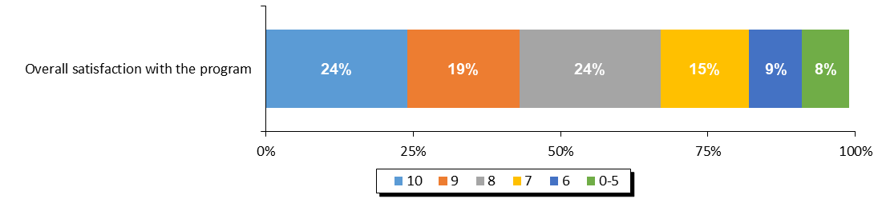

**Source:** *Overall satisfaction with the program.*

#### Overall Web Content Satisfaction

Libraries were asked to rate their level of satisfaction with the web content available to them on the librarians’ website. The levels of satisfaction in 2017 are similar to 2016 (66% vs. 67% for the top 3 box). Both years are higher than the previous three years, and in both cases 36% rate their satisfaction as 10.

**Figure 10. Satisfaction with Website and Web Content for Librarians**

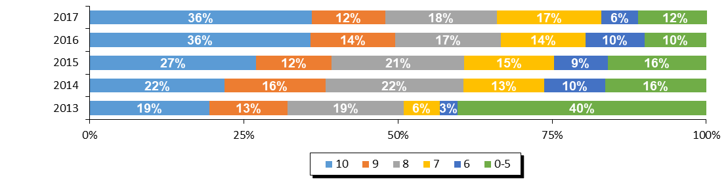

|  |  |  |  |  |  |
| --- | --- | --- | --- | --- | --- |
| **Region** | **Overall Satisfaction With Librarians' Website (Top 3 Box)** | | | | |
| **2017** | **2016** | **2015** | **2014** | **2013** |
| Saskatchewan | 66% | 67% | 60% | 60% | 51% |

**Source:** *Q5.* *Website and Web Content For Librarians Satisfaction Questions.*

#### Website Navigation

The only element of the web content for librarians which was measured was the ease of navigating the website. The level of satisfaction with the navigation of the website specifically was also on very similar to 2016 (70% vs. 71% for the top 3 box). Moreover, the percentage of top box ratings for the past two years is the same (37%).

**Figure 11. Ease of Navigating the Website for Librarians**

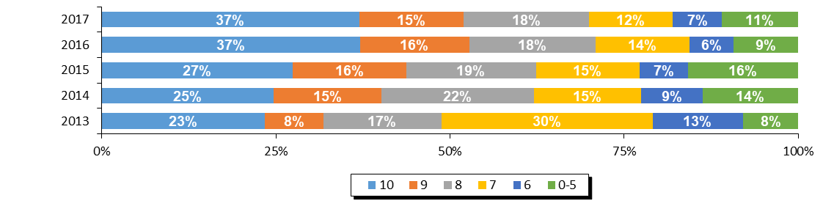

|  |  |  |  |  |  |
| --- | --- | --- | --- | --- | --- |
| **Region** | **Ease of Navigation (Top 3 Box)** | | | | |
| **2017** | **2016** | **2015** | **2014** | **2013** |
| Saskatchewan | 70% | 61% | 62% | 62% | 48% |

**Source:** *Q5.* *Website and Web Content For Librarians Satisfaction Questions.*

#### Librarian Web Resources

Librarians were asked specifically which of the resources that were available to them were actually used in running their TD Summer Reading Club in 2017. The three resources most used were the recommended reads (62%), the images (61%), and the activities (60%). The staff newsfeed was reported as the least used (40%).

**Figure 12. Usage of Librarian Web Resources**

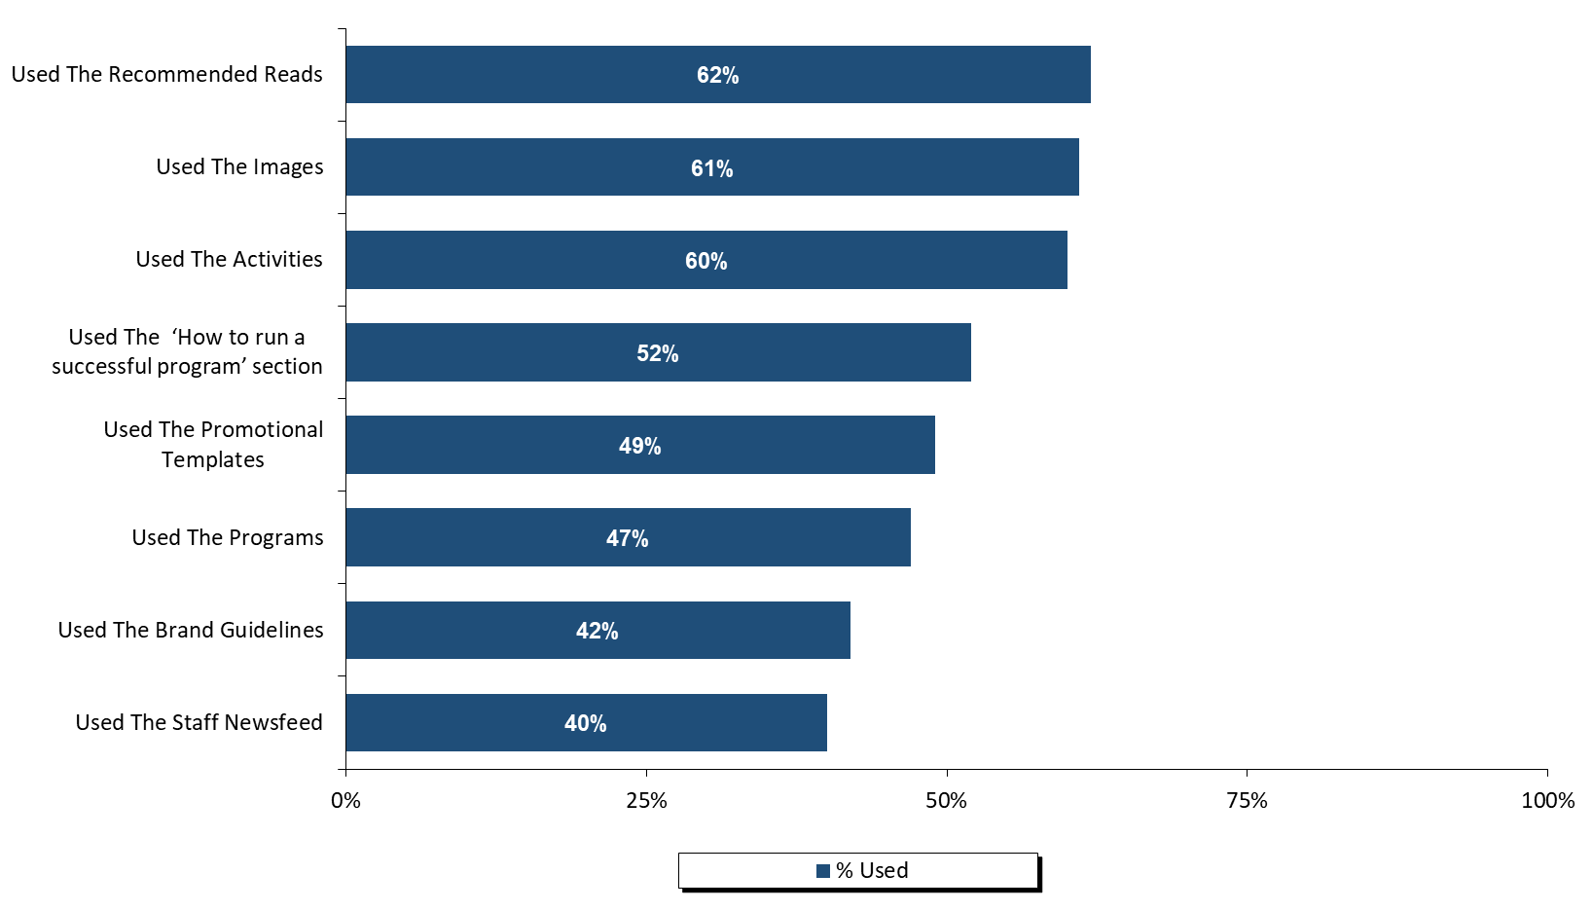

**Source:** *Q6.**Please identify which of the resources on the Librarians’ website you used and, for each resource that you did use, please give your level of satisfaction with it.*

Those who reported using the web resources were then asked to rate their satisfaction with those resources. Although satisfaction with the promotional templates (53%) and brand guidelines (52%) obtained the highest proportion of top scores (10 out of 10), top three box satisfaction was highest with the images (79%) and recommended reads (78%).

**Figure 13. Satisfaction with the Librarian Web Resources**

**Top 3 Box %**

**79%**

**78%**

**77%**

**72%**

**72%**

**72%**

**71%**

**70%**

**(Ranked By Top Three Box Score)**

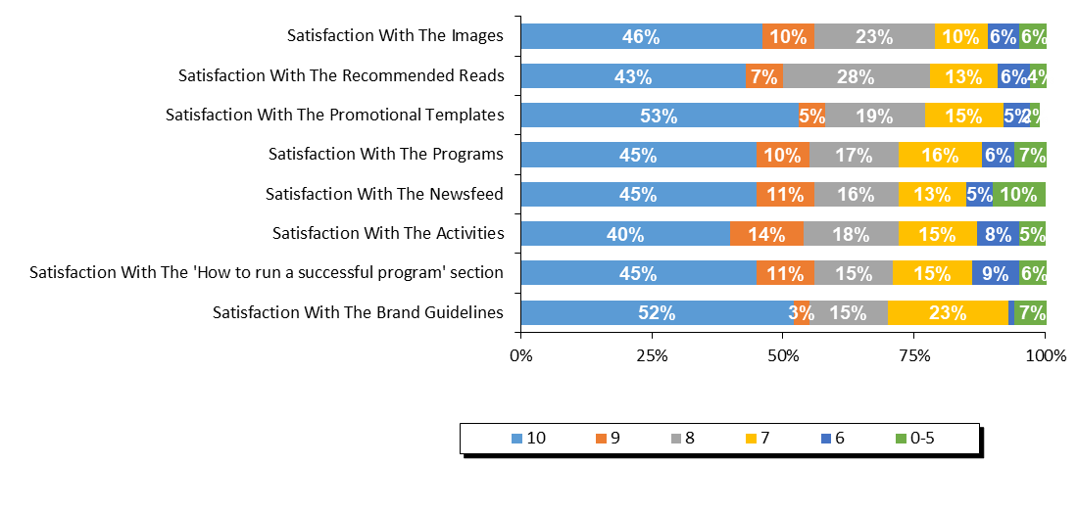

**Source:** *Q6A.**Please identify which of the resources on the Librarians’ website you used and, for each resource that you did use, please give your level of satisfaction with it.*

Librarians were asked for suggestions on how to improve the librarians’ website for future years. Almost two thirds of respondents (63%) were satisfied or had no suggestions. The most common suggestions were related to having simpler, more user friendly, navigation/search/print functions (15%).

**Figure 14. Suggestions for Librarian Web Resources**

|  |  |
| --- | --- |
| **Suggestions on how to improve any of the web resources for library staff?** | **2017** |
| Satisfied/no suggestions | *63%* |
| Simpler/more user friendly/better navigation/search/print functions | 15% |
| Age specific content/separate by age/school level | *4%* |
| Better/more recent/broader booklists | 4% |
| Improve clip art/more visually appealing/more variety | *4%* |
| Lack of relevance/relation to theme/reading programs | 4% |
| Make material available sooner | *4%* |
| Other | 7% |

**Source:** *QD10.* *Do you have any suggestions on how to improve any of the web resources for library staff?*

#### Satisfaction With The Program Evaluation

Finally, libraries were asked to rate their level of satisfaction with the program evaluation and statistics process for 2017. When looking at the top three box scores, satisfaction decreased from 72% in 2016 to 62% in 2017.

Among the elements of the program evaluation process, the score for ‘ease of using the system’ is notably higher than ‘the evaluation asks about relevant concerns.’

**Figure 15. Satisfaction with Program Evaluation and Statistics Process**

**Top 3 Box %**

**62%**

**72%**

**58%**

**48%**

**65%**

**38%**

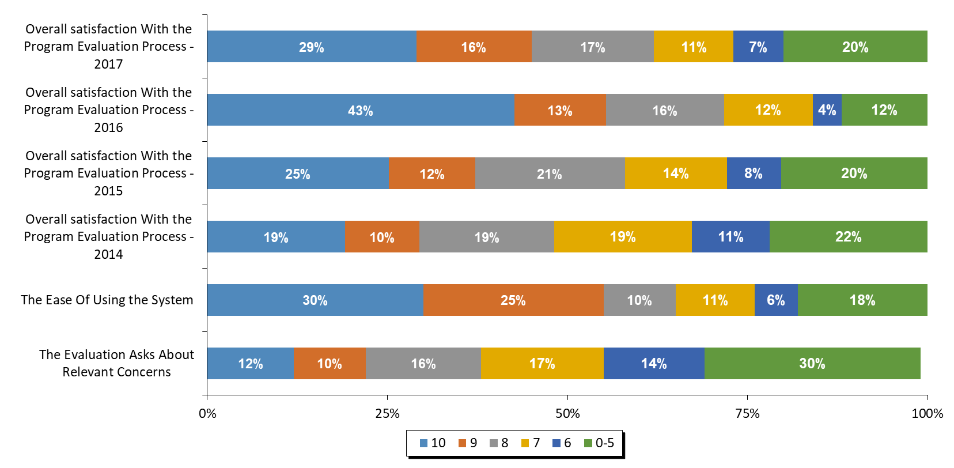

**Source:** *Q7.* *Program Evaluation and Statistics Process Questions.*

Librarians were asked for their suggestions on how the program evaluation and statistical collection process could be improved. By far the most common single response was to say that they were satisfied or had no suggestions to offer (70%). The most common suggestions were related to making the questions or forms available sooner (13%).

**Figure 16. Suggestions for Improving the Program Evaluation and Statistics Process**

|  |  |
| --- | --- |
| **Suggestions on how to improve the statistical collection and program evaluation process?** | **2017** |
| Satisfied/no suggestions | *70%* |
| Make questions/forms available sooner/let us know what to track | 13% |
| Include a comments section for each question to allow for explanation of data collected | *4%* |
| Fewer questions/reduce survey length | 4% |
| Make survey available online | *4%* |
| Offer a printable version | 4% |
| Questions don't apply/we can't collect certain statistics | *4%* |
| Clarify/better define information requested | 4% |
| Other | *26%* |

**Source:** *QD11. Do you have any suggestions for how to improve the statistical collection and program evaluation process?*

Finally, libraries were asked to indicate whether they had any indicators of children’s increased enjoyment of reading, reading successes or changes in attitudes toward reading. The most common response were that the children and parents enjoyed the activities, crafts, and websites (26%), as well as pointing out that the program makes children excited and keeps them reading over the summer (26%).

**Figure 17. Testimonials Indicating an Increased Love of Reading**

|  |  |
| --- | --- |
| **Testimonials indicating increased love of reading?** | **2017** |
| Children/parents enjoyed the activities/crafts/website | 26% |
| Makes them excited/keeps them reading over the summer | 26% |
| Brings more children to the library/they enjoy coming | 16% |
| Children checking out more books from library | 16% |
| Children enjoyed the program/enjoyed reading/were motivated to read more (unspecified) | 16% |
| Challenges/incentives were a motivating factor | 11% |
| Children exceeding goals of club/reading extra | 11% |
| Noticeable improvement in reading level | 11% |
| Children enjoyed story time/hearing stories recited | 5% |
| Higher program registration numbers | 5% |
| Children love adding stickers to their passports | 5% |
| Children enjoyed this year's theme | 5% |
| Children exploring more/new genres/topics | 5% |
| Children learned new words/information | 5% |
| Other | 37% |

**Source:** *QD12. Do you have any testimonials from parents, caregivers or teachers that may indicate an increased love of reading?*

# 

# Appendix 6 – Alberta

**ALBERTA PROGRAM STATISTICS**

### Response Rate

The participating libraries in Alberta were asked to tally the results of participants in the summer reading club for all of their subsidiary branches. Within Alberta, 240 of the 291 participating individual libraries submitted their results, representing an overall response rate of 82%.

Figure 1. Response Rate

|  |  |
| --- | --- |
|  | **Alberta** |
| **(A) Total Participating Libraries** | 291 |
| **(B) Total Responded to Survey** | 240 |
| **(C) Survey Response Rate** | **82%** |

**Source:** Row (A) provided by Library and Archives Canada. Rows (B) and (C)represent data collected by Nielsen.

## Statistics on Registration & Attendance

### TD Summer Reading Program Registration

The first section of the Statistics and Evaluation Form asked librarians to indicate the total number of children registered for the TDSRC 2017. This reflects the number of children who registered on the sign-up sheet, with the intent to read books as part of the TD Summer Reading Club. In Alberta, an estimated 63,814 children registered for the TDSRC 2017 program, which is a sizeable increase over 2016 and is the highest total ever reported for Alberta.

Figure 2. Total Registration 2009 – 2017

|  |  |  |  |  |  |  |  |  |  |
| --- | --- | --- | --- | --- | --- | --- | --- | --- | --- |
|  | **Total Registration** | | | | | | | | |
| **Region** | **2017** | **2016** | **2015** | **2014** | **2013** | **2012** | **2011** | **2010** | **2009** |
| Alberta | 63,814 | 55,717 | 48,661 | 51,138 | 53,857 | 54,869 | 49,683 | 36,637 | 36,793 |

**Source:** *Q1 Total number of children who registered for the TDSRC 2017.*

The figure below shows the age breakdown of registered children. For the summer of 2017, 26% of the registered children were in the 0-5 age group, 39% were 6-8, 32% were 9-12, and 4% were 13 years or older. Although proportions among age groups remain fairly the same, participation of 13+ minors doubled compared to 2016.

**Figure 3. Percentage of Registered Children by Age 2009 – 2017**

|  |  |  |  |  |  |  |  |  |  |
| --- | --- | --- | --- | --- | --- | --- | --- | --- | --- |
| **Alberta** | **2017** | **2016** | **2015** | **2014** | **2013** | **2012** | **2011** | **2010** | **2009** |
| **0-5** | 26% | 29% | 27% | 27% | 31% | 29% | 28% | 28% | 24% |
| **6-8** | 39% | 39% | 39% | 38% | 38% | 38% | 39% | 39% | 38% |
| **9-12** | 32% | 29% | 31% | 32% | 29% | 31% | 31% | 32% | 32% |
| **13+** | 4% | 2% | 4% | 2% | 2% | 2% | 3% | 5% | 5% |

**Source:** *Q1 Total number of children who registered for the TDSRC 2017.*

Figure 4 below summarizes the participation rate for Alberta by age based on 2011 census data. The proportion of all children who were registered in 2017 was higher than in previous years and increased from 6.74% to 7.72% in the most recent wave. The age group with the highest proportion of the total population taking part in the TD Summer Reading Club was 6-8 year olds, with more than 18% of all of the children in the province in this age group taking part in the program.

Figure 4. Number of Registered Children

|  |  |  |  |  |  |
| --- | --- | --- | --- | --- | --- |
|  | **2011 CENSUS** | **2017 TD SRC  REGISTRANTS** | **% PARTICIP.  CHILDREN** | **% PARTICIP.  CHILDREN** | **% PARTICIP.  CHILDREN** |
|  | **(A)** | **(B)** | **2017** | **2016** | **2015** |
| **Province / Territory** | **Total Children** | **Total Children** | **Total Children** | **Total Children** | **Total Children** |
| **Alberta** | **826,285** | **63,814** | **7.72%** | **6.74%** | **5.89%** |
| 0-5 | 290,125 | 16,370 | 5.64% | 5.66% | 4.45% |
| 6-8 | 131,415 | 24,576 | 18.70% | 16.53% | 14.31% |
| 9-12 | 173,625 | 20,580 | 11.85% | 9.39% | 8.62% |
| 13+ | 231,120 | 2,288 | 0.99% | 0.56% | 0.86% |

**Source:** *Q1 Total number of children who registered for the TDSRC 2017, 2016, 2015. Column (A) provided by Statistics Canada Census 2011. Column (B)*

### TD Summer Reading Program Attendance & Activities

To help gauge the success of the TDSRC, libraries were asked to indicate the total number of programs and activities organized around this year’s club theme as well as the total attendance of children at these activities (not including parents or care givers).

When reviewing these numbers, several points need to be kept in mind:

* Every child who registered for the reading club with the library is considered to have attended an activity;
* It is possible that a child did not register for the TDSRC, but attended one or more of the activities; and
* Attendance was calculated on a per activity basis. It is possible that a child attended more than one activity, and thus is represented more than once in total attendance.

A total of 112,670 children attended the 6,093 theme-related activities which were organized in libraries across Alberta over the summer months of 2017. Overall, an average of 18 children attended each activity in 2017, and 75% of all activities were conducted in libraries.

Figure 5. Total Activities and Attendance

|  |  |  |  |  |  |
| --- | --- | --- | --- | --- | --- |
|  | **Activity Attendance** | | | | |
| **Region** | **Theme-Related Activities** | **Total Attendance** | **Avg. Attendance per Activity** | **% of Activities In Library** | **% of Activities In Community** |
| Alberta | 6,093 | 112,670 | 18 | 75% | 25% |

**Source:** *Q2. Total number of activities in your libraries and in your community. Attendance at activities in your libraries and in your community.*

The number of activities run by Alberta libraries was lower than 2016, but attendance increased slightly. 2017 had the highest level of attendance in Alberta since 2012.

Figure 6. Activities and Attendance 2014 – 2016

|  |  |  |  |  |  |  |
| --- | --- | --- | --- | --- | --- | --- |
|  | **2017** | | **2016** | | **2015** | |
| **Region** | **Theme-Related Activities** | **Total Attendance** | **Theme-Related Activities** | **Total Attendance** | **Theme-Related Activities** | **Total Attendance** |
| Alberta | 6,093 | 112,670 | 6,416 | 112,219 | 6,198 | 89,935 |

**Source:** *Q2. How many of the children registered in your library had participated in the TD Summer Reading Club in previous years and how many were new to the program?*

## Promotion of Program

Librarians were asked to indicate if anyone from their library branch made any visits to the local schools, child care centres, day camps, or to any other locations in order to promote the program.

In Alberta, 74% of libraries indicated that their library staff made promotional visits to schools, while 16% visited child care centres, 12% visited day camps, and 16% made other promotional visits. A total of 2,315 visits were made, reaching a total of 81,896 children (the vast majority of them at schools).

**Figure 7. Total Number of Visits and Children Reached by Segment**

|  |  |  |  |  |  |  |
| --- | --- | --- | --- | --- | --- | --- |
|  | **Made Visits 2017 (%)** | | | | | |
|  | **Schools** | | | **Day Camps** | | |
|  | **School Visits (% Yes)** | **Total Visits** | **Children Attended** | **Day Camp Visits (%)** | **Total Visits** | **Children Attended** |
| Alberta | 74% | 1,993 | 75,722 | 12% | 40 | 1,241 |
|  | **Child Care Centres** | | | **Other Locations** | | |
|  | **Childcare Visits (%)** | **Total Visits** | **Children Attended** | **Other Visits (%)** | **Total Visits** | **Children Attended** |
| Alberta | 16% | 140 | 1,957 | 16% | 142 | 2,976 |

**Source:** *Q3. Total number of activities in your libraries and in your community. Attendance at activities in your libraries and in your community.*

### Previous Participation

In Alberta, 59% of all registered children said that they had participated in previous years and half were new registrants in 2017. The proportion of children saying they participated in previous years rebounded this year to a three-year high.

Figure 8. Previous Participation

|  |  |  |  |  |
| --- | --- | --- | --- | --- |
| **Region** | **Joined in previous years** | | **New Registrants** | |
| Alberta | 37,836 | 59% | 25,978 | 41% |

|  |  |  |  |
| --- | --- | --- | --- |
| **% Joined in Previous Years** | | | |
| **Region** | **2017** | **2016** | **2015** |
| Alberta | 59% | 50% | 56% |

**Source:** *Q4. How many of the children registered in your library had participated in the TD Summer Reading Club in previous years and how many were new to the program?*

## Satisfaction & Suggestions

The following section will provide satisfaction scores for every question asked by giving the proportion of libraries who responded with each score from 10 down to 6, along with those who gave a score of 0-5. The overall satisfaction question for each section is reported first and directly compared to previous waves of data (wherever applicable). It is followed by the individual element scores, ranked by the proportion giving a score of 10 (unless otherwise noted). Libraries were also asked for their suggestions and comments in each section.

Please note that libraries that did not provide information for any given question are not considered in the percentages reported here so that each graph will sum to 100%. In some cases, the sum of percentages reported may not add exactly to 100% due to rounding.

#### Overall Satisfaction with the Program

This question was added in 2017 to be able to obtain a measurement of the satisfaction with the program as a whole. Top 3 box overall satisfaction with the program in Alberta is 79%, with almost 30% of libraries rating it a perfect 10.

#### **Figure 9. Overall Satisfaction with the Program**

**Top 3 Box %**

**79%**

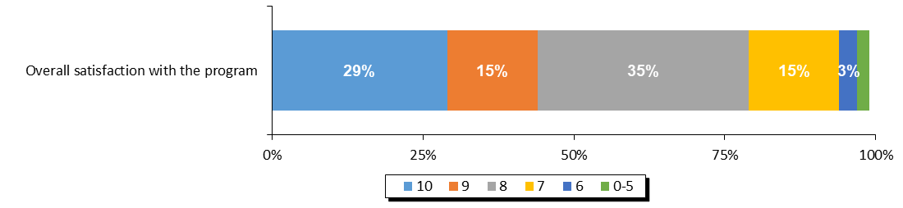

**Source:** *Overall satisfaction with the program.*

#### Overall Web Content Satisfaction

Libraries were asked to rate their level of satisfaction with the web content available to them on the librarians’ website. The top 3 box satisfaction in 2017 (65%) is the highest in the past 5 years.

**Figure 10. Satisfaction with Website and Web Content for Librarians**

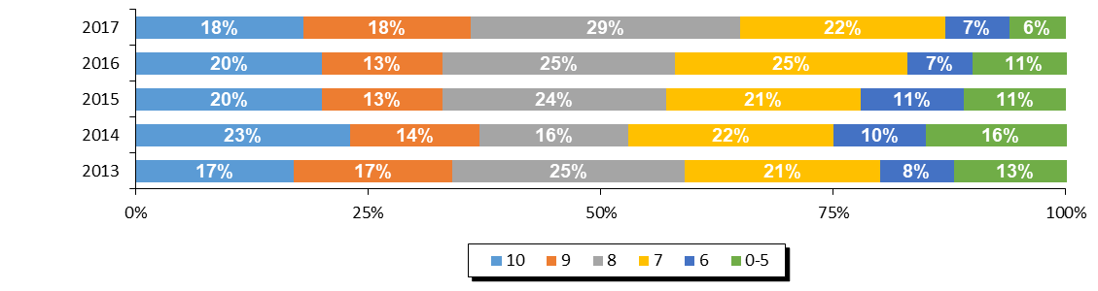

|  |  |  |  |  |  |
| --- | --- | --- | --- | --- | --- |
| **Region** | **Overall Satisfaction With Librarians' Website (Top 3 Box)** | | | | |
| **2017** | **2016** | **2015** | **2014** | **2013** |
| Alberta | 65% | 58% | 57% | 53% | 59% |

**Source:** *Q5.* *Website and Web Content For Librarians Satisfaction Questions.*

#### Website Navigation

The only element of the web content for librarians which was measured was the ease of navigating the website. Again, the top three box satisfaction in 2017 (74%) is at its highest level in the past 5 years. Satisfaction increased more than 10 percentage points compared to 2016.

**Figure 11. Ease of Navigating the Website for Librarians**

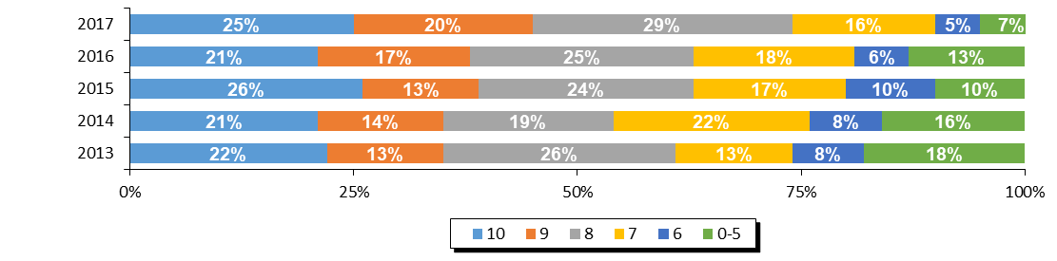

|  |  |  |  |  |  |
| --- | --- | --- | --- | --- | --- |
| **Region** | **Ease of Navigation (Top 3 Box)** | | | | |
| **2017** | **2016** | **2015** | **2014** | **2013** |
| Alberta | 74% | 63% | 63% | 54% | 61% |

**Source:** *Q5.* *Website and Web Content For Librarians Satisfaction Questions.*

#### Librarian Web Resources

Librarians were asked specifically which of the resources that were available to them were actually used in running their TD Summer Reading Club in 2017. The three web resources most used were the images (80%), the recommended reads (68%), and the activities (62%). Only 14% reported using the staff newsfeed.

**Figure 12. Usage of Librarian Web Resources**

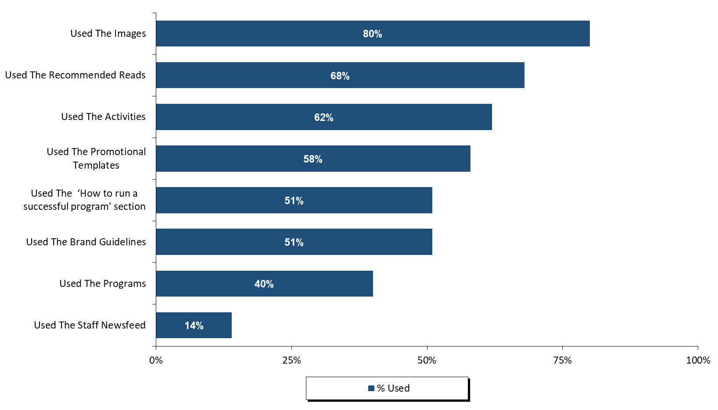

**Source:** *Q6.**Please identify which of the resources on the Librarians’ website you used and, for each resource that you did use, please give your level of satisfaction with it.*

Those who reported using the web resources were then asked to rate their satisfaction with those resources. Satisfaction with the images (45%) obtained by far the highest proportion of top scores (10 out of 10). Top three box satisfaction with the images was also the highest (84%), followed by promotional templates (76%), and brand guidelines (74%).

**Figure 13. Satisfaction with the Librarian Web Resources**

**Top 3 Box %**

**85%**

**76%**

**75%  
70%**

**69%**

**65%**

**63%**

**57%**

**57**

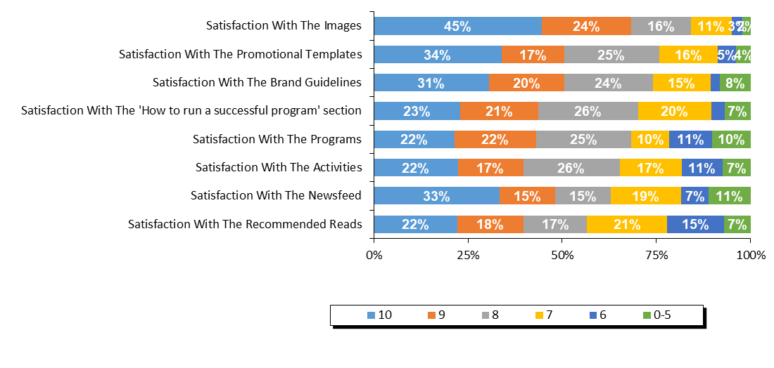**(Ranked By Top Three Box Score)**

**Source:** *Q6A.**Please identify which of the resources on the Librarians’ website you used and, for each resource that you did use, please give your level of satisfaction with it.*

Librarians were asked for suggestions on how to improve the librarians’ website for future years. More than a third of respondents (38%) commented they were satisfied or did not have any suggestions. The most common suggestions were related to receiving more ideas for programs and activities (19%).

Other common suggestions were related to having age specific content separate by age or school level; offering better, more recent, or broader booklists; and improving the navigation, search, and print functions.

**Figure 14. Suggestions for Librarian Web Resources**

|  |  |
| --- | --- |
| **Suggestions on how to improve any of the web resources for library staff?** | **2017** |
| Satisfied/no suggestions | 38% |
| More suggestions/ideas for programs/activities | 19% |
| Age specific content/separate by age/school level | 14% |
| Better/more recent/broader booklists | 14% |
| Simpler/more user friendly/better navigation/search/print functions | 14% |
| Improve clip art/more visually appealing/more variety | 10% |
| More promotion/awareness for website/website content | 10% |
| Provide more detailed/clearer information | 10% |
| Make material available sooner | 10% |
| Lack of relevance/relation to theme/reading programs | 5% |
| Less restrictive/more flexible promotional templates/brand guidelines | 5% |
| Better craft ideas | 5% |
| Other | 24% |

**Source:** *QD10.* *Do you have any suggestions on how to improve any of the web resources for library staff?*

#### Satisfaction with The Program Evaluation

Finally, libraries were asked to rate their level of satisfaction with the program evaluation and statistics process for 2017. When looking at the top three box scores, satisfaction increased substantially from 66% to 71% in 2017. Moreover, the proportion of people giving a top box score (33%) was the highest in the past 4 years.

Among the elements of the program evaluation process, the score for ‘ease of using the system’ was higher than ‘the evaluation asks about relevant concerns.’

**Figure 15. Satisfaction with Program Evaluation and Statistics Process**

**Top 3 Box %**

**71%**

**66%**

**58%  
56%**

**65%**

**44%**

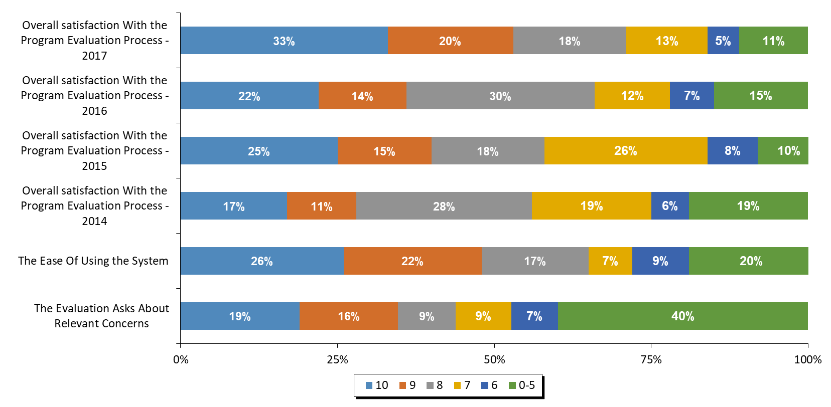

**Source:** *Q7.* *Program Evaluation and Statistics Process Questions.*

Librarians were asked for their suggestions on how the program evaluation and statistical collection process could be improved. The most common single theme was to make questions/forms available sooner (56%).

*The table below details all of the responses given by at least 2% of respondents.*

**Figure 16. Suggestions for Improving the Program Evaluation and Statistics Process**

|  |  |
| --- | --- |
| **Suggestions on how to improve the statistical collection and program evaluation process?** | **2017** |
| Make questions/forms available sooner/let us know what to track | 56% |
| Satisfied/no suggestions | 28% |
| Clarify/better define information requested | 12% |
| Include a comments section for each question to allow for explanation of data collected | 8% |
| Survey should ask feedback on themes/future themes | 4% |
| Problems recording children who weren't officially registered | 4% |
| Other | 32% |

**Source:** *QD11. Do you have any suggestions for how to improve the statistical collection and program evaluation process?*

Finally, libraries were asked to indicate whether they had any indicators of children’s increased enjoyment of reading, reading successes or changes in attitudes toward reading. The most common response was that the challenges and incentives were a motivating factor for kids (41%). Others mentioned that the program it makes them excited and keeps them reading over the summer (35%).

**Figure 17. Testimonials Indicating an Increased Love of Reading**

|  |  |
| --- | --- |
| **Testimonials indicating increased love of reading?** | **2017** |
| Challenges/incentives were a motivating factor | 41% |
| Makes them excited/keeps them reading over the summer | 35% |
| Children checking out more books from library | 18% |
| Children enjoyed story time/hearing stories recited | 18% |
| Children enjoyed the program/enjoyed reading/were motivated to read more (unspecified) | 18% |
| Brings more children to the library/they enjoy coming | 12% |
| Children enjoy coming back each year | 12% |
| Children exploring more/new genres/topics | 12% |
| Increased interest/abilities in school | 12% |
| Children/parents enjoyed the activities/crafts/website | 12% |
| Children more willing to read at home/share with family | 6% |
| Improved confidence/communication skills | 6% |
| Children love adding stickers to their passports | 6% |
| Other | 29% |

**Source:** *QD12. Do you have any testimonials from parents, caregivers or teachers that may indicate an increased love of reading?*

# 

# Appendix 7 – Prince Edward Island

**PEI PROGRAM STATISTICS**

### Response Rate

The participating libraries in PEI were asked to tally the results of participants in the summer reading club for all of their subsidiary branches. Within all systems, 23 of the 23 participating individual libraries submitted their results, representing an overall response rate of 100%.

Figure 1. Response Rate

|  |  |
| --- | --- |
|  | **PEI** |
| **(A) Total Participating Libraries** | **23** |
| **(B) Total Responded to Survey** | **23** |
| **(C) Survey Response Rate** | **100%** |

**Source:** Row (A) provided by Library and Archives Canada. Rows (B) and (C)represent data collected by Nielsen.

## Statistics on Registration & Attendance

### TD Summer Reading Program Registration

The first section of the Statistics and Evaluation Form asked librarians to indicate the total number of children registered for the TDSRC 2017. This reflects the number of children who registered on the sign-up sheet, with the intent to read books as part of the TD Summer Reading Club. In PEI, an estimated 1,804 children registered for the TDSRC 2017 program, which is the highest number recorded ever.

Figure 2. Total Registration 2009 – 2017

|  |  |  |  |  |  |  |  |  |  |
| --- | --- | --- | --- | --- | --- | --- | --- | --- | --- |
|  | **Total Registration** | | | | | | | | |
| **Region** | **2017** | **2016** | **2015** | **2014** | **2013** | **2012** | **2011** | **2010** | **2009** |
| PEI | 1,804 | 1,716 | 1,787 | 1,380 | 1,391 | 1,447 | 1,413 | 1,371 | 1,260 |

**Source:** *Q1 Total number of children who registered for the TDSRC 2017.*

The figure below shows the age breakdown of registered children. For the summer 2017, 30% of the registered children were in the 0-5 age group, 44% were 6-8, 19% were 9-12, and 7% were 13 years or older. The age make-up of registered children is similar from year to year and there is no discernable trend in PEI over time in terms of the age of children registered for the program.

**Figure 3. Percentage of Registered Children by Age 2009 – 2017**

|  |  |  |  |  |  |  |  |  |  |
| --- | --- | --- | --- | --- | --- | --- | --- | --- | --- |
| **PEI** | **2017** | **2016** | **2015** | **2014** | **2013** | **2012** | **2011** | **2010** | **2009** |
| **0-5** | 30% | 33% | 31% | 32% | 34% | 34% | 32% | 31% | 30% |
| **6-8** | 44% | 38% | 36% | 41% | 40% | 40% | 39% | 44% | 43% |
| **9-12** | 19% | 24% | 26% | 22% | 21% | 21% | 27% | 23% | 25% |
| **13+** | 7% | 4% | 6% | 5% | 4% | 4% | 2% | 1% | 2% |

**Source:** *Q1 Total number of children who registered for the TDSRC 2017.*

Figure 4 below summarizes the participation rate for PEI by age based on 2011 census data. The proportion of all children who were registered in 2017 is consistent with previous years and increased slightly from 5.96% to 6.26% in the most recent wave. The age group with the highest proportion of the total population taking part in the TD Summer Reading Club was 6-8 year olds, with more than 17% of all of the children in the province in this age group taking part in the program.

Figure 4. Number of Registered Children

|  |  |  |  |  |  |
| --- | --- | --- | --- | --- | --- |
|  | **2011 CENSUS** | **2017 TD SRC  REGISTRANTS** | **% PARTICIP.  CHILDREN** | **% PARTICIP.  CHILDREN** | **% PARTICIP.  CHILDREN** |
|  | **(A)** | **(B)** | **2017** | **2016** | **2015** |
| **Province / Territory** | **Total Children** | **Total Children** | **Total Children** | **Total Children** | **Total Children** |
| **PEI** | **28,795** | **1,804** | **6.26%** | **5.96%** | **6.21%** |
| 0-5 | 8,665 | 537 | 6.20% | 6.54% | 6.49% |
| 6-8 | 4,525 | 792 | 17.50% | 14.50% | 14.41% |
| 9-12 | 6,380 | 348 | 5.45% | 6.57% | 7.24% |
| 13+ | 9,225 | 127 | 1.38% | 0.80% | 1.20% |

**Source:** *Q1 Total number of children who registered for the TDSRC 2017, 2016, 2015. Column (A) provided by Statistics Canada Census 2011. Column (B)*

### TD Summer Reading Program Attendance & Activities

To help gauge the success of the TDSRC, libraries were asked to indicate the total number of programs and activities organized around this year’s club theme as well as the total attendance of children at these activities (not including parents or care givers).

When reviewing these numbers, several points need to be kept in mind:

* Every child who registered for the reading club with the library is considered to have attended an activity;
* It is possible that a child did not register for the TDSRC, but attended one or more of the activities; and
* Attendance was calculated on a per activity basis. It is possible that a child attended more than one activity, and thus is represented more than once in total attendance.

A total of 6,707 children attended the 801 theme-related activities which were organized in libraries across PEI over the summer months of 2017. Overall, an average of 8 children attended each activity in 2017, and 92% of all activities were conducted in libraries.

Figure 5. Total Activities and Attendance

|  |  |  |  |  |  |
| --- | --- | --- | --- | --- | --- |
|  | **Activity Attendance** | | | | |
| **Region** | **Theme-Related Activities** | **Total Attendance** | **Avg. Attendance per Activity** | **% of Activities In Library** | **% of Activities In Community** |
| PEI | 801 | 6,707 | 8 | 92% | 8% |

**Source:** *Q2. Total number of activities in your libraries and in your community. Attendance at activities in your libraries and in your community.*

While the number of activities run by PEI libraries increased compared to 2016, the total attendance by children at those activities decreased.

Figure 6. Activities and Attendance 2015 – 2017

|  |  |  |  |  |  |  |
| --- | --- | --- | --- | --- | --- | --- |
|  | **2017** | | **2016** | | **2015** | |
| **Region** | **Theme-Related Activities** | **Total Attendance** | **Theme-Related Activities** | **Total Attendance** | **Theme-Related Activities** | **Total Attendance** |
| PEI | 801 | 6,707 | 694 | 7,389 | 588 | 5,559 |

**Source:** *Q2. How many of the children registered in your library had participated in the TD Summer Reading Club in previous years and how many were new to the program?*

## Promotion of Program

Librarians were asked to indicate if anyone from their library branch made any visits to the local schools, child care centres, day camps, or to any other locations in order to promote the program.

In PEI, 91% of libraries indicated that their library staff made promotional visits to schools, while 65% visited child care centres, 35% visited day camps, and 13% made other promotional visits. A total of 104 visits were made, reaching a total of 12,223 children (the vast majority of them at schools).

**Figure 7. Total Number of Visits and Children Reached by Segment**

|  |  |  |  |  |  |  |
| --- | --- | --- | --- | --- | --- | --- |
|  | **Made Visits 2017 (%)** | | | | | |
|  | **Schools** | | | **Day Camps** | | |
|  | **School Visits (% Yes)** | **Total Visits** | **Children Attended** | **Day Camp Visits (%)** | **Total Visits** | **Children Attended** |
| PEI | 91% | 53 | 11,340 | 35% | 17 | 264 |
|  | **Child Care Centres** | | | **Other Locations** | | |
|  | **Childcare Visits (%)** | **Total Visits** | **Children Attended** | **Other Visits (%)** | **Total Visits** | **Children Attended** |
| PEI | 65% | 29 | 514 | 13% | 5 | 105 |

**Source:** *Q3. Total number of activities in your libraries and in your community. Attendance at activities in your libraries and in your community.*

### Previous Participation

In PEI, 41% of all registered children said that they had participated in previous years and the rest were new registrants in 2017. The proportion of children saying they participated in previous years has ranged from 39% to 45%.

Figure 8. Previous Participation

|  |  |  |  |  |
| --- | --- | --- | --- | --- |
| **Region** | **Joined in previous years** | | **New Registrants** | |
| PEI | 737 | 41% | 1,067 | 59% |

|  |  |  |  |
| --- | --- | --- | --- |
| **% Joined in Previous Years** | | | |
| **Region** | **2017** | **2016** | **2015** |
| PEI | 41% | 45% | 39% |

**Source:** *Q4. How many of the children registered in your library had participated in the TD Summer Reading Club in previous years and how many were new to the program?*

## Satisfaction & Suggestions

The following section will provide satisfaction scores for every question asked by giving the proportion of libraries who responded with each score from 10 down to 6, along with those who gave a score of 0-5. The overall satisfaction question for each section is reported first and directly compared to previous waves of data (wherever applicable). It is followed by the individual element scores, ranked by the proportion giving a score of 10 (unless otherwise noted). Libraries were also asked for their suggestions and comments in each section.

Please note that libraries that did not provide information for any given question are not considered in the percentages reported here so that each graph will sum to 100%. In some cases, the sum of percentages reported may not add exactly to 100% due to rounding.

#### Overall Satisfaction with the Program

This question was added in 2017 to be able to obtain a measurement of the satisfaction with the program as a whole. Top 3 box overall satisfaction with the program in PEI is very high at 87%, although only 9% rate their satisfaction as a perfect 10.

#### **Figure 9. Overall Satisfaction with the Program**

**Top 3 Box %**

**87%**

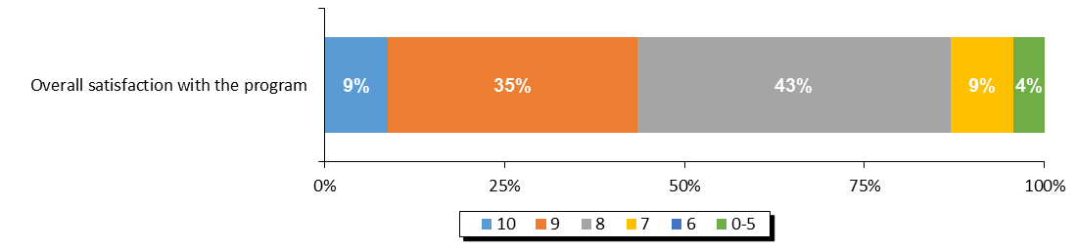

**Source:** *Overall satisfaction with the program.*

#### Overall Web Content Satisfaction

Libraries were asked to rate their level of satisfaction with the web content available to them on the librarians’ website. The top three box level of satisfaction in 2017 (79%) is the highest on record, rebounding from a notable decrease in 2016. However, top box satisfaction (9%) is low compared to other years.

**Figure 10. Satisfaction with Website and Web Content for Librarians**

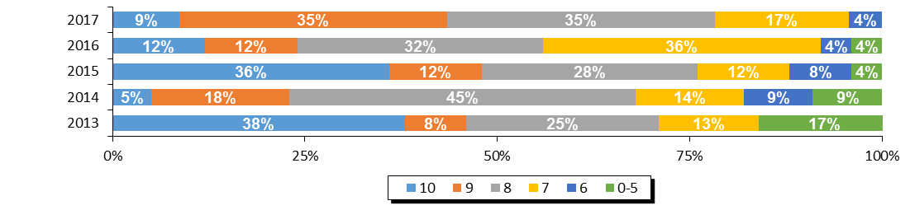

|  |  |  |  |  |  |
| --- | --- | --- | --- | --- | --- |
| **Region** | **Overall Satisfaction With Librarians' Website (Top 3 Box)** | | | | |
| **2017** | **2016** | **2015** | **2014** | **2013** |
| PEI | 79% | 56% | 76% | 68% | 71% |

**Source:** *Q5.* *Website and Web Content For Librarians Satisfaction Questions.*

#### Website Navigation

The only element of the web content for librarians which was measured was the ease of navigating the website. The level of satisfaction with the navigation of the website in 2017 (73%) also rebounded from a notable decrease in 2016 (60%). While top three box satisfaction is at its highest point in 5 years, top box satisfaction (13%) is lower than the previous 2 years.

**Figure 11. Ease of Navigating the Website for Librarians**

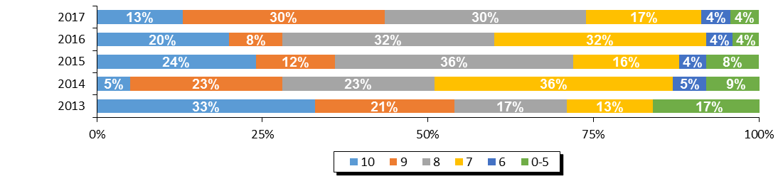

|  |  |  |  |  |  |
| --- | --- | --- | --- | --- | --- |
| **Region** | **Ease of Navigation (Top 3 Box)** | | | | |
| **2017** | **2016** | **2015** | **2014** | **2013** |
| PEI | 73% | 60% | 72% | 51% | 71% |

**Source:** *Q5.* *Website and Web Content For Librarians Satisfaction Questions.*

#### Librarian Web Resources

Librarians were asked specifically which of the resources that were available to them were actually used in running their TD Summer Reading Club in 2017. Almost all PEI librarians reported using the images and the activities (91%), while most used the recommended reads (86%). The staff newsfeed was the least used web resource (27%).

**Figure 12. Usage of Librarian Web Resources**

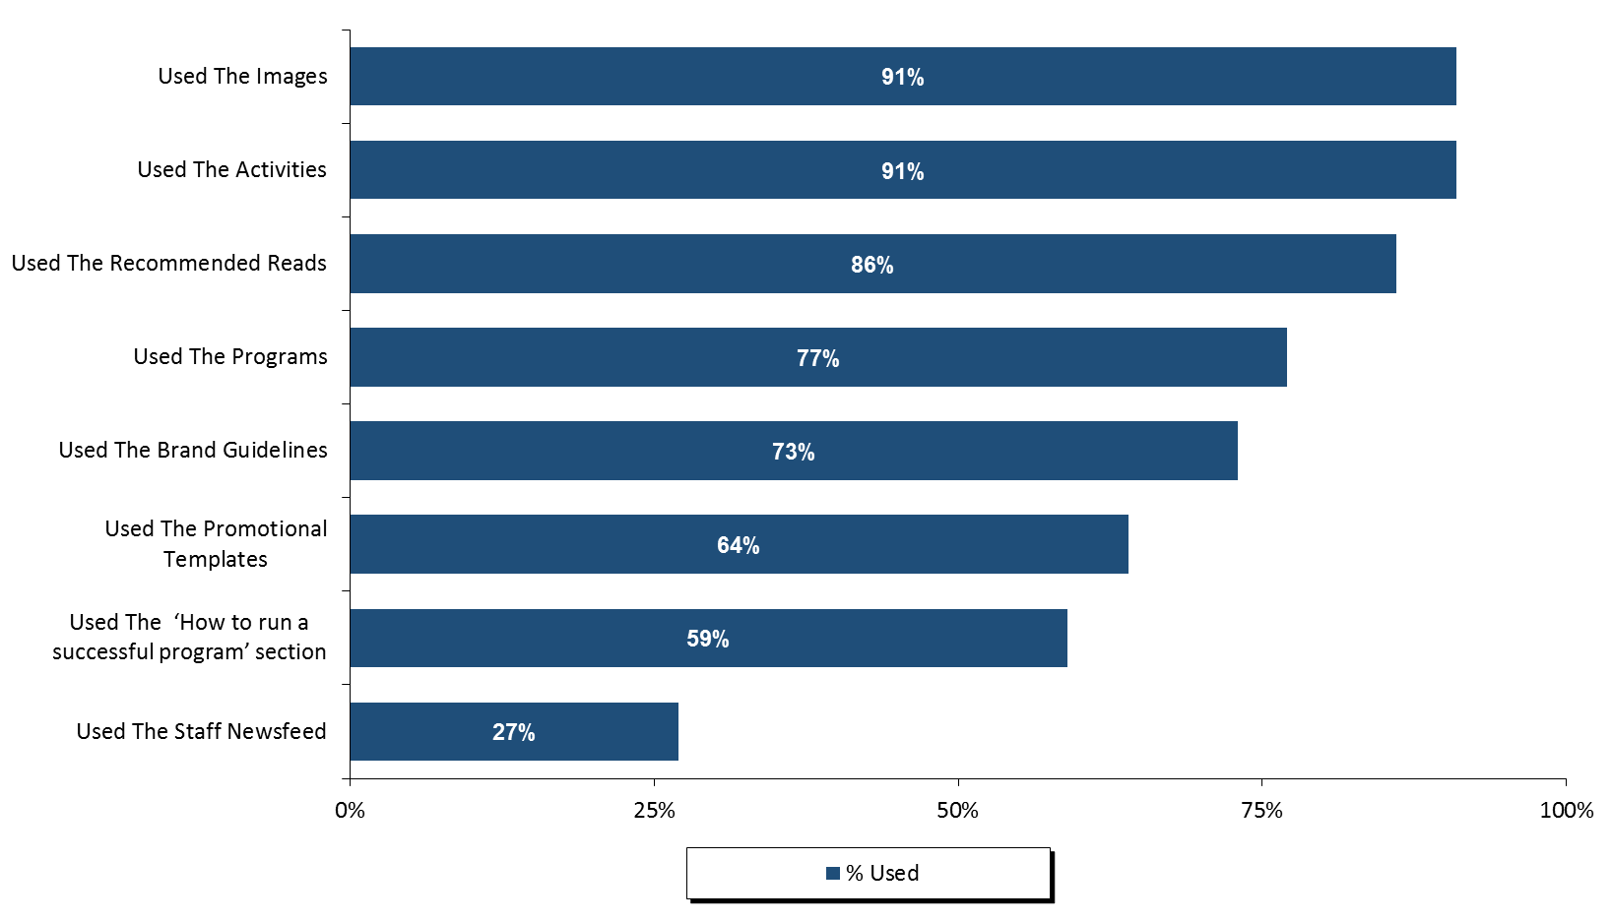

**Source:** *Q6.**Please identify which of the resources on the Librarians’ website you used and, for each resource that you did use, please give your level of satisfaction with it.*

Those who reported using the web resources were then asked to rate their satisfaction with those resources. Although satisfaction was high for the librarian resources in general, it was highest for the images, where 80% of respondents provided a top three box score. Just over three quarter of respondents (76%) were satisfied with the ‘how to run a successful program’ section, the programs, and the brand guidelines.

**Figure 13. Satisfaction with the Librarian Web Resources**

**(Ranked By Top Three Box Score)**

**Top 3 Box %**

**80%**

**76%**

**76%  
76%**

**70%**

**69%**

**68%**

**64%**

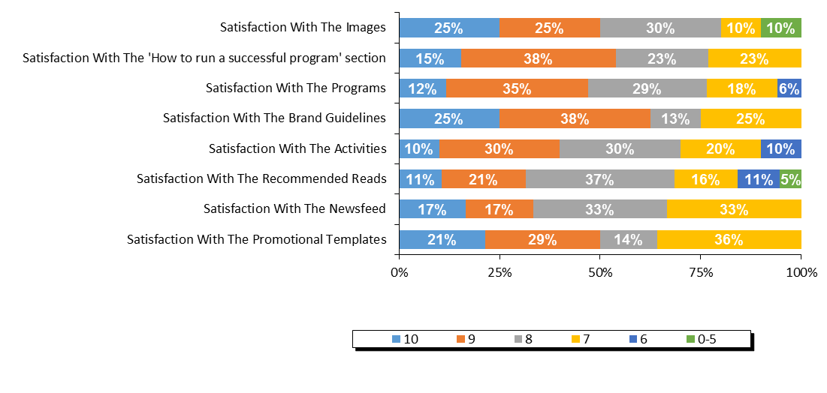

**Source:** *Q6A.**Please identify which of the resources on the Librarians’ website you used and, for each resource that you did use, please give your level of satisfaction with it.*

Librarians were asked for suggestions on how to improve the librarians’ website for future years. More than 40% of respondents said that they were satisfied or had nothing to suggest. The most common theme of suggestions was related to providing more age-specific content (29%).

**Figure 14. Suggestions for Librarian Web Resources**

|  |  |
| --- | --- |
| **Suggestions on how to improve any of the web resources for library staff?** | **2017** |
| Satisfied/no suggestions | 43% |
| Age specific content/separate by age/school level | 29% |
| Better/more recent/broader booklists | 14% |
| More suggestions/ideas for programs/activities | 14% |
| Simpler/more user friendly/better navigation/search/print functions | 14% |
| Other | 14% |

**Source:** *QD10.* *Do you have any suggestions on how to improve any of the web resources for library staff?*

#### Satisfaction With The Program Evaluation

Finally, libraries were asked to rate their level of satisfaction with the program evaluation and statistics process for 2017. When looking at the top three box scores, satisfaction increased substantially from 56% in 2016 to 70% in 2017.

Among the elements of the program evaluation process, the score for ‘ease of using the system’ was higher than ‘the evaluation asks about relevant concerns.’

**Figure 15. Satisfaction with Program Evaluation and Statistics Process**

**Top 3 Box %**

**69%**

**56%**

**80%  
55%**

**82%**

**65%**

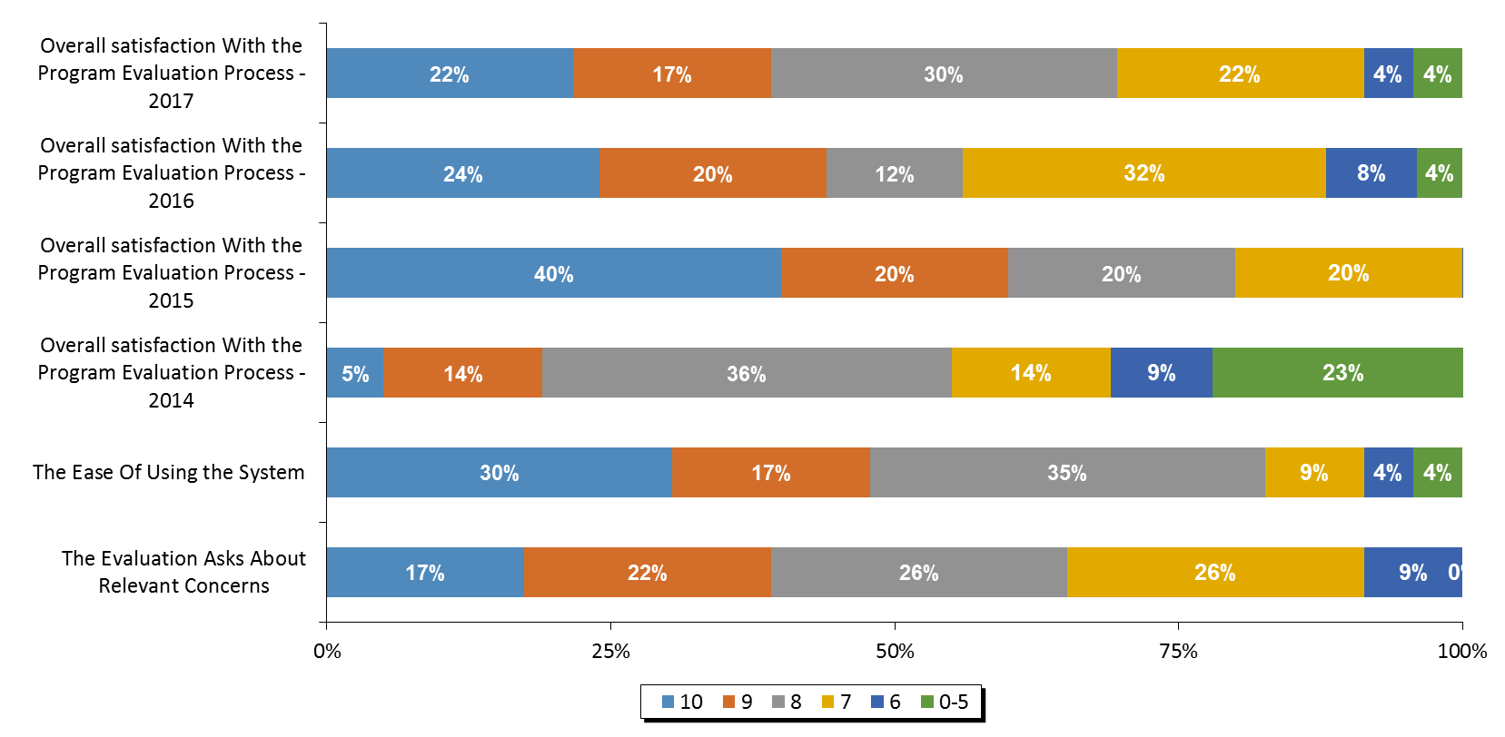

**Source:** *Q7.* *Program Evaluation and Statistics Process Questions.*

Librarians were asked for their suggestions on how the program evaluation and statistical collection process could be improved. The most common single response was to say that they were satisfied or had no suggestions to offer (40%). Other common suggestions were related to making the date for Get your summer read closer to school break (30%) and making questions/forms available sooner (20%).

**Figure 16. Suggestions for Improving the Program Evaluation and Statistics Process**

|  |  |
| --- | --- |
| **Suggestions on how to improve the statistical collection and program evaluation process?** | **2017** |
| Satisfied/no suggestions | 40% |
| Date for Get your summer read on was too early/should be closer to school break | 30% |
| Make questions/forms available sooner/let us know what to track | 20% |
| Clarify/better define information requested | 10% |
| Survey should ask feedback on themes/future themes | 10% |
| Include stats on number of books read | 10% |
| Other | 30% |

**Source:** *QD11. Do you have any suggestions for how to improve the statistical collection and program evaluation process?*

Finally, libraries were asked to indicate whether they had any indicators of children’s increased enjoyment of reading, reading successes or changes in attitudes toward reading. A series of responses were given, but the most common was that children were checking out more books from libraries (44%) and that the program brings more children to the libraries (22%).

**Figure 17. Testimonials Indicating an Increased Love of Reading**

|  |  |
| --- | --- |
| **Testimonials indicating increased love of reading?** | **2017** |
| Children checking out more books from library | 44% |
| Brings more children to the library/they enjoy coming | 22% |
| Challenges/incentives were a motivating factor | 11% |
| Children enjoyed this year's theme | 11% |
| Children learned new words/information | 11% |
| Children/parents enjoyed the activities/crafts/website | 11% |
| Makes them excited/keeps them reading over the summer | 11% |
| Improved confidence/communication skills | 11% |
| Other | 33% |

**Source:** *QD12. Do you have any testimonials from parents, caregivers or teachers that may indicate an increased love of reading?*

# 

# Appendix 8 – Nova Scotia

# Nova Scotia Program Statistics

### Response Rate

The participating libraries in Nova Scotia were asked to tally the results of participants in the summer reading club for all of their subsidiary branches. Within Nova Scotia, 63 of the 64 participating individual libraries submitted their results, representing an overall response rate of 98%.

Figure 1. Response Rate

|  |  |
| --- | --- |
|  | **Nova Scotia** |
| **(A) Total Participating Libraries** | **64** |
| **(B) Total Responded to Survey** | **63** |
| **(C) Survey Response Rate** | **98%** |

**Source:** Row (A) provided by Library and Archives Canada. Rows (B) and (C)represent data collected by Nielsen.

## Statistics on Registration & Attendance

### TD Summer Reading Program Registration

The first section of the Statistics and Evaluation Form asked librarians to indicate the total number of children registered for the TDSRC 2017. This reflects the number of children who registered on the sign-up sheet, with the intent to read books as part of the TD Summer Reading Club. In Nova Scotia, an estimated 12,739 children registered for the TDSRC 2017 program, which is a notable increase from 2016, and on par with 2015.

Figure 2. Total Registration 2009 – 2017

|  |  |  |  |  |  |  |  |  |  |
| --- | --- | --- | --- | --- | --- | --- | --- | --- | --- |
|  | **Total Registration** | | | | | | | | |
| **Region** | **2017** | **2016** | **2015** | **2014** | **2013** | **2012** | **2011** | **2010** | **2009** |
| Nova Scotia | 12,739 | 9,357 | 12,739 | 9,518 | 13,848 | 15,131 | 13,348 | 12,003 | 13,197 |

**Source:** *Q1 Total number of children who registered for the TDSRC 2017.*

The figure below shows the age breakdown of registered children. For the summer 2017, 23% of the registered children were in the 0-5 age group, 38% were 6-8, 34% were 9-12, and 5% were 13 years or older. The age make-up of registered children is similar from year to year and there is no discernable trend in Nova Scotia over time in terms of the age of children registered for the program.

**Figure 3. Percentage of Registered Children by Age 2009 – 2017**

|  |  |  |  |  |  |  |  |  |  |
| --- | --- | --- | --- | --- | --- | --- | --- | --- | --- |
| **Nova Scotia** | **2017** | **2016** | **2015** | **2014** | **2013** | **2012** | **2011** | **2010** | **2009** |
| **0-5** | 23% | 22% | 24% | 23% | 23% | 22% | 21% | 20% | 19% |
| **6-8** | 38% | 42% | 38% | 40% | 38% | 39% | 39% | 38% | 38% |
| **9-12** | 34% | 33% | 32% | 34% | 34% | 34% | 35% | 36% | 37% |
| **13+** | 5% | 2% | 6% | 3% | 6% | 6% | 6% | 6% | 5% |

**Source:** *Q1 Total number of children who registered for the TDSRC 2017.*

Figure 4 below summarizes the participation rate for Nova Scotia by age based on 2011 census data. The proportion of all children who were registered in 2017 was higher than in 2016, matching the percentage achieved in 2015 (7.42%). The age group with the highest proportion of the total population taking part in the TD Summer Reading Club was 6-8 year olds, with around 15% of all of the children in the province in this age group taking part in the program.

Figure 4. Number of Registered Children

|  |  |  |  |  |  |
| --- | --- | --- | --- | --- | --- |
|  | **2011 CENSUS** | **2017 TD SRC  REGISTRANTS** | **% PARTICIP.  CHILDREN** | **% PARTICIP.  CHILDREN** | **% PARTICIP.  CHILDREN** |
|  | **(A)** | **(B)** | **2017** | **2016** | **2015** |
| **Province / Territory** | **Total Children** | **Total Children** | **Total Children** | **Total Children** | **Total Children** |
| **Nova Scotia** | **171,790** | **12,739** | **7.42%** | **5.45%** | **7.42%** |
| 0-5 | 52,725 | 2,982 | 5.66% | 3.96% | 5.83% |
| 6-8 | 26,460 | 4,778 | 18.06% | 14.96% | 18.17% |
| 9-12 | 38,310 | 4,282 | 11.18% | 8.16% | 10.63% |
| 13+ | 54,295 | 697 | 1.28% | 0.34% | 1.44% |

**Source:** *Q1 Total number of children who registered for the TDSRC 2017, 2016, 2015. Column (A) provided by Statistics Canada Census 2011. Column (B)*

### TD Summer Reading Program Attendance & Activities

To help gauge the success of the TDSRC, libraries were asked to indicate the total number of programs and activities organized around this year’s club theme as well as the total attendance of children at these activities (not including parents or care givers).

When reviewing these numbers, several points need to be kept in mind:

* Every child who registered for the reading club with the library is considered to have attended an activity;
* It is possible that a child did not register for the TDSRC, but attended one or more of the activities; and
* Attendance was calculated on a per activity basis. It is possible that a child attended more than one activity, and thus is represented more than once in total attendance.

A total of 35,750 children attended the 1,485 theme-related activities which were organized in libraries across Nova Scotia over the summer months of 2017. Overall, an average of 24 children attended each activity in 2017, and 91% of all activities were conducted in libraries.

Figure 5. Total Activities and Attendance

|  |  |  |  |  |  |
| --- | --- | --- | --- | --- | --- |
|  | **Activity Attendance** | | | | |
| **Region** | **Theme-Related Activities** | **Total Attendance** | **Avg. Attendance per Activity** | **% of Activities In Library** | **% of Activities In Community** |
| Nova Scotia | 1,485 | 35,750 | 24 | 91% | 9% |

**Source:** *Q2. Total number of activities in your libraries and in your community. Attendance at activities in your libraries and in your community.*

Similar to the registration numbers, the number of activities run by Nova Scotia libraries, and the attendance at those activities, increased compared to 2016.

Figure 6. Activities and Attendance 2015 – 2017

|  |  |  |  |  |  |  |
| --- | --- | --- | --- | --- | --- | --- |
|  | **2017** | | **2016** | | **2015** | |
| **Region** | **Theme-Related Activities** | **Total Attendance** | **Theme-Related Activities** | **Total Attendance** | **Theme-Related Activities** | **Total Attendance** |
| Nova Scotia | 1,485 | 35,750 | 796 | 22,151 | 1,245 | 40,110 |

**Source:** *Q2. How many of the children registered in your library had participated in the TD Summer Reading Club in previous years and how many were new to the program?*

## Promotion of Program

Librarians were asked to indicate if anyone from their library branch made any visits to the local schools, child care centres, day camps, or to any other locations in order to promote the program.

In Nova Scotia, 100% of libraries indicated that their library staff made promotional visits to schools, while no visits to child care centres or day camps were reported. In total, 30,790 children were reached by visits to schools.

**Figure 7. Total Number of Visits and Children Reached by Segment**

|  |  |  |  |  |  |  |
| --- | --- | --- | --- | --- | --- | --- |
|  | **Made Visits 2017 (%)** | | | | | |
|  | **Schools** | | | **Day Camps** | | |
|  | **School Visits (% Yes)** | **Total Visits** | **Children Attended** | **Day Camp Visits (%)** | **Total Visits** | **Children Attended** |
| Nova Scotia | 100% | 161 | 30,790 | 0% | 0 | 0 |
|  | **Child Care Centres** | | | **Other Locations** | | |
|  | **Childcare Visits (%)** | **Total Visits** | **Children Attended** | **Other Visits (%)** | **Total Visits** | **Children Attended** |
| Nova Scotia | 0% | 0 | 0 | 0% | 0 | 0 |

**Source:** *Q3. Total number of activities in your libraries and in your community. Attendance at activities in your libraries and in your community.*

### Previous Participation

In Nova Scotia, 60% of all registered children said that they had participated in previous years and 40% were new registrants. The proportion of children saying they participated in previous years has been relatively stable in Nova Scotia since 2015.

Figure 8. Previous Participation

|  |  |  |  |  |
| --- | --- | --- | --- | --- |
| **Region** | **Joined in previous years** | | **New Registrants** | |
| Nova Scotia | 7,702 | 60% | 5,036 | 40% |

|  |  |  |  |
| --- | --- | --- | --- |
| **% Joined in Previous Years** | | | |
| **Region** | **2017** | **2016** | **2015** |
| Nova Scotia | 60% | 56% | 58% |

**Source:** *Q4. How many of the children registered in your library had participated in the TD Summer Reading Club in previous years and how many were new to the program?*

## Satisfaction & Suggestions

The following section will provide satisfaction scores for every question asked by giving the proportion of libraries who responded with each score from 10 down to 6, along with those who gave a score of 0-5. The overall satisfaction question for each section is reported first and directly compared to previous waves of data (wherever applicable). It is followed by the individual element scores, ranked by the proportion giving a score of 10 (unless otherwise noted). Libraries were also asked for their suggestions and comments in each section.

Please note that libraries that did not provide information for any given question are not considered in the percentages reported here so that each graph will sum to 100%. In some cases, the sum of percentages reported may not add exactly to 100% due to rounding.

#### Overall Satisfaction with the Program

This question was added in 2017 to be able to obtain a measurement of the satisfaction with the program as a whole. Top 3 box overall satisfaction with the program in Nova Scotia is 72%, with 29% of libraries rating it a perfect 10.

#### **Figure 9. Overall Satisfaction with the Program**

**Top 3 Box %**

**72%**

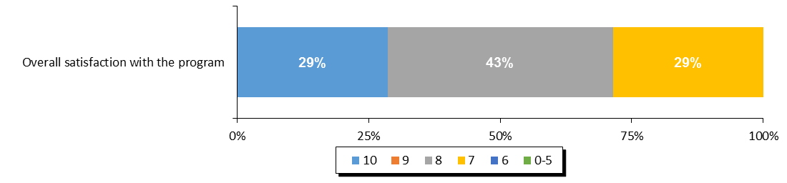

**Source:** *Overall satisfaction with the program.*

#### Overall Web Content Satisfaction

Libraries were asked to rate their level of satisfaction with the web content available to them on the librarians’ website. The levels of satisfaction in 2017 rebounded from an all-time low rating in 2016 (16%) to 67%, the highest rating in the past five years. Nonetheless, the proportion of librarians rating their satisfaction with the website content as a 10 is relatively low when compared to the years 2013-2015.

**Figure 10. Satisfaction with Website and Web Content for Librarians**

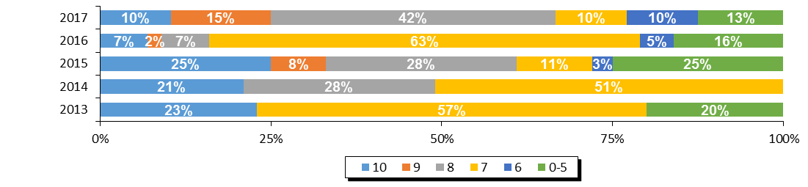

|  |  |  |  |  |  |
| --- | --- | --- | --- | --- | --- |
| **Region** | **Overall Satisfaction With Librarians' Website (Top 3 Box)** | | | | |
| **2017** | **2016** | **2015** | **2014** | **2013** |
| Nova Scotia | 67% | 16% | 61% | 49% | 23% |

**Source:** *Q5.* *Website and Web Content For Librarians Satisfaction Questions.*

#### Website Navigation

The only element of the web content for librarians which was measured was the ease of navigating the website. The level of satisfaction with the navigation of the website specifically was higher than any other year with 71% rating giving a top three box score. Satisfaction ratings of 10 out of 10 were comparable to the previous year.

**Figure 11. Ease of Navigating the Website for Librarians**

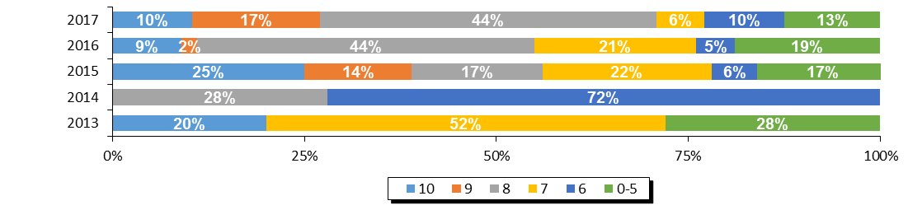

|  |  |  |  |  |  |
| --- | --- | --- | --- | --- | --- |
| **Region** | **Ease of Navigation (Top 3 Box)** | | | | |
| **2017** | **2016** | **2015** | **2014** | **2013** |
| Nova Scotia | 71% | 55% | 56% | 28% | 20% |

**Source:** *Q5.* *Website and Web Content For Librarians Satisfaction Questions.*

#### Librarian Web Resources

Librarians were asked specifically which of the resources that were available to them were actually used in running their TD Summer Reading Club in 2017. With only one exception, almost all web resources were used by all libraries.

**Figure 12. Usage of Librarian Web Resources**

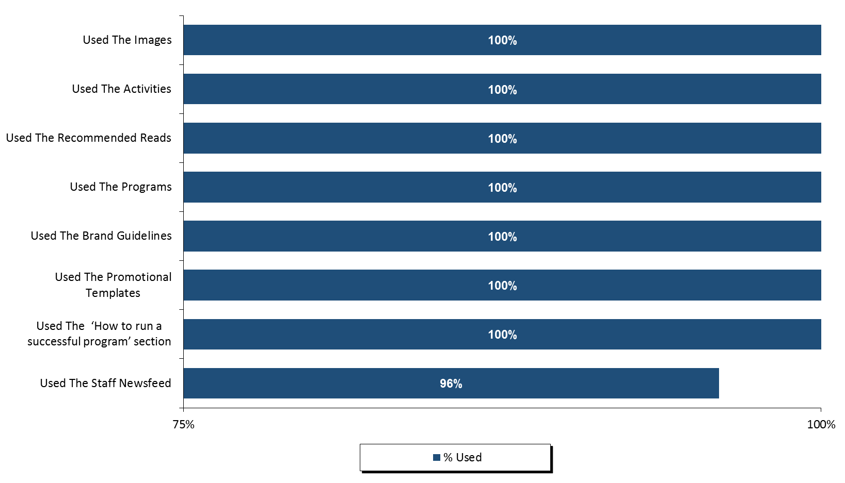

**Source:** *Q6.**Please identify which of the resources on the Librarians’ website you used and, for each resource that you did use, please give your level of satisfaction with it.*

Those who reported using the web resources were then asked to rate their satisfaction with those resources. Top three box satisfaction with the resources is over 60% for all items. Taking into account the top three scores, satisfaction was higher with the activities (84%), the programs (83%), the ‘how to run a successful program’ section (83%), and the images (82%).

**Figure 13. Satisfaction with the Librarian Web Resources**

**Top 3 Box %**

**84%**

**82%**

**83%**

**82%**

**75%**

**74%**

**73%**

**63%**

**(Ranked By Top Three Box Score)**

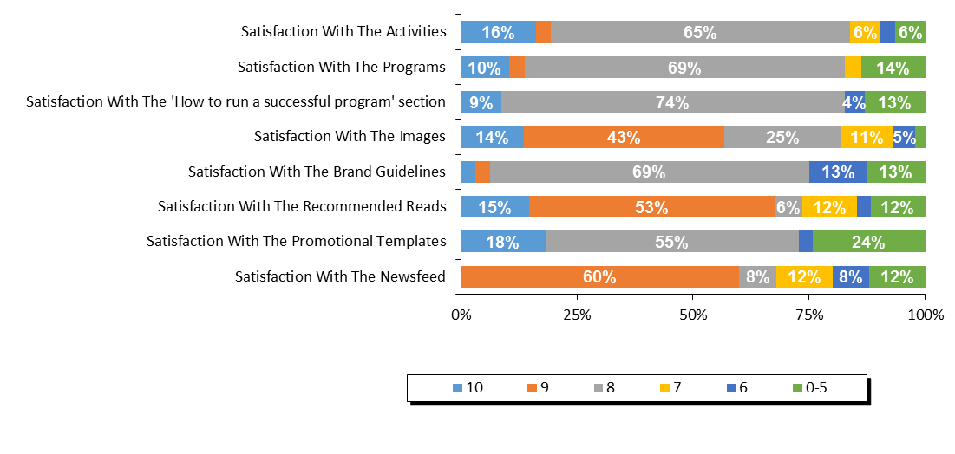

**Source:** *Q6A.**Please identify which of the resources on the Librarians’ website you used and, for each resource that you did use, please give your level of satisfaction with it.*

Librarians were asked for suggestions on how to improve the librarians’ website for future years. Although the majority stated that they were satisfied or provided no suggestions (75%), some suggested making the material available sooner, improving the navigation, search, and print functions, and having age specific content separate by age or school level.

**Figure 14. Suggestions for Librarian Web Resources**

|  |  |
| --- | --- |
| **Suggestions on how to improve any of the web resources for library staff?** | **2017** |
| Satisfied/no suggestions | 75% |
| Make material available sooner | 25% |
| Simpler/more user friendly/better navigation/search/print functions | 25% |
| Age specific content/separate by age/school level | 25% |
| Other | 25% |

**Source:** *QD10.* *Do you have any suggestions on how to improve any of the web resources for library staff?*

#### Satisfaction with the Program Evaluation

Finally, libraries were asked to rate their level of satisfaction with the program evaluation and statistics process for 2017. Overall, satisfaction was lower in 2017 than in 2016 with no one rating it a 10 out of 10. The top three box this year declined from 57% in 2016 to 50% in 2017.

Satisfaction with ‘the ease of using the system’ is notably low (72% rated 5 or lower). Satisfaction with ‘the evaluation asks about relevant concerns’ is polarized between those rating it as a perfect 10 (45%) and 5 or lower (38%).

**Figure 15. Satisfaction with Program Evaluation and Statistics Process**

**Top 3 Box %**

**50%**

**57%**

**60%**

**16%**

**60%**

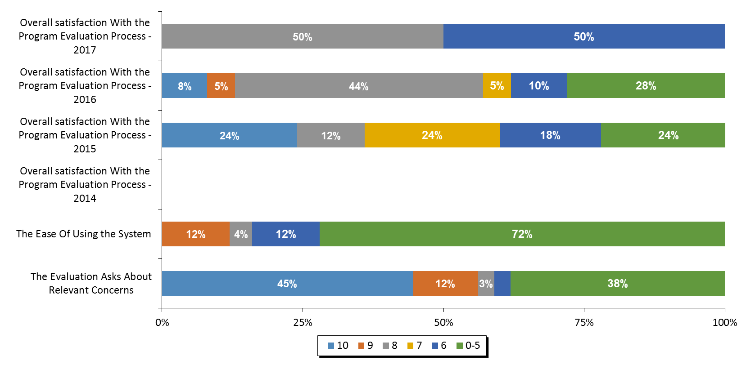

**Source:** *Q7.* *Program Evaluation and Statistics Process Questions.*

Librarians were asked for their suggestions on how the program evaluation and statistical collection process could be improved. A variety of responses were given and are listed in the table below.

**Figure 16. Suggestions for Improving the Program Evaluation and Statistics Process**

|  |  |
| --- | --- |
| **Suggestions on how to improve the statistical collection and program evaluation process?** | **2017** |
| Fewer questions/reduce survey length | 25% |
| Later deadline/allow longer time frame for completion | 25% |
| Make questions/forms available sooner/let us know what to track | 25% |
| Offer a printable version | 25% |
| Satisfied/no suggestions | 25% |
| Other | 25% |

**Source:** *QD11. Do you have any suggestions for how to improve the statistical collection and program evaluation process?*

Libraries were asked to share whether they had any indicators of children’s increased enjoyment of reading, reading successes or changes in attitudes toward reading. A number of responses were given for this question and are all listed in the table below.

**Figure 17. Testimonials Indicating an Increased Love of Reading**

|  |  |
| --- | --- |
| **Testimonials indicating increased love of reading?** | **2017** |
| Makes them excited/keeps them reading over the summer | 33% |
| Noticeable improvement in reading level | 33% |
| Challenges/incentives were a motivating factor | 33% |
| Brings more children to the library/they enjoy coming | 33% |
| Children enjoy coming back each year | 33% |
| Children/parents enjoyed the activities/crafts/website | 17% |
| Children enjoyed the program/enjoyed reading/were motivated to read more (unspecified) | 17% |
| Increased interest/abilities in school | 17% |
| Children exploring more/new genres/topics | 17% |
| Other | 33% |

**Source:** *QD12. Do you have any testimonials from parents, caregivers or teachers that may indicate an increased love of reading?*

# 

# Appendix 9 – Newfoundland & Labrador

**NEWFOUNDLAND & LABRADOR PROGRAM STATISTICS**

### Response Rate

The participating libraries in Newfoundland & Labrador were asked to tally the results of participants in the summer reading club for all of their subsidiary branches. Within all systems, 68 of the 77 participating individual libraries submitted their results, representing an overall response rate of 88%.

Figure 1. Response Rate

|  |  |
| --- | --- |
|  | **Newfoundland & Labrador** |
| **(A) Total Participating Libraries** | 77 |
| **(B) Total Responded to Survey** | 68 |
| **(C) Survey Response Rate** | **88%** |

**Source:** Row (A) provided by Library and Archives Canada. Rows (B) and (C)represent data collected by Nielsen.

## Statistics on Registration & Attendance

### TD Summer Reading Program Registration

The first section of the Statistics and Evaluation Form asked librarians to indicate the total number of children registered for the TDSRC 2017. This reflects the number of children who registered on the sign-up sheet, with the intent to read books as part of the TD Summer Reading Club. In Newfoundland & Labrador, an estimated 2,093 children registered for the TDSRC 2017 program, which is the lowest recorded in the past nine years.

Figure 2. Total Registration 2009 – 2017

|  |  |  |  |  |  |  |  |  |  |
| --- | --- | --- | --- | --- | --- | --- | --- | --- | --- |
|  | **Total Registration** | | | | | | | | |
| **Region** | **2017** | **2016** | **2015** | **2014** | **2013** | **2012** | **2011** | **2010** | **2009** |
| Newfoundland & Labrador | 2,093 | 2,591 | 2,453 | 2,497 | 2,608 | 3,788 | 3,148 | 3,388 | 2,912 |

**Source:** *Q1 Total number of children who registered for the TDSRC 2017.*

The figure below shows the age breakdown of registered children. For the summer 2017, 23% of the registered children were in the 0-5 age group, 38% were 6-8, 34% were 9-12, and 5% were 13 years or older. A notable difference in proportions compared to 2016 was recorded among the 0-5 age group (36% in 2016 vs. 23% in 2017) and among the 9-12 age group (24% in 2016 vs. 34% in 2017).

**Figure 3. Percentage of Registered Children by Age 2009 – 2017**

|  |  |  |  |  |  |  |  |  |  |
| --- | --- | --- | --- | --- | --- | --- | --- | --- | --- |
| **Newfoundland & Labrador** | **2017** | **2016** | **2015** | **2014** | **2013** | **2012** | **2011** | **2010** | **2009** |
| **0-5** | 23% | 36% | 40% | 38% | 41% | 40% | 38% | 32% | 29% |
| **6-8** | 38% | 38% | 36% | 37% | 35% | 27% | 36% | 36% | 40% |
| **9-12** | 34% | 24% | 22% | 23% | 23% | 20% | 24% | 29% | 29% |
| **13+** | 5% | 1% | 2% | 1% | 1% | 13% | 2% | 3% | 2% |

**Source:** *Q1 Total number of children who registered for the TDSRC 2017.*

Figure 4 below summarizes the participation rate for Newfoundland & Labrador by age based on 2011 census data. The proportion of all children who were registered in 2017 was lower than in the previous two years. The age group with the highest proportion of the total population taking part in the TD Summer Reading Club was 6-8 year olds, with more than 5% of all of the children in the province in this age group taking part in the program.

Figure 4. Number of Registered Children

|  |  |  |  |  |  |
| --- | --- | --- | --- | --- | --- |
|  | **2011 CENSUS** | **2017 TD SRC  REGISTRANTS** | **% PARTICIP.  CHILDREN** | **% PARTICIP.  CHILDREN** | **% PARTICIP.  CHILDREN** |
|  | **(A)** | **(B)** | **2017** | **2016** | **2015** |
| **Province / Territory** | **Total Children** | **Total Children** | **Total Children** | **Total Children** | **Total Children** |
| **Newfoundland & Labrador** | **94,150** | **2,093** | **2.22%** | **2.75%** | **2.61%** |
| 0-5 | 29,415 | 767 | 2.61% | 3.17% | 3.32% |
| 6-8 | 15,085 | 807 | 5.35% | 6.58% | 5.88% |
| 9-12 | 21,030 | 490 | 2.33% | 3.02% | 2.62% |
| 13+ | 19,170 | 29 | 0.15% | 0.17% | 0.21% |

**Source:** *Q1 Total number of children who registered for the TDSRC 2017, 2016, 2015. Column (A) provided by Statistics Canada Census 2011. Column (B)*

### TD Summer Reading Program Attendance & Activities

To help gauge the success of the TDSRC, libraries were asked to indicate the total number of programs and activities organized around this year’s club theme as well as the total attendance of children at these activities (not including parents or care givers).

When reviewing these numbers, several points need to be kept in mind:

* Every child who registered for the reading club with the library is considered to have attended an activity;
* It is possible that a child did not register for the TDSRC, but attended one or more of the activities; and
* Attendance was calculated on a per activity basis. It is possible that a child attended more than one activity, and thus is represented more than once in total attendance.

A total of 568 children attended the 5,368 theme-related activities which were organized in libraries across Newfoundland & Labrador over the summer months of 2017. Overall, an average of 9 children attended each activity in 2017, and 92% of all activities were conducted in libraries.

Figure 5. Total Activities and Attendance

|  |  |  |  |  |  |
| --- | --- | --- | --- | --- | --- |
|  | **Activity Attendance** | | | | |
| **Region** | **Theme-Related Activities** | **Total Attendance** | **Avg. Attendance per Activity** | **% of Activities In Library** | **% of Activities In Community** |
| Newfoundland & Labrador | 568 | 5,368 | 9 | 92% | 8% |

**Source:** *Q2. Total number of activities in your libraries and in your community. Attendance at activities in your libraries and in your community.*

The number of activities run by Newfoundland & Labrador libraries decreased notably when compared to 2016. Consequently, total attendance also decreased notably.

Figure 6. Activities and Attendance 2014 – 2016

|  |  |  |  |  |  |  |
| --- | --- | --- | --- | --- | --- | --- |
|  | **2017** | | **2016** | | **2015** | |
| **Region** | **Theme-Related Activities** | **Total Attendance** | **Theme-Related Activities** | **Total Attendance** | **Theme-Related Activities** | **Total Attendance** |
| Newfoundland & Labrador | 568 | 5,368 | 687 | 8,188 | 747 | 6,732 |

**Source:** *Q2. How many of the children registered in your library had participated in the TD Summer Reading Club in previous years and how many were new to the program?*

## Promotion of Program

Librarians were asked to indicate if anyone from their library branch made any visits to the local schools, child care centres, day camps, or to any other locations in order to promote the program.

In Newfoundland & Labrador, 51% of libraries indicated that their library staff made promotional visits to schools, while 21% visited child care centres, 16% visited day camps, and 21% made other promotional visits. A total of 218 visits were made, reaching a total of 6,316 children (the vast majority of them at schools).

**Figure 7. Total Number of Visits and Children Reached by Segment**

|  |  |  |  |  |  |  |
| --- | --- | --- | --- | --- | --- | --- |
|  | **Made Visits 2017 (%)** | | | | | |
|  | **Schools** | | | **Day Camps** | | |
|  | **School Visits (% Yes)** | **Total Visits** | **Children Attended** | **Day Camp Visits (%)** | **Total Visits** | **Children Attended** |
| Newfoundland & Labrador | 51% | 96 | 4,049 | 16% | 20 | 725 |
|  | **Child Care Centres** | | | **Other Locations** | | |
|  | **Childcare Visits (%)** | **Total Visits** | **Children Attended** | **Other Visits (%)** | **Total Visits** | **Children Attended** |
| Newfoundland & Labrador | 21% | 43 | 598 | 21% | 59 | 944 |

**Source:** *Q3. Total number of activities in your libraries and in your community. Attendance at activities in your libraries and in your community.*

### Previous Participation

In Newfoundland & Labrador, 45% of all registered children said that they had participated in previous years and the rest were new registrants in 2017. The proportion of children saying they participated in previous years is the lowest in the past three years.

Figure 8. Previous Participation

|  |  |  |  |  |
| --- | --- | --- | --- | --- |
| **Region** | **Joined in previous years** | | **New Registrants** | |
| Newfoundland & Labrador | 944 | 45% | 1,149 | 55% |

|  |  |  |  |
| --- | --- | --- | --- |
| **% Joined in Previous Years** | | | |
| **Region** | **2017** | **2016** | **2015** |
| Newfoundland & Labrador | 45% | 51% | 48% |

**Source:** *Q4. How many of the children registered in your library had participated in the TD Summer Reading Club in previous years and how many were new to the program?*

## Satisfaction & Suggestions

The following section will provide satisfaction scores for every question asked by giving the proportion of libraries who responded with each score from 10 down to 6, along with those who gave a score of 0-5. The overall satisfaction question for each section is reported first and directly compared to previous waves of data (wherever applicable). It is followed by the individual element scores, ranked by the proportion giving a score of 10 (unless otherwise noted). Libraries were also asked for their suggestions and comments in each section.

Please note that libraries that did not provide information for any given question are not considered in the percentages reported here so that each graph will sum to 100%. In some cases, the sum of percentages reported may not add exactly to 100% due to rounding.

#### Overall Satisfaction with the Program

This question was added in 2017 to be able to obtain a measurement of the satisfaction with the program as a whole. Top 3 box overall satisfaction with the program in Newfoundland & Labrador is 62%, with 32% of libraries rating it a perfect 10.

#### **Figure 9. Overall Satisfaction with the Program**

**Top 3 Box %**

**62%**

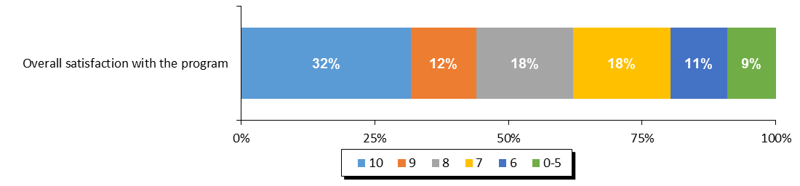

**Source:** *Overall satisfaction with the program.*

#### Overall Web Content Satisfaction

Libraries were asked to rate their level of satisfaction with the web content available to them on the librarians’ website. The levels of satisfaction in 2017 were the highest since 2013, with one third rating their satisfaction a 10 out of 10. Moreover, top three box satisfaction (68%) was the highest on record.

**Figure 10. Satisfaction with Website and Web Content for Librarians**

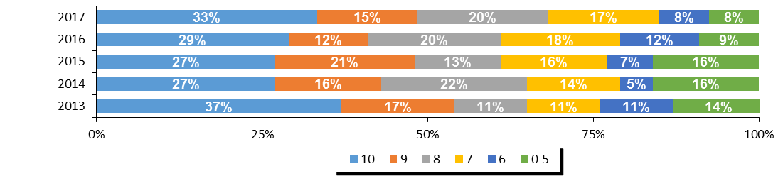

|  |  |  |  |  |  |
| --- | --- | --- | --- | --- | --- |
| **Region** | **Overall Satisfaction With Librarians' Website (Top 3 Box)** | | | | |
| **2017** | **2016** | **2015** | **2014** | **2013** |
| Newfoundland & Labrador | 68% | 61% | 61% | 65% | 65% |

**Source:** *Q5.* *Website and Web Content For Librarians Satisfaction Questions.*

#### Website Navigation

The only element of the web content for librarians which was measured was the ease of navigating the website. The level of satisfaction with the navigation of the website was similar to previous years, with a slight increase when considering top three box (68% in 2017 compared to 65% in 2016).

**Figure 11. Ease of Navigating the Website for Librarians**

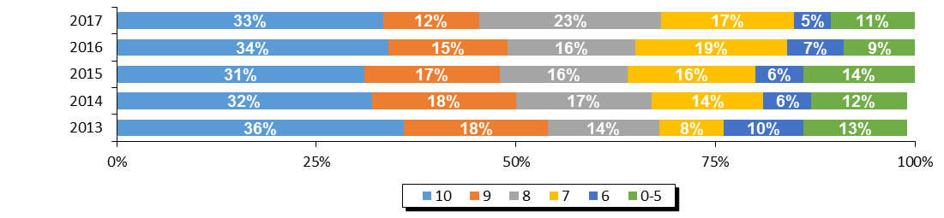

|  |  |  |  |  |  |
| --- | --- | --- | --- | --- | --- |
| **Region** | **Ease of Navigation (Top 3 Box)** | | | | |
| **2017** | **2016** | **2015** | **2014** | **2013** |
| Newfoundland & Labrador | 68% | 65% | 64% | 67% | 68% |

**Source:** *Q5.* *Website and Web Content For Librarians Satisfaction Questions.*

#### Librarian Web Resources

Librarians were asked specifically which of the resources that were available to them were actually used in running their TD Summer Reading Club in 2016. The activities was the resource most used (82%), followed by the recommended reads (72%) and the programs (68%).

**Figure 12. Usage of Librarian Web Resources**

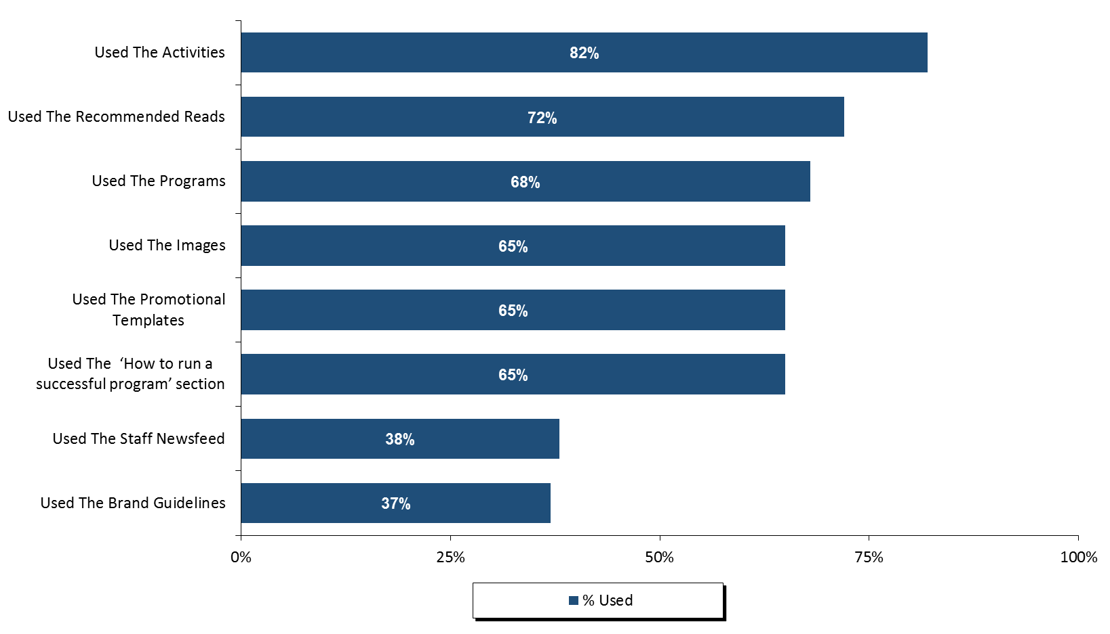

**Source:** *Q6.**Please identify which of the resources on the Librarians’ website you used and, for each resource that you did use, please give your level of satisfaction with it.*

Those who reported using the web resources were then asked to rate their satisfaction with those resources. Satisfaction was high for all of the librarian resources in 2017, but it was highest for the staff’s newsfeed (81% top three box), the brand guidelines (80%) and the ‘how to run a successful program’ section (79%).

**Figure 13. Satisfaction with the Librarian Web Resources**

**Top 3 Box %**

**81%**

**80%**

**79%  
76%**

**72%**

**70%  
68%**

**67%**

**(Ranked By Top Three Box Score)**

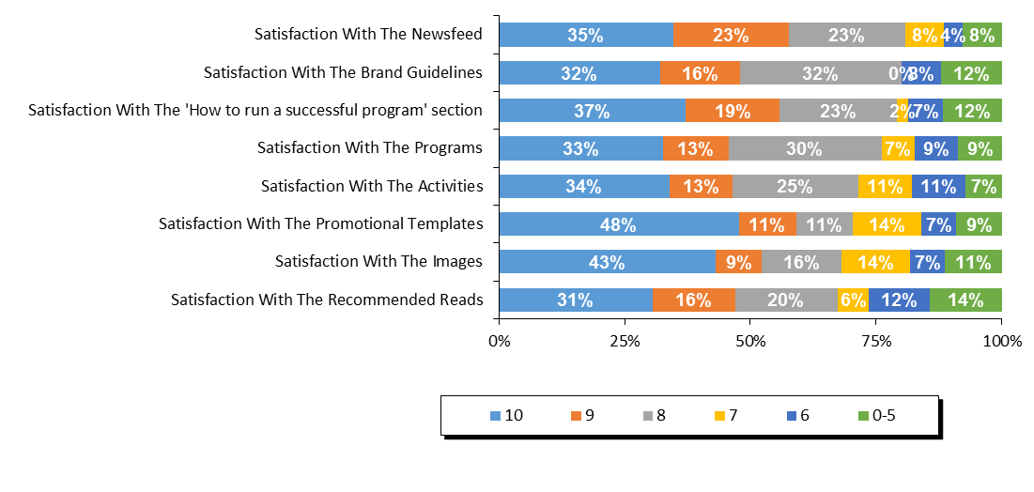

**Source:** *Q6A.**Please identify which of the resources on the Librarians’ website you used and, for each resource that you did use, please give your level of satisfaction with it.*

Librarians were asked for suggestions on how to improve the librarians’ website for future years. Almost two thirds of respondents (65%) were satisfied or had nothing to suggest. Among the suggestions that were given, the two most common was to improve the visual appeal of the clip art or providing a better variety, and to be less restrictive or more flexible with the promotional templates or brand guidelines.

**Figure 14. Suggestions for Librarian Web Resources**

|  |  |
| --- | --- |
| **Suggestions on how to improve any of the web resources for library staff?** | **2017** |
| Satisfied/no suggestions | 65% |
| Improve clip art/more visually appealing/more variety | 10% |
| Less restrictive/more flexible promotional templates/brand guidelines | 10% |
| More suggestions/ideas for programs/activities | 5% |
| Printable certificate/participation award | 5% |
| Provide more detailed/clearer information | 5% |
| Better/more recent/broader booklists | 5% |

**Source:** *QD10.* *Do you have any suggestions on how to improve any of the web resources for library staff?*

#### Satisfaction with the Program Evaluation

Finally, libraries were asked to rate their level of satisfaction with the program evaluation and statistics process for 2017. When looking at the top three box scores, satisfaction increased to 67% from 62% in 2016. However, top box rating decreased slightly from 39% in 2016 to 35% in 2017.

Among the elements of the program evaluation process, the score for ‘ease of using the system’ was higher than ‘the evaluation asks about relevant concerns.’

**Figure 15. Satisfaction with Program Evaluation and Statistics Process**

**Top 3 Box %**

**67%**

**59%**

**63%  
62%**

**74%**

**66%**

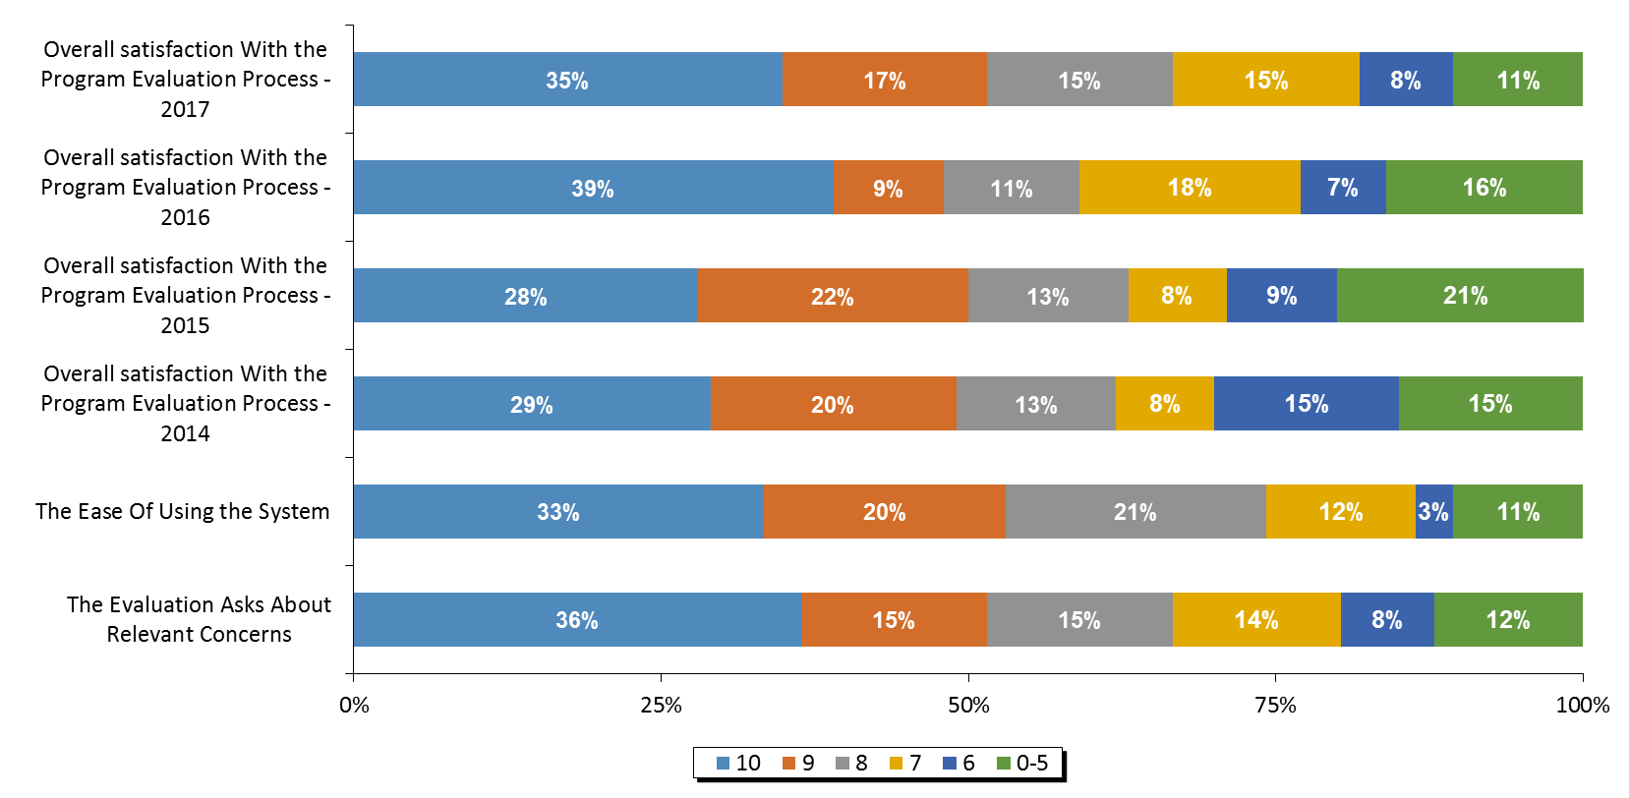

**Source:** *Q7.* *Program Evaluation and Statistics Process Questions.*

Librarians were asked for their suggestions on how the program evaluation and statistical collection process could be improved. Most stated they were satisfied or had no suggestions. Other themes provided have been included in the table below.

**Figure 16. Suggestions for Improving the Program Evaluation and Statistics Process**

|  |  |
| --- | --- |
| **Suggestions on how to improve the statistical collection and program evaluation process?** | **2017** |
| Satisfied/no suggestions | 83% |
| Clarify/better define information requested | 6% |
| Questions don't apply/we can't collect certain statistics | 6% |
| Other | 11% |

**Source:** *QD11. Do you have any suggestions for how to improve the statistical collection and program evaluation process?*

Libraries were asked to share whether they had any indicators of children’s increased enjoyment of reading, reading successes or changes in attitudes toward reading. The most common response was that children said they enjoyed the program and were motivated to read more (33%). Other common responses were related to children and parents enjoying the activities, and related to the children being excited and motivated to read over the summer.

**Figure 17. Testimonials Indicating an Increased Love of Reading**

|  |  |
| --- | --- |
| **Testimonials indicating increased love of reading?** | **2017** |
| Children enjoyed the program/enjoyed reading/were motivated to read more (unspecified) | 33% |
| Children/parents enjoyed the activities/crafts/website | 20% |
| Makes them excited/keeps them reading over the summer | 20% |
| Children enjoy coming back each year | 13% |
| Noticeable improvement in reading level | 13% |
| Challenges/incentives were a motivating factor | 7% |
| Improved confidence/communication skills | 7% |
| Brings more children to the library/they enjoy coming | 7% |
| Children enjoyed story time/hearing stories recited | 7% |
| Other | 13% |

**Source:** *QD12. Do you have any testimonials from parents, caregivers or teachers that may indicate an increased love of reading?*

# 

# Appendix 10 – Territories

**TERRITORIES PROGRAM STATISTICS**

### Response Rate

The participating libraries in the Territories were asked to tally the results of participants in the summer reading club for all of their subsidiary branches. Within all of the Territories, 3 of the 3 participating individual libraries submitted their results, representing an overall response rate of 100%.

Figure 1. Response Rate

|  |  |  |  |  |
| --- | --- | --- | --- | --- |
|  | **Territories** | **NWT** | **Nunavut** | **Yukon** |
| **(A) Total Participating Libraries** | **3** | **2** | **-** | **1** |
| **(B) Total Responded to Survey** | **3** | **2** | **-** | **1** |
| **(C) Survey Response Rate** | **100%** | **100%** | **-** | **100%** |

**Source:** Row (A) provided by Library and Archives Canada. Rows (B) and (C)represent data collected by Nielsen.

## Statistics on Registration & Attendance

### TD Summer Reading Program Registration

The first section of the Statistics and Evaluation Form asked librarians to indicate the total number of children registered for the TDSRC 2017. This reflects the number of children who registered on the sign-up sheet, with the intent to read books as part of the TD Summer Reading Club. In the Territories, an estimated 428 children registered for the TDSRC 2017 program, which is similar to 2016.

Figure 2. Total Registration 2009 – 2017

|  |  |  |  |  |  |  |  |  |  |
| --- | --- | --- | --- | --- | --- | --- | --- | --- | --- |
|  | **Total Registration** | | | | | | | | |
| **Region** | **2017** | **2016** | **2015** | **2014** | **2013** | **2012** | **2011** | **2010** | **2009** |
| Territories | 428 | 430 | 296 | 829 | 1,412 | 609 | 1,300 | 761 | 744 |

**Source:** *Q1 Total number of children who registered for the TDSRC 2017.*

The figure below shows the age breakdown of registered children. For the summer 2017, 28% of the registered children were in the 0-5 age group, 29% were 6-8, 27% were 9-12, and 17% were 13 years or older. Compared to the previous two years, the proportion of registrants 13 years old or older increased notably.

**Figure 3. Percentage of Registered Children by Age 2009 – 2017**

|  |  |  |  |  |  |  |  |  |  |
| --- | --- | --- | --- | --- | --- | --- | --- | --- | --- |
| **Territories** | **2017** | **2016** | **2015** | **2014** | **2013** | **2012** | **2011** | **2010** | **2009** |
| **0-5** | 28% | 43% | 44% | 27% | 36% | 31% | 26% | 30% | 24% |
| **6-8** | 29% | 31% | 28% | 36% | 35% | 37% | 40% | 44% | 38% |
| **9-12** | 27% | 23% | 29% | 27% | 26% | 21% | 30% | 22% | 33% |
| **13+** | 17% | 3% | 0% | 10% | 3% | 11% | 3% | 3% | 5% |

**Source:** *Q1 Total number of children who registered for the TDSRC 2017.*

Figure 4 below summarizes the participation rate for the Territories by age based on 2011 census data. The proportion of all children who were registered in 2017 is practically the same as 2016. The age group with the highest proportion of the total population taking part in the TD Summer Reading Club was 6-8 year olds, with almost 3% of all of the children in the Territories in this age group taking part in the program.

Figure 4. Number of Registered Children

|  |  |  |  |  |  |
| --- | --- | --- | --- | --- | --- |
|  | **2011 CENSUS** | **2017 TD SRC  REGISTRANTS** | **% PARTICIP.  CHILDREN** | **% PARTICIP.  CHILDREN** | **% PARTICIP.  CHILDREN** |
|  | **(A)** | **(B)** | **2017** | **2016** | **2015** |
| **Province / Territory** | **Total Children** | **Total Children** | **Total Children** | **Total Children** | **Total Children** |
| **Territories** | **30,490** | **428** | **1.40%** | **1.41%** | **0.97%** |
| 0-5 | 10,845 | 118 | 1.09% | 1.70% | 1.19% |
| 6-8 | 4,930 | 124 | 2.52% | 2.74% | 1.66% |
| 9-12 | 6,310 | 115 | 1.82% | 1.58% | 1.35% |
| 13+ | 8,405 | 71 | 0.84% | 0.13% | 0.00% |

**Source:** *Q1 Total number of children who registered for the TDSRC 2017, 2016, 2015. Column (A) provided by Statistics Canada Census 2011. Column (B)*

### TD Summer Reading Program Attendance & Activities

To help gauge the success of the TDSRC, libraries were asked to indicate the total number of programs and activities organized around this year’s club theme as well as the total attendance of children at these activities (not including parents or care givers).

When reviewing these numbers, several points need to be kept in mind:

* Every child who registered for the reading club with the library is considered to have attended an activity;
* It is possible that a child did not register for the TDSRC, but attended one or more of the activities; and
* Attendance was calculated on a per activity basis. It is possible that a child attended more than one activity, and thus is represented more than once in total attendance.

A total of 747 children attended the 57 theme-related activities which were organized in libraries across the Territories over the summer months of 2017. Overall, an average of 13 children attended each activity in 2016, and 96% of all activities were conducted in libraries.

Figure 5. Total Activities and Attendance

|  |  |  |  |  |  |  |
| --- | --- | --- | --- | --- | --- | --- |
|  | **Activity Attendance** | | | | | |
| **Region** | | **Theme-Related Activities** | **Total Attendance** | **Avg. Attendance per Activity** | **% of Activities In Library** | **% of Activities In Community** |
| Territories | | 57 | 747 | 13 | 91% | 9% |

**Source:** *Q2. Total number of activities in your libraries and in your community. Attendance at activities in your libraries and in your community.*

The number of activities run by the Territories libraries decreased over 2016, as did attendance at activities.

Figure 6. Activities and Attendance 2015 – 2017

|  |  |  |  |  |  |  |  |  |  |
| --- | --- | --- | --- | --- | --- | --- | --- | --- | --- |
|  | **2017** | | | **2016** | | | **2015** | | |
| **Region** | | **Theme-Related Activities** | **Total Attendance** | | **Theme-Related Activities** | **Total Attendance** | | **Theme-Related Activities** | **Total Attendance** |
| Territories | | 57 | 747 | | 96 | 948 | | 52 | 707 |

**Source:** *Q2. How many of the children registered in your library had participated in the TD Summer Reading Club in previous years and how many were new to the program?*

## Promotion of Program

Librarians were asked to indicate if anyone from their library branch made any visits to the local schools, child care centres, day camps, or to any other locations in order to promote the program.

In 2017, there were no promotional visits reported for the Territories.

### Previous Participation

In the Territories, around a quarter of all registered children (26%) said that they had participated in previous years and the remainder were new registrants in 2017.

Figure 7. Previous Participation

|  |  |  |  |  |  |
| --- | --- | --- | --- | --- | --- |
| **Region** | **Joined in previous years** | | | **New Registrants** | |
| Territories | 110 | 26% | 318 | | 74% |

|  |  |  |  |
| --- | --- | --- | --- |
| **% Joined in Previous Years** | | | |
| **Region** | **2017** | **2016** | **2015** |
| Territories | 26% | 36% | 16% |

**Source:** *Q4. How many of the children registered in your library had participated in the TD Summer Reading Club in previous years and how many were new to the program?*

## Satisfaction & Suggestions

The following section will provide satisfaction scores for every question asked by giving the proportion of libraries who responded with each score from 10 down to 6, along with those who gave a score of 0-5. The overall satisfaction question for each section is reported first and directly compared to previous waves of data (wherever applicable). It is followed by the individual element scores, ranked by the proportion giving a score of 10 (unless otherwise noted). Libraries were also asked for their suggestions and comments in each section.

Please note that libraries that did not provide information for any given question are not considered in the percentages reported here so that each graph will sum to 100%. In some cases, the sum of percentages reported may not add exactly to 100% due to rounding.

#### Overall Satisfaction with the Program

This question was added in 2017 to be able to obtain a measurement of the satisfaction with the program as a whole. Top 3 box overall satisfaction with the program in the Territories is 100%, with half of the libraries responding rating it a perfect 10.

#### **Figure 8. Overall Satisfaction with the Program**

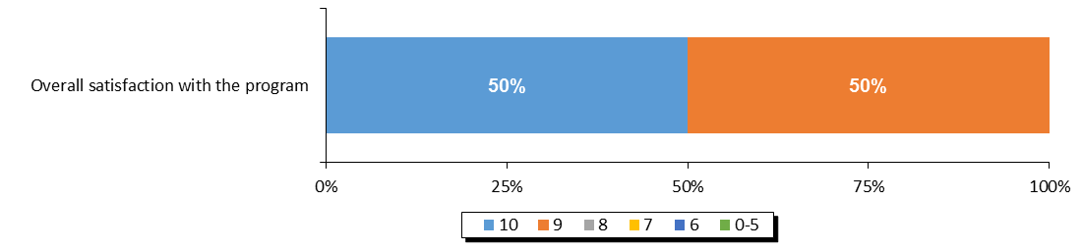

**Top 3 Box %**

**100%**

**Source:** *Overall satisfaction with the program.*

#### Overall Website Satisfaction

Libraries were asked to rate their level of satisfaction with the web content available to them on the librarian’s website. The satisfaction level is comparable to 2016, with all libraries rating their satisfaction within the top three scores.

**Figure 9. Satisfaction with Website and Web Content for Librarians**

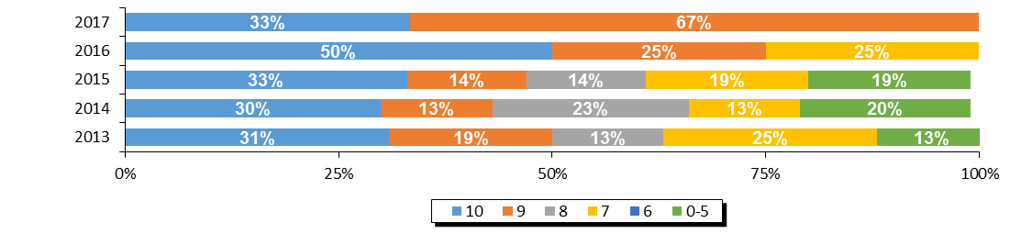

|  |  |  |  |  |  |
| --- | --- | --- | --- | --- | --- |
| **Region** | **Overall Satisfaction With Librarians' Website (Top 3 Box)** | | | | |
| **2017** | **2016** | **2015** | **2014** | **2013** |
| Territories | 100% | 75% | 61% | 66% | 63% |

**Source:** *Q5.* *Website and Web Content For Librarians Satisfaction Questions.*

#### Website Navigation

The only element of the web content for librarians which was measured was the ease of navigating the website. All libraries state that they are fully satisfied with the website navigation.

**Figure 10. Ease of Navigating the Website for Librarians**

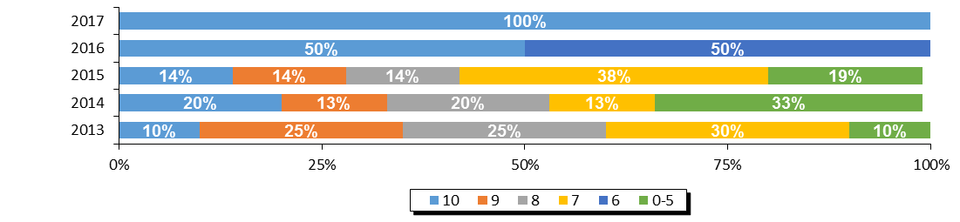

|  |  |  |  |  |  |
| --- | --- | --- | --- | --- | --- |
| **Region** | **Ease of Navigation (Top 3 Box)** | | | | |
| **2017** | **2016** | **2015** | **2014** | **2013** |
| Territories | 100% | 50% | 42% | 53% | 60% |

**Source:** *Q5.* *Website and Web Content For Librarians Satisfaction Questions.*

#### Librarian Web Resources

Librarians were asked specifically which of the resources that were available to them were actually used in running their TD Summer Reading Club in 2017. Overall, almost all the resources were used by all libraries. The only exceptions are the programs (67%), the brand guidelines (67%), and the staff newsfeed (33%).

**Figure 11. Usage of Librarian Web Resources**

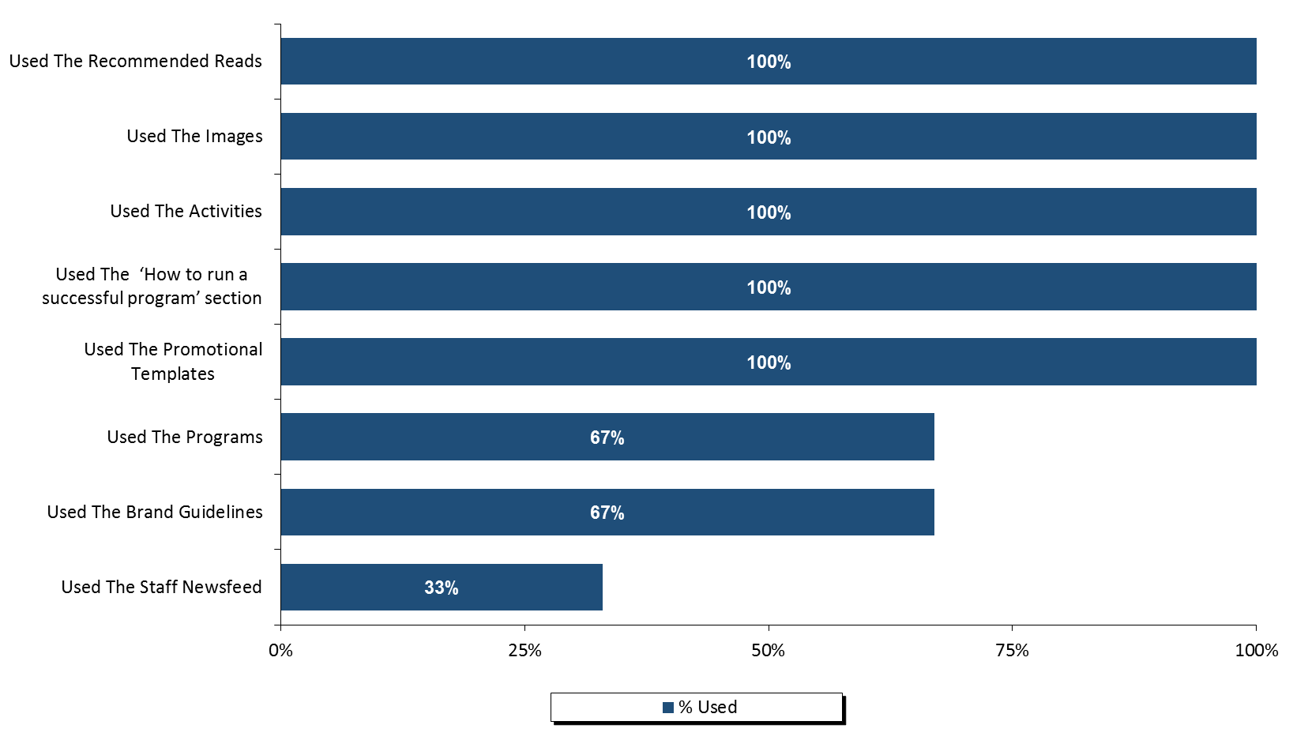

**Source:** *Q6.**Please identify which of the resources on the Librarians’ website you used and, for each resource that you did use, please give your level of satisfaction with it.*

Those who reported using the web resources were then asked to rate their satisfaction with those resources. Top three box satisfaction was 100% for almost all the resources tested. The only exception was a rating of six for the images.

**Figure 12. Satisfaction with the Librarian Web Resources**

**(Ranked By Top Three Box Score)**

**Top 3 Box %**

**100%**

**99%**

**99%  
100%**

**100%**

**100%**

**100%**

**99%**

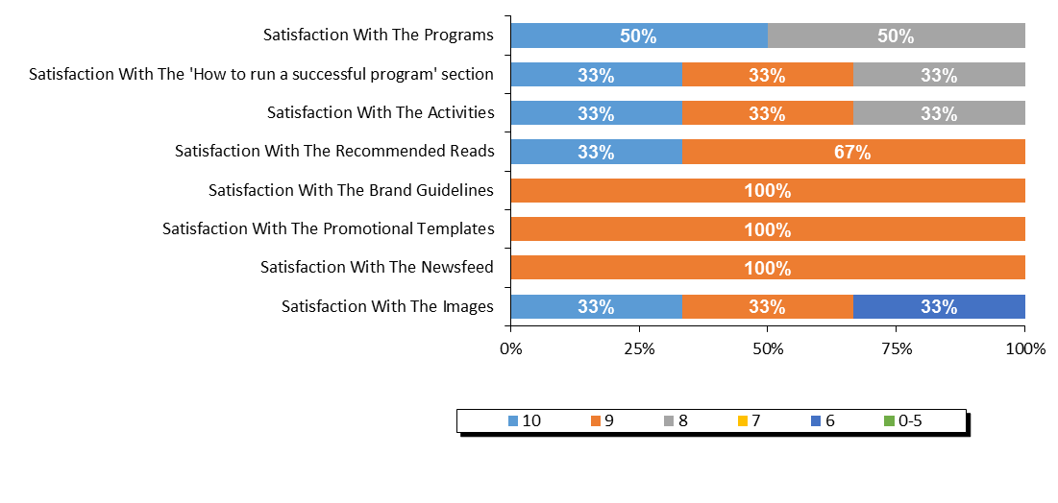

**Source:** *Q6A.**Please identify which of the resources on the Librarians’ website you used and, for each resource that you did use, please give your level of satisfaction with it.*

Librarians were asked in an open ended question for suggestions on how to improve the librarian’s website for future years. No actual suggestions were offered.

**Figure 13. Suggestions for Librarian Web Resources**

|  |  |
| --- | --- |
| **Suggestions on how to improve any of the web resources for library staff?** | **2017** |
| *Satisfied/no suggestions* | *100%* |

**Source:** *QD10.* *Do you have any suggestions on how to improve any of the web resources for library staff?*

#### Satisfaction with the Program Evaluation

Finally, libraries were asked to rate their level of satisfaction with the program evaluation and statistics process for 2017. All libraries responding to the questionnaire indicated that their satisfaction with the program evaluation was 10 out of 10. This satisfaction level correlates with libraries’ satisfaction with the ease of using the system, where all ratings received were also 10 out of 10. There is a gap in satisfaction with the evaluation asking relevant questions.

**Figure 14. Satisfaction with Program Evaluation and Statistics Process**

**Top 3 Box %**

**100%**

**60%**

**62%**

**79%**

**100%**

**28%**

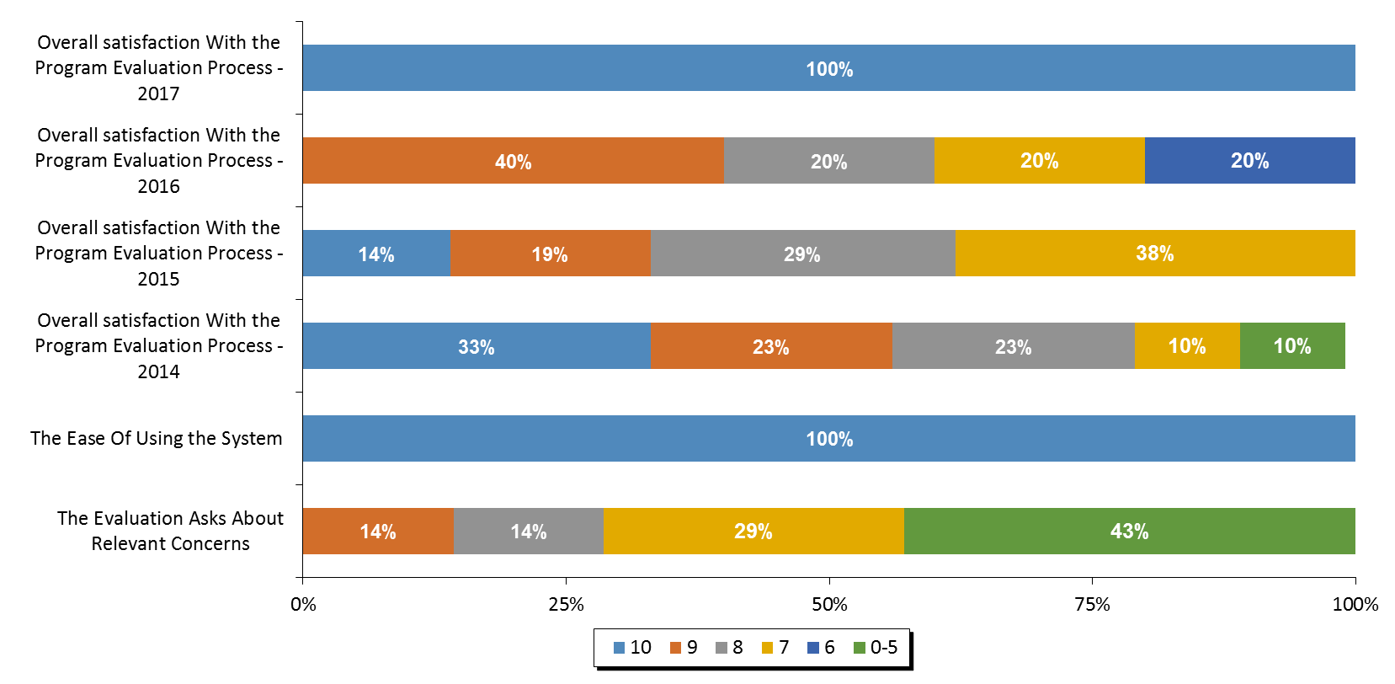

**Source:** *Q7.* *Program Evaluation and Statistics Process Questions.*

Librarians were asked for their suggestions on how the program evaluation and statistical collection process could be improved. No actual suggestions were received*.*

**Figure 15. Suggestions For Improving The Program Evaluation and Statistics Process**

|  |  |
| --- | --- |
| **Suggestions on how to improve the statistical collection and program evaluation process?** | **2017** |
| *Satisfied/no suggestions* | *100%* |

**Source:** *QD11. Do you have any suggestions for how to improve the statistical collection and program evaluation process?*

Libraries were asked to share whether they had any indicators of children’s increased enjoyment of reading, reading successes or changes in attitudes toward reading. The theme of the responses given by the libraries in the Territories is summarized below.

**Figure 16. Testimonials Indicating An Increased Love Of Reading**

|  |  |
| --- | --- |
| **Testimonials indicating increased love of reading?** | **2017** |
| Higher program registration numbers | 50% |
| Children/parents enjoyed the activities/crafts/website | 50% |
| Other | 50% |

**Source:** *QD12. Do you have any testimonials from parents, caregivers or teachers that may indicate an increased love of reading?*

1. The province of New Brunswick did not participate in the program and are not included in this report. The territory of Nunavut participated, but no statistics were available so no extrapolations could be made about their participation statistics.
2. A library system may have many branches, but this number refers to the total number of individual libraries, regardless of whether they are part of a larger system or not.
3. Based on the 1,844 libraries that submitted their information, extrapolations have been made to represent all 2,009 participating branches.