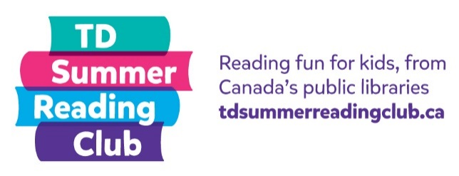
Non-Fiction
Reading Report

My name: __________________________ Age: _______
What I read: ____________________________________
Author: ________________________________________
Rating (Circle one): A = Awesome B = Okay C = Awful
OR My own rating: ______________________________
Answer these questions:
Did you read about something new or interesting in this book?

Why did you choose to read this?
