Dear Principal:
We are sending your school these TD Summer Reading Club (TD SRC) brochures, to include in each child’s year-end report card.
The TD SRC is an inclusive program, in English and French, that strives to engage all children in the joy of reading while championing Canadian writers and illustrators. The program helps to connect families with books and to build confidence in reading through the delivery of free incentives and fun, accessible library activities. Across Canada, libraries aim to inspire a sense of adventure and wonder, nurture children’s imaginations and celebrate their accomplishments.
This summer, the TD Summer Reading Club invites children to unplug and take a moment to explore the stories and science of nature through adventure and play—to marvel at a growing seed, be awed by extreme weather, and wonder about our connection to each other and the earth that sustains us. For more information, please visit our website at www.tdsummerreadingclub.ca.
Please provide your teacher-librarian with one package of the Promotional and Program Materials (pictured on the back of this letter), so they can raise awareness about the program with classroom teachers, students and parents. Your teacher-librarian may also connect with your local library to jointly promote the program or have local library staff visit your school.
Children who register for the TD SRC at their local library receive free program materials and are encouraged to earn stickers by reading over the summer. They are also invited to participate in programs organized at their local library and to share their love of reading with children across the country through the TD SRC website. We provide a list of recommended reads, but children can also connect with local library staff for more great reading suggestions.
Here are some suggestions on how to raise awareness about the value of summer reading:
- Consider adding the TD SRC as a topic for discussion at your next staff meeting.
- Discuss the TD SRC with parents and caregivers through school council, parenting centres or community events.
- Promote the TD SRC in your school newsletter, website or other school-home communications.
- Connect with staff at your local library to jointly promote the program at your school or to organize school visits to the library for this purpose.
- Encourage students to submit jokes, book reviews and stories on the TD SRC website.
- Invite students to bring their completed notebooks to school in the fall. Celebrate their accomplishments on a bulletin board or during the morning announcements. Consider asking your teacher-librarian to coordinate this process.

Thank you for helping us to promote the TD SRC program to children at your school and for sharing the joy of reading!

If you have any questions about this package, please contact:

[Insert contact information]

A guide to the TD SRC materials:
Promotional Materials

Top Recommended Reads brochure  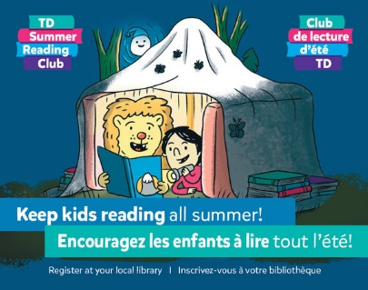 | Please distribute one Top Recommended Reads brochure to each student in his or her year-end report card package.
Poster | Please display in prominent locations in your school.
Program Materials (items the children will receive at their local library)

Notebooks  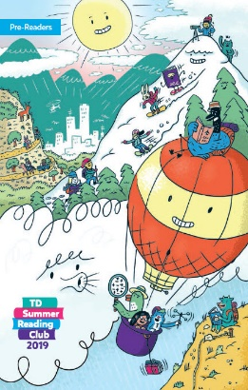  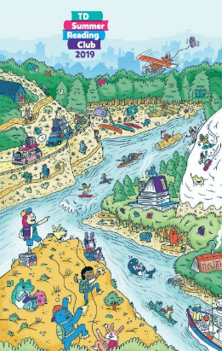 | All children receive this item. There are two versions, one for pre-readers (children ages 0–5) and their parents and caregivers, and the other for children ages 6–12. The notebook gives children space to record their summer reading, and it offers blank spaces for stickers they collect, or to draw and design anything they want.
Web Access Sticker  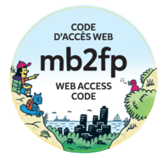 | All children receive this item. This sticker will contain a unique access code, which a child may enter at the TD SRC website to create his or her online notebook, where virtual stickers and books read will be stored.
Fortune Teller  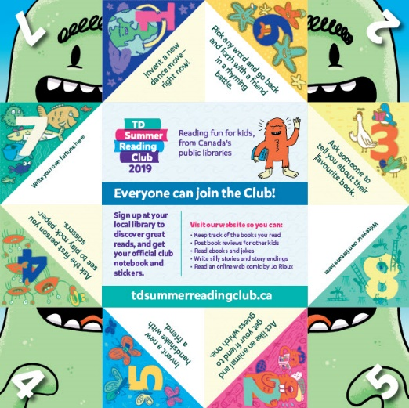 | The fortune teller includes folding instructions, jokes, and encouragement to join the Club.
Stickers  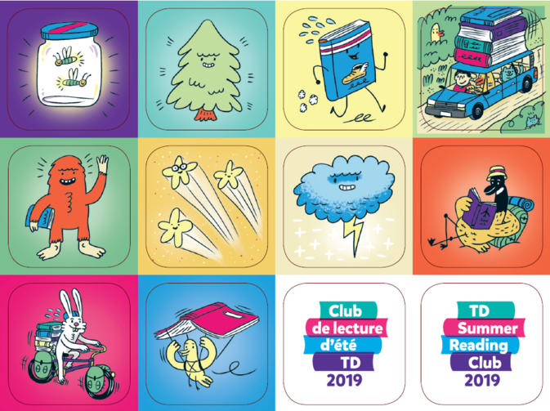 | Children can get a sticker by visiting their library, where staff will usually ask them a question about the book they read. If parents or caregivers cannot bring the children into the library to collect stickers throughout the summer, they can request the whole sheet, and distribute them at home as the books are read.

