Quick Guide to the TD Summer Reading Club Print Materials

School-age notebook

A bilingual notebook designed for school-age children. Distribute one to each child aged 6 to 12.

Pre-reader notebook

A bilingual notebook designed for parents and caregivers to use with pre-readers. Distribute one to each child aged 0 to 5.
Web access sticker

A sticker with a unique code that allows kids and families to create an online notebook, read ebooks and track reading at tdsummerreadingclub.ca. The sticker should be placed in the inside cover of the notebook. Distribute one to each child.

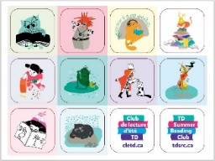 | Sticker sheet  Stickers for use with the notebooks. The 12 stickers are placed in the empty boxes throughout the pre-reader and school-age notebooks. Distribute the entire sheet or one sticker at a time, depending on your library’s procedure.
Top recommended reads brochure

A brochure to promote the Club to parents, caregivers and educators. Distribute for promotional purposes.

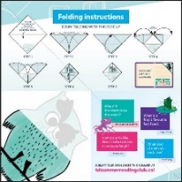 | Corner bookmark  A promotional item for kids. There are separate English and French bookmarks. Distribute to kids as desired for promotional purposes.
Poster
A bilingual 11” x 17” promotional poster to be displayed in your library or posted in your community to promote the Club. There is space at the bottom of the poster to add your library’s information.

