Dear Teacher-Librarian:

Thank you for helping us promote the TD Summer Reading Club program to kids at your school.

The TD Summer Reading Club (TDSRC) is Canada’s biggest, bilingual summer reading program for kids of all ages, interests and abilities. This free Club is offered at more than 2,200 public libraries across Canada, as well as online. The TDSRC celebrates Canadian authors, illustrators and stories, and inspires kids to explore the fun of reading their way. This is key to building a lifelong love of reading.

For more information about the TDSRC, check us out online: www.tdsummerreadingclub.ca.
In May, your school’s principal will receive a package containing brochures to go home with year-end report cards.
We’ve asked principals to give teacher-librarians a sample package and we also offered suggestions on how to promote the TD Summer Reading Club. You may consider connecting with your local library to jointly promote the program at your school or to organize visits to the library for this purpose.
You may wish to ask students to bring their completed notebooks to school in the fall to celebrate their accomplishments.

Attached is a quick guide to the TD Summer Reading Club materials. If you have any questions about this package, please contact:

TD SUMMER READING CLUB MATERIALS

Promotional Materials

Top Recommended Reads Brochure

Please distribute a Top Recommended Reads brochure to each student in their year-end report card package.
Poster

Please display the poster in a prominent location in your school.

Program Materials (Items kids will receive at their local library)
Notebooks  There are multiple versions of the notebook:  - A bilingual pre-reader notebook for parents and caregivers to use with their kids aged 0–5.  - A bilingual school-age notebook for kids aged 6–12.  - Accessible notebooks in a variety of formats (audio, large print, braille and OpenDyslexic font). The accessible notebooks are not included in this sample package, but they are available at participating public libraries and online. | 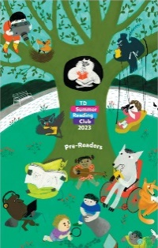
Web Access Sticker  This sticker contains a unique access code that kids can enter at the TD Summer Reading Club website to create their online notebook. It gives kids access to free ebooks and allows them to collect badges for reading and participating in activities. | 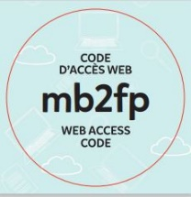
Corner Bookmark  The corner bookmark includes folding instructions, jokes and encouragement to join the Club.  There is an English bookmark and a French bookmark. | 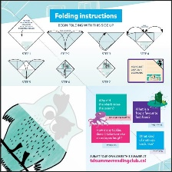
Stickers  Stickers can be used as reading incentives by library staff or by parents and caregivers. | 