- Collect pieces of nature that have fallen to the ground or dried materials or plastic materials that resemble nature

- Cut a circle out of the plate

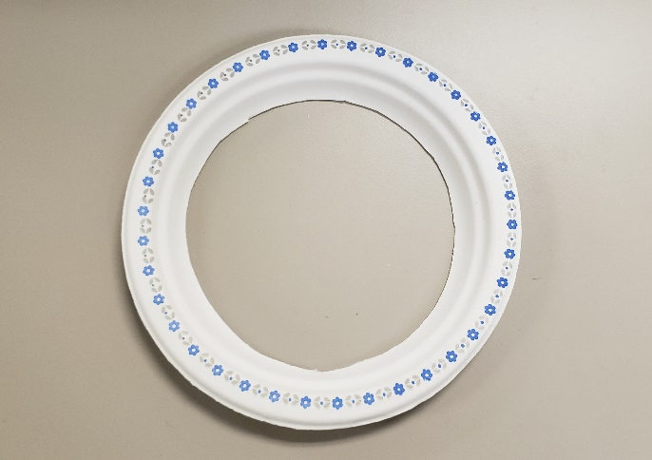

- Cover the back of the circle with packing tape or contact paper and press down on the tape to secure it

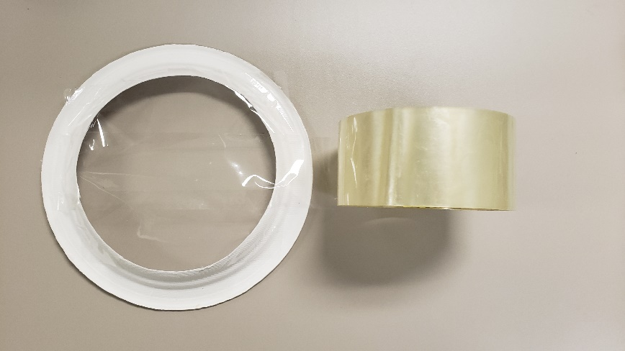

- Cut excess tape around the rim of the plate
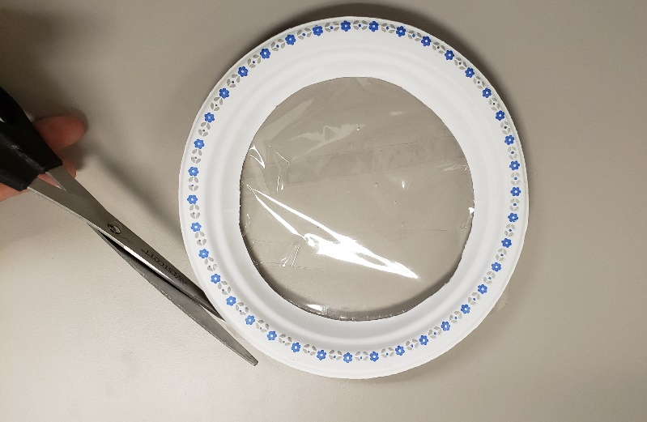

- Add pieces of nature that have fallen to the ground, dried plants or flowers or plastic nature material. This example includes plastic berries and flowers, real dried lavender and small rocks in the circle of the chime

- Add beads or bells to a piece of string, yarn or ribbon by tying knots between beads, and then attach it to the back of the wind chime. Then add a string, yarn or ribbon to the top to hang.

