Dear Principal:
We are sending your school these TD Summer Reading Club brochures to include in each child’s year-end report card.

The TD Summer Reading Club (TDSRC) is Canada’s biggest, bilingual summer reading program for kids of all ages, interests and abilities. This free Club is offered at more than 2,200 public libraries across Canada, as well as online. The TDSRC celebrates Canadian authors, illustrators and stories, and inspires kids to explore the fun of reading their way. This is key to building a lifelong love of reading.

For more information about the TDSRC, check us out online: www.tdsummerreadingclub.ca.
Please give your teacher-librarian the Promotional Materials and Program Materials packages (pictured on the back of this letter), so they can raise awareness about the program with classroom teachers, students and parents.
Here are some ways to raise awareness about the value of summer reading:
- Make the TD Summer Reading Club a discussion topic at your next staff meeting.
- Discuss the Club with parents and caregivers through your school council, parenting centres or community events.
- Promote the TD Summer Reading Club in your school newsletter, on your website or in other school-home communications.
- Encourage teachers and the teacher-librarian to connect with staff at your local library to jointly promote the program at your school or to organize visits to the library for this purpose.
- Encourage students to check us out online at tdsummerreadingclub.ca.

Thank you for helping us to promote the TDSRC to kids at your school and for sharing the joy of reading!

If you have any questions about this package, please contact:

TD SUMMER READING CLUB MATERIALS

Promotional Materials

Top Recommended Reads Brochure  Please distribute a Top Recommended Reads brochure to each student in their year-end report card package. | 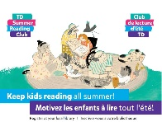
Poster  Please display the poster in a prominent location in your school. | 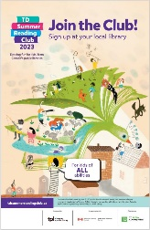
Program Materials (Items kids will receive at their local library)
Notebooks  There are multiple versions of the notebook:  - A bilingual pre-reader notebook for parents and caregivers to use with their kids aged 0–5.  - A bilingual school-age notebook for kids aged 6–12.  - Accessible notebooks in a variety of formats (audio, large print, braille and OpenDyslexic font). The accessible notebooks are not included in this sample package, but they are available at participating public libraries and online. | 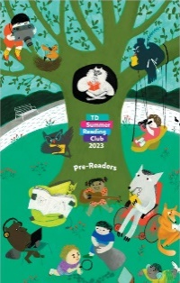
Web Access Sticker  This sticker contains a unique access code that kids can enter at the TD Summer Reading Club website to create their online notebook. It gives kids access to free ebooks and allows them to collect badges for reading and participating in activities. | 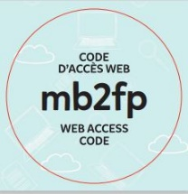
Corner Bookmark  The corner bookmark includes folding instructions, jokes and encouragement to join the Club.  There is an English bookmark and a French bookmark. | 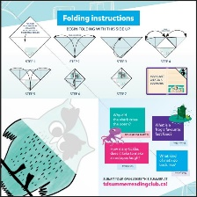
Stickers  Stickers can be used as reading incentives by library staff or by parents and caregivers. | 