- Draw cloud and cut it out or cut cloud out from template
- Glue cotton balls, tissue paper or other materials to cloud to decorate it
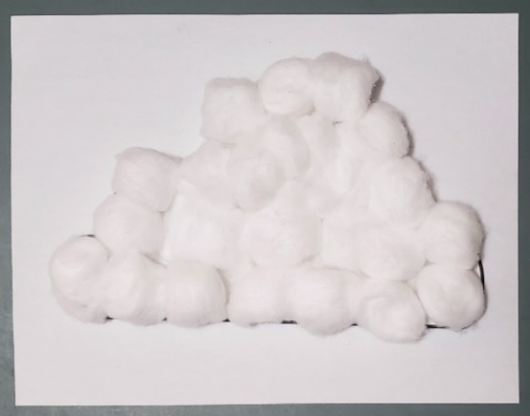

- Create rainbow using tissue paper strips, paper strips or string
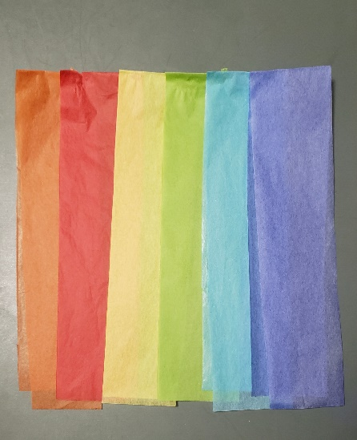

- Attach rainbow to the back of the cloud

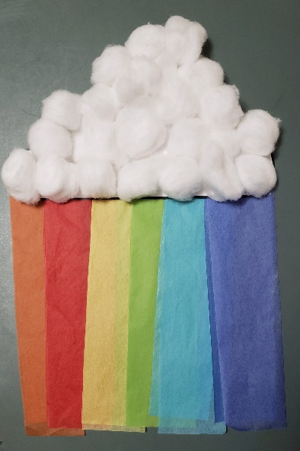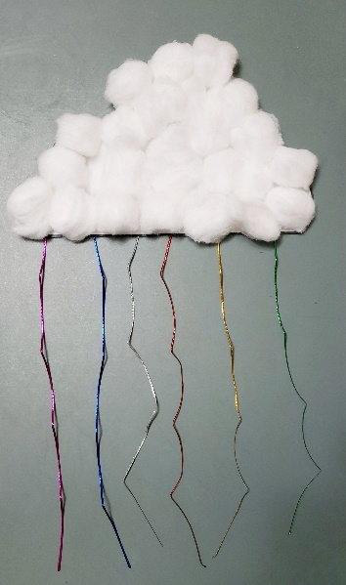

Accessibility Considerations
- Offer kids a variety of instruments to create their cloud, and encourage them to choose what they feel most comfortable with
- Pre-cut strips of paper, tissue paper, strings or ribbons
- Offer easy-grip scissors
- Offer larger glue sticks
- Pour glue into a shallow container with large craft sticks for kids to share

Book Suggestions
In the Clouds by Elly MacKay
I Sang You Down from the Stars by Tasha Spillett-Sumner and Michaela Goade
Kumo: The Bashful Cloud by Kyo Maclear and Nathalie Dion
Lizzy and the Cloud by The Fan Brothers
Mii maanda ezhi-gkendmaanh / This Is How I Know by Brittany Luby and Joshua Mangeshig Pawis-Steckley
The Secret Signs of Nature: How to Uncover Hidden Clues in the Sky, Water, Plants, Animals and Weather by Craig Caudill and Carrie Shryock

