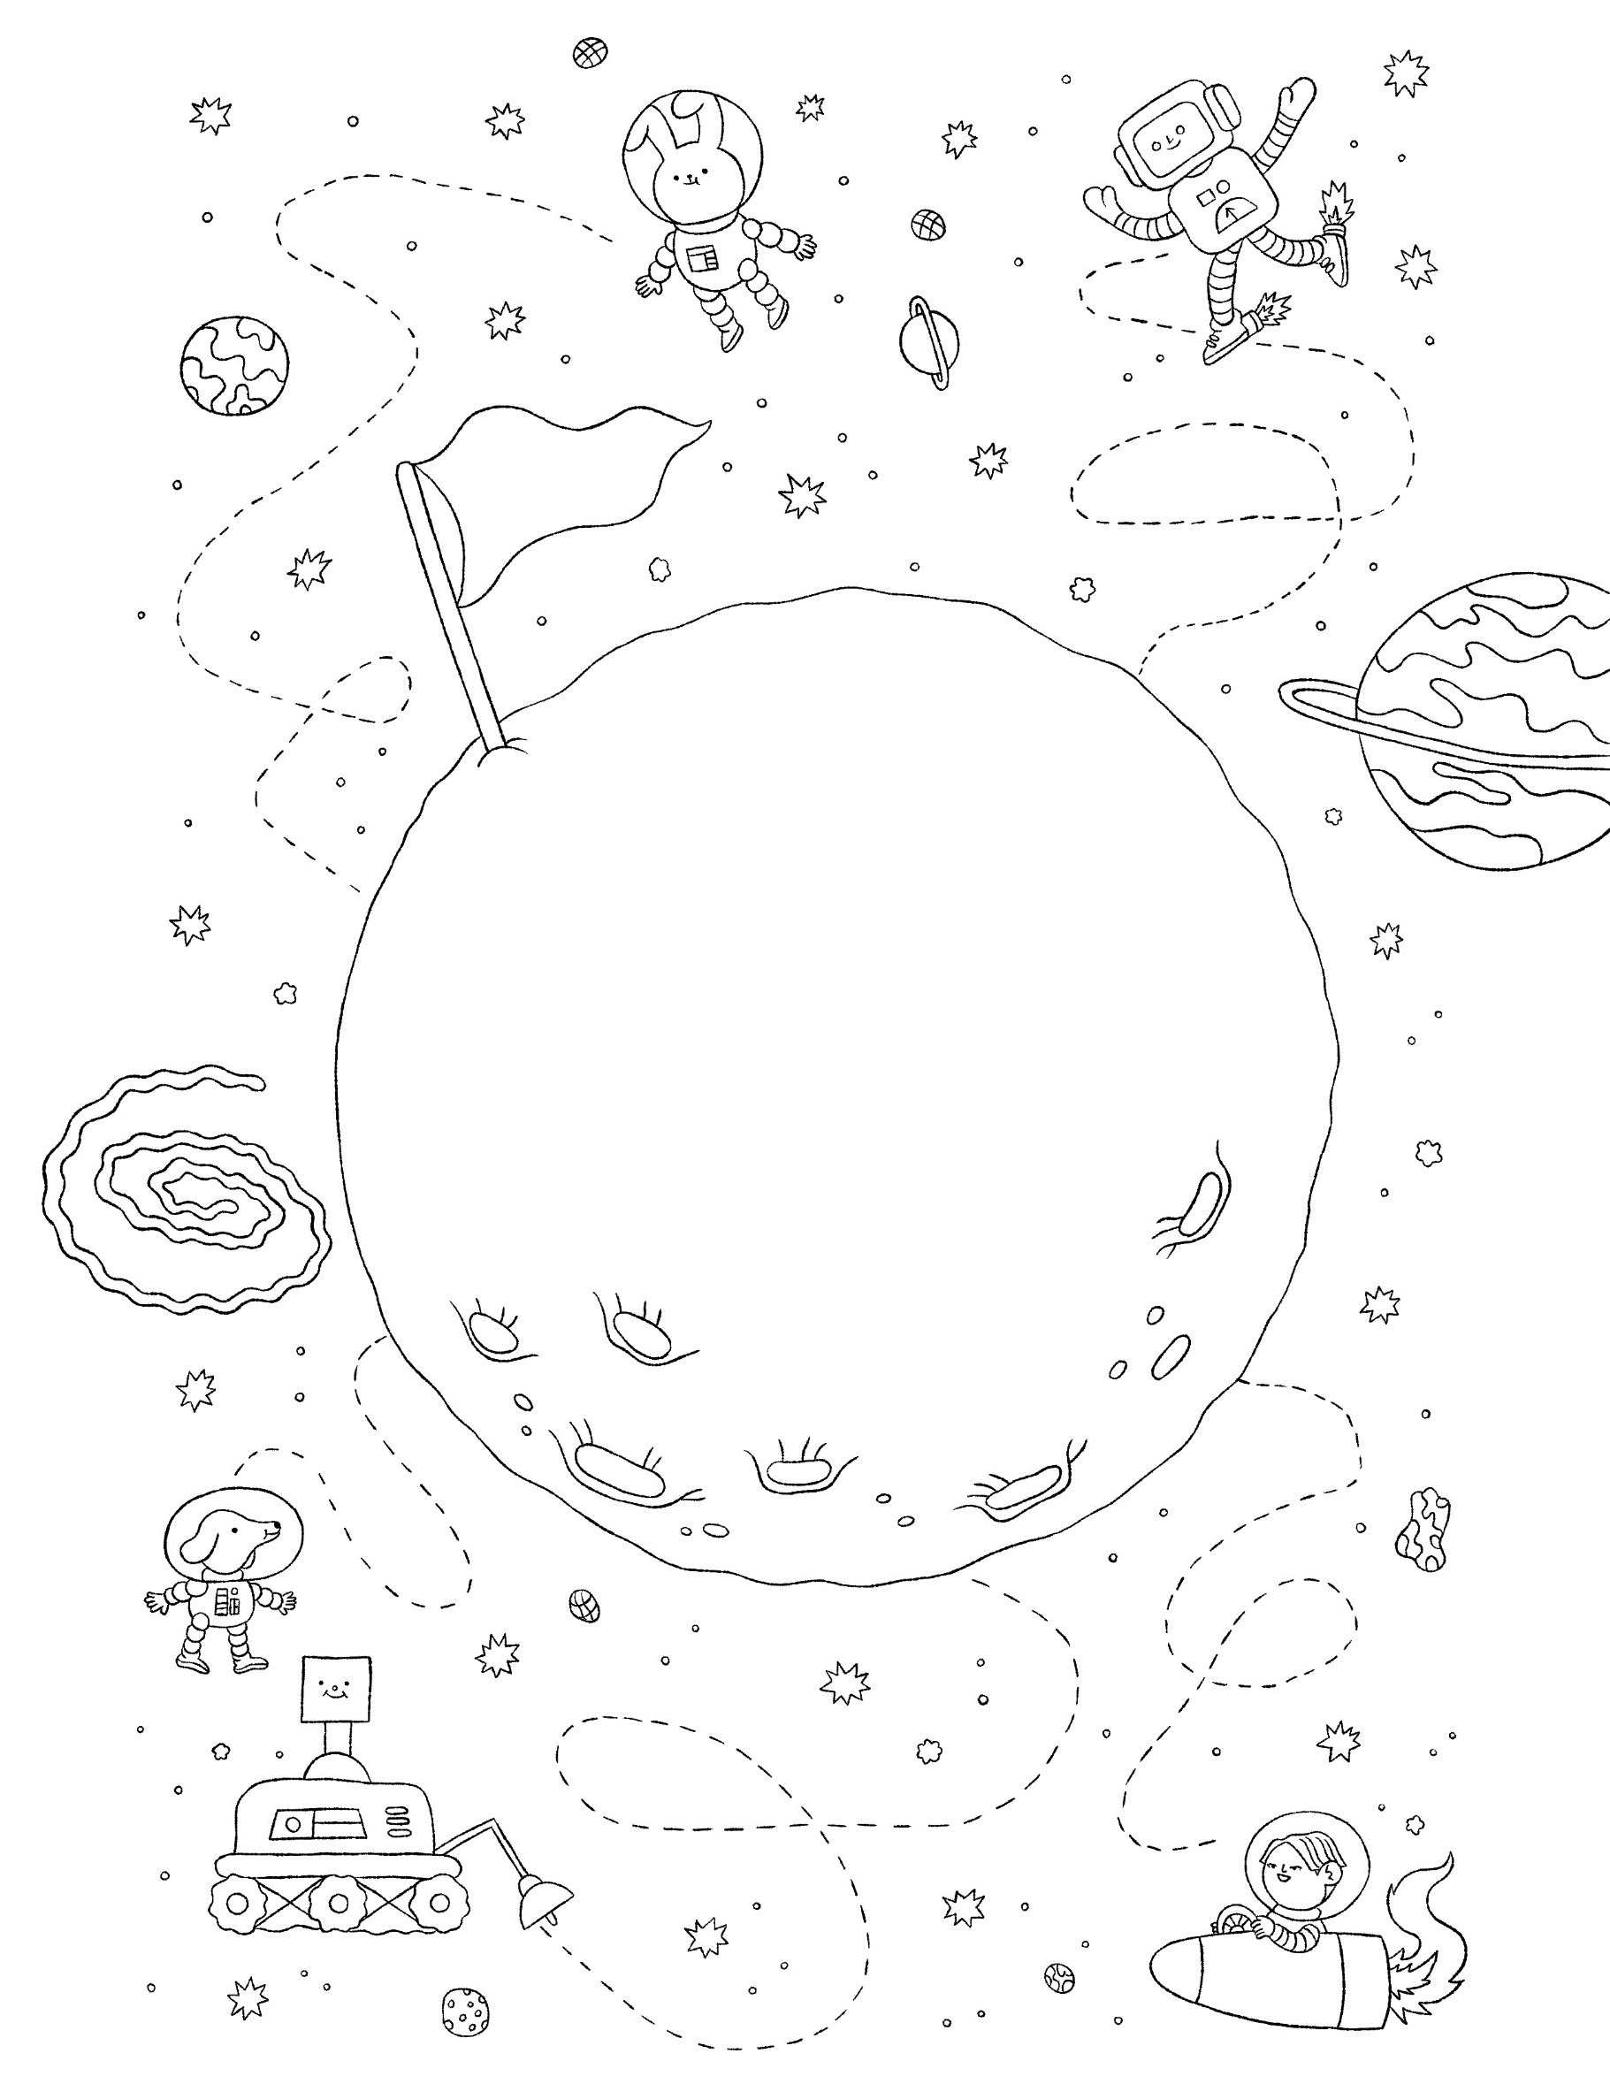

Rules of Measurement

- Start at one end point
- No gaps
- No overlaps
- Use the same measuring tool the entire way

For example, using paperclips. These paperclips could be even closer together. Can you try?
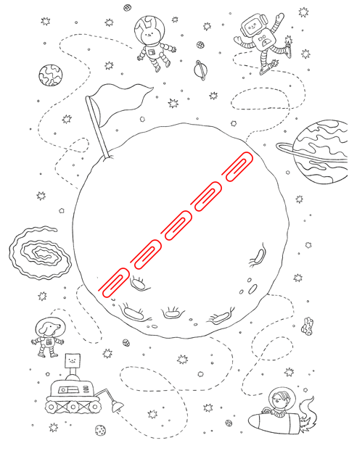
Measure the length of the paper, the moon, the flag, the rover, Cosmo the robot, etc.

