① Each constellation below uses a 30 cm pipe cleaner

② Count out how many beads you need

③ Bend and twist the pipe cleaners, then add the beads or add beads as you go

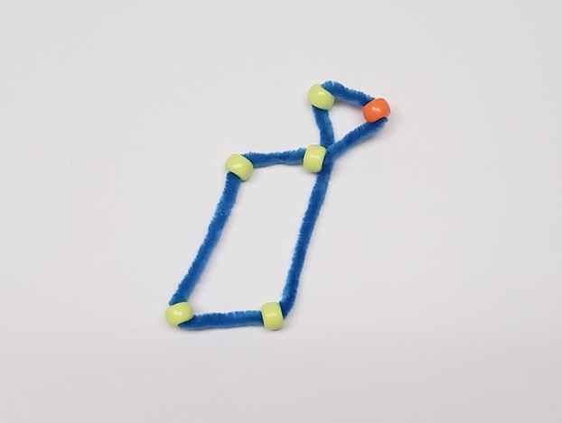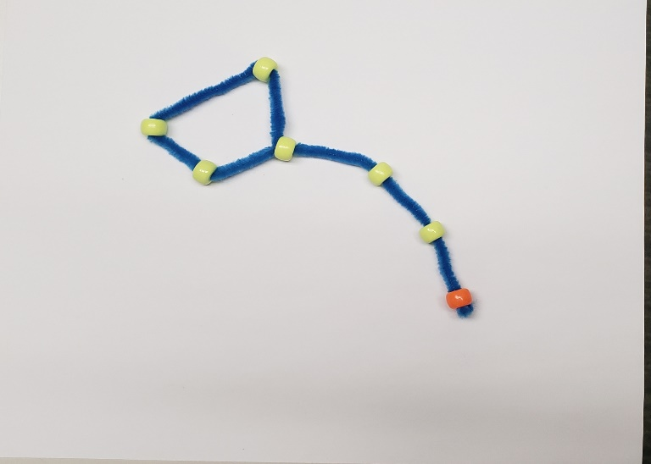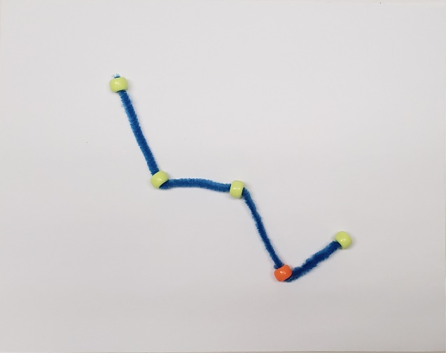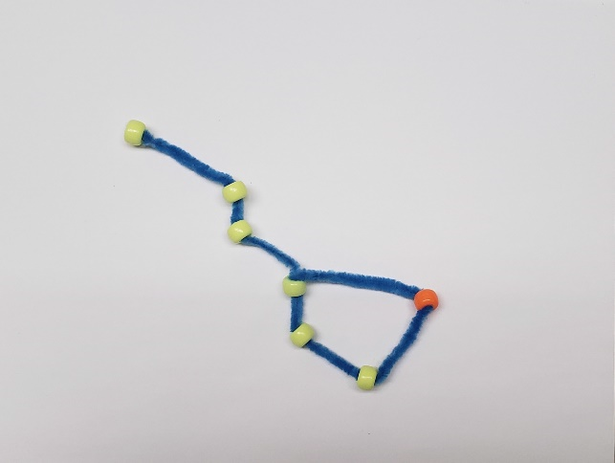 

**Big Dipper**

**Lyra**

**Little Dipper**

**Cassiopeia**