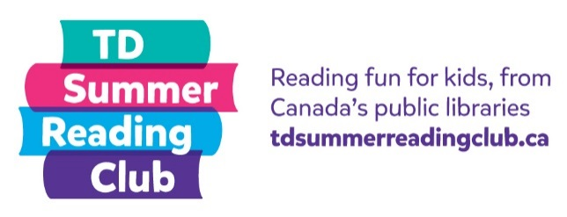
Reading report:
Non-fiction

Name: __________________ Age: _______

Title: _______________________________
Author: _______________________________

My rating:

Not so good OK Amazing!

What was the most interesting thing you read in this book?

Why did you choose this book?

