Social Media Plan

Social media platforms are great for gaining attention, reaching out and engaging with our audiences. Think about how you can promote the TD Summer Reading Club to your audience in the days and weeks leading up to Get Your Summer Read On Day, on the day itself, and throughout the summer.

The official social media usernames for the TD Summer Reading Club are @TDSRC_CLETD for Twitter and Instagram, and @TDSRC.CLETD for Facebook. The official hashtag is #TDSRC. Please be sure to include this in your social media posts so we can track and share your posts on Get Your Summer Read On Day. And don’t forget to include it in all your social media throughout the summer!

We have also created a 2021 TD Summer Reading Club board on Pinterest to provide libraries with craft and activity ideas.

If you are including program participants in your photos, please let them know that their image could be shared on the TDSRC’s social media platforms and get their approval before sharing their image with us.

General Tips

- Early in the morning or after kids’ bedtime is the best time to reach parents on Facebook and Twitter. You can also use analytics to find out the best times to post.

- Visual content gets better results than text-based posts on social media. In addition to text, post illustrations, photos and videos of your programming and special events to help liven up your posts.

- Good quality photos help increase the engagement rate (this includes likes, shares and comments). Avoid posting blurry images and make sure to have good lighting when taking your photos.

- Use all the options provided by social media platforms (from Reels to Stories, to Lives and Highlights) to engage with your audience. Also, use live tweet and streaming features when possible.

- Think branding—whenever possible, try to incorporate the TDSRC logo by holding a notebook, wearing a T-shirt, or taking a picture near a poster.

- Hashtags provide audiences with an easier way to find relevant content to interact with and share, especially when using platforms like Instagram and Twitter. Test the waters and see which hashtags work well for your library and be sure to always include the hashtag #TDSRC in your posts.

- Use @mention or tag prominent figures in the community who can help share your post and widen its reach.

- Engage with your followers by responding to social media comments in a timely manner.

- Tag other libraries so you can share and promote each another’s activities.

- If you need help with graphic design, Canva is a great tool that makes graphic design amazingly simple for everyone!

Pinterest/Instagram

Post pictures of your TD Summer Reading Club’s fun activities and tag them #TDSRC.
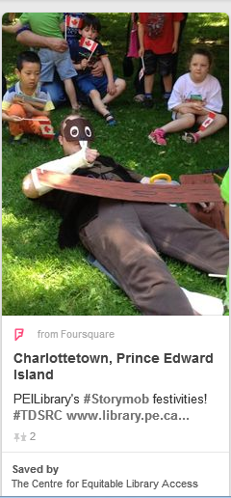
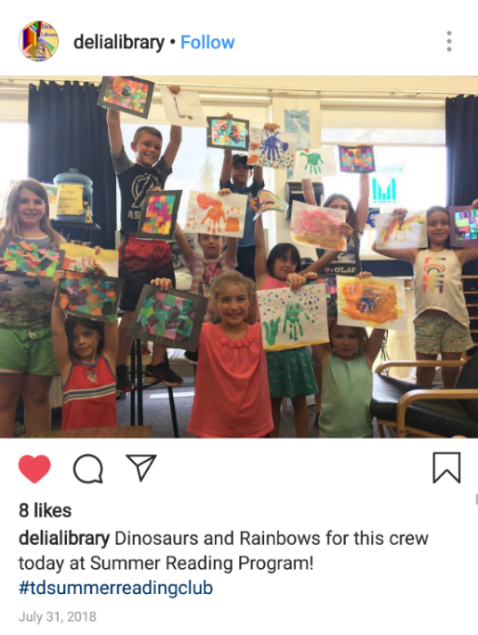

Sample Social Media Images:

Here are some sample images that would work well on social media. Use your own images in your social media posts to liven them up! We’ll be happy to share your posts on the Club’s national social media.

For Quebec ONLY
