Preparation
Ice Cube Excavation
- One day or more before the program, put various items in ice cube trays and freeze them
Recommendations
- Use items that would be easy to excavate
- The same items can be used for all of the ice cubes or you can vary the items
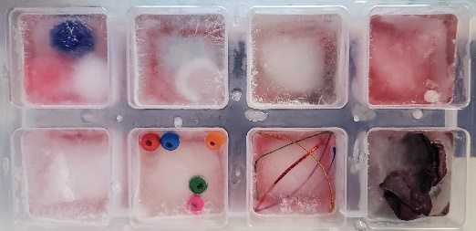
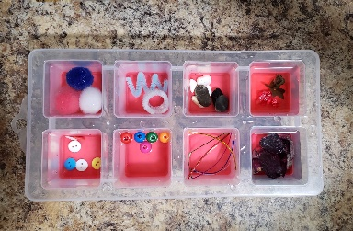
- Size of item should match the ice cube mold – even if item sticks out of the cube, it is better than it being so small that it takes a long time to excavate

Sandbox Excavation
- Put various items inside tub(s) filled with sand

Newspaper Bin Excavation
- Put various items inside small containers like plastic Easter eggs, gacha containers or just wrapped inside newspaper
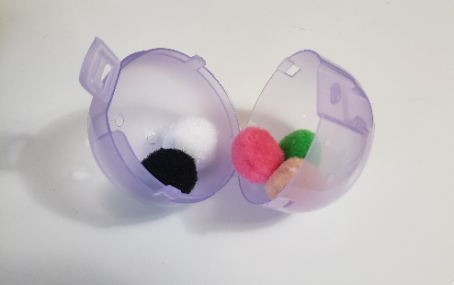
- Create newspaper balls for a newspaper bin

Implementation
Ice Cube Excavation
- Distribute an ice cube to each participant on a dish or in a container
- Participants can rub their hands together and then pick up the ice cube and try to melt it with their body heat
- They can use a bit of salt (optional)
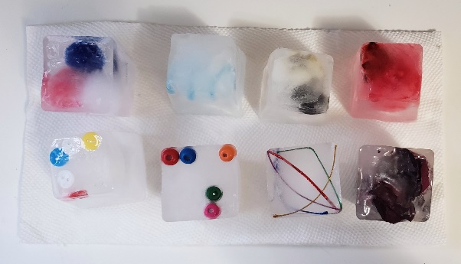

Sand Box Excavation
- Distribute a sandbox with hidden items and a spoon or shovel to each participant OR have participants line up in front of one or several containers with each child excavating an item
- Participants can use their hands, a spoon or a shovel to dig up an object
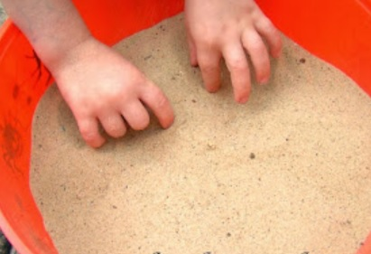

Newspaper Bin Excavation
- Have participants line up in front of one or several bins of newspaper balls and take turns trying to find an item

