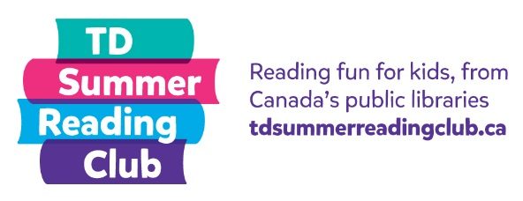
Book Reporting

Research shows that children who engage in conversations with adults have better language and cognitive skills. Consider book reporting as a fun way to start a conversation with kids about what they’ve read. It’s a great opportunity to get to know kids in your library and learn about their reading interests.

There are a variety of ways to determine which question to start with when a child comes to report on something they’ve read. Consider using one of the following popular methods:

Dice: Use a pair of dice and ask the question that corresponds to the total roll (number the questions 2 to 12, since 2 is the lowest roll with a pair of dice and 12 is the maximum). If desired, you can remove six of the questions and have them roll only one die (number the questions 1 to 6).

Picking numbers: Make a special box or decorate a container. Add the questions or numbers that correspond to one of the questions and have the kids draw from the container.

Plastic eggs: Fill a basket with plastic eggs. Fill each egg with a different question or a number that corresponds to one of the questions. Have the kids select an egg.

Using a wheel: Create a wheel with corresponding numbers, which kids spin to determine their question. If you have access to a 3D printer, we’ve created a spinner and arrow you can download, print and then put together to create a wheel. Alternatively, use an online wheel that kids can spin:

Online wheel

We’ve included three sets of book report questions:
- For fiction books
- For non-fiction books
- For very young children (under 5 years old)—This list is organized based on whether or not they have the book they are reporting on in front of them. You may have to modify the questions based on the book and the conversational ability of the child. If a child is struggling to answer a question, you can ask simple follow up questions or choose a different question entirely.

Modify the suggested questions and question numbers as desired.
Book Report Questions for Fiction

- What was the best part of the book?

- Who was the main character? Did you like them? Why?

- Imagine you could take a character from the book to any place. Where would you go? What would you do together?

- What happened at the beginning of the story?

- FREE STICKER—no questions asked!

- If you could be someone in the story, who would you be and why?

- What was the most interesting part of the story?

- How did the story end?

- Can you think of anything that would make the story even better?

- Why did you choose this book?

- Where did this story take place? Is it a place you would like to visit?

Book Report Questions for Non-fiction

- Describe one thing that you didn’t know until you read this book.

- What was the funniest, weirdest or most interesting fact you read in this book?

- Out of a possible 5 stars, how many stars would you give this book? Why?

- FREE STICKER—no questions asked!

- Why did you choose this book?

- If you could ask the author one question, what would you ask?

Book Report Questions for Young Children (Under 5)

With the reporting book in hand:

- Can you show me your favourite picture in the book?

- What/who is this? (Point to something in the book.)

- Who was your favourite character/person/animal in this book? Can you point to them?

- What are they doing here? (Point to a character.)

- What happened on the first page of this book?

- What happened on the last page of this book?

Without the reporting book:

- Did you like the book? Why?
- What was your favourite thing about the book?
- Do you give the book a thumbs up (good) or a thumbs down (bad)?
- Who was your favourite character/person/animal in the book?
- What happened at the end of the book?
- Did you read the book with someone else? Did they like the book?

