Glue-filled Ghost
- Participants may use a glue ghost stencil and fill the ghost in with a thin layer of glue or create their own ghost shape and fill it in with a thin layer of glue.
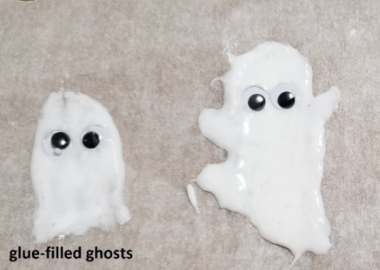
  - Note: The more glue added, the less see-through it will be and the longer it will take to dry
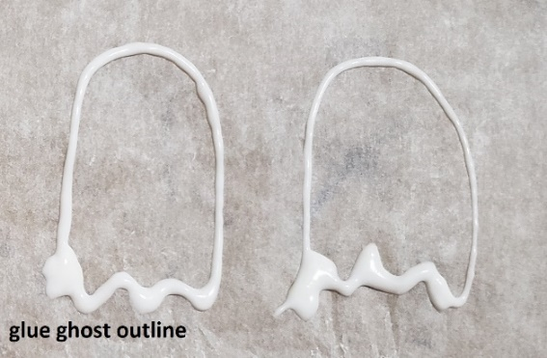
- Add googly eyes to the ghost while glue is wet or wait until ghost is dry to add eyes with a marker
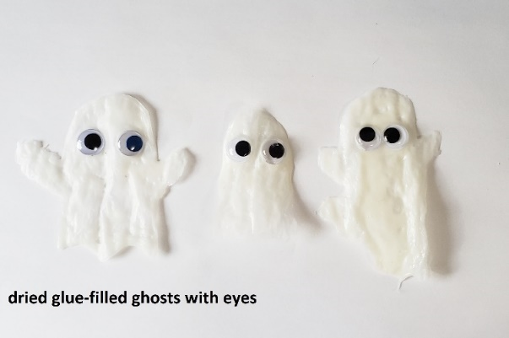
Glue-outlined Ghost
- Participants may use a glue stencil or create their own ghost shape
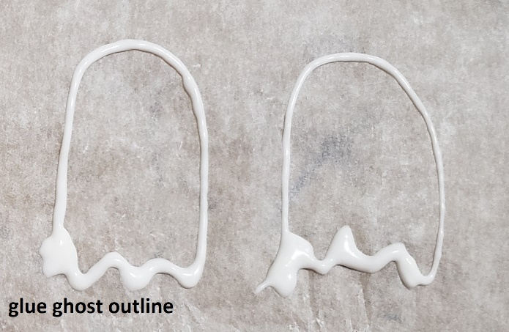
- Add face to glue-outline ghost using a marker
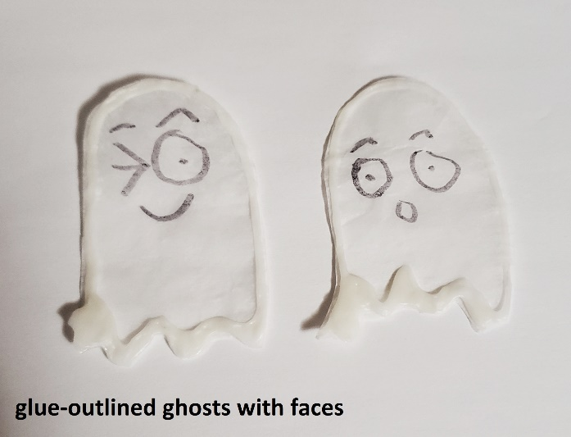
- Once glue outline is dry, carefully cut ghost out and add it to the background you have created

Glue Ghost Background Environment
- While glue ghost is drying, create a background environment for your ghost on a separate piece of paper or use the template
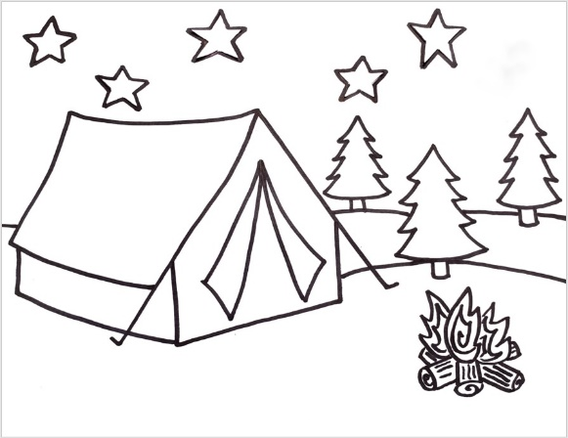
- When glue ghosts are dry, add them to your background
