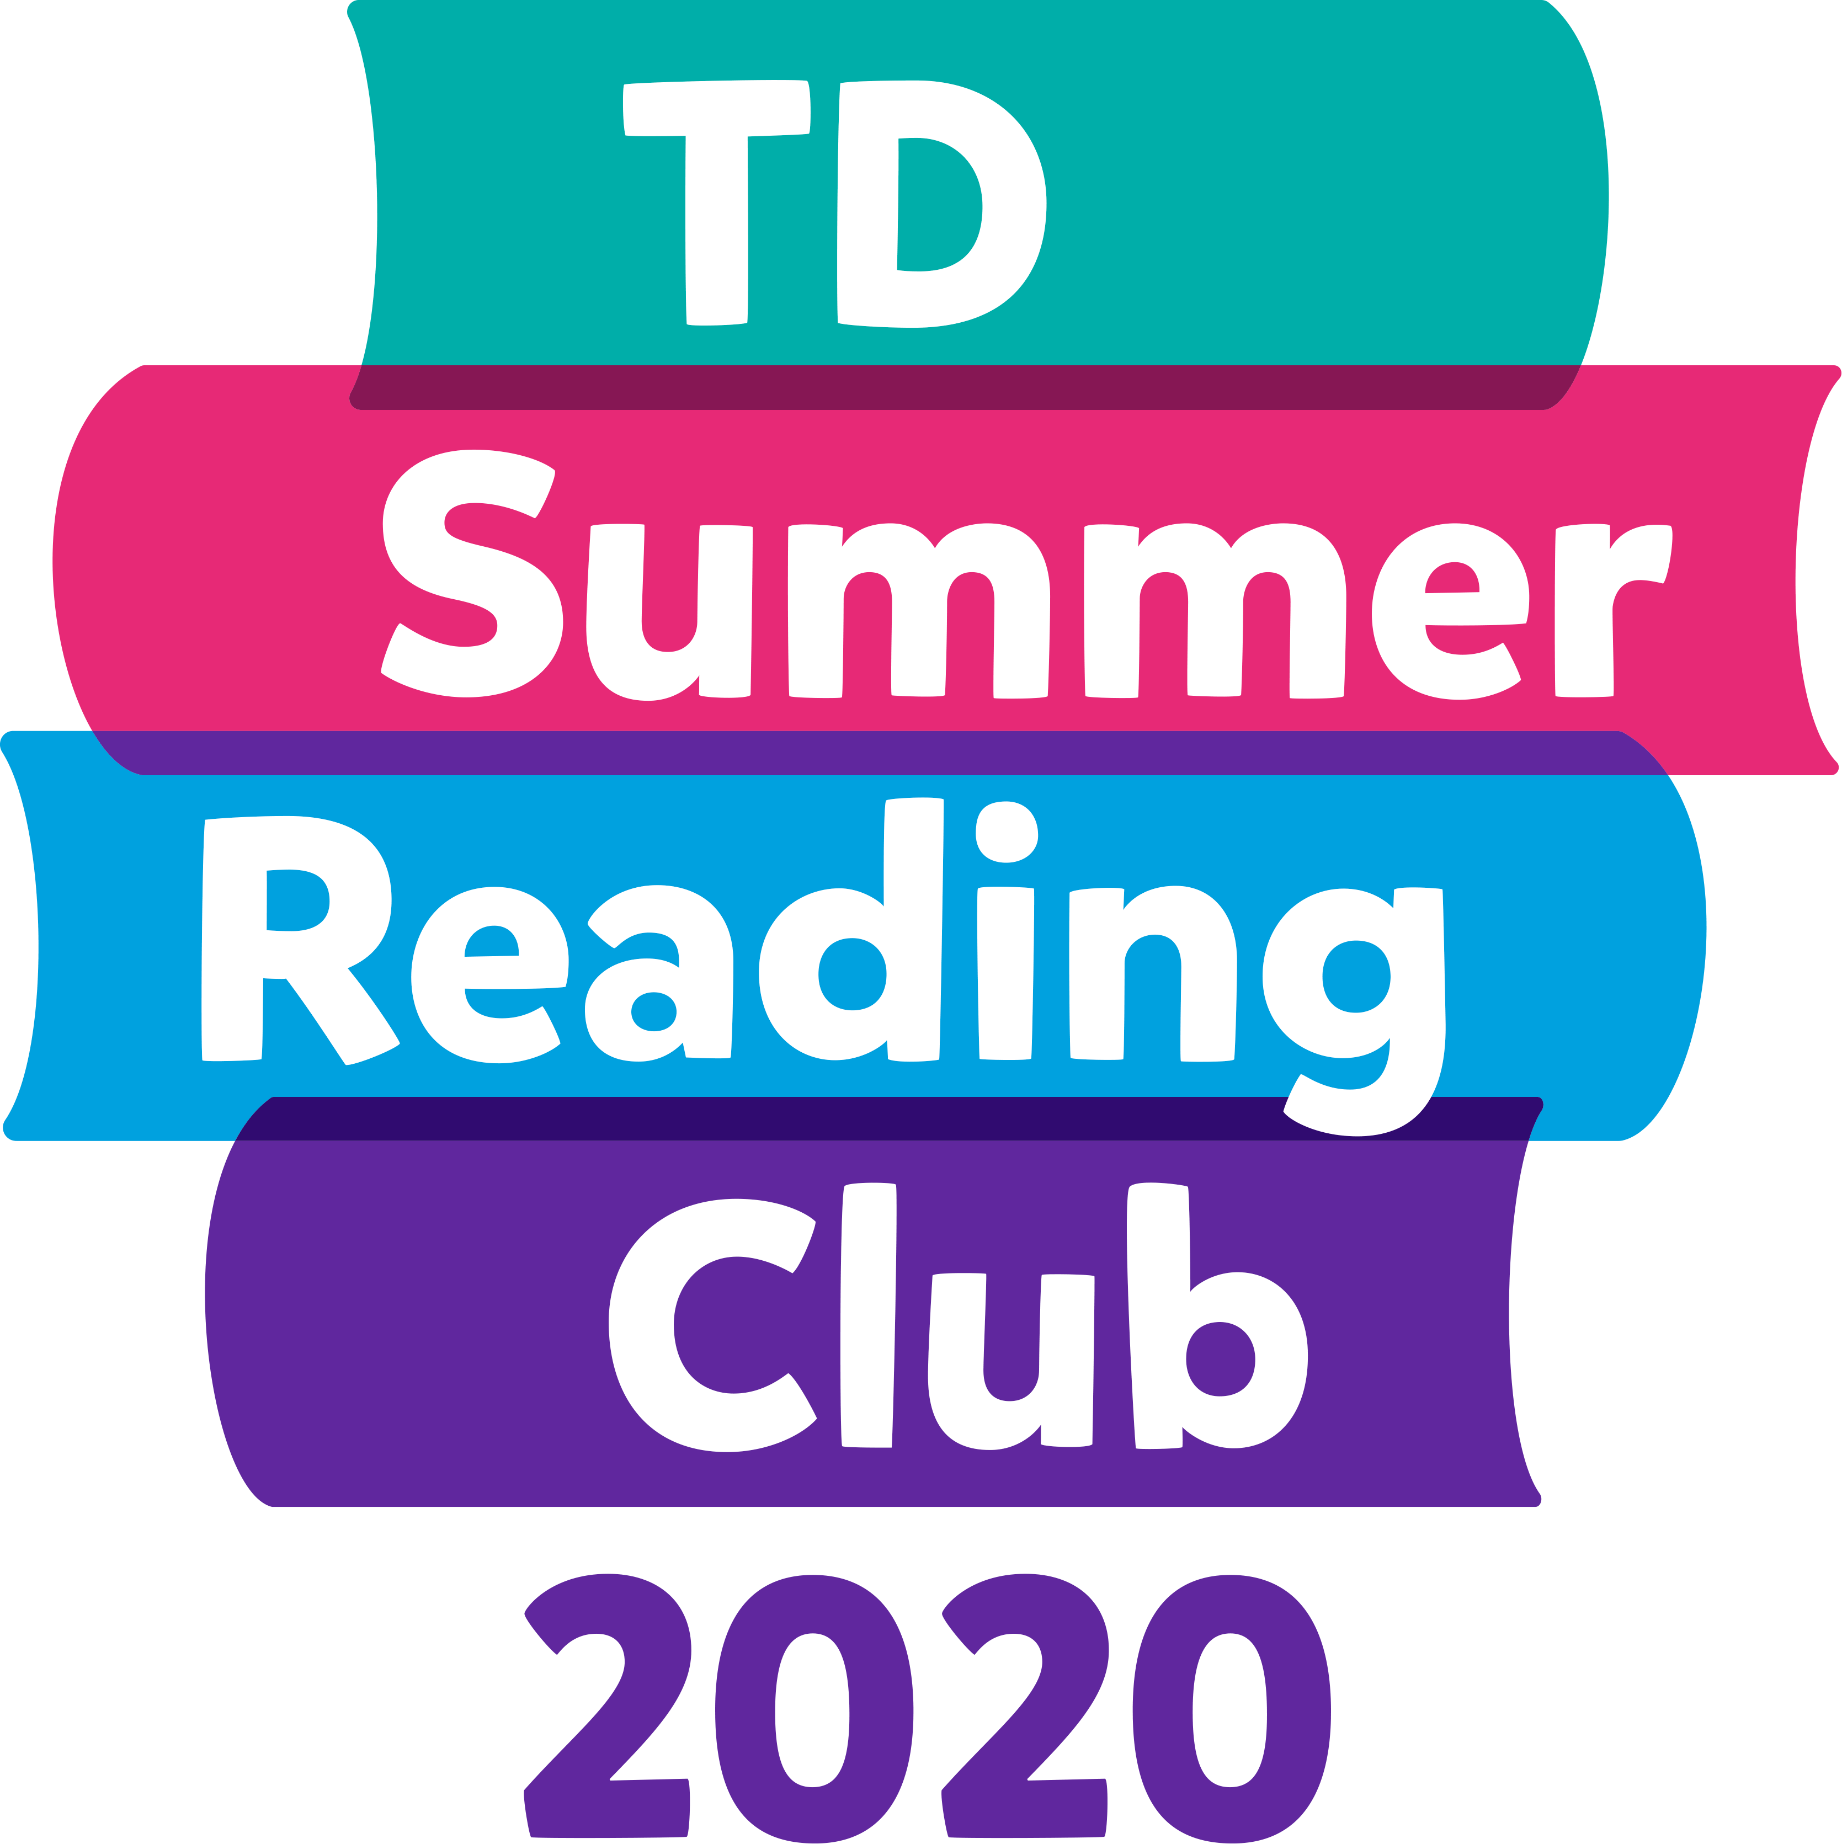
Dear School Staff,
Thank you for helping us promote the TD Summer Reading Club (TD SRC) program to children at your school.
The TD SRC is an inclusive program, in English and in French, that strives to engage all children in the joy of reading, while also championing Canadian writers and illustrators. The program helps to connect families with books and to build confidence in reading.
For the summer of 2020, kids will be able to register and participate online through the TD SRC website, which will launch on June 15 at tdsummerreadingclub.ca.
The website will allow kids to do the following:
- Create an online notebook—Kids can generate web access codes directly on our website. This allows them to create their own digital notebooks, which link to their respective library systems. Kids can track their reading by adding the books they read over the summer to their digital notebooks. There is also a special section in their notebooks to record reading material other than books, such as games and recipes. Kids can personalize their notebooks with a nickname and avatar, and the notebook will store any contributions kids make to other parts of our website, such as jokes and stories (see below). Each time a kid adds a book or submits content, they are rewarded with a digital badge that is stored in their notebook.
- Read ebooks—We have ebooks for all ages and interests, and in both English and French. Once kids set up their online notebooks, they can access the ebooks at any time over the summer—no waiting lists or restrictions!
- Vote in the Battle of the Books—This is an 8-book tournament in which two books battle for top choice each week. All of the books are available as ebooks, so kids can read the books online and then vote for their favourite. At the end of the summer one book will be crowned as the summer’s champion.
- Review books—Kids can share what they think about books they have read for other kids to see.
- Participate in weekly trivia—Each week, we will have a new multiple choice trivia question for kids to answer. After selecting an answer, kids see an explanation and a prompt to explore the topic further.
- Write stories—Our silly stories ask kids to add their own words to a pre-written, hidden story. Once kids fill in the word prompts, the full story is revealed—and it’s usually silly! We also have story starters, where kids continue writing a story that we’ve started for them. Kids can read the story endings that other kids have submitted.
- Read and write jokes—Kids can write their own jokes and read the jokes submitted by other kids. There is an option to like a joke and sort the jokes by most popular and trending.
- Read an original web comic—Kean Soo has written an original web comic called The Transfer Student. Kids can read it and then participate in discussion questions with other kids. For bilingual kids, Yves Bourgelas has written an original web comic in French that they can check out as well.
- View author/illustrator readings and workshops—We will be offering 28 online readings and workshops that can be accessed through the Kids’ Site, including videos from Dave Whamond, Kean Soo and Yves Bourgelas.
- Print colouring sheets—Colouring sheets ranging from simple to advanced for parents to print out for kids of all ages.
- Find the perfect book—Kids answer our book-finder questions to find the book most suited for them.
We hope you’ll help us spread the word about the Club. If you have any questions, please don’t hesitate to get in touch.
[Insert contact information]

