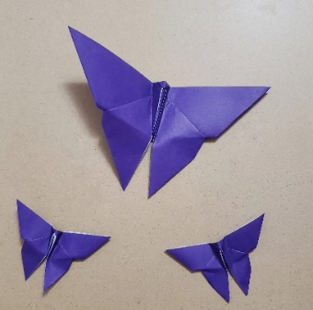

- Place square with the colour side up (white side down). Fold in half horizontally and then fold in half vertically
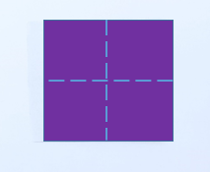

- Flip square over (white side up) and fold diagonally in both directions
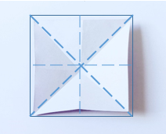

- Flip square over and push the triangles on the left and right side towards the centre with your pointer fingers. Use your middle fingers and thumbs to flatten the top and bottom triangles together
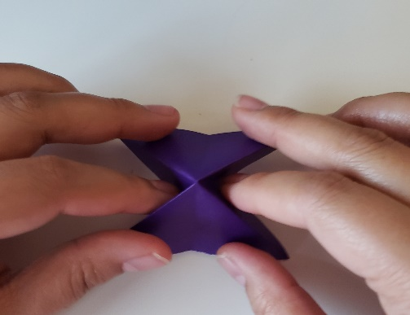
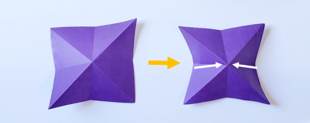
- Position triangle flat on a surface and fold the first layer corner flaps to meet the center line.
Rotate the figure so the triangle point is on the bottom

- Fold the figure horizontally in half backwards (it should look like a paper boat). The tip of the back triangle should extend slightly above the top edge of the figure, and the crease down the centre of the back triangle should align with the crease down the centre of the front triangle
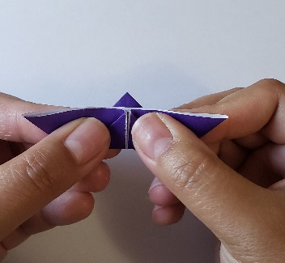

- Flip over the figure and try to flatten it. As you do, you will notice two small triangles on the sides of the bottom triangle automatically flatten out. Press down on these triangles and then flip figure over

- You will notice the tip of the triangle extending past the top edge of the figure. Fold this over the top edge and then fold the butterfly in half backwards. The back of the wings should align and touch each other
- Pinch the butterfly body with your left pointer finger and thumb, so you are covering the butterfly head and part of the body. Now take your right thumb and pointer finger and place them between the back of the wings
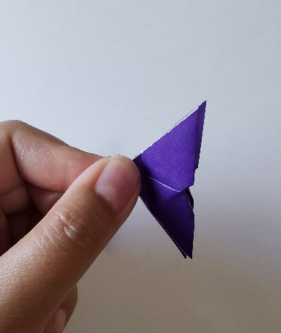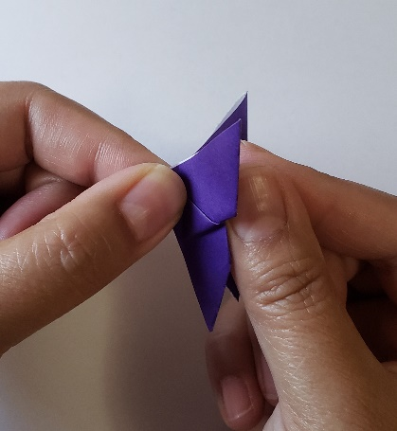
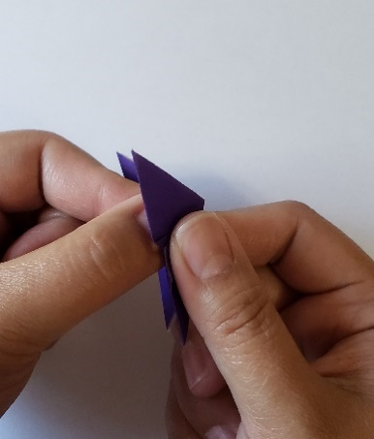
- Push the wings forward towards your pinched fingers on your left hand, wrapping the wings around them, and remove your pinched fingers. You can pinch the wings together with your right thumb and pointer finger, then open it up like a book. Congratulations! You have completed your butterfly!

