Quick Guide to the TD Summer Reading Club Print Materials

School-age notebook

A bilingual notebook designed for school-age children. Distribute one to each child aged 6 to 12.

Pre-reader notebook

A bilingual notebook designed for parents and caregivers to use with pre-readers. Distribute one to each child aged 0 to 5.
Web access sticker

A sticker with a unique code that allows kids and families to create an online notebook, read ebooks and track reading at tdsummerreadingclub.ca. The sticker should be placed in the inside cover of the notebook. Distribute one to each child.

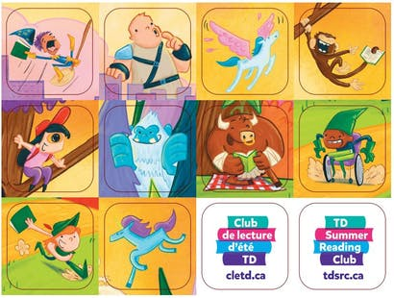 | Pre-reader sticker sheet  Stickers for use with the pre-reader notebook. The 12 stickers should be placed in the image in the centrefold of the pre-reader notebook. Distribute the entire sheet or one sticker at a time, depending on your library’s procedure.
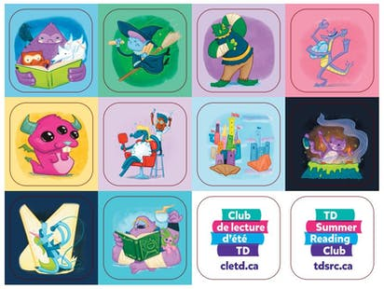 | School-age sticker sheet  Stickers for use with the school-age notebook. The 12 stickers are placed in the empty boxes throughout the school-age notebook. Distribute the entire sheet or one sticker at a time, depending on your library’s procedure.
Top recommended reads brochure

A brochure to promote the Club to parents, caregivers and educators. Distribute for promotional purposes.

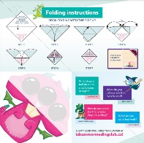 | Corner bookmark  A promotional item for kids. There are separate English and French bookmarks. Distribute to kids as desired for promotional purposes.

