Dear Staff:
The TD Summer Reading Club (TDSRC) is Canada’s biggest, bilingual summer reading program for kids of all ages, interests and abilities. This free Club is offered at more than 2,200 public libraries across Canada, as well as online. The TDSRC celebrates Canadian authors, illustrators and stories, and inspires kids to explore the fun of reading their way. This is key to building a lifelong love of reading.

For more information about the TDSRC, check us out online: www.tdsummerreadingclub.ca.

On the back of this page, you will find a description of the promotional materials and program materials that we are sending you.

Our bilingual pre-reader notebook is designed for parents and caregivers to use with children aged 0 to 5. It includes the following:
- Activities to encourage skill-building practices—talking, singing, playing, writing and reading—to help raise a reader
- Space to record items read or listened to, record the number of minutes read, or draw pictures
- An illustration to be completed with the Club’s stickers
- Fun challenges
- A summer recap page
- A program certificate
We ask that you help to promote the TDSRC in any way that works for your centre, including displaying our poster, distributing the Top Recommended Reads brochure, and talking to kids and families about joining the TDSRC at their local participating library.

If you have any questions about this package, please contact:

[Insert contact information]

TD SUMMER READING CLUB MATERIALS

Promotional Materials

Top Recommended Reads Brochure  Please distribute a Top Recommended Reads brochure to parents and caregivers. | 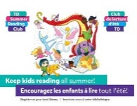
Poster

Please display the poster in a prominent location in your centre.

Program Materials (items kids will receive at their local library)
Notebooks

There are multiple versions of the notebook:
- A bilingual pre-reader notebook for parents and caregivers to use with their kids aged 0–5.
- A bilingual school-age notebook for kids aged 6–12.
- Accessible notebooks in a variety of formats (audio, large print, braille and OpenDyslexic font). The accessible notebooks are not included in this sample package, but they are available at participating public libraries and online.

Web Access Sticker  This sticker contains a unique access code that kids can enter at the TDSRC website to create their online notebook. It gives kids access to free ebooks and allows them to collect badges for reading and participating in activities. | 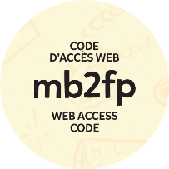
Corner Bookmark  The corner bookmark includes folding instructions, jokes and encouragement to join the Club.  There is an English bookmark and a French bookmark. | 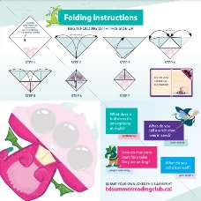
Stickers  Stickers can be used as reading incentives by library staff or by parents and caregivers. | 