MY SUPER POTATO
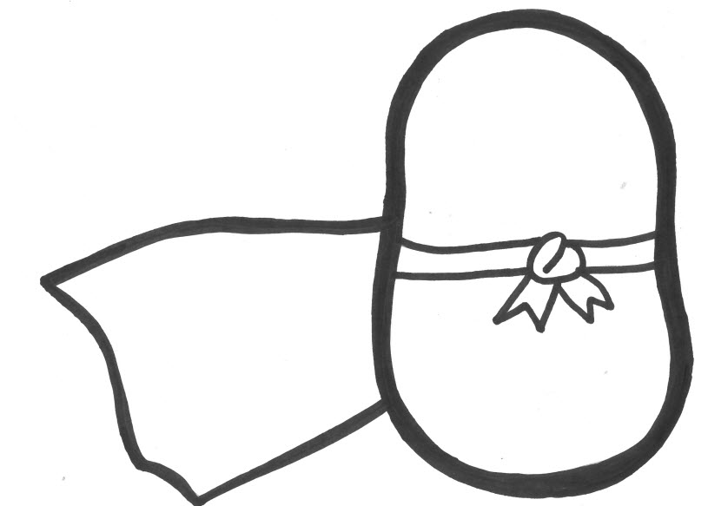
Show us what your super potato looks like in the box above.

SUPER POTATO FEELS LIKE THIS…
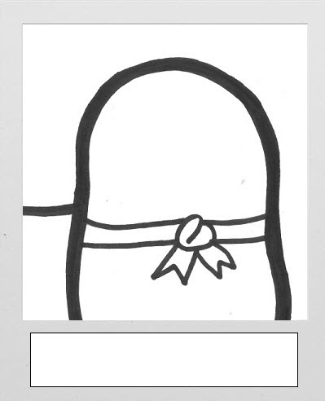
Fill in Super Potato’s mood in the white boxes of the polaroid pictures.
Then draw in what their face looks like when they feel that way.

MY SUPER POTATO
Show us what your super potato looks like in the box above.

SUPER POTATO FEELS LIKE THIS…
Fill in Super Potato’s mood in the white boxes of the polaroid pictures.
Then draw in what their face looks like when they feel that way.

MY SUPER POTATO
Super Potato Name: _______________________________________________
Age: _______________
Special abilities include: ____________________________________________
_________________________________________________________________
_________________________________________________________________
Needs this many hours of sleep: _______________
Has this kind of pet: _______________________
Tell a short story about your Super Potato:
One windy day… ____________________________________________________
___________________________________________________________________
___________________________________________________________________
___________________________________________________________________
___________________________________________________________________
___________________________________________________________________
___________________________________________________________________
___________________________________________________________________
___________________________________________________________________
___________________________________________________________________
___________________________________________________________________
___________________________________________________________________
___________________________________________________________________
___________________________________________________________________
___________________________________________________________________

